Assignment No. 02

1. Search for a specific word “apple” in a file and count it.
2. Show current users logged in.
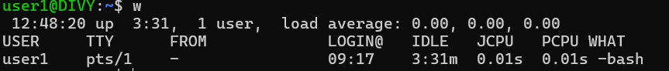
3. Show total number of .txt files in current directory.
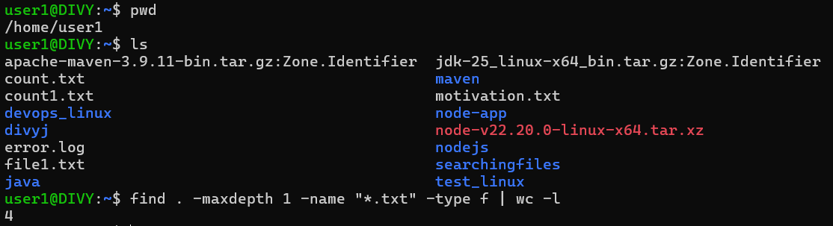
4. Show list of all system users from /etc/passwd.
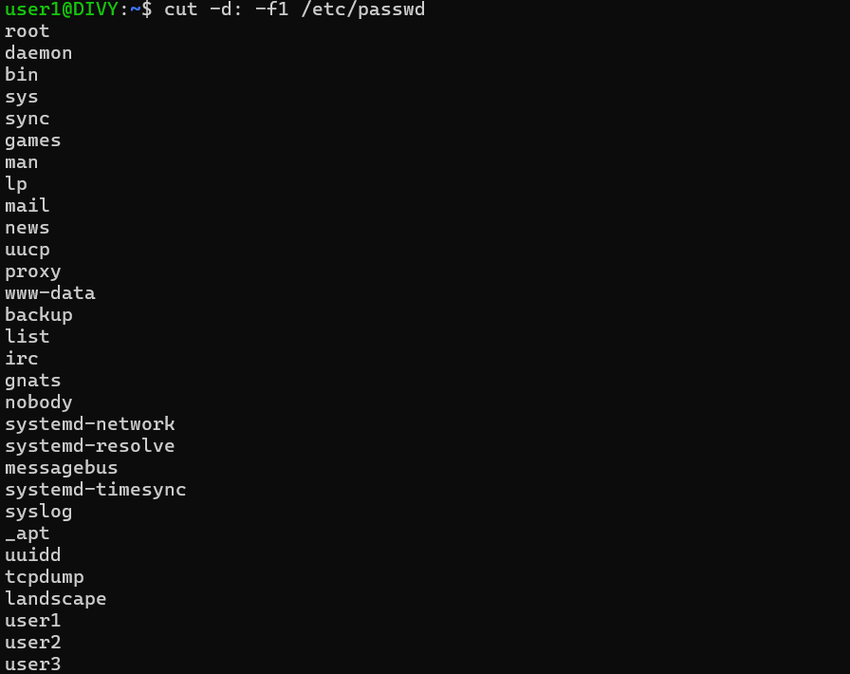
5. Find how many times a word and each match should be on newline.
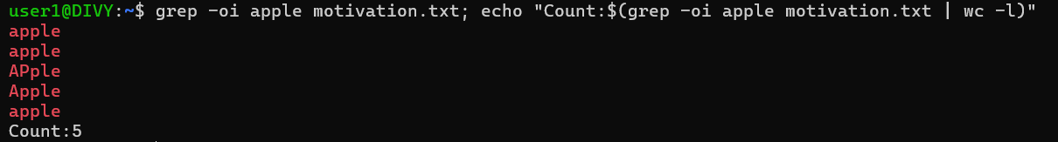
6. Show running processes and search for “root”.
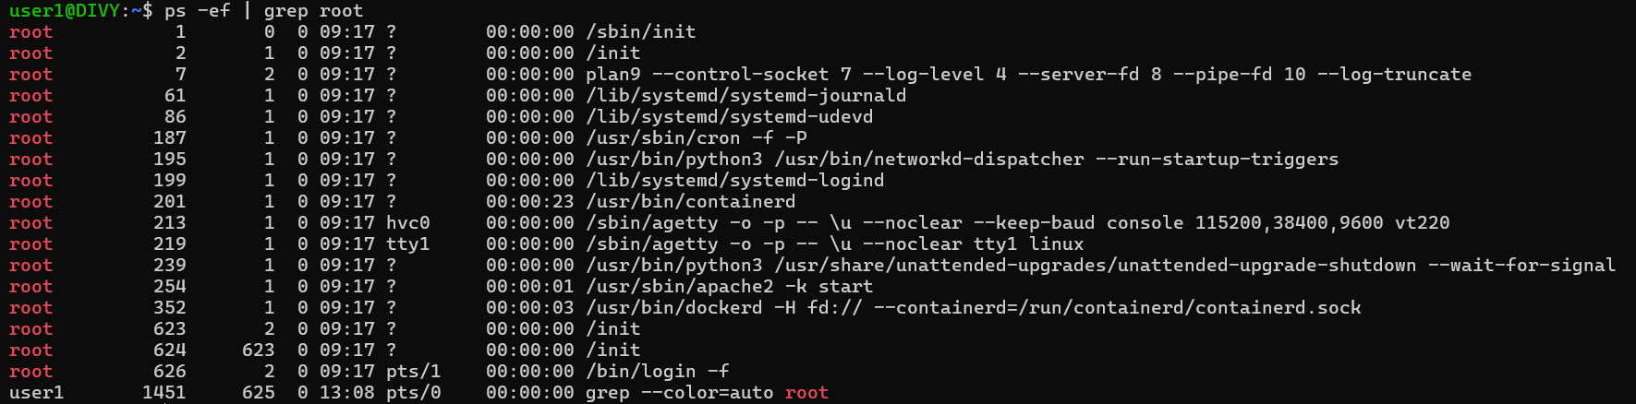
7. Show only .log files and sort them alphabetically.
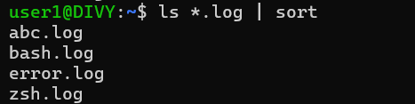
8. See disk space and filter “drivers”.
9. Sort names alphabetically and remove duplicates.
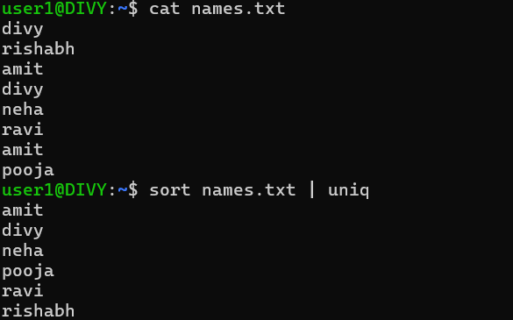
10. Find all .log files modified in last 1 day.
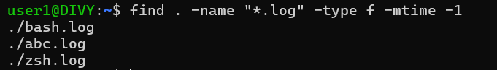
11. Delete .tmp files older than 7 days.
12. Count how many .java files exist in a project.
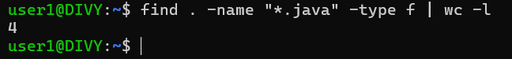
13. Create the access.log file with the following contents.
192.168.0.2 - - [03/Aug/2025:10:01:23 +0000] “GET /index.html HTTP/1.1” 200 1024
192.168.0.3 - - [03/Aug/2025:10:01:24 +0000] “POST /login HTTP/1.1” 200 512
192.168.0.2 - - [03/Aug/2025:10:01:25 +0000] “GET /about HTTP/1.1” 200 2048
192.168.0.4 - - [03/Aug/2025:10:01:26 +0000] “GET /index.html HTTP/1.1” 200 1024
192.168.0.2 - - [03/Aug/2025:10:01:27 +0000] “GET /contact HTTP/1.1” 404 256
192.168.0.3 - - [03/Aug/2025:10:01:28 +0000] “GET /profile HTTP/1.1” 200 512
192.168.0.2 - - [03/Aug/2025:10:01:29 +0000] “GET /products HTTP/1.1” 200 3072
192.168.0.2 - - [03/Aug/2025:10:01:30 +0000] “GET /cart HTTP/1.1” 200 4096

• Count how many times the log was accessed.
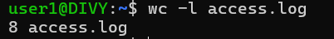
• Show only lines where status code is 404
List all unique IPs that accessed the server. Please note, IP means example,
192.168.0.2.
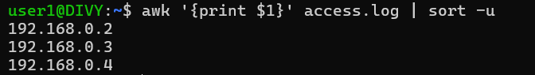
• Count how many requests were POST
• List all requested URLs
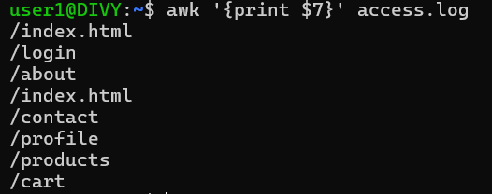
• Find which IPs triggered 404 errors

