Assignment No. 03

1. Write a script that creates a new directory, then creates three empty files
inside it, and finally lists the contents of the directory.
#!/bin/bash
mkdir new_dir
cd new_dir
touch file{1..3}
ls
2. Create a script that prompts the user for a filename, then checks if the file
exists and whether it is a regular file or a directory.
#!/bin/bash
read -p "Enter filename:" filename
if [ -e "$filename" ]; then
if [ -f "$filename" ]; then
echo "$filename exists and it is a regular file"
elif [ -d "$filename" ]; then
echo "$filename exists and it is a directory"
else
echo "$filename exists but it is not a regular file or directory"
fi
else
echo "$filename does not exists"
fi
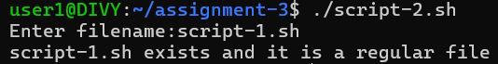
3. Write a script to copy a file from a source path to a destination path
provided as arguments. Handle cases where source or destination are
invalid.
#!/bin/bash
if [ "$#" -ne 2 ]; then
echo "Usage: $0 <source_path> <destination_path>"
exit 1
fi
SOURCE=$1
DESTINATION=$2
if [ ! -f "$SOURCE" ]; then
echo "Error File: Source File: '$SOURCE' does not exists and is not a regular file"
exit 2
fi
DEST_DIR=$(dirname "$DESTINATION")
if [ ! -d "$DEST_DIR" ]; then
echo "Error destination directory '$DEST_DIR' does not exists"
exit 3
fi

cp "$SOURCE" "$DESTINATION"
if [ $? -eq 0 ]; then
echo "File copied successfully from '$SOURCE' to '$DESTINATION'."
else
echo "Error: Failed to copy file"
exit 4
fi
4. Develop a script that displays the current date, time, and your username.
#!/bin/bash
echo "Current Date: $(date '+%d/%b/%y')"
echo "Current time: $(date '+%I:%M:%S')"
echo "$(whoami)"
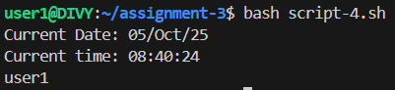
5. Create a script that checks if a given file has read, write, and execute
permissions for the owner.
#!/bin/bash
if [ "$#" -ne 1 ]; then
echo "Usage: $0 <filename>"
exit 1
fi
file=$1
if [ ! -f "$file" ]; then
echo "Error: File:'$file' does not exist"
exit 2
fi
if [ -r "$file" ]; then
echo "The owner has permission to read the file: '$file'."
else
echo "The owner does not have permission to read the file: '$file'."
fi
if [ -w "$file" ]; then
echo "The owner has permission to write to the file: '$file'."
else
echo "The owner does not have permission to write to the file: '$file'."
fi
if [ -x "$file" ]; then
echo "The owner has permission to execute the file: '$file'."
else
echo "The owner does not have permission to execute the file: '$file'."
fi
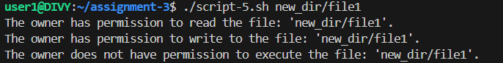
6. Develop a script that compares two strings provided as arguments and
indicates if they are equal or different.
#!/bin/bash
if [ "$#" -ne 2 ]; then
echo "Usage: $0 <string1> <string2>"
exit 1
fi
string1=$1
string2=$2
if [ "$string1" == "$string2" ]; then
echo "string1 and string2 both are equal"
else
echo "string1: "$string1" and string2: "$string2" are not equal"
fi
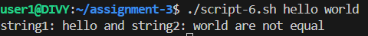

7. Write a script that lists all currently running processes and their PIDs.
#!/bin/bash
ps -e -o user,pid,cmd
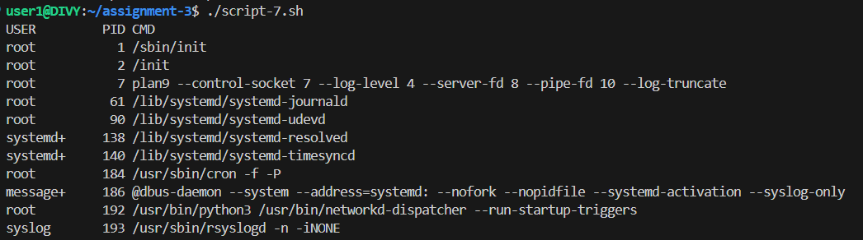

8. Create a script that takes a process ID as an argument and attempts to
terminate that process.
#!/bin/bash
if [ $# -ne 1 ]; then
echo "Usage: $0 <Process-id>"
exit 1
fi
PID=$1
if ! ps -p "$PID" > /dev/null 2>&1; then
echo "Process id: '$PID' not found"
exit 2
fi
kill "$PID" 2> /dev/null
if [ $? -eq 0 ]; then
echo "Process id: '$PID' killed successfully"
else
echo "Failed to kill process '$PID' — it may require elevated privileges."
fi
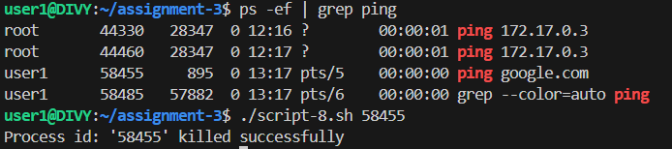

9. Develop a script that displays disk usage information for all mounted
filesystems.
#!/bin/bash
df -h
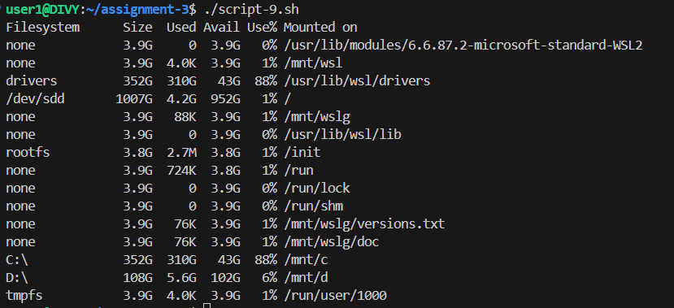
10. Write a script that counts the number of words, lines, and characters in a
given text file.
#!/bin/bash
if [ $# -ne 1 ]; then
echo "Usage: $0 <filename>"
exit 1
fi
file=$1
if [ ! -e "$file" ]; then
echo "file: $file does not exist"
exit 2
else
if [ -f "$file" ]; then
echo "No of words: $(wc -w < $file)"
echo "No of characters: $(wc -c < $file)"
echo "No of lines: $(wc -l < $file)"
fi
fi
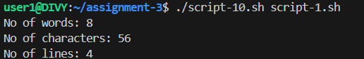
11. Create a script that searches for a specific string within a file or directory
recursively.
#!/bin/bash
if [ $# -ne 2 ]; then
echo "Usage: $0 <file_or_directory> <search_string>"
exit 1
fi
target=$1
search=$2
# Check if target exists
if [ ! -e "$target" ]; then
echo "Error: '$target' does not exist."
exit 2
fi
# Search function
if [ -f "$target" ]; then
grep -n "$search" "$target" 2>/dev/null || echo "No matches found in file '$target'."
elif [ -d "$target" ]; then
matches=$(grep -rnwi "$search" "$target" 2>/dev/null)
if [ -z "$matches" ]; then
echo "No matches found in directory '$target'."
else
echo "$matches"
fi
else
echo "'$target' is neither a file nor a directory."
exit 3
fi
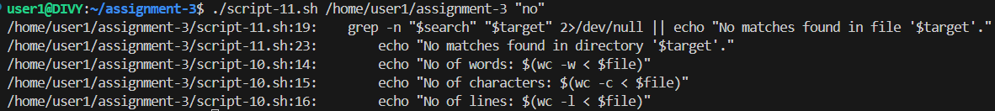
12. Develop a script that backs up a specific directory to a compressed
archive, including a timestamp in the filename.
#!/bin/bash
if [ $# -ne 1 ]; then
echo "Usage: $0 <directory_to_backup>"
exit 1
fi
dir=$1
if [ ! -d "$dir" ]; then
echo "Error: '$dir' is not a valid directory."
exit 2
fi
timestamp=$(date +"%d.%m.%Y_%H-%M-%S")
backup_file="backup_$(basename "$dir")_${timestamp}.tar.gz"
tar -czf "$backup_file" "$dir"
if [ $? -eq 0 ]; then
echo "Backup successful! File created: $backup_file"
else
echo "Backup failed."
fi
13. Write a script that schedules a task to run at a specific time using cron.
#!/bin/bash
read -p "Enter time in 24-hour format (HH:MM): " time
read -p "Enter the full command or script path to run: " task
hour=${time%%:*}
minute=${time##*:}
(crontab -l 2>/dev/null; echo "$minute $hour * * * $task") | crontab -
echo "Task scheduled at $hour:$minute"
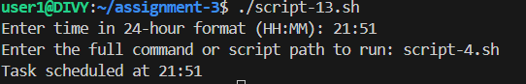
14. Write a script to replace all occurrences of one word with another
throughout data.txt.
#!/bin/bash
if [ $# -ne 2 ]; then
echo "Usage: $0 <old_word> <new_word>"
exit 1
fi
old_word=$1
new_word=$2
file="data.txt"
if [ ! -f "$file" ]; then
echo "Error: $file not found!"
exit 2
fi
sed -i "s/$old_word/$new_word/g" "$file"
echo "All occurrences of '$old_word' have been replaced with '$new_word' in $file."

15. Print only the lines from data.txt where the second field is a number greater
than 10. Use awk command.
#!/bin/bash
file="data.txt"
if [ ! -f "$file" ]; then
echo "Error: $file not found!"
exit 1
fi
awk '$2 > 10' "$file"
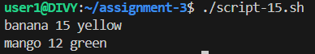
16. Print lines from data.txt that contain a specific pattern, and then print a
custom message for each matched line.
#!/bin/bash
read -p "Enter the pattern to search: " pattern
awk -v pat="$pattern" '
$0 ~ pat {
print "Matched Line: " $0
print "Custom Message: This line contains the pattern!"
}' data.txt


