**PRACTICAL 4**

**IMPLEMENT SEARCH ENGINE _ GOOGLE APP ENGINE(GAE)**

**1.** Download Eclipse IDE for **Enterprise Java Developers** and Install.

Open Eclipse and choose your workspace and click on it.



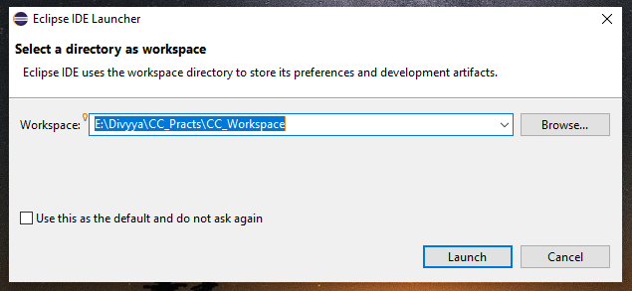

2. Click on >> **Help** >> **Eclipse Marketplace**

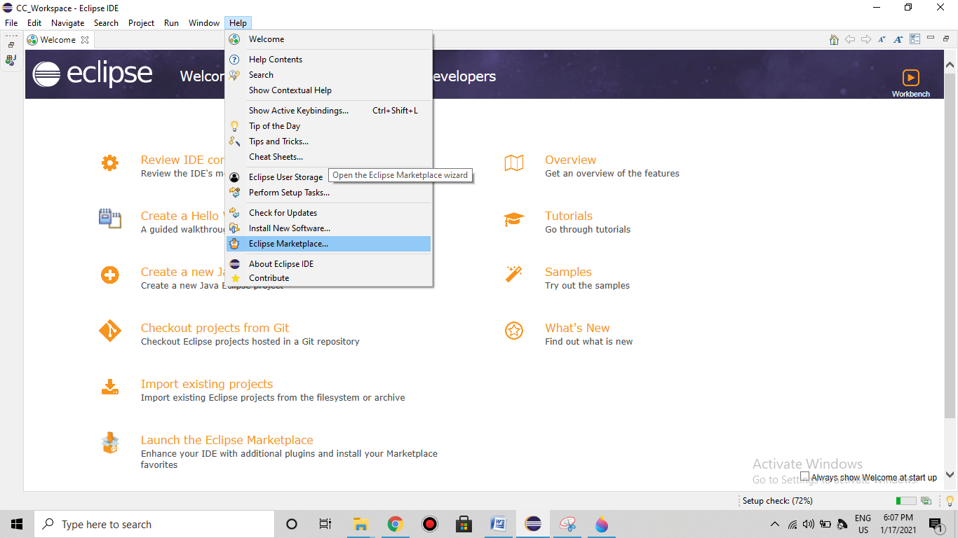

3. In **Find** Search Box**: Search for “Google cloud tools for eclipse”** and click on **Install** button. After complete installation of the plugin restart the Eclipse.

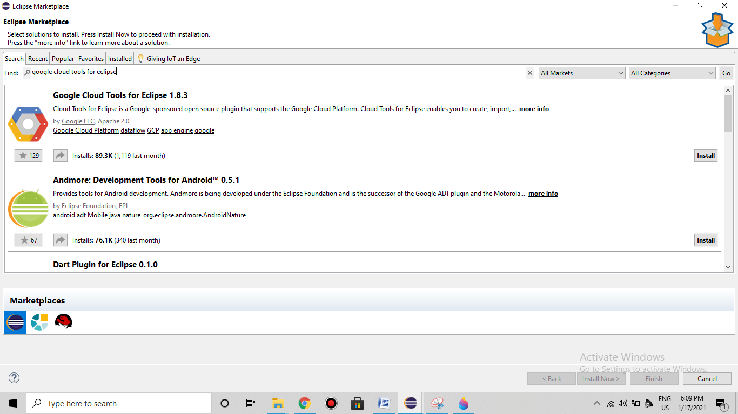

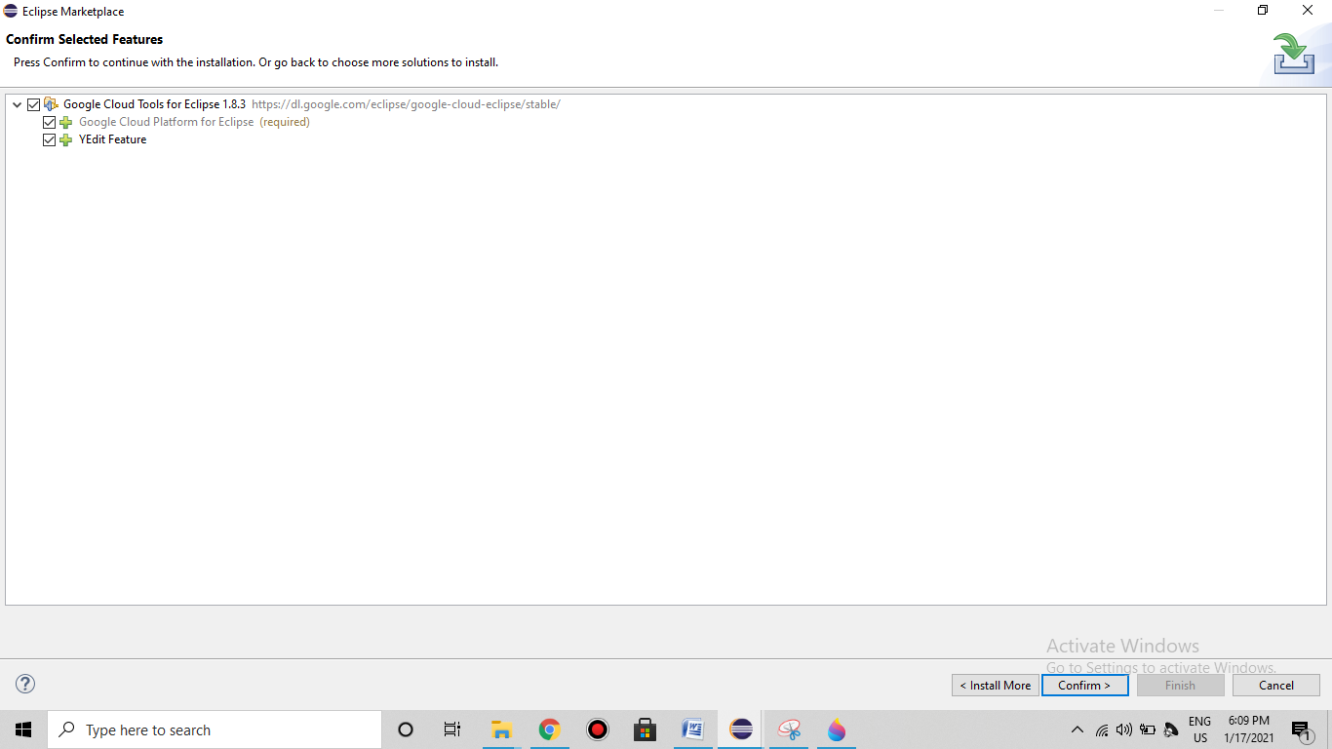

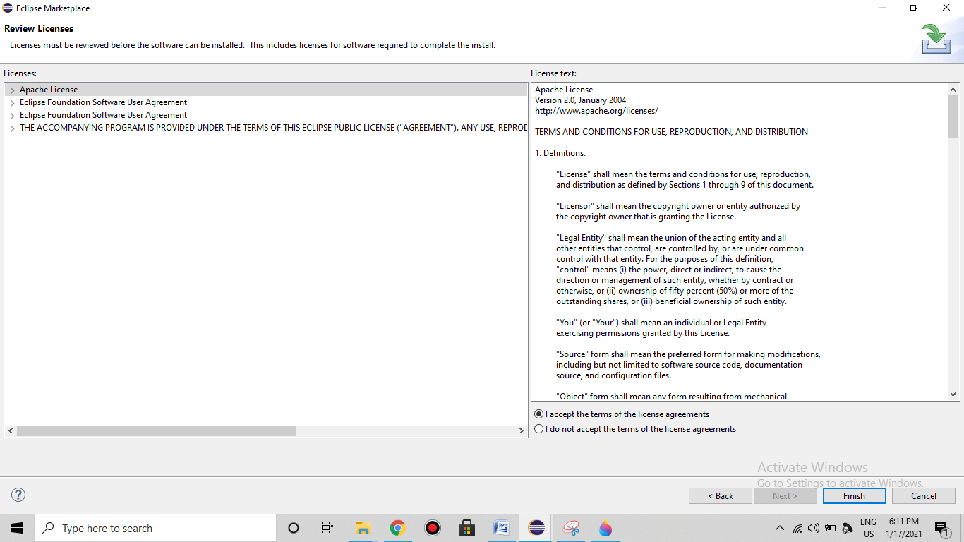

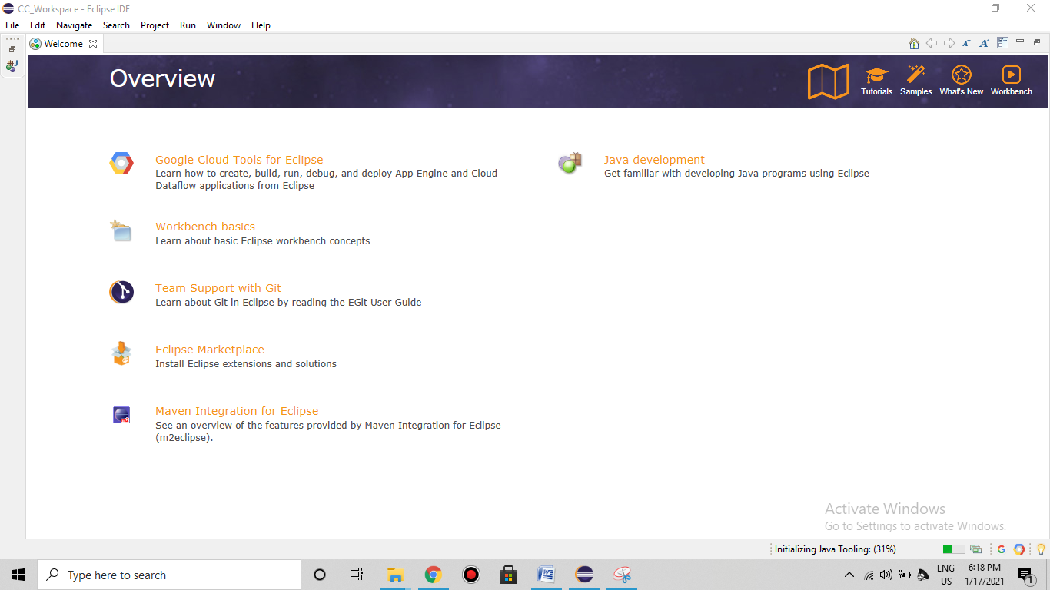

4. Click on ‘**File**’ menu and select >> **New** >> **Other** and search with “Google” keyword and select Google **App Engine Standard Java Project** under **Google Cloud Platform** and click on Next.

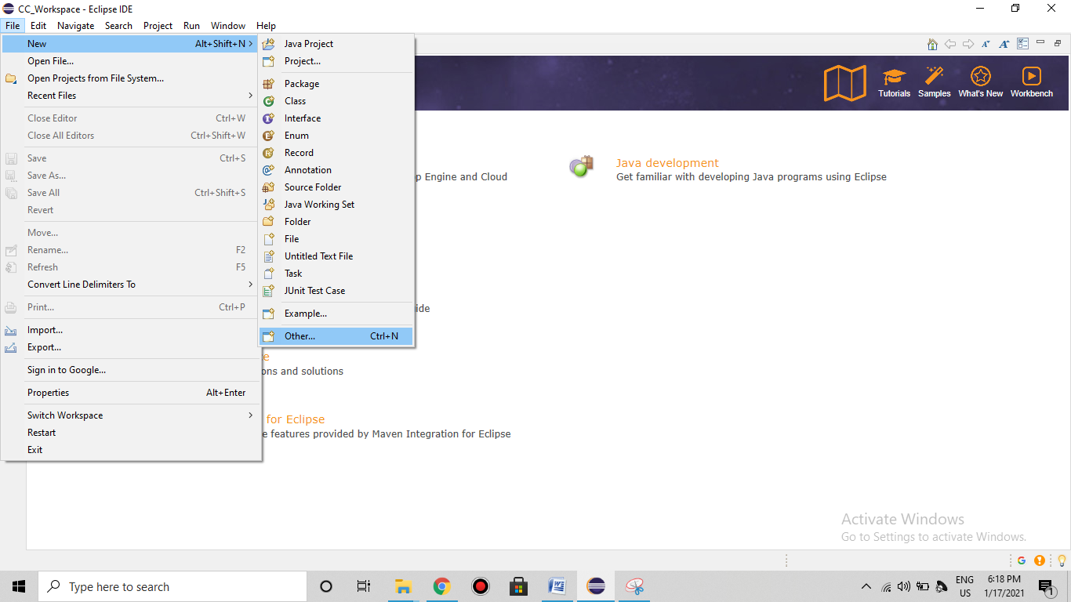

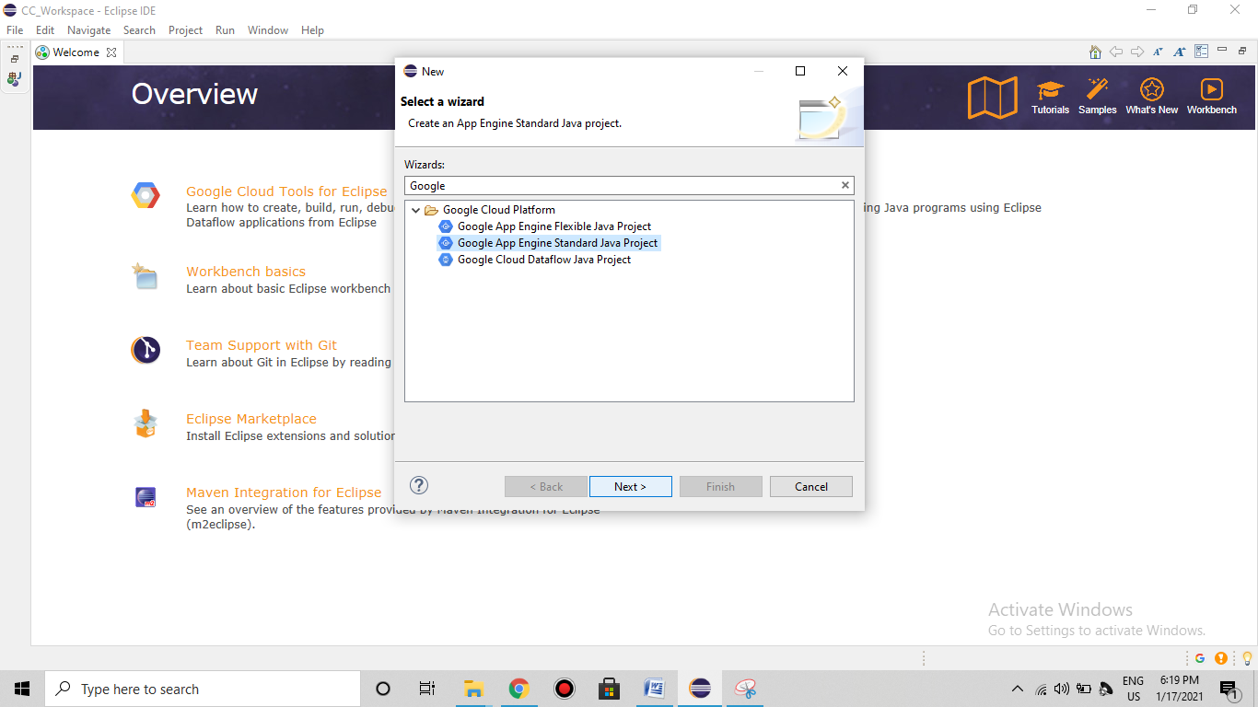

5. Enter **Project Name** “**FirstGAEProject”** and Package Name “**com.GAE”** and then Click on >> **Next** >> **Finish.**

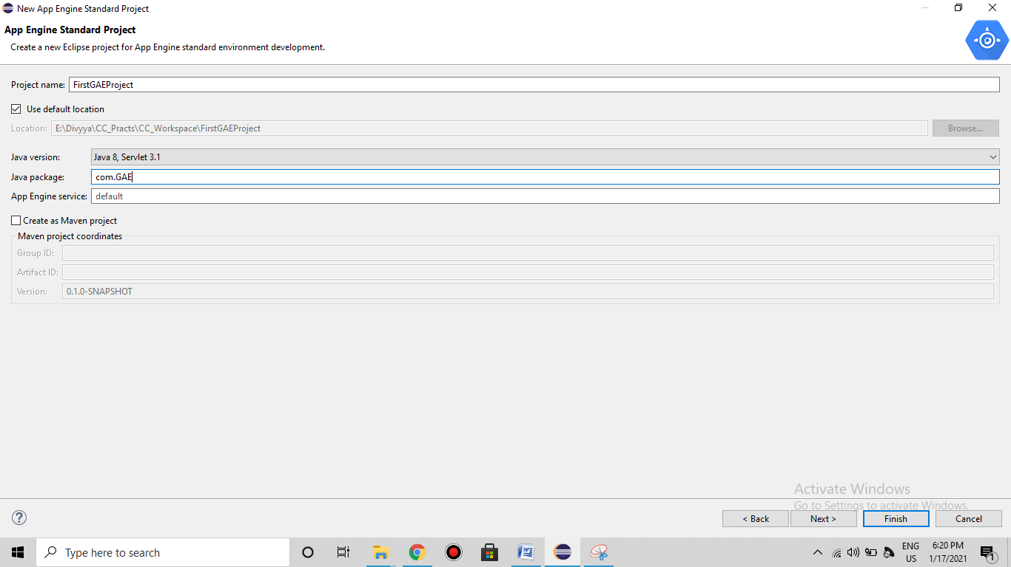

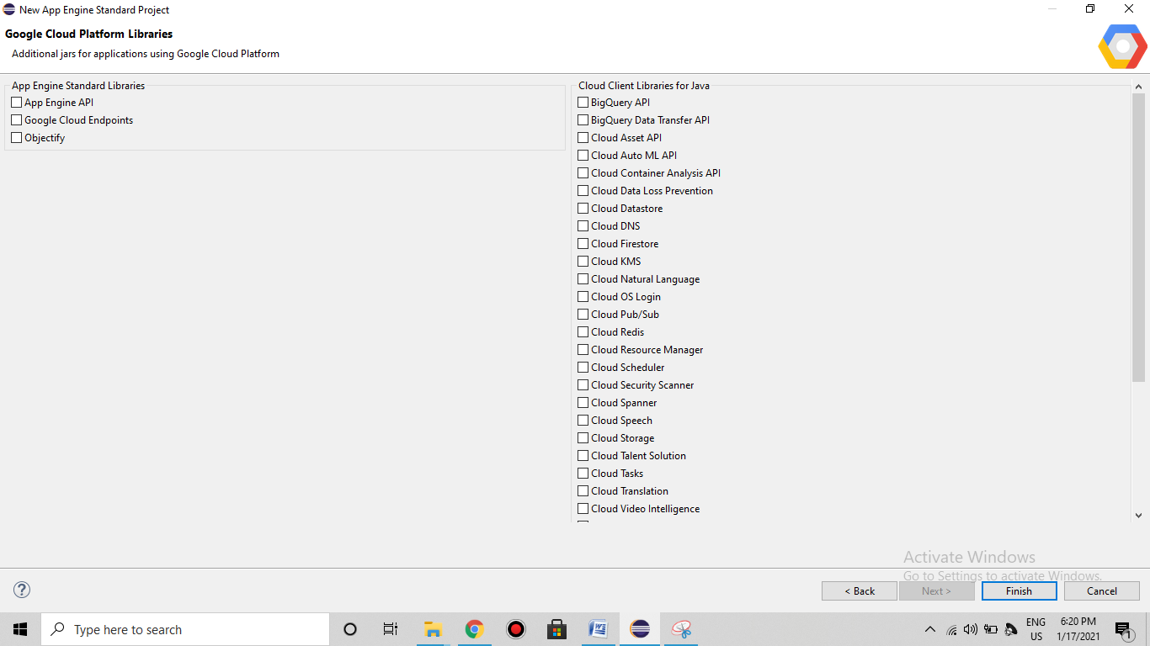

6. Open project hierarchy.

Edit the file as required (Unedited file too can be used. Here the editing is done to “what should be displayed” on the browser). Save the file.

**HelloAppEngine.java**

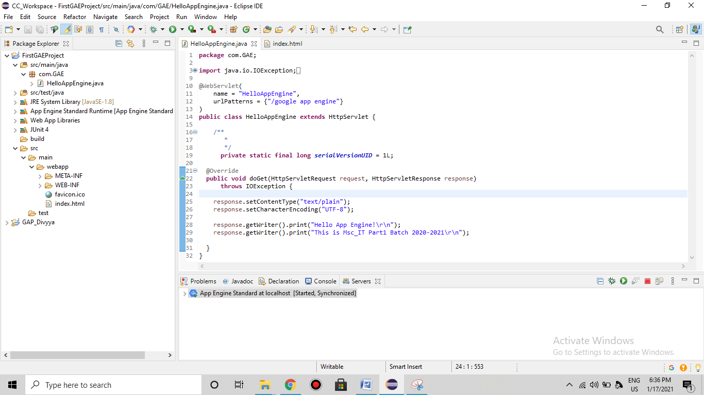

**index.html**

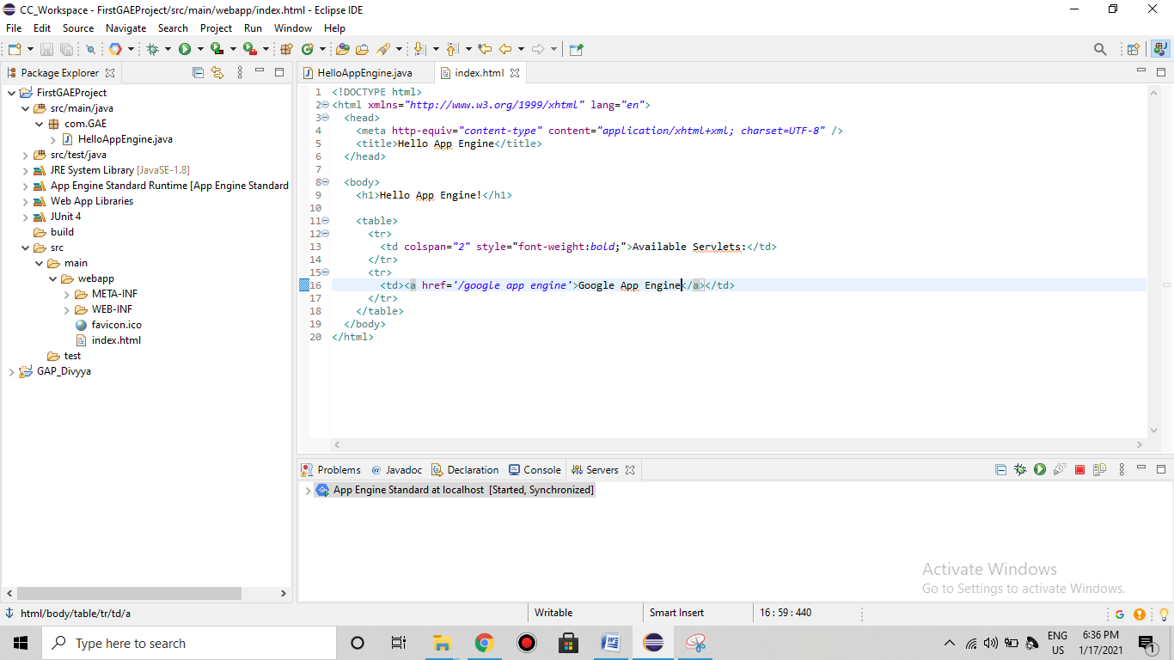

7. Configuring “App Engine Standard” Server. Click on the link to create a new server under **Server tab** >> Click Next >> Add the “**FirstGAEProject**” and click on “**Finish**”.

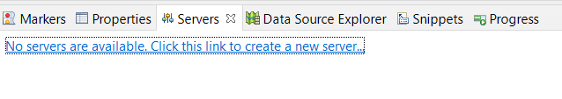

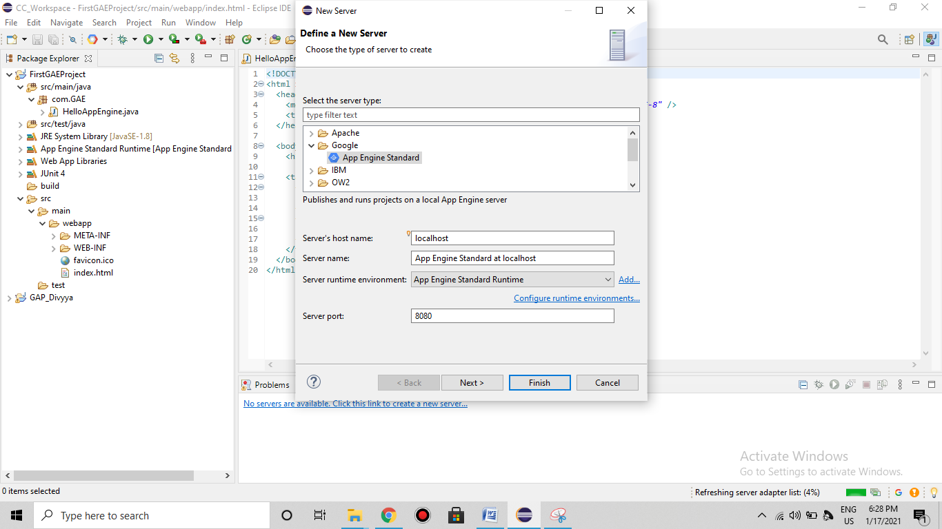

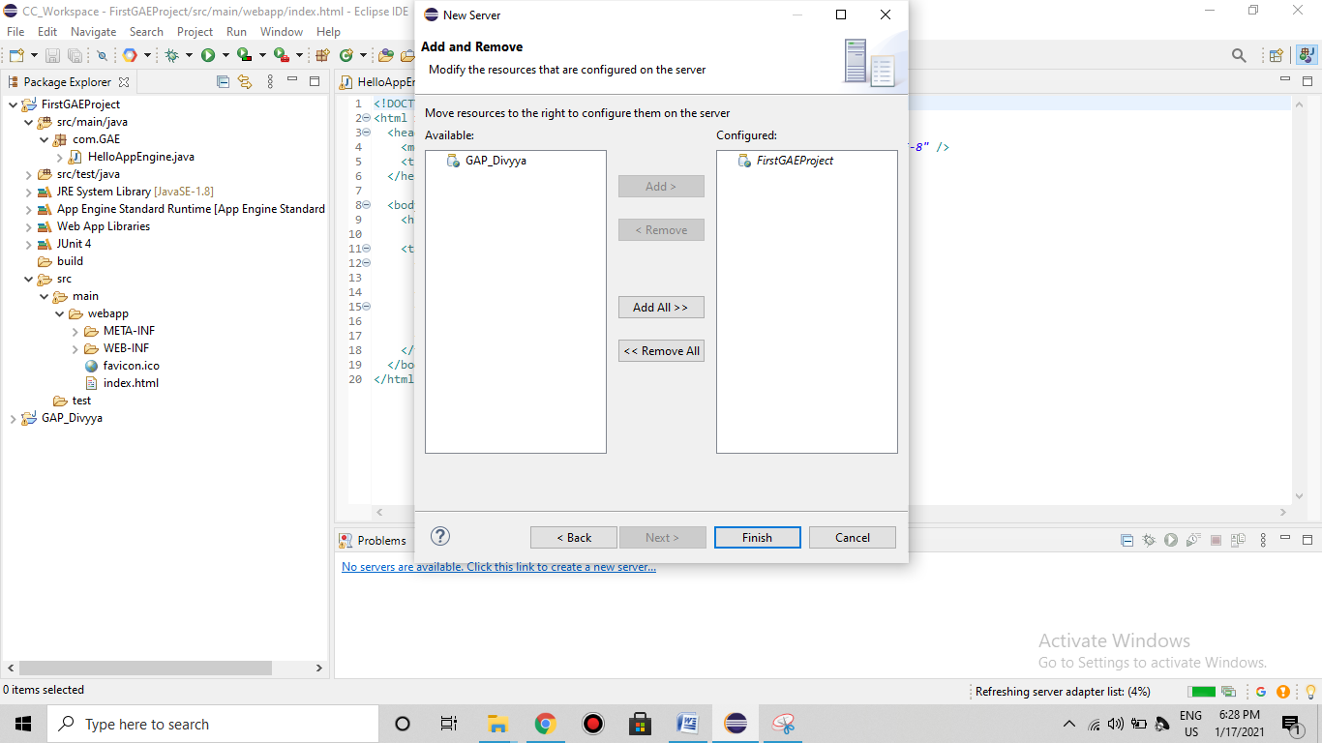

9. Start the “**App Engine Standard**” server.

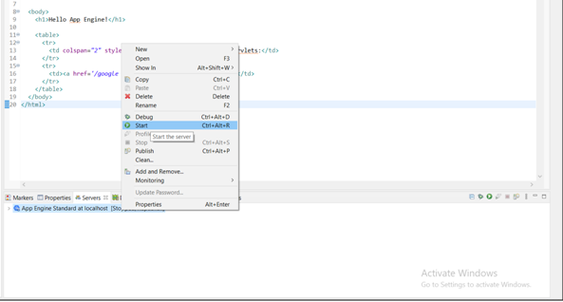

10. In the browser (Here, Google Chrome) type the address as “**localhost:8080**” which is "**Default**" for http protocol.

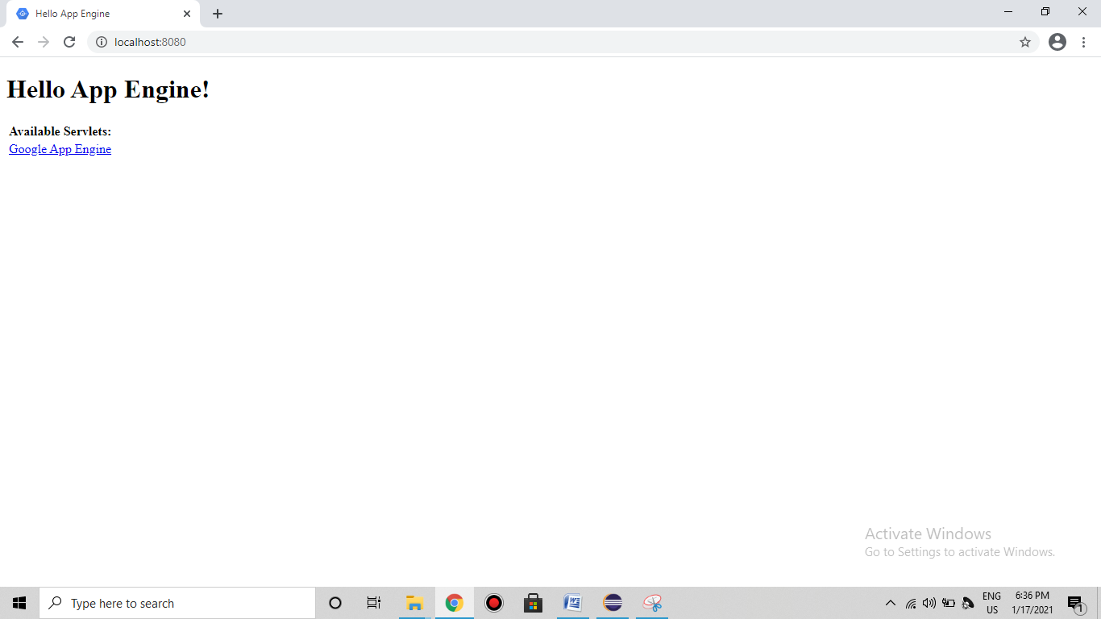

11. Click on this link “**Google App Engine**”. It will redirect with the address “**localhost:8080/google app engine**”.

