PRACTICAL: 6
NATIVE VIRTUALIZATION USING Hyper-V

First we have to uninstall vmware software if already installed on computer because the VMware Workstation installer does not support running on a
Hyper-V virtual machine.
After uninstalling VMware, we can proceed to next step - go to control panel and click on uninstall a program

After Restart Search for hyper-v manager in search box and click on that

For creating virtual machine first we have to create virtual switch
Click on virtual switch manager option

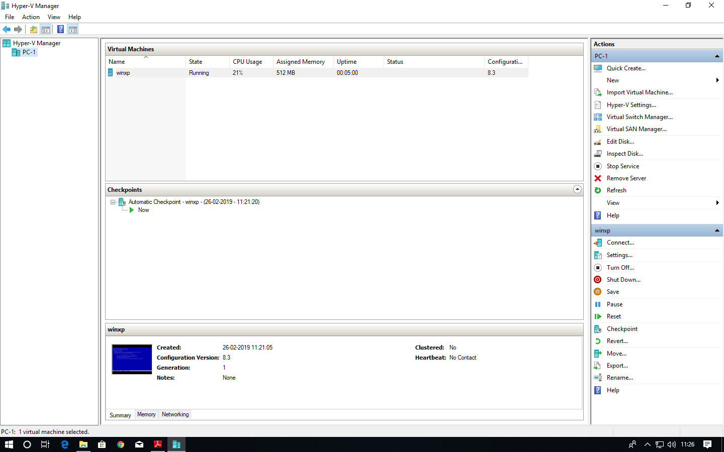

Select External as a connection type and then click on create virtual switch

Give name to our virtual switch then click on apply button

after click on Apply button it will show warning about our connection
click on yes

Now right click on server and select new virtual machine

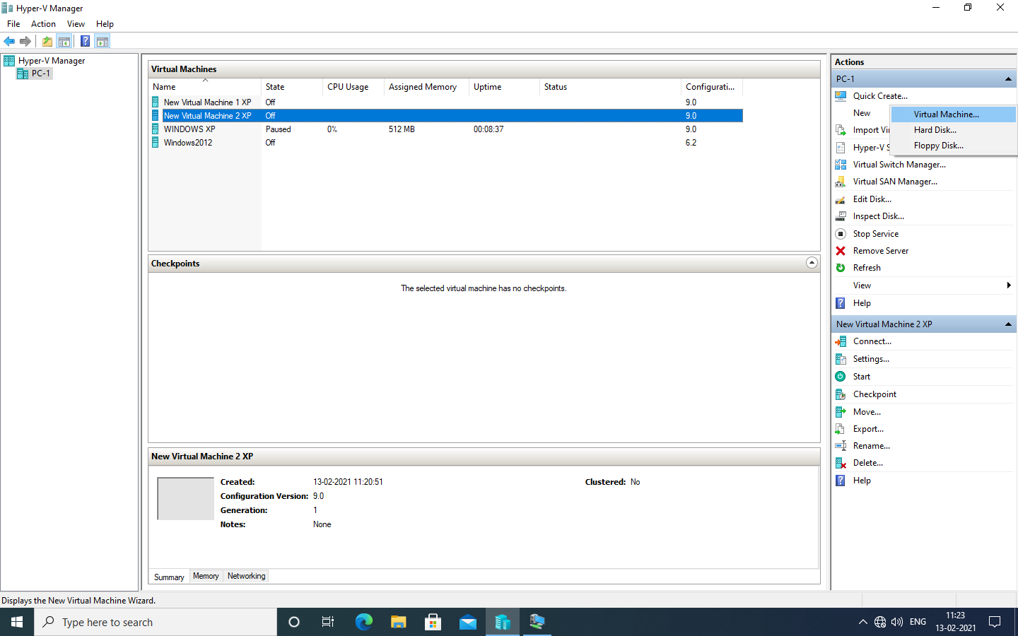

Click on next button

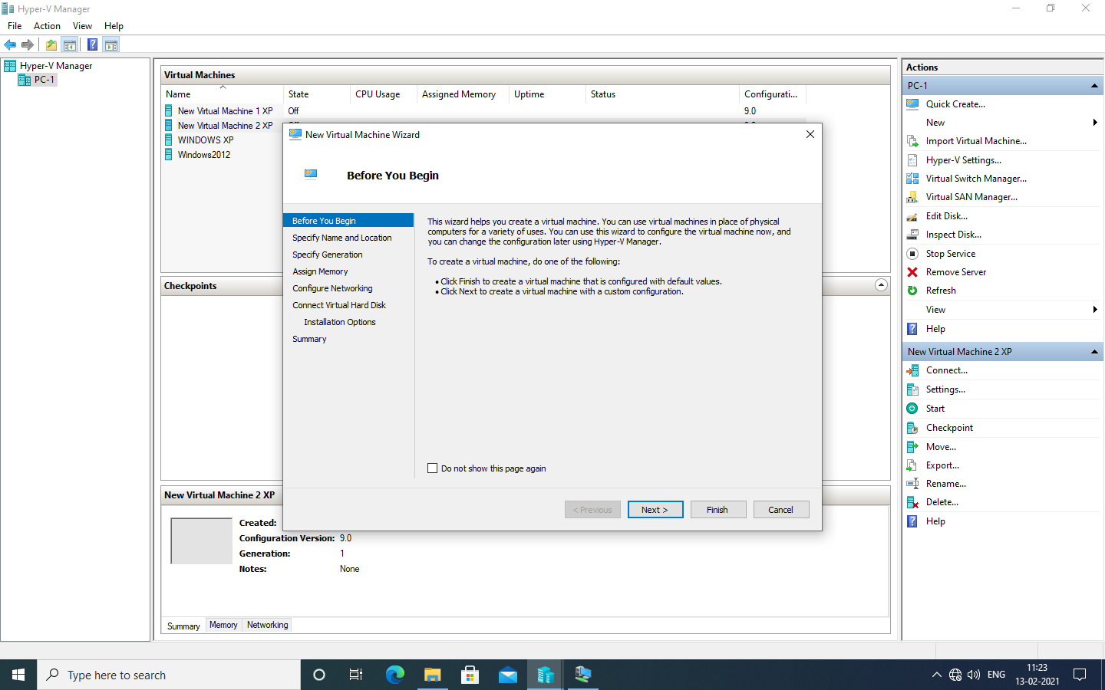

Provide name to virtual machine then click on Next button
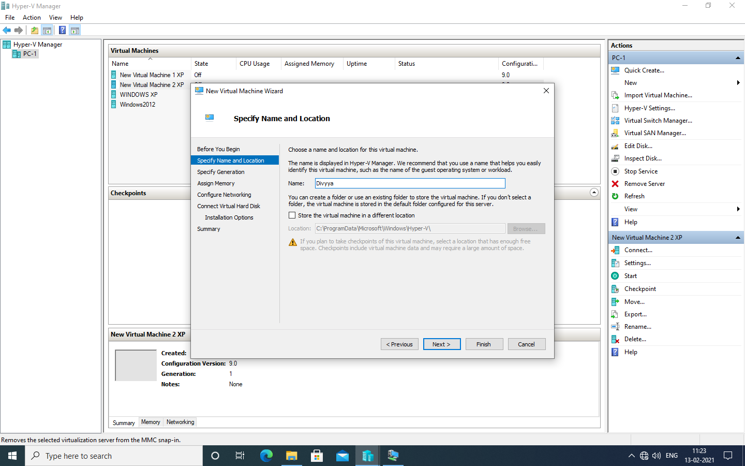

Specify generation : generation 1

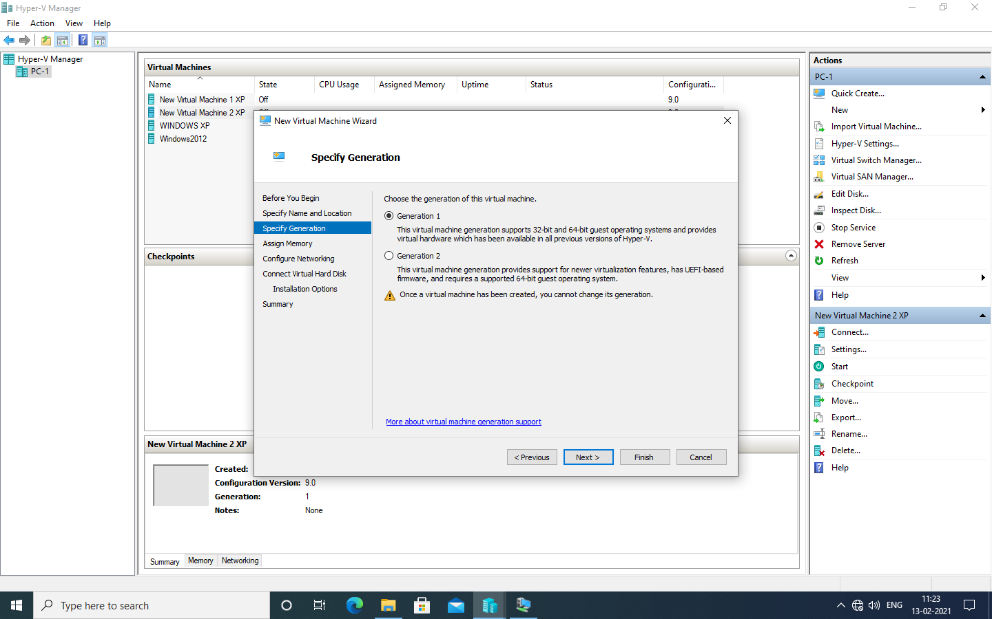

Tick on use dynamic memory for this virtual machine
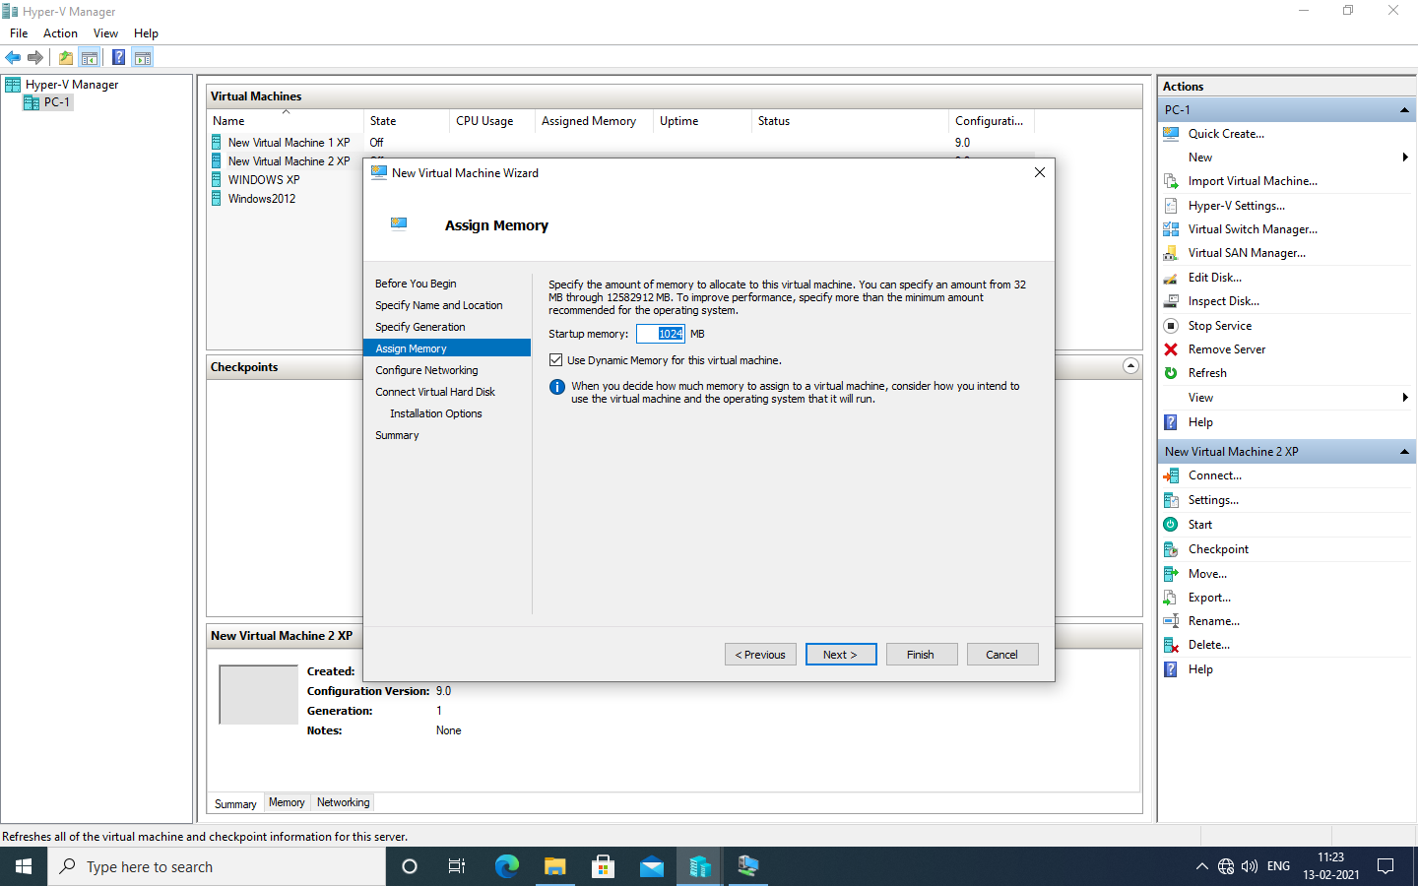

Select switch which we created earlier for our virtual machine from drop-down list and then click on next

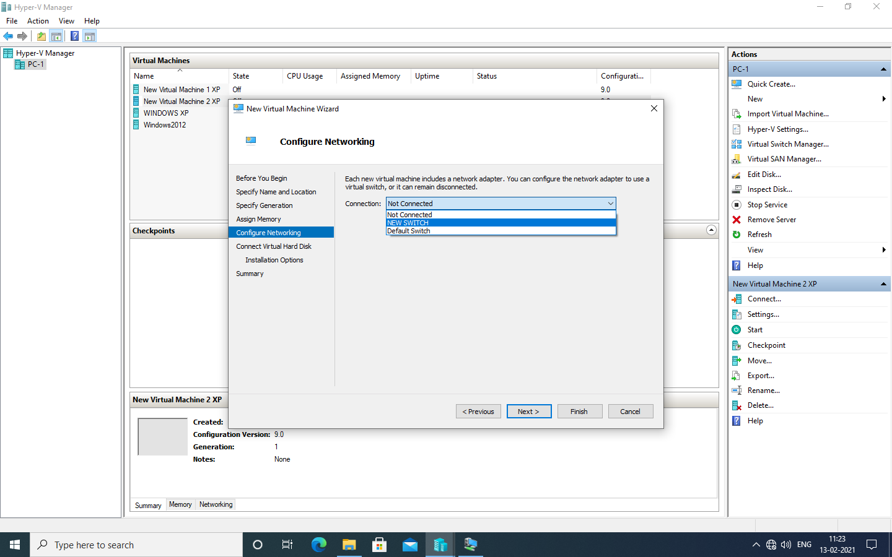
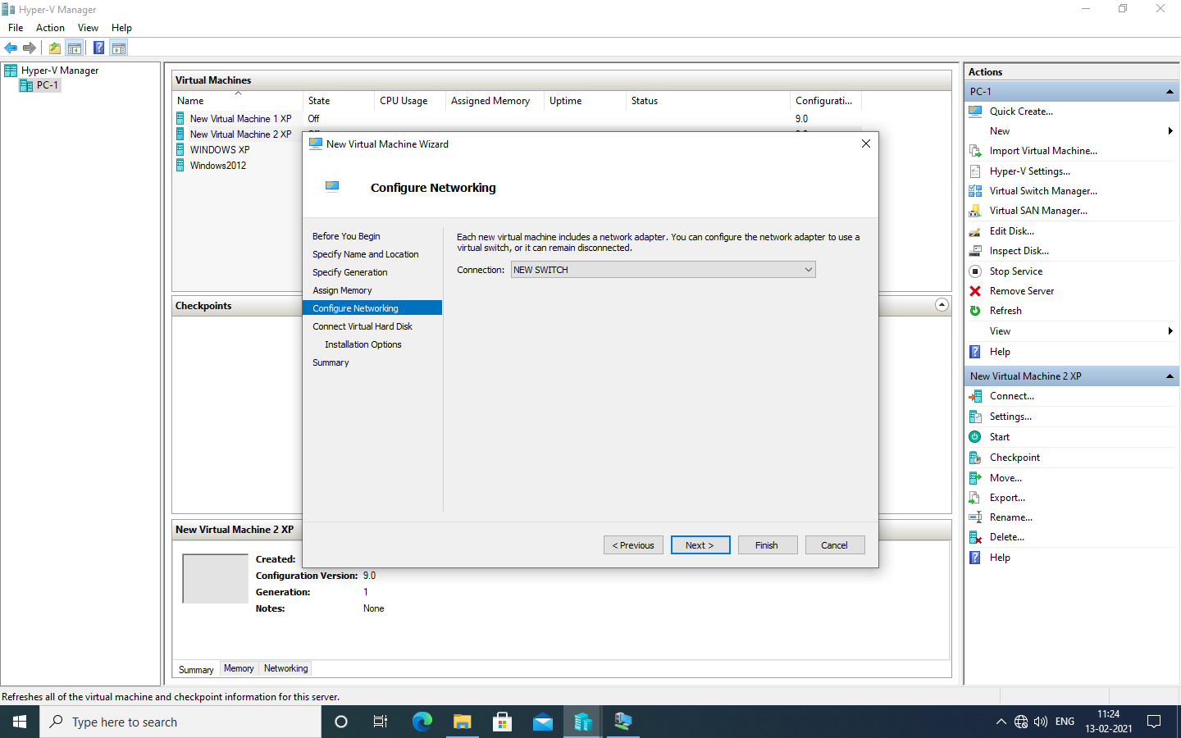

Description of virtual machine and location where it will store virtual machine related files and size require for this machine click on next.
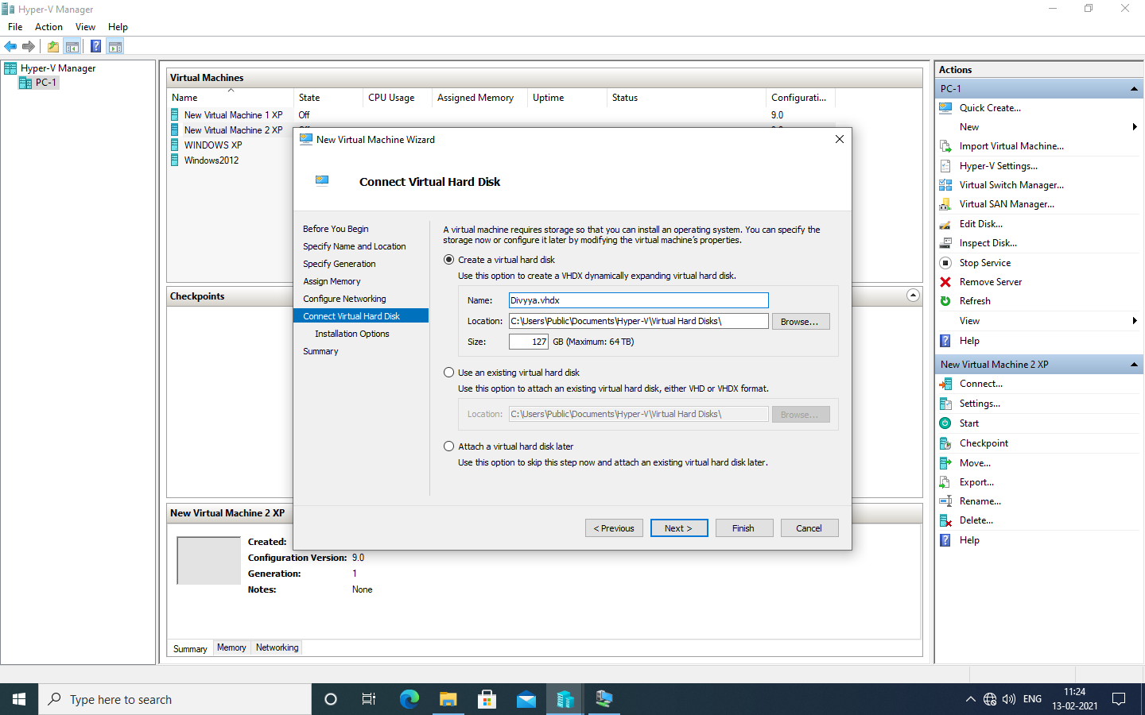

New virtual machine wizard panel will appear, where we will choose operating system which we want to install on virtual machine
select install an operating system from boot CD/DVD-ROM and then select Image file(.iso) and browse our OS iso file then click on next button

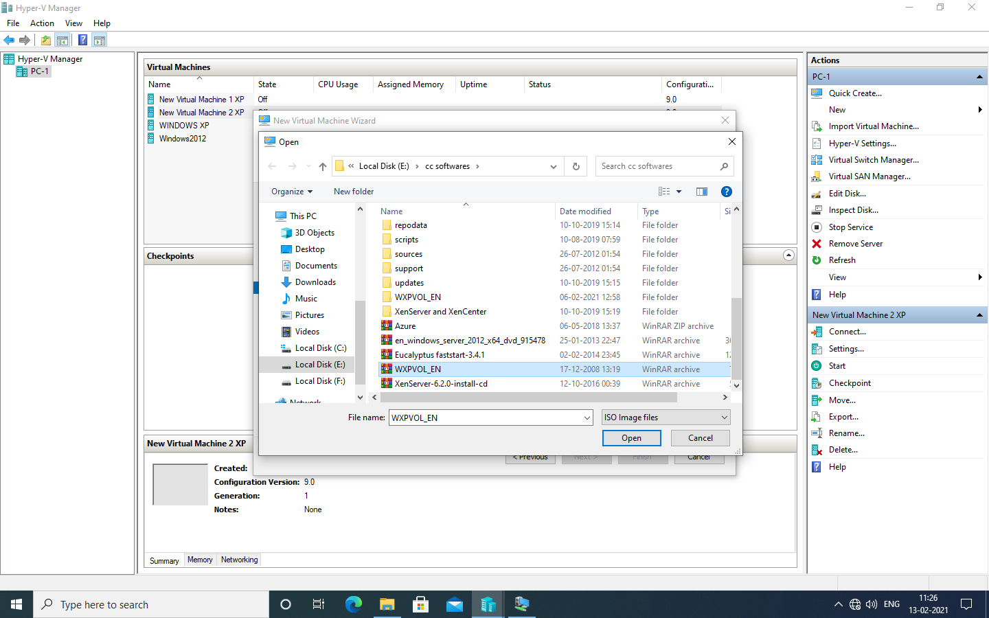

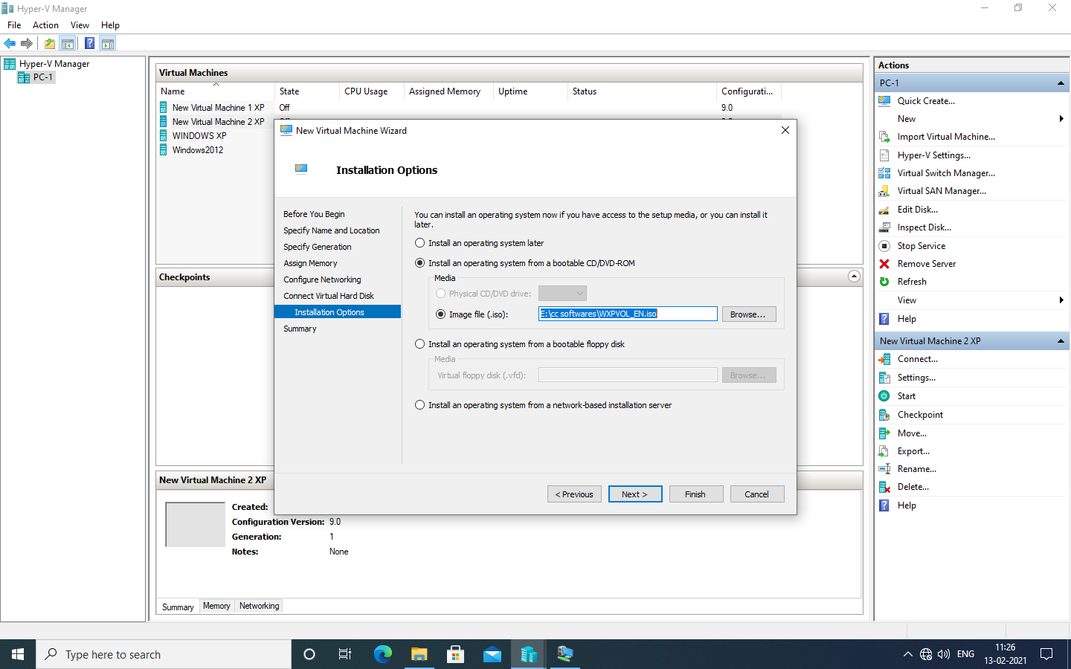

Summary report will be generated about virtual machine then click on Finish button >>Click finish

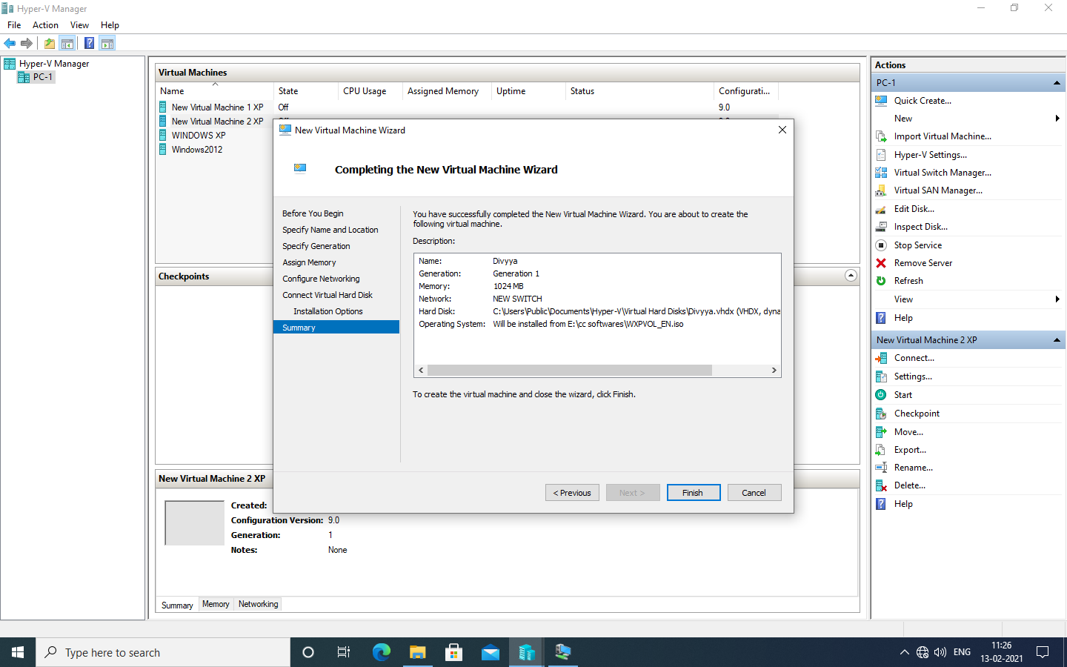

In virtual machine panel our virtual machine will appear which has off state.

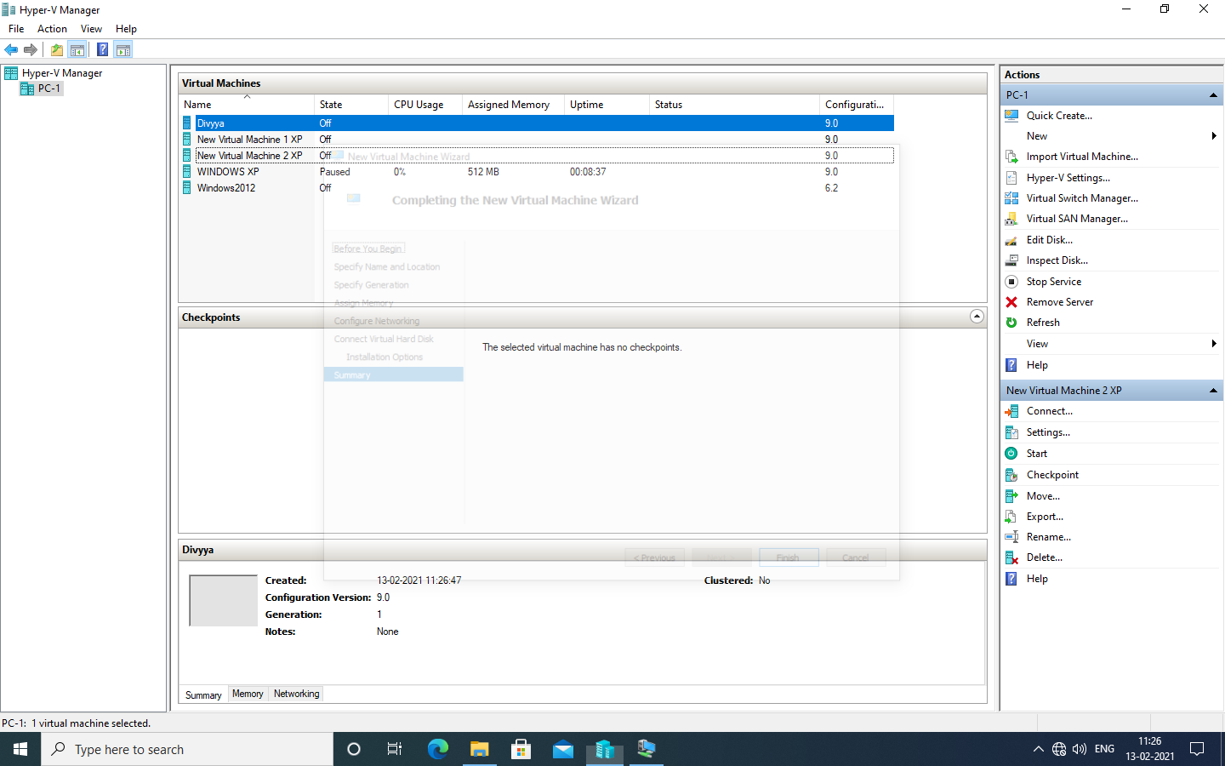

Right click on virtual machine and click on connect option.

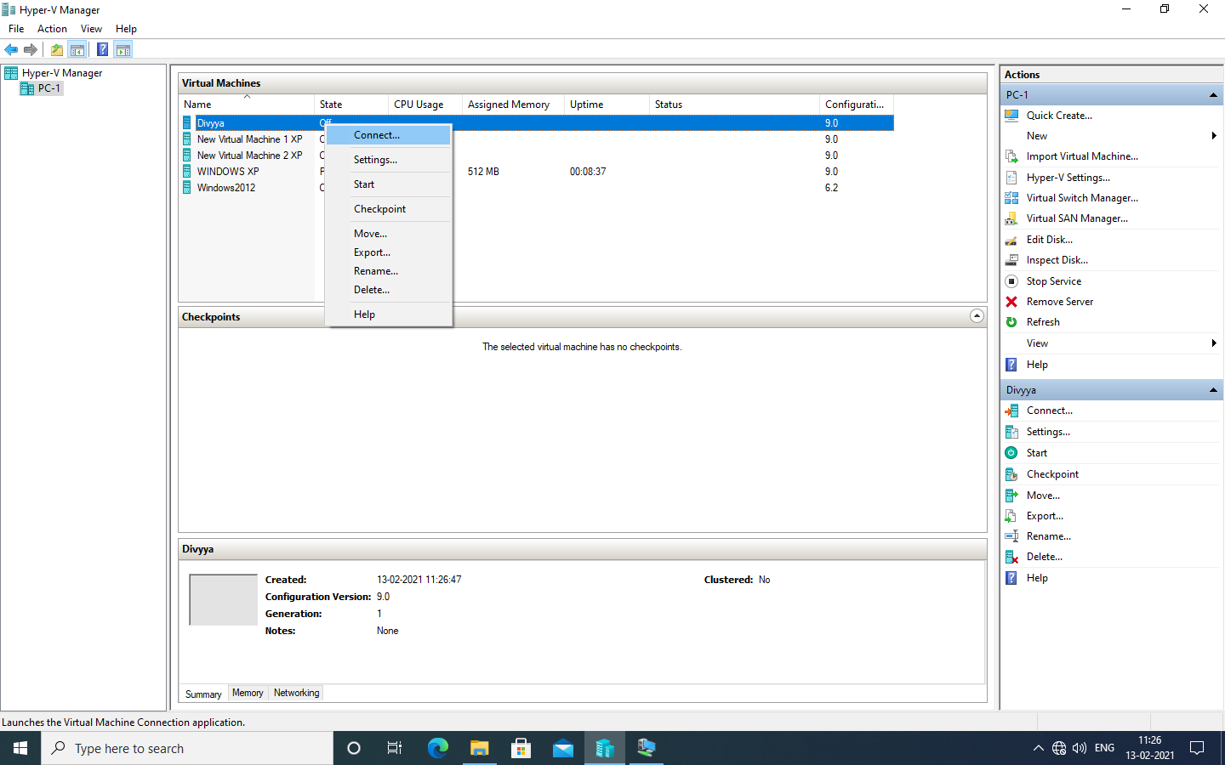
Now turn on virtual machine on
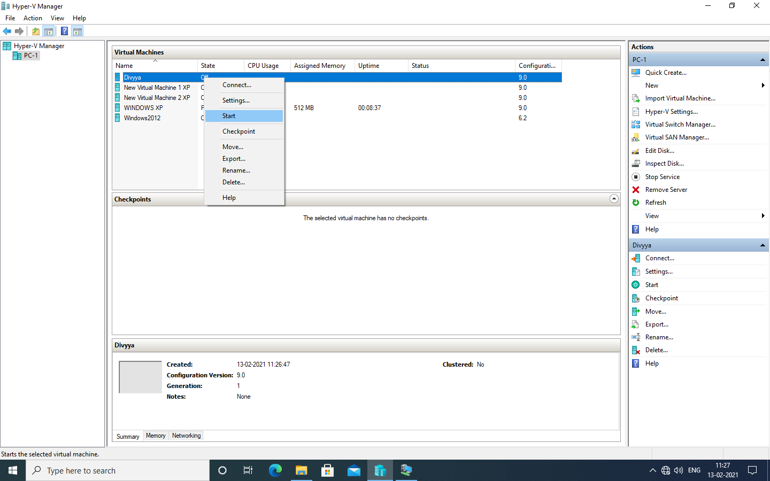

Virtual machine will start with below screen.

