Ex.No : 5

Date : 18.10.2020

**Aim:**

To write a python program to check whether the given string is pangram or not. If its not it must print missing characters to make it as a pangram.

**Program:**

def pangram(s):

a2z="abcdefghijklmnopqrstuvwxyz"

a=[pan for pan in a2z if pan in s]

b=[npan for npan in a2z if npan not in s]

if(len(a)==26):

I2s="".join([str(i) for i in a])

return I2s

else:

I2s="".join([str(i) for i in b])

return I2s

st=str(input())

st=st.lower()

p=pangram(st)

print(p)

**Link:**

<http://103.53.53.18/mod/vpl/forms/submissionview.php?id=235&userid=1673>

**Output:**

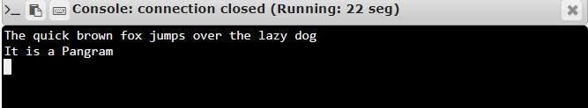

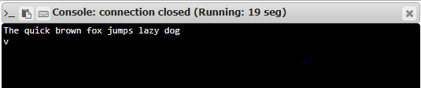

**Result:**

Thus the program to check the given string is pangram or not is executed as per the given conditions and the output is executed.