Ex.No : 8

Date : 20/11/20

**Aim:**

To write a python program to get a list, sorted in increasing order by the last element in each tuple from a given list of non-empty tuples.

**Program:**

def last(n):

return n[-1]

def sort_list_last(tuples):

return sorted(tuples, key=last)

print(sort_list_last([(2,5), (1,2), (4,4), (2,3), (2,1)]))

**Link:**

<http://103.53.53.18/mod/vpl/forms/submissionview.php?id=317&userid=1673>

**Output:**

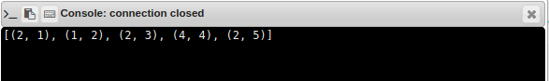

**Result:**

Thus the program to sort the given non-empty tuples increasing order by the last element in each tuple is executed and output is obtained.