1.

ssh -i diwakarworkspace_key.pem [azureuser@74.235.121.218](mailto:azureuser@74.235.121.218)

sudo apt update && sudo apt upgrade -y

sudo apt install -y nodejs npm

sudo apt install -y nginx

sudo systemctl enable nginx

sudo systemctl start nginx

sudo systemctl status nginx

sudo nano /etc/ssh/sshd_config

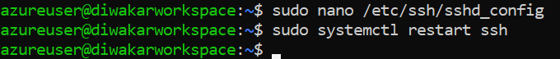

2.

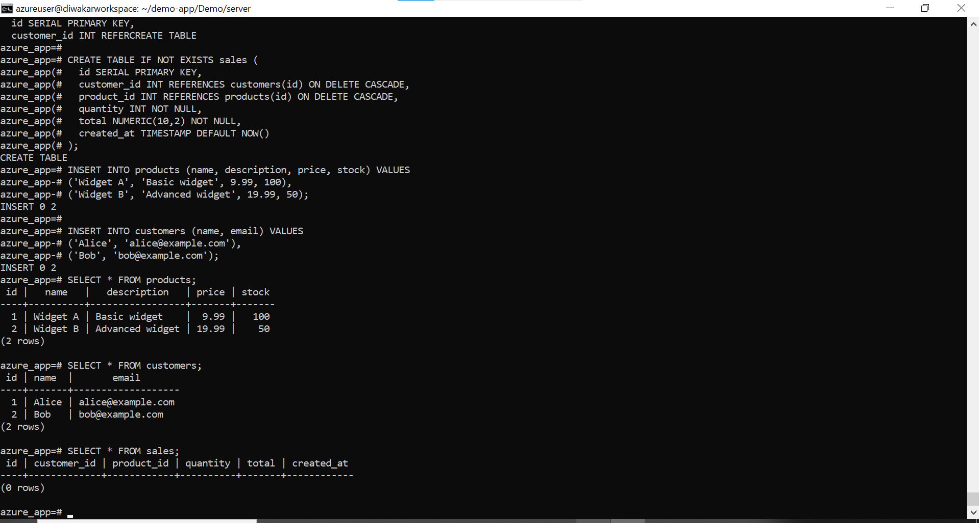

sudo npm install -g pm2

sudo apt update

sudo apt install nginx -y

sudo systemctl status nginx

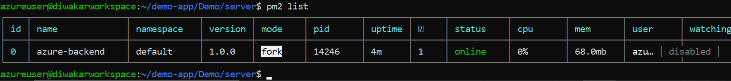

3.

npm install

npm run build

sudo rm -rf /var/www/react-app/*

sudo cp -r dist/* /var/www/react-app/

sudo systemctl reload nginx

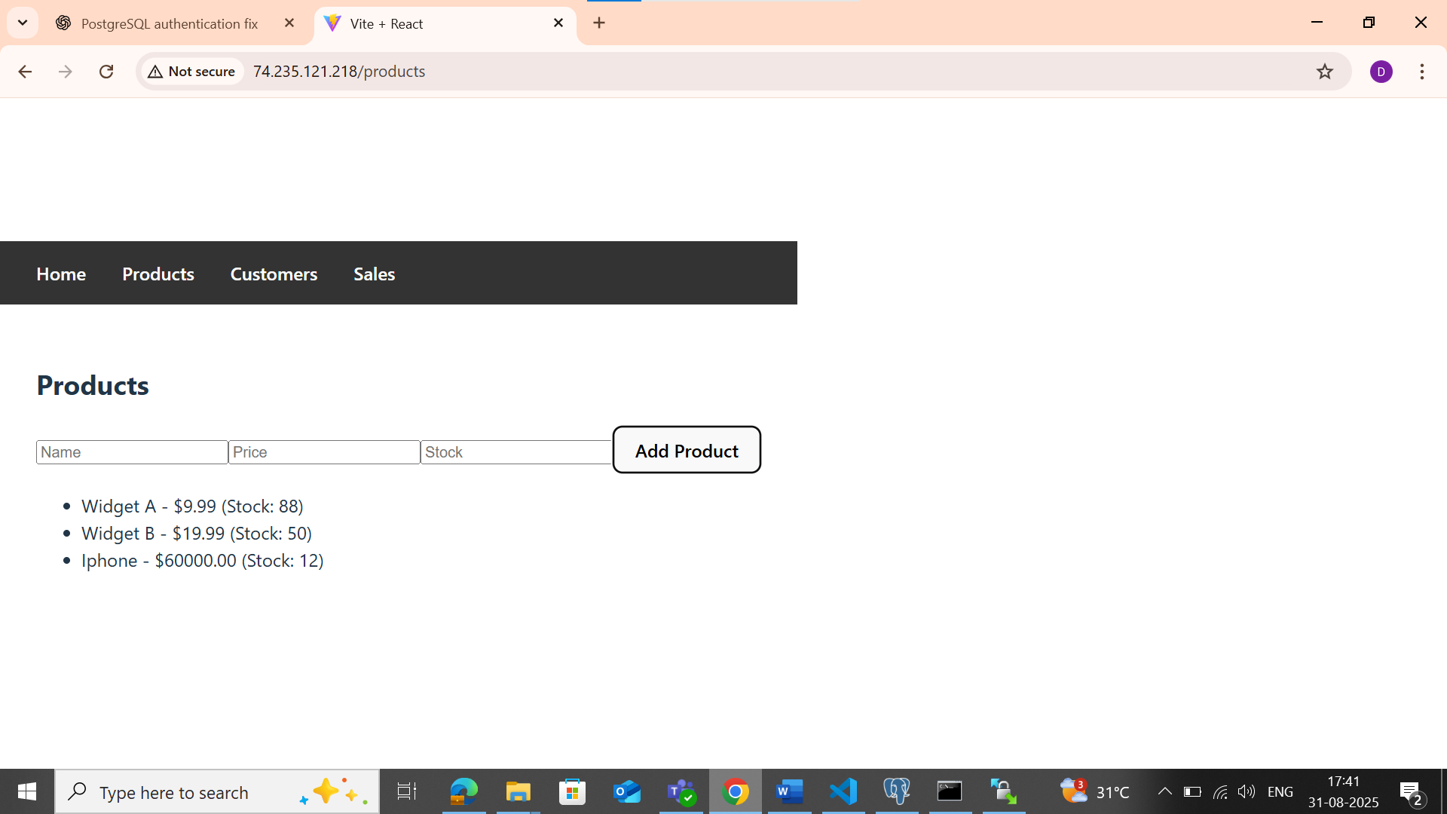

Frontend <http://74.235.121.218/>

Backend http://74.235.121.218/api

2.

