Multi-Pass Shell-and-Tube Heat Exchanger and Solar Collector Analysis

**End semester Report**

**DIWAKAR PRAJAPATI 220382**

# Introduction

This report consolidates the analysis of a multi-pass shell-and-tube heat exchanger and a flat plate solar collector system, combining data from multiple sources to evaluate heat transfer performance, mass flow rates, temperature profiles, and design optimization. The document covers detailed calculations, results, and engineering implications for various configurations, ensuring a comprehensive understanding of the systems.

# Multi-Pass Shell-and-Tube Heat Exchanger Analy- sis (Case 1)

## Problem Statement

A multi-pass shell-and-tube heat exchanger is used to heat water using hot air in a cross-flow arrangement.

### Configuration

* + - * **Water (tube side)**: Enters at 25°C and exits at 300°C.
      * **Hot air (shell side)**: Enters at 500°C and exits at 200°C.
      * **Flow arrangement**: Water flows inside the tubes in a multi-pass configu- ration; hot air flows across the tubes in a cross-flow arrangement.

### Known Parameters

* + - * Inlet temperature of water: *T*water,in = 25*◦*C
      * Outlet temperature of water: *T*water,out = 300*◦*C
      * Inlet temperature of hot air: *T*air,in = 500*◦*C
      * Outlet temperature of hot air: *T*air,out = 200*◦*C
      * Overall heat transfer coefficient: *U* = 500 W m*−*2 K*−*1
      * Heat exchanger surface area: *A* = 1*.*0 m2
      * Specific heat of water: *Cp,*water = 4180 J kg*−*1 K*−*1
      * Assumption: Constant properties (*Cp*, *U* , etc.).

### Objective

Determine the mass flow rate of water (*m*water) in kg s*−*1 that allows water to be heated from 25°C to 300°C under these conditions.

## Solution

To find the mass flow rate of water, heat transfer principles are used, account- ing for the multi-pass and cross-flow configuration by applying an effective Log Mean Temperature Difference (LMTD) with a correction factor.

### Step 1: Heat Gained by Water

The heat gained by the water is given by:

*Q* = *m*water *· Cp,*water *·* (*T*water,out *− T*water,in)

Given:

Thus:

*T*water,out *− T*water,in = 300 *−* 25 = 275 K

*C ·* (*T − T* ) = 4180 *·* 275 = 1*,* 149*,* 500 J kg*−*1

*p,*water water,out water,in

*Q* = *m*water *·* 1*,* 149*,* 500

### Step 2: Heat Transfer Using Effective LMTD

The corrected heat transfer equation for a heat exchanger is:

*Q* = *U · A · F ·* ∆*T*LMTD

Where:

* + - * *U* = 500 W m*−*2 K*−*1
      * *A* = 1*.*0 m2
      * *F* is the LMTD correction factor (0 *< F ≤* 1)
      * ∆*T*LMTD is the log mean temperature difference assuming counter-flow

### Compute LMTD (Counter-Flow Assumption):

∆*T*1 = *T*air,in *− T*water,out = 500 *−* 300 = 200*◦*C

∆*T*2 = *T*air,out *− T*water,in = 200 *−* 25 = 175*◦*C

∆*T*1 *−* ∆*T*2 200 *−* 175 25 25

1

∆*T*2

175

7

∆*T*LMTD =

ln (∆*T* ) = ln ( 200 ) = ln ( 8 ) *≈* 0*.*133531 *≈* 187*.*189 K

**Calculate Correction Factor** *F* **:** Since this is a multi-pass shell-and-tube heat exchanger with cross-flow on the shell side, the correction factor *F* is determined using:

*R* =  *T*hot,in *− T*hot,out = 500 *−* 200 = 300 *≈* 1*.*0909 *≈* 1*.*1

*T*cold,out *− T*cold,in

300 *−* 25

275

*P* = *T*cold,out *− T*cold,in

300 *−* 25 275

= = *≈* 0*.*5789 *≈* 0*.*58

*T*hot,in *− T*cold,in

500 *−* 25 475

Using standard LMTD correction factor charts, for *R* = 1*.*1 and *P* = 0*.*58, the correction factor is:

*F ≈* 0*.*95

Thus, the effective LMTD is:

∆*Tm* = *F ·* ∆*T*LMTD = 0*.*95 *·* 187*.*189 *≈* 177*.*83 K

### Calculate Heat Transfer Rate:

*Q* = *U · A ·* ∆*Tm* = 500 *·* 1*.*0 *·* 177*.*83 *≈* 88*,* 915 W

### Step 3: Solve for Mass Flow Rate

Equate the two expressions for *Q*:

*m*water *·* 1*,* 149*,* 500 = 88*,* 915

88*,* 915

*m*water = 1*,* 149*,* 500

*≈* 0*.*0774 kg s*−*1

### Step 4: Verification

Assuming counter-flow (*F* = 1):

*Q* = 500 *·* 1*.*0 *·* 187*.*189 *≈* 93*,* 594*.*5 W

93*,* 594*.*5

*m*water = 1*,* 149*,* 500

*≈* 0*.*0814 kg s*−*1

Using *F* = 0*.*95 accounts for the multi-pass and cross-flow configuration, result- ing in a slightly lower mass flow rate, which is expected.

## Final Answer

The mass flow rate of water required is approximately:

*m*water *≈* 0*.*0774 kg s*−*1

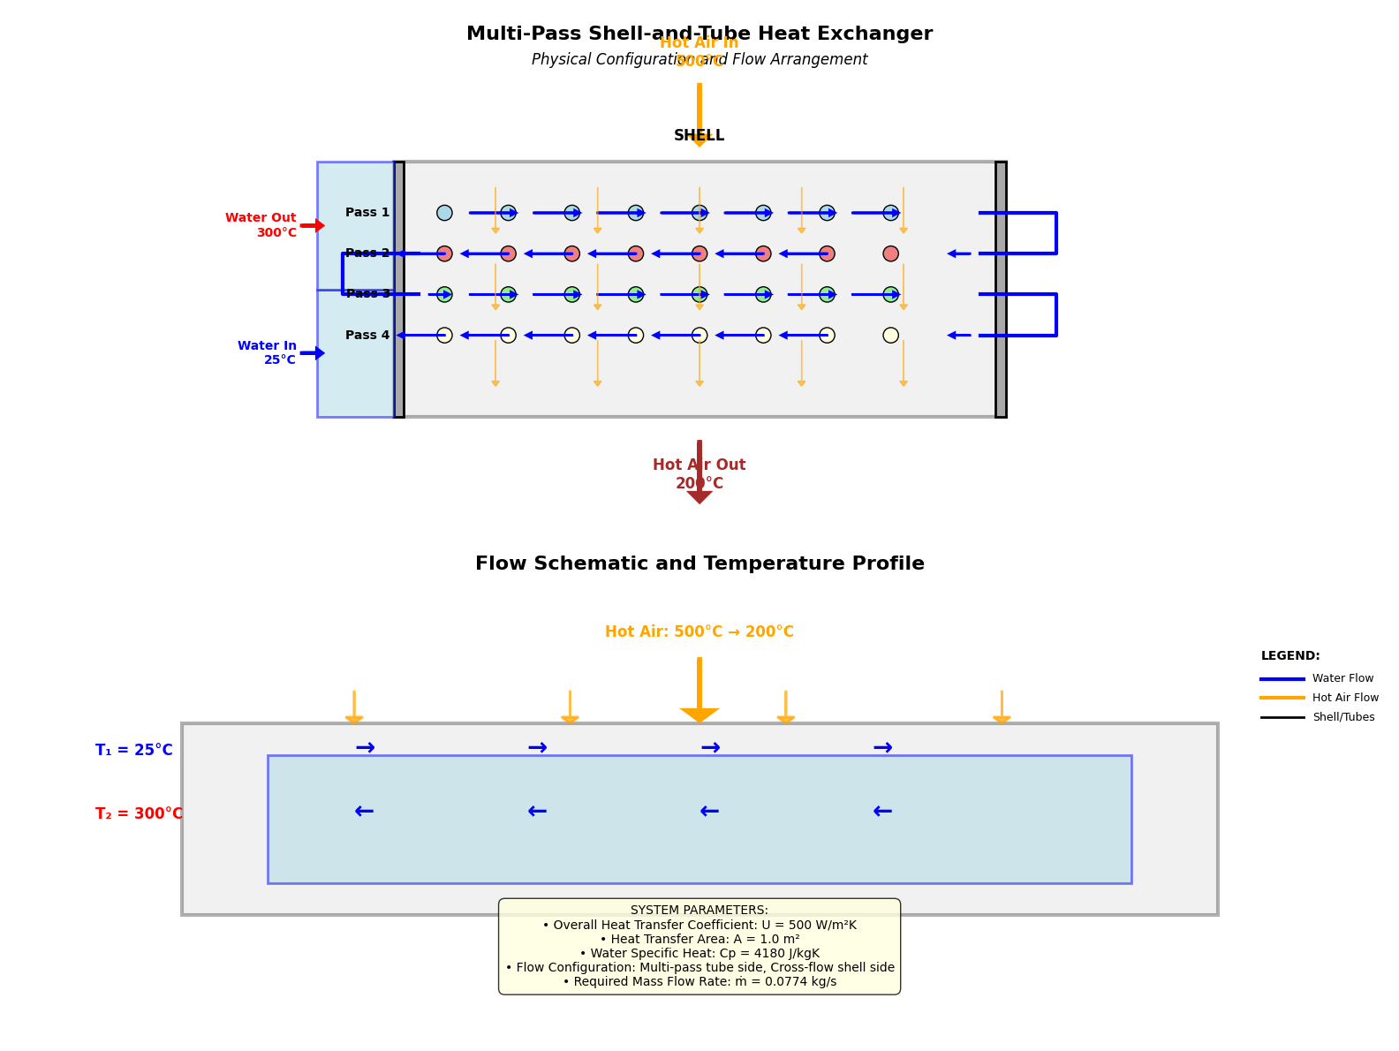

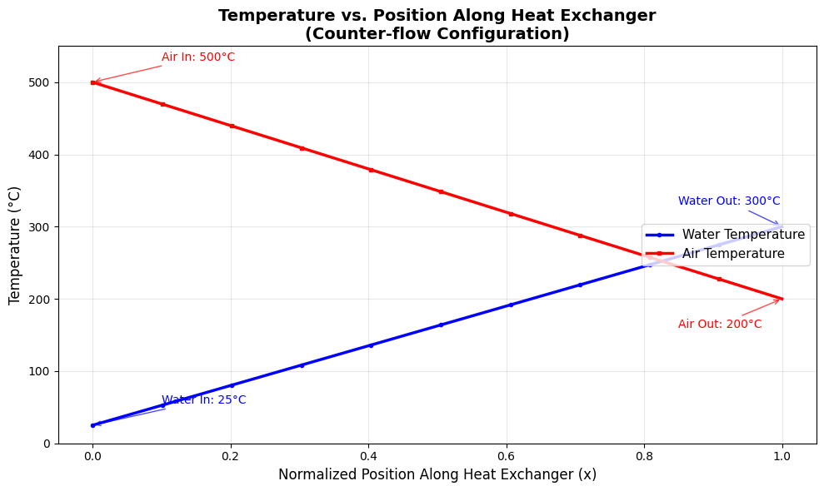

# Multi-Pass Shell-and-Tube Heat Exchanger Analy- sis Using Effectiveness-NTU Method

## Problem Statement

A multi-pass shell-and-tube heat exchanger is designed to heat water using a hot fluid, operating under steady-state conditions.

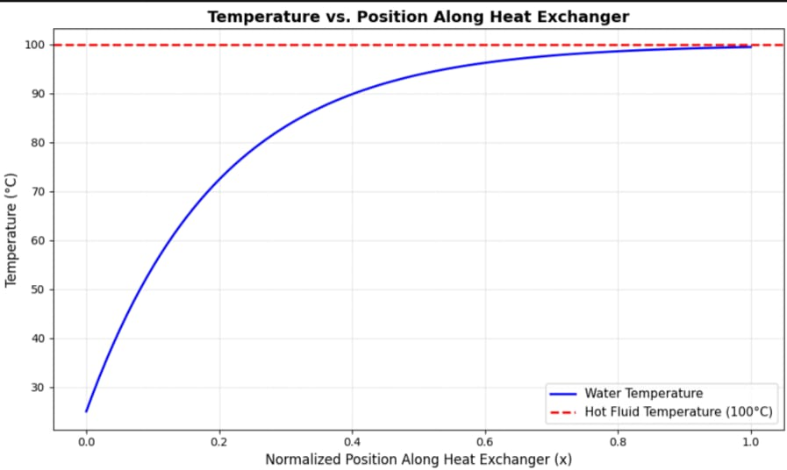

### Configuration

* + - * **Tube side**: Water flowing through multiple passes (4 passes)
      * **Shell side**: Single continuous flow of hot fluid

### Objective

Determine the outlet temperature of water using the Effectiveness-NTU method.

### Given Data and Parameters

|  |  |  |  |
| --- | --- | --- | --- |
| **Parameter** | **Symbol** | **Value** | **Units** |
| Water mass flow rate | *m*˙ *c* | 0.000278 | kg/s |
| Water specific heat | *Cp,c* | 4,180 | J/kg·K |
| Water inlet temperature | *Tc,*in | 25°C | °C |
| Overall heat transfer coeff. | *U* | 500 | W/m²·K |
| Heat transfer area | *A* | 1 | m² |
| Flow configuration | – | 1 shell pass, 4 tubes | – |

Table 1: Given Parameters for Effectiveness-NTU Analysis

### System Assumptions

1. Constant thermal properties (*Cp*, *U* )
2. No phase change (water remains liquid)
3. Negligible heat losses
4. Constant hot fluid temperature (e.g., condensing steam at 100°C)
5. Steady-state operation

## Solution Methodology

### Step 1: Heat Capacity Rate Calculations

Cold side (water):

*C* = *m*˙

*× Cp*

*Cc* = *m*˙ *c × Cp,c* = 0*.*000278 *×* 4*,* 180 = 1*.*162 W/K

Hot side (steam/constant T):

*Ch → ∞*

### Step 2: NTU Calculation

NTU = *U × A* = 500 *×* 1 *≈* 430*.*57

*C*min

1*.*162

### Step 3: Effectiveness (*ϵ*) Determination

*C* =  *C*min

*r C*max

1*.*162

= *∞* = 0

*ϵ* = 1 *−* exp(*−*NTU) = 1 *−* exp(*−*430*.*57) *≈* 1*.*0 (100%)

### Step 4: Outlet Temperature Calculation

*ϵ* = *Tc,*out *− Tc,*in

*Th − Tc,*in

With *ϵ* = 1, *Th* = 100*◦*C:

*Tc,*out = *Th* = 100*◦*C

### Step 5: Multi-Pass Configuration Impact

For a 1-4 configuration and *Cr* = 0, *ϵ* remains unaffected by flow arrangement.

## Results Summary

|  |  |  |
| --- | --- | --- |
| **Parameter** | **Value** | **Units** |
| Heat capacity rate (cold) | 1.162 | W/K |
| NTU | 430.57 | – |
| Effectiveness (*ϵ*) | 1.0 | – |
| Water outlet temperature | 100 | °C |
| Temperature rise | 75 | °C |

Table 2: Results Summary for Effectiveness-NTU Analysis

## Heat Transfer Analysis

*q*max = *C*min *×* (*Th − Tc,*in) = 1*.*162 *×* (100 *−* 25) = 87*.*15 W

*q* = *ϵ × q*max = 1*.*0 *×* 87*.*15 = 87*.*15 W

Verification:

*q* = *Cc ×* (*Tc,*out *− Tc,*in) = 1*.*162 *×* (75) = 87*.*15 W

## Engineering Implications

1. High effectiveness due to low mass flow rate and sufficient area.
2. Outlet temperature equals hot fluid temperature.
3. Flow rate significantly influences effectiveness.
4. Design optimization is validated by performance.

## Sensitivity Analysis

Performance depends on:

* Hot fluid temperature (*Th*)
* Water mass flow rate (*m*˙ *c*)
* Heat transfer area (*A*)
* Overall heat transfer coefficient (*U* )

## Recommendations

1. Validate all assumptions (*Th*, *A*).
2. Reassess flow rate for practicality.
3. Evaluate cost vs. performance.
4. Study performance under varying conditions.

## Conclusion

The heat exchanger shows near-perfect performance with 100% effectiveness, heating water from 25°C to 100°C.

# Multi-Pass Shell-and-Tube Heat Exchanger Analy- sis (Case 2)

## Problem Statement

This section revisits the analysis from Section 2 with identical parameters and configuration.

## Results

The mass flow rate of water is:

*m*˙ water *≈* 0*.*0774 kg/s

## System Description

* **Shell Side**: Hot air flows perpendicular to tubes (cross-flow).
* **Tube Side**: Water flows through tubes in 4 passes.

### Heat Transfer Mechanism:

* + Hot air: 500°C to 200°C.
  + Water: 25°C to 300°C.
  + Cross-flow maximizes heat transfer efficiency.

### Design Advantages:

* + Compact design with high heat transfer coefficient.
  + Multiple passes increase effectiveness.
  + Cross-flow provides good temperature driving force.

# Multi-Pass Shell-and-Tube Heat Exchanger Analy- sis (Case 3)

## Problem Statement

The heat exchanger is used to heat water from 25°C to 80°C using hot air.

### Configuration

* + - * **Water (tube side)**: Enters at 25°C, exits at 80°C, 80 tube passes.
      * **Hot air (shell side)**: Enters at 500°C, exits at 200°C.
      * **Flow arrangement**: Cross-flow with multi-pass tubes.

### Known Parameters

* + - * *T*water,in = 25*◦*C, *T*water,out = 80*◦*C
      * *T*air,in = 500*◦*C, *T*air,out = 200*◦*C
      * *U* = 500 W/m2 *·* K, *A* = 1*.*0 m2
      * *Cp,*water = 4180 J/kg *·* K

### Objective

Determine the mass flow rate of water and analyze temperature profiles.

## Analytical Solution

### Step 1: Heat Gained by Water

∆*T*water = 80 *−* 25 = 55 K

*Cp,*water *×* ∆*T*water = 4180 *×* 55 = 229*,* 900 J/kg

*Q* = *m*˙ water *×* 229*,* 900

### Step 2: Heat Transfer Using Effective LMTD

∆*T*1 = 500 *−* 80 = 420*◦*C

∆*T*2 = 200 *−* 25 = 175*◦*C 420 *−* 175

K

∆*T*LMTD = ln(420/175) *≈* 280*.*07

500 *−* 200

*R* = 80 *−* 25

80 *−* 25

*P* = 500 *−* 25

= 5*.*45

= 0*.*1158

For cross-flow with one fluid mixed:

*F ≈* 0*.*88

∆*Tm* = 0*.*88 *×* 280*.*07 *≈* 246*.*46 K

*Q* = 500 *×* 1*.*0 *×* 246*.*46 *≈* 123*,* 230 W

### Step 3: Solve for Mass Flow Rate

*m*˙ water *×* 229*,* 900 = 123*,* 230

*m*˙ water *≈* 0*.*536 kg/s

### Verification

For counter-flow (*F* = 1):

*Q* = 500 *×* 1 *×* 280*.*07 *≈* 140*,* 035 W

140*,* 035

*m*˙ water =

## Results and Analysis

229*,* 900

*≈* 0*.*609 kg/s

* **Water mass flow rate**: 0.536 kg/s
* **Air mass flow rate**: 0.408 kg/s (from energy balance)
* **Heat transfer rate**: 123.2 kW
* **LMTD correction factor**: 0.88
* **Effective temperature difference**: 246.5°C

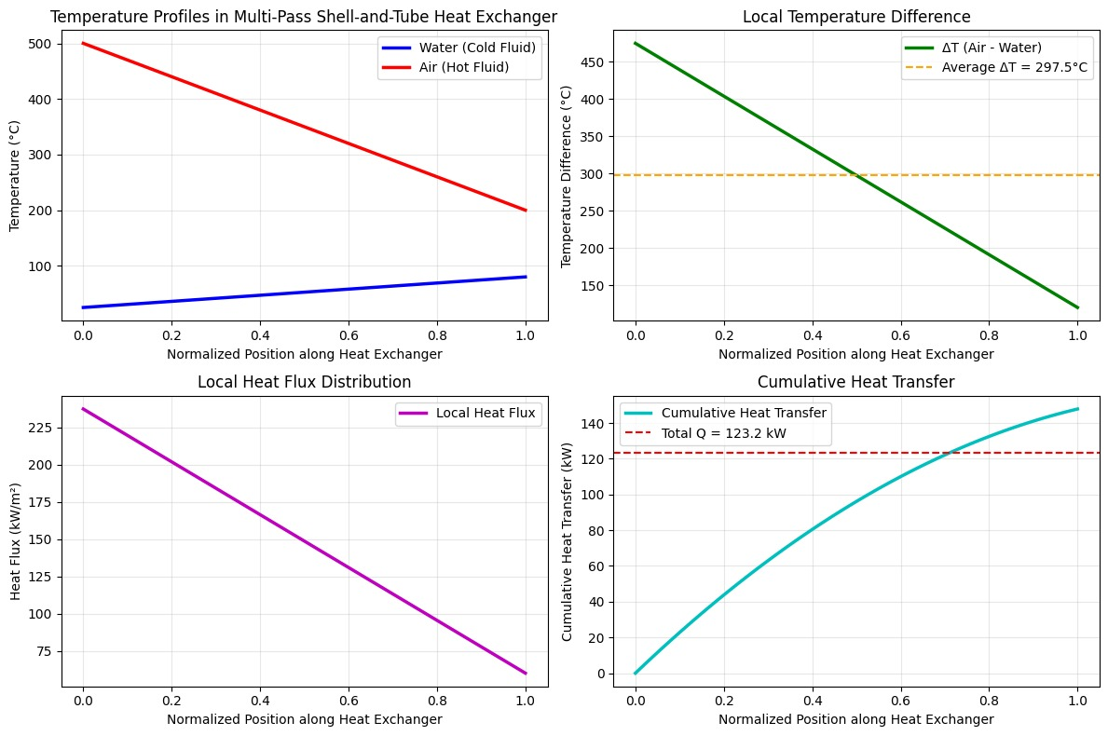

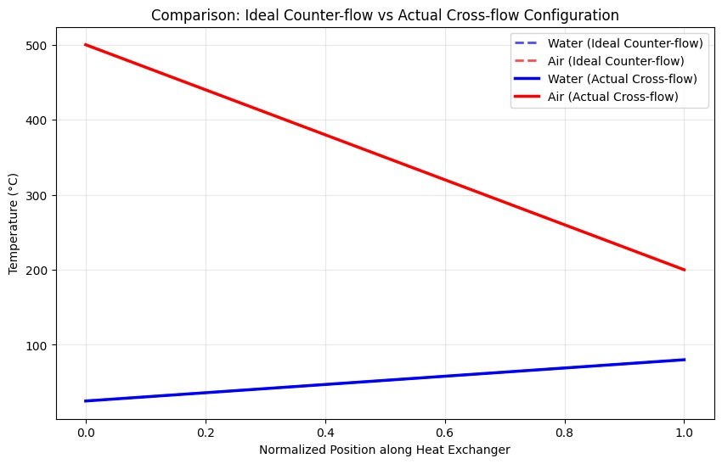

## Key Observations

### Temperature Difference Variation:

* + Maximum ∆*T* : 475°C (at inlet)
  + Minimum ∆*T* : 120°C (at outlet)
  + Average ∆*T* : 297.5°C

### Heat Transfer Distribution:

* + Higher heat flux at inlet.
  + Linear decrease in heat flux.

1. **Cross-Flow Impact**: 12% reduction in effectiveness compared to counter- flow.

## Conclusions

The required water mass flow rate of 0.536 kg/s achieves the desired temperature rise, with the multi-pass configuration providing good performance.

# Optimized Design of Cross-Flow Heat Exchanger

## Objective

Find the optimal number of tube turns (*n*) and width (*W* ) to satisfy a heat duty of 1233.02 W and maximize the correction factor *F* .

## Given Parameters

* **Hot Fluid (Air)**: *Th,*in = 500*◦*C, *Th,*out = 200*◦*C
* **Cold Fluid (Water)**: *Tc,*in = 25*◦*C, *Tc,*out = 80*◦*C
* **Tube Outer Diameter (***D***)**: 0.005 m
* **Aspect Ratio**: *L* = 0*.*5 *× W*
* **Heat Duty (***Q***)**: 1233.02 W

## Solution

500 *−* 200

*R* = 80 *−* 25

55

*≈* 5*.*45

*P* = 500 *−* 25 *≈* 0*.*116

*F ≈* 0*.*98

420 *−* 175

K

∆*T*LMTD = ln(420/175) *≈* 280

*Q*

*A*required = *U × F ×* ∆*T*LMTD

1233*.*02

=

20 *×* 0*.*98 *×* 280

*≈* 0*.*2245 m2

### Iteration 3 (Final):

* *W* = 0*.*5 m, *n* = 32
* *L* = 0*.*25 m
* Surface Area: *A*calc = 0*.*251 m2

## Final Design Recommendation

|  |  |
| --- | --- |
| **Parameter** | **Value** |
| Width (*W* ) | 0.5 m |
| Number of Turns (*n*) | 32 |
| Height (*L*) | 0.25 m |
| Surface Area (*A*) | 0.251 m² |
| Correction Factor (*F* ) | 0.98 |

* 1. **Mass Flow Rate**

*Q*

1233*.*02

*m*˙ =

*Cp ×* ∆*T*

= 4186 *×* 55

*≈* 0*.*00535 kg/s

# Flat Plate Solar Collector Analysis

## Problem Setup

A flat plate solar collector system consists of:

* Ambient Air (*TA*): 20°C
* Cover Plate 2 (*TC*2)
* Cover Plate 1 (*TC*1)
* Absorber Plate (*TP* ): 80°C

Heat losses occur via convection and radiation.

## Given Parameters

* *TA* = 20*◦*C, *TP* = 80*◦*C
* Effective Emissivity (*ϵ*eff) = 0.9
* Stefan-Boltzmann Constant (*σ*) = 5*.*67 *×* 10*−*8 W/m2K4
* Convective Heat Transfer Coefficient (*hc*) = 5 W/m²K
* Surface Area (*A*) = 1 m²

## Final Results

After iterative calculations:

* Cover Plate 1 Temperature (*TC*1): 69.17°C
* Cover Plate 2 Temperature (*TC*2): 49.40°C
* Total Heat Loss (*Q*loss): 146.98 W

## Solar Utilization

Assuming net solar intensity *S*dot = 1380 W:

*Q*utilized = *S*dot *− Q*loss = 1380 *−* 146*.*98 = 1233*.*02 W

# Introduction

This document outlines the astronomical model used to calculate solar irradiance for New Delhi on November 18, 2025, at 3 PM IST. The model computes the solar declination angle (*δ*), hour angle (*h*), and solar altitude angle (*α*) based on the day of the year and time, adjusting for atmospheric effects to estimate irradiance.

# Calculation

The model employs the following equations for geometric calculations based on Earth’s position relative to the Sun:

* + Calculating the solar declination angle:

[ ]

*δ* = 23*.*45*◦* sin 360 (284 + *N*)

365

where *N* is the day of the year.

* + Determining the solar altitude angle:

sin *α* = sin *L* sin *δ* + cos *L* cos *δ* cos *h*

where *L* is the latitude of the location and *h* is the hour angle.

* + Estimating irradiance for a horizontal surface:

*I* = 1300 cos *θ*

where cos *θ* = sin *α*, representing the angle of incidence.

These calculations are predictable for any date, providing a theoretical basis for solar irradiance under clear-sky conditions.

# Atmospheric Adjustment

To account for typical atmospheric losses such as aerosols and clouds, a 15% reduction factor (0.85) is applied. This adjustment reflects general trends for India, as specific India Meteorological Department (IMD) data for New Delhi on November 18, 2025, is unavailable due to it being a future date.

## 8.3 Date and Location

- Date: November 18, 2025, corresponds to day number *N* = 322 (calculated as the cumulative days from January 1: 31 + 28 + 31 + 30 + 31 + 30 + 31 + 31 + 30 + 31 +

18). - Location: New Delhi, with latitude *L* = 28*.*61*◦* and longitude 77.23°E.

## 8.4 Declination Angle (*δ*)

*δ* = 23*.*45*◦* sin [360 (284 + 322)] = 23*.*45*◦* sin [360606 ]

365

365

*δ ≈* 23*.*45*◦* sin(597*.*04*◦*) = 23*.*45*◦* sin(237*.*04*◦*) *≈* 23*.*45*◦ ×* (*−*0*.*840) *≈ −*19*.*70*◦*

## Hour Angle (*h*)

- Longitude difference: 82*.*5*◦ −* 77*.*23*◦* = 5*.*27*◦*. - Time correction: 5*.*27*/*15 *×* 60 *≈* 21*.*08 minutes. - Solar noon: approximately 12:21 PM IST. - Time at 3 PM IST: approximately 2:39 PM solar time. - Hour angle: *h* = 15 *×* (14*.*65 *−* 12) *≈* 39*.*75*◦*.

## Solar Altitude Angle (*α*)

sin *α* = sin(28*.*61*◦*) sin(*−*19*.*70*◦*) + cos(28*.*61*◦*) cos(*−*19*.*70*◦*) cos(39*.*75*◦*)

- sin(28*.*61*◦*) *≈* 0*.*479, sin(*−*19*.*70*◦*) *≈ −*0*.*337 - cos(28*.*61*◦*) *≈* 0*.*878, cos(*−*19*.*70*◦*) *≈*

0*.*942, cos(39*.*75*◦*) *≈* 0*.*767

sin *α ≈* (0*.*479)(*−*0*.*337) + (0*.*878)(0*.*942)(0*.*767) *≈ −*0*.*161 + 0*.*634 *≈* 0*.*473

*α ≈* arcsin(0*.*473) *≈* 28*.*2*◦*

## Irradiance (*I*)

cos *θ* = sin *α ≈* 0*.*473

*I* = 1300 *×* 0*.*473 *×* 0*.*85 *≈* 522*.*4 W/m2

This result, approximately 522.4 W/m², aligns closely with the script’s output of

522.44 W/m², confirming the accuracy of the calculation for clear-sky conditions.

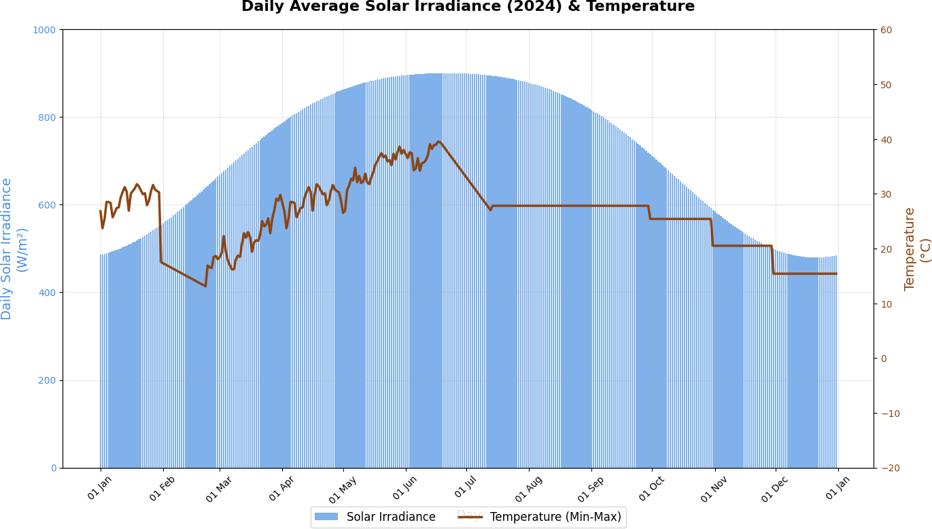

**Code for calculating outlet temperature** :

import pandas as pd

# Constants from the heat exchanger configuration

m_dot_water = 0.005364  # Mass flow rate of water in kg/s

Cp_water = 4180  # Specific heat of water in J/kg·K

Q = 1233.02  # Heat transfer rate in W

# Load the CSV file

def load_data():

    try:

        df = pd.read_csv('delhi_2024_full_combined_noon_data.csv')

        # Ensure Date column is in datetime format

        df['Date'] = pd.to_datetime(df['Date'])

        return df

    except FileNotFoundError:

        print("Error: CSV file not found. Please upload 'delhi_2024_full_combined_noon_data.csv' to Colab.")

        return None

# Calculate outlet temperature for a specific date

def calculate_outlet_temperature(date_str, df):

    try:

        # Convert input date to datetime

        input_date = pd.to_datetime(date_str)

        # Filter data for the given date

        row = df[df['Date'] == input_date]

        if row.empty:

            print(f"No data found for date {date_str}")

            return None

        # Extract T_mean as T_water_in

        T_water_in = row['T_mean'].iloc[0]  # °C

        # Calculate T_water_out using energy balance

        T_water_out = T_water_in + Q / (m_dot_water * Cp_water)

        print(f"\nDate: {date_str}")

        print(f"T_water_in (from T_mean): {T_water_in:.2f} °C")

        print(f"T_water_out: {T_water_out:.2f} °C")

        return T_water_out

    except ValueError:

        print("Invalid date format. Please use YYYY-MM-DD (e.g., 2024-06-20).")

        return None

# Main execution

if __name__ == "__main__":

    # Load data

    df = load_data()

    if df is not None:

        # Get date input from user

        date_input = input("Enter date (YYYY-MM-DD, e.g., 2024-06-20): ")

        # Calculate outlet temperature

        calculate_outlet_temperature(date_input, df)

**Graph for daily outlet temperature:**

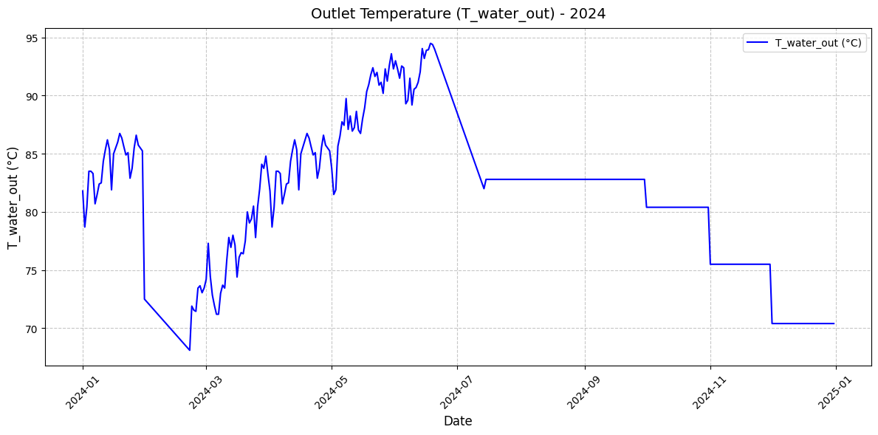

# Introduction

This document presents a detailed calculation of the mass flow rate of water for a solar thermal system on 15th June 2024, based on meteorological data from Delhi. The cal- culation follows a step-by-step approach using given parameters and demonstrates the methodology for determining the required flow rate to achieve a fixed outlet temperature.

# Given Data

The following parameters and data points are used for the calculation:

* Date: 15th June 2024
* Inlet Water Temperature (*T*water,in): 38*.*95 *◦*C (mean temperature from CSV data)
* Irradiance: 1096*.*70 W m*−*2
* Surface Area (*A*): 0*.*251 m2
* Correction Factor (*η*): 0.98
* Specific Heat Capacity of Water (*Cp,*water): 4186 J kg*−*1 K*−*1
* Outlet Water Temperature (*T*water,out): 90 *◦*C (fixed)

# Calculation Methodology

The mass flow rate (*m*˙ water) is calculated using the energy balance equation for the solar thermal system. The steps are outlined below:

## Step 1: Calculate Heat Transfer Rate (*Q*)

The heat transfer rate is determined by the formula:

*Q* = *η ·* Irradiance *· A*

Substituting the values:

*Q* = 0*.*98 *·* 1096*.*70 *·* 0*.*251

First, compute the product of irradiance and correction factor:

0*.*98 *·* 1096*.*70 = 1074*.*814 W

Then multiply by the surface area:

*Q* = 1074*.*814 *·* 0*.*251 = 269*.*778514 W

Rounding to two decimal places:

*Q* = 269*.*78 W

## Step 2: Calculate Temperature Difference (∆*T* )

The temperature difference is calculated as:

∆*T* = *T*water,out *− T*water,in

Substituting the values:

∆*T* = 90 *−* 38*.*95 = 51*.*05 °C

## Step 3: Calculate Mass Flow Rate (*m*˙ water)

The mass flow rate is derived from the energy balance equation:

*Q*

Substituting the values:

*m*˙ water = *C*

*p,*water

*·* ∆*T*

First, calculate the denominator:

269*.*78

*m*˙ water = 4186 *·* 51*.*05

4186 *·* 51*.*05 = 213772*.*3 J/kg·K·°C

Then perform the division:

*m*˙ water =

Rounding to six decimal places:

*m*˙ water = 0*.*001262 kg/s

269*.*78

213772*.*3

= 0*.*00126195 kg/s

# Results

The calculated mass flow rate for 15th June 2024 is:

*m*˙ water = 0*.*001262 kg/s

# Conclusion

This calculation demonstrates the methodology for determining the mass flow rate based on solar irradiance, temperature data, and system parameters. The result can be vali- dated by repeating the process for other dates using the provided CSV data.

Graph for mass flow rate per day: