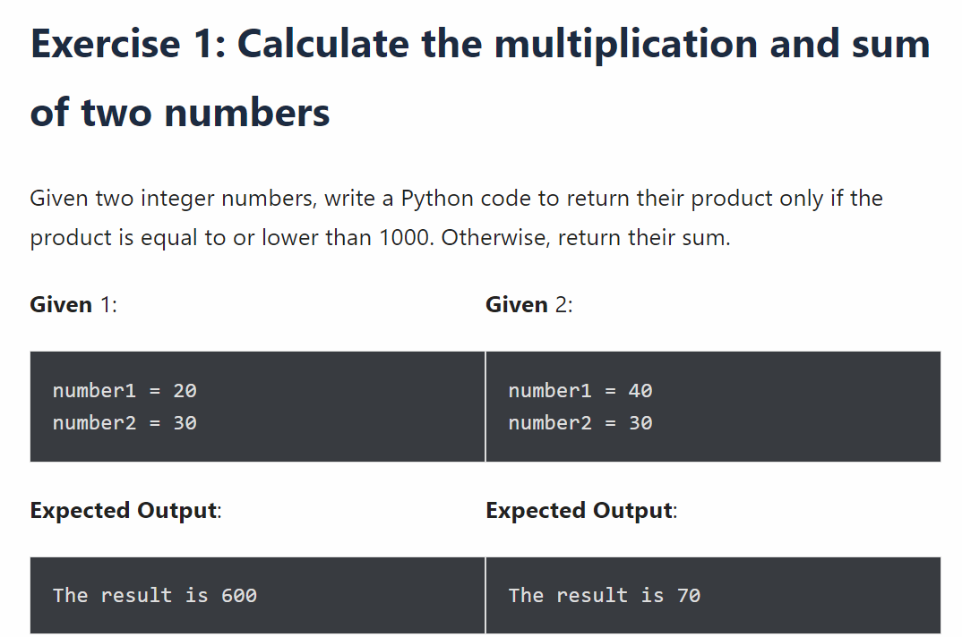

Solution:

num1 = int(input("Enter first number"))

num2 = int(input("Enter second number"))

prod = num1\*num2

add = num1+num2

if(prod <= 1000):

print(f"Product of {num1} and {num2} is {prod}")

else:

print(f"Sum of {num1} and {num2} is {add}")