[VISUAL SLAM BASED AUTONOMOUS ROBOT]
Submitted
By

M.DIWAKAR REDDY – BU21EECE0100601
G.MAHESH REDDY - BU21EECE0100531
D.VINAY KUMAR - BU21EECE0100452

Under the Guidance of
(H.J.JAYATHEERTHA ASSISTANT PROFESSOR)
(Duration:14/08/2)



Department of Electrical,Electronics and Communication Engineering [14 Bold]
GITAM School of Technology
GITAM
(DEEMED TO BE UNIVERSITY)
(Estd. u/s 3 of the UGC act 1956)
NH 207, Nagadenehalli, Doddaballapur taluk, Bengaluru-561203 Karnataka, INDIA.

DECLARATION
I/We declare that the project work contained in this report is original and it has been done by me under the guidance of my project guide.

Name:

Date: Signature of the Student

M.DIWAKAR REDDY – BU21EECE0100601
G.MAHESH REDDY - BU21EECE0100531
D.VINAY KUMAR - BU21EECE0100452

Department of Electrical,Electronics and Communication Engineering [14 Bold]
GITAM School of Technology, Bengaluru-561203



CERTIFICATE
This is to certify that (Student Name) bearing (Regd. No.:) has satisfactorily completed Mini Project Entitled in partial fulfillment of the requirements as prescribed by University for VIIIth semester, Bachelor of Technology in “Electrical, Electronics and Communication Engineering” and submitted this report during the academic year 2024-2025.

[Signature of the Guide] [Signature of HOD]

Table of contents

Chapter 1: Introduction 1
1.1 Overview of the problem statement 1
1.2 Objectives and goals 1
Chapter 2 : Literature Review 2
Chapter 3 : Strategic Analysis and Problem Definition 3
3.1 SWOT Analysis 3
3.2 Project Plan - GANTT Chart 3

3.3 Refinement of problem statement 3
Chapter 4 : Methodology 4
4.1 Description of the approach 4
4.2 Tools and techniques utilized 4
4.3 Design considerations 4
Chapter 5 : Implementation 5
5.1 Description of how the project was executed 5
5.2 Challenges faced and solutions implemented 5
Chapter 6:Results 6
6.1 outcomes 6
6.2 Interpretation of results 6
6.3 Comparison with existing literature or technologies 6
Chapter 7: Conclusion 7
Chapter 8 : Future Work 8
Here write Suggestions for further research or development Potential improvements or extensions 8
References 9

Chapter 1: Introduction

Overview of the problem statement
In many real-world scenarios, autonomous robots need to navigate dynamic and unstructured environments where traditional navigation technologies, like GPS, may be unreliable or unavailable. Examples include indoor spaces (warehouses, homes, offices) or GPS-denied environments (tunnels, dense urban areas, and forests). The challenge is to develop a robust and efficient solution that allows autonomous robots to localize themselves and map their environment in real-time, enabling them to navigate safely and perform tasks without human intervention.

Objectives and goals
Objective :-
The objective of the Visual SLAM-based autonomous robot project is to develop a system that allows the robot to navigate and map its environment autonomously using visual inputs from cameras. This involves integrating advanced computer vision techniques to detect and track features, estimate the robot's position, and continuously update a detailed map of the surroundings. The goal is to achieve accurate, real-time localization and mapping, enabling the robot to operate efficiently in dynamic and unstructured environments without human intervention.

Goals :-
- Real-Time Navigation: Enable the robot to autonomously navigate through its environment using visual data, avoiding obstacles and following predefined paths.
- Accurate Localization: Ensure precise estimation of the robot’s position and orientation within the environment based on visual inputs.
Map Creation and Updating: Develop and continuously update a detailed map of the environment, capturing both static and dynamic features

Chapter 2 : Literature Review

1. Introduction to Visual SLAM
- Definition and Purpose: Visual SLAM is the process of generating a map of an unknown environment while tracking the location of the robot using visual sensors like cameras. This is crucial for autonomous navigation, especially in environments where GPS is unreliable.
- Historical Context: Visual SLAM has evolved from basic landmark-based methods to sophisticated algorithms incorporating machine learning and deep learning.
2. Core Components of Visual SLAM
- Feature Extraction and Matching: Key algorithms such as SIFT, SURF, ORB, and BRISK have been extensively used for feature extraction and matching, which is the foundation of Visual SLAM.
- Pose Estimation: Techniques like the Extended Kalman Filter (EKF) and Particle Filter are commonly used for pose estimation, with newer methods exploring optimization-based approaches like Bundle Adjustment.
- Map Representation: Maps can be represented in various forms, including sparse, dense, and semi-dense maps, depending on the application's requirements. Point clouds and occupancy grids are popular representations.
3. Popular Visual SLAM Algorithms
- MonoSLAM: One of the earliest successful SLAM algorithms that use a single camera for real-time operation.
- ORB-SLAM: An open-source Visual SLAM system that works in real-time for Monocular, Stereo, and RGB-D cameras. ORB-SLAM is known for its robustness and accuracy.
- LSD-SLAM: A direct SLAM technique that operates with a semi-dense map, offering advantages in handling large-scale environments.
- PTAM (Parallel Tracking and Mapping): An early and influential algorithm that separated tracking and mapping processes into parallel threads.
4.Applications of Visual SLAM in Autonomous Robots
- Indoor Navigation: Robots in warehouses, hospitals, and domestic environments use Visual SLAM for navigation and task execution.
- Self-Driving Cars: Visual SLAM contributes to the perception and localization modules of autonomous vehicles, particularly in urban environments where GPS signals can be obstructed.
- Aerial Drones: Drones rely on Visual SLAM for navigation in GPS-denied environments such as indoors or in densely built-up areas.
- Service Robots: Visual SLAM enables service robots to operate autonomously in dynamic human-centric environments like malls and airports.
5.Future Directions
- Scalability: Improving the scalability of Visual SLAM systems to operate in vast and complex environments.
- Robustness: Enhancing robustness in challenging conditions such as extreme lighting, weather, and highly dynamic environments.
- Interoperability: Developing systems that can seamlessly switch between different SLAM algorithms or sensor modalities depending on the situation.
- Energy Efficiency: Reducing the power consumption of SLAM processes to make them more suitable for small robots and drones.
6. Conclusion
Visual SLAM remains a rapidly evolving field with significant implications for the future of autonomous robots. As the technology matures, it will continue to enable more complex, reliable, and versatile autonomous systems, bringing them closer to widespread real-world deployment.

Chapter 3 : Strategic Analysis and Problem Definition

3.1 SWOT Analysis
Strengths:-
  - Enhanced Navigation Capabilities
  - Detailed Environmental Mapping
  - Real-Time Operation
Weaknesses:-
  - Sensitivity to Environmental Conditions
  - W2. Computational Demands
Opportunities:-
  - Technological Innovation
Threats-
  - Technological Advancements
  - T2. Security Vulnerabilities

Research and Planning | 3 weeks
System Design | 6 weeks
Development and Prototyping | 8 weeks
Testing and Validation | 5 weeks
Deployment and Documentation | 2 weeks

3.2 Project Plan - GANTT Chart

3.3 Refinement of problem statement

Design and implement a Visual SLAM-based autonomous robot system that can accurately navigate and map an indoor environment with dynamic obstacles, using minimal computational resources and without relying on pre-existing maps.
Technology:
- Visual SLAM (using monocular, stereo, or RGB-D cameras) will be the primary method for real-time localization and mapping.
- The system should leverage machine learning techniques for object recognition to avoid dynamic obstacles.

Chapter 4 : Methodology

4.1 Description of the approach
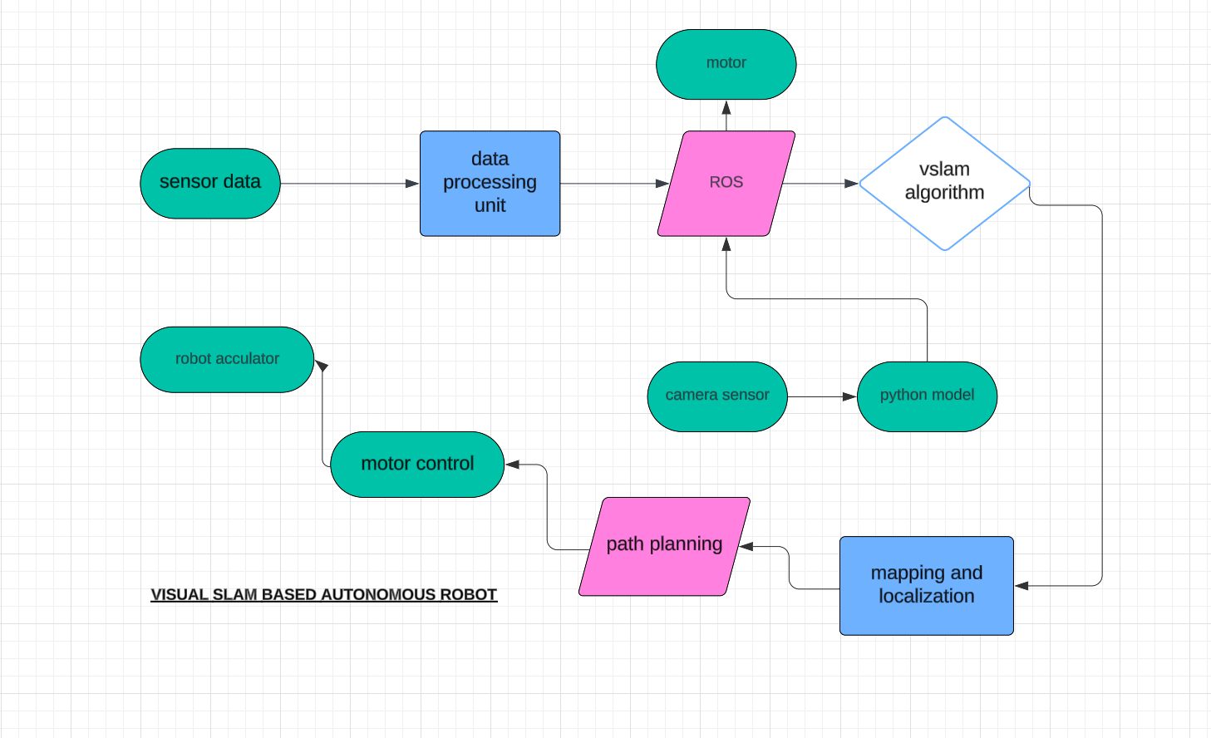

4.2 Tools and techniques utilized

4.3 Design considerations

Chapter 5 : Implementation

5.1 Description of how the project was executed

5.2 Challenges faced and solutions implemented

Chapter 6:Results

6.1 outcomes

6.2 Interpretation of results

6.3 Comparison with existing literature or technologies

Chapter 7: Conclusion

Here write Suggestions for further research or development and Potential improvements or extensions

Chapter 8 : Future Work

Here write Suggestions for further research or development Potential improvements or extensions

References

