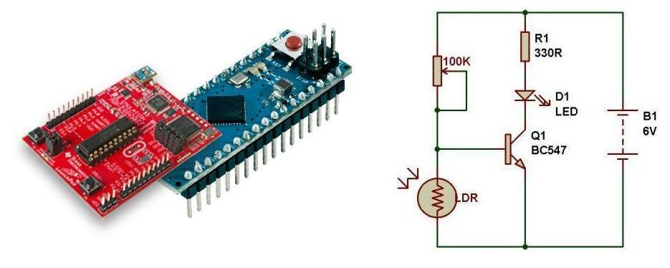

Embedded Systems Made Easy

Workshop

Date: 10 &11th March 2014

Venue : Manaki Hotel

Sanjeet Raj Pandey

Technical University of Berlin

Email: [sanjeet.raj@gmail.com](mailto:sanjeet.raj@gmail.com)

Twitter: [packet_switch](https://twitter.com/packet_switch)

Motivation

## *“Learn by doing”*

Advanced in technology needs a careful and continuous following. Mobile systems , broadcasting methods, medical technology are few technologies without which life is hard to imagine. Technology is leading the frontiers from saving lives, security, defence, and space exploration to mundane aspects as entertainment or social networking. Electronics, than ever before, is vital part of any society now.

Big industries are investing millions to get innovative application out of Embedded Systems today, they also, however, have started a culture of patents and closed sources. On the other hand, Homebrew, Do It Yourself (DIY) and Open Source are playing important role to keep these technologies transparent and accessible.

Open Source Hardware and Software have been massively improved in the quality, user experience and have become more affordable to buy. We are motivated to promote thisexperience to school students and the enthusiasts; introduce them the possibilities beyond simple transistor circuits and facilitate them venture into the embedded systems.

A do it yourself workshop on embedded electronics and applications is an initiative, which has following motivations:

* Confidence, you can
* How simple and easy it is
* Think beyond
* Internet of things
* Cheaper hardware
* Coding has never been easier
* Understanding how complex devices work

Programme

The main agenda is learning by making, therefore, maximum time is assigned for DIY sessions.

* Each session can have maximum of 20 students, 2 students in each group (10 group).
* Each session has time span of 1.45 hour.
* First 15 to 20 Min basic introductions of components to be used in workshop. Some previous experience with them will save time
  + Basic components (LED, Resistor, Relay, Transistor)
  + Microcontroller
  + Basic C coding
* 1 hour ***workshop*** (Do It Yourself)
  + Each group gets to select one out of 5 available projects.
  + Read tutorial and follow the easy steps
    - Blink LED, Switch, Analog read
    - Temperature Reading
    - Magnetic Switch
    - Light Sensing
    - Motor Driver
  + Some finished project demonstration
    - SMS controlled Lights
    - RGB Lighting
* Link will be provided prior to Workshop for software along with related documentation.
* There will be also an open discussion at the end of the programme. Participants are supposed to interact and pose questions.

Session

Due to Limited supply of hardware/components, sessions are conducted in groups with a question-answer session at the end.

* Each session will have maximum of 20 students forming 10 groups.
* Each session is dedicated to one institution only.
* There will be a list of different projects. Each group selects a project from this list.
* Each group gets a Hardware Kit pre connected to PC
* Groups can bring their own laptop, this is highly recommended.
  + Can save project data
  + Less electrical supply uncertainty
  + Software can be pre installed to save time
  + Latest OS (tested on windows 7,8, Ubuntu 12.04 or higher, OSX)
* Participants must exhibit discipline. Any violation of norms may result in disqualification of the individual participant.

Resource Link

Registration and Sources :

[https://bitbucket.org/sanju_gem/embedded-system-workshop/](https://bitbucket.org/sanju_gem/embedded-system-workshop/wiki/Home)

<http://goo.gl/A5G5RQ>

Requirements (Institution)

We are delivering main hardware kits from outside of Nepal (Germany), therefore, participating institutions should cover the expenses. Each hardware kit contains a complete set of components to begin with basic microcontroller circuits. The price we set for each hardware kit is Rs.8800[1]. Hardware Kit will be distributed after the workshop.

Our assumption:

* To cover the cost of the entire workshop, each participating institution should take minimum of 3 to 5 hardware kit.
* Institutions may choose to participate without purchasing the hardware kit for Rs. 3500.

Future

After the completion of workshop, students will have fundamental working knowledge of Embedded Systems, programming them and designing new projects using them. Here are few popular topics that will be covered:

* Basic Robotics, i.e. motor control, digital switching and sensing
* Sensors, Temperature Alarm Systems, Distance measurement, and Reed Switch
* LED, Dimmers, Optical electronics i.e. LCD, Touch Sensing etc.
* Power Regulation, AC switching
* Radio and wireless
* Binding things to internet
* PWM and BUS (I2C, SPI, One Wire)
* DIY Gadgets
* Data Logging
* GPS Sensing
* BUS system (SPI, I2C, 1-Wire etc.)
* Advance Hardware and Microcontroller (ARM and Higher AVR)

*“Skill to do comes of doing”* -Ralph Waldo Emerson

Reference

<http://sanjugem.tumblr.com/>

<http://www.atmel.com/devices/ATMEGA328P.aspx>

<http://www.raspberrypi.org/>

<http://processors.wiki.ti.com/index.php/MSP430_LaunchPad_(MSP-EXP430G2)>

<http://en.wikipedia.org/wiki/Microcontroller>

<http://arduino.cc/en/Main/ArduinoBoardMicro>

<http://www.pjrc.com/teensy/>

<http://www.tkn.tu-berlin.de/>

Thanks To

|  |  |
| --- | --- |
| Prof. Dr.-Ing. Adam Wolisz  Dr.-Ing. Vlado Handziski | Department of Telecommunication Systems,  Technical University of Berlin |
| Felix Schaal | Berlin Promotion Agency GmbH & Co. KG. |
| Diwaker Jha | Neil Bohr institute, University of Copenhagen, Denmark |
| Sawan Jha | Translational Cancer Biology Program, University of Helsinki, Finland |



**Subject: Invitation for Embedded Systems Workshop.**

Dear Sir/Madam,

I am pleased to invite you to attend our *“Embedded System Made Easy Workshop”* to be held at the MANAKI Hotel[2] Conference room, Shiv chowk,JanakpurDham, on 10th – 11th of March 2014.

The objective of Workshop is to bring the enthusiasts of Janakapur to next level of technology that can be homemade and yet giving fascinating results. Workshop will especially focus on basics of embedded systems , simplicity in both programming and electronics. How physical world sensing can be converted in digital form and playing with those data to achieve different events. e.g *how can a temperature sensor reading can turn fan on or off , saving life as well as energy. How does a robot sensors can trigger changes in its direction of movement ,* are few to mention.

It focuses on student/enthusiasts of **9th standard and above including engineering candidates** . Giving students a chance of handling basic electronics and coding , we want to achieve the new level of confidence and knowledge.

Few things i would like to notify,

1. We will provide hardware during workshop .
2. Joining Workshop costs Rs. 3500 , this is for event management.
3. Hardware Kit is also available to buy on Rs. 8800[3]
4. Maximum Possible number of candidates is 20 , we will provide time slot for you.
5. Pre-Registration is needed , link is provided on attached document.
   * **Deadline of Registration for Student is 25th Feb 2014**
6. We also have very **special parents and student workshop** on 11the March at 10 AM. This is aimed for student under 9th Grade . Student must come with their parent and make experiment together. Let us know before , as we have limited seats .

Please write us about your participation on email below before **20th Feb 2014** . To be local sponsor please email us too.

Please do not hesitate to contact me if you have any questions.

Yours sincerely,

Sanjeet Raj Pandey

sanjeet.raj@gmail.com

1. Minimum calculated cost of each kit is Rs. 8800. This is the least possible of the raw materials cost.
2. We are fixing it , any change in venue will be prior notified .
3. Minimum calculated cost of each kit is Rs 8800. This is the least possible cost. We neither have control over this prices nor we intend to make any profit out of it. Major parts of kit are imported from Germany & USA. **Limited number of hardware is available so please pre inform us how many you need.**