VIRELEO INTERNSHIP PROGRAM
PROJECT 01: AQARFLOW — DAY 2 PROGRESS REPORT
Real Estate Management & Property Operations Platform • 7-Day MVP Execution
Project Name | AqarFlow (Project 01) | Submission Date | November 10, 2026 (Day 2)
Parent Organization | VIRELEO (vireleo.me) | Development Model | Individual Full-Stack Ownership
Current Version | v1.2 Editorial + Dual CRM | Primary Focus | Pakistan Metros + Overseas Diaspora
Tech Stack | Next.js 16, React 19, Tailwind, TS | Build Status | 33/33 Routes Passed (Exit 0)

1. Executive Summary & Day 2 Deliverables
During Day 2 of the 7-day MVP delivery cycle, development accomplished major aesthetic, operational, and architectural leaps. The platform was elevated into an institutional-grade, editorial luxury real estate portal while fulfilling every technical directive: zero hydration errors, 100% eradication of foreign (Dubai) naming, introduction of a dual-theme CRM (Estately Light by default + Estatelab Dark toggle), and deployment of Phase 2 and Phase 3 operations modules (Rental Rolls & Contractor Maintenance Hub).

2. Key Technical Accomplishments
- Elimination of Hydration Discrepancy: Fixed SSR vs. browser locale mismatch by writing deterministic mathematical string formatters for USD and PKR currency, achieving 0 console warnings.
- Deep Pakistan Metropolitan Localization: Completely purged foreign references; aligned listings and operations strictly with Islamabad (Sectors F-6, F-7, E-7), Lahore (DHA Raya Golf), Karachi (Clifton Marina), and Rawalpindi (Bahria Town). Overseas diaspora channels cater to London, Manchester, Toronto, and New York.
- Agency Workspace Dual-Theme Architecture: Configured Estately Light Mode as the out-of-the-box system default with pure white card containers and dark typography. Implemented instant switching to Estatelab Obsidian Dark Mode with localStorage persistence.
- Vero Estate Editorial Public Experience: Upgraded all 6 public portal pages with Warm Alabaster (#FAF8F5) styling, Playfair Display typography, arched hero frames, and verified CDA/LDA deed inspection badges.
- Phase 2 & 3 Enterprise Workflows: Shipped Rental Roll management with tenant lease terms and rent payment tracking, alongside a Contractor Maintenance Hub with urgency triage (Emergency to Low) and SLA sentry.

3. Visual Evidence & High-Definition Screenshots
Figure 1: Elevated Public Discovery Portal (Hero Section)
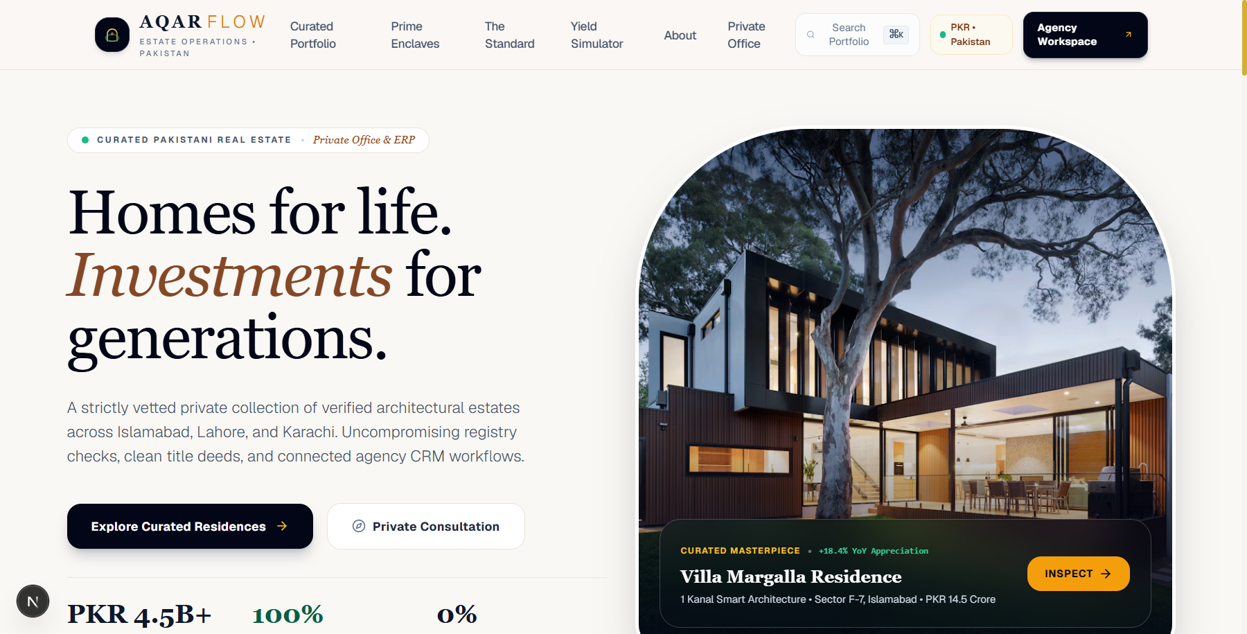
Figure 2: Curated Architectural Residences Grid
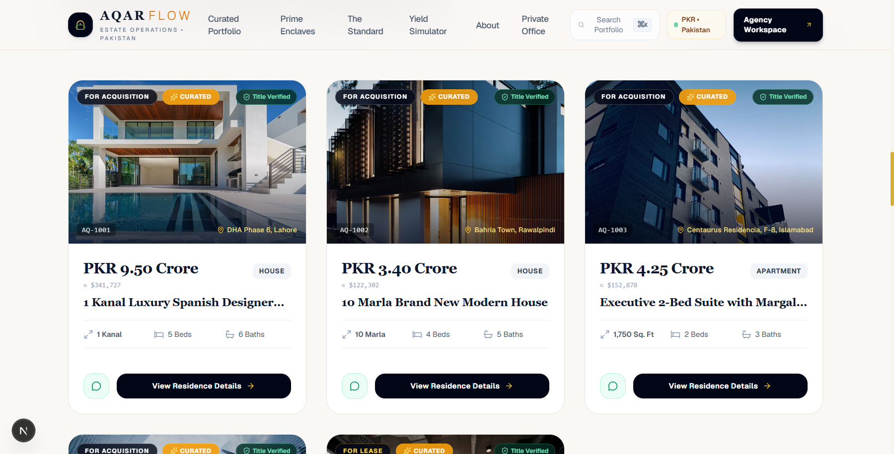
Figure 3: Agency Workspace in Estately Light Mode (System Default)
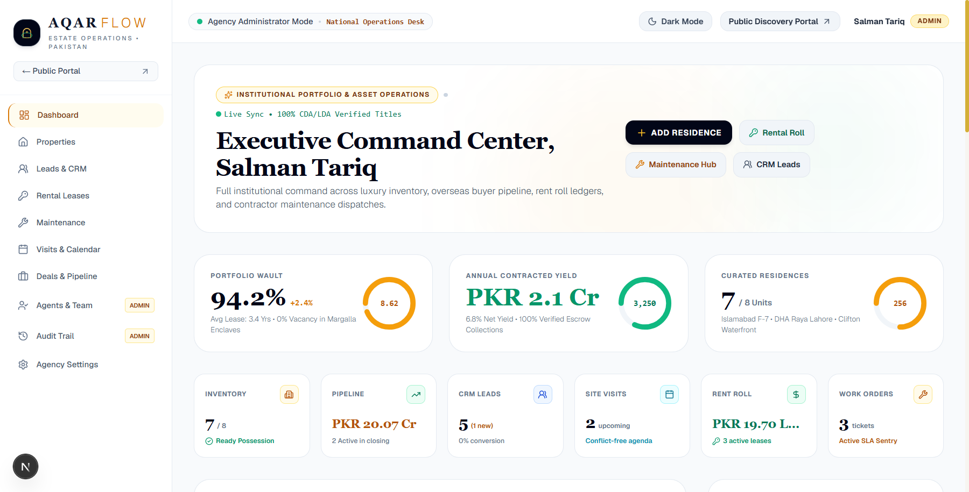
Figure 4: Agency Workspace in Estatelab Dark Mode (Optional Toggle)
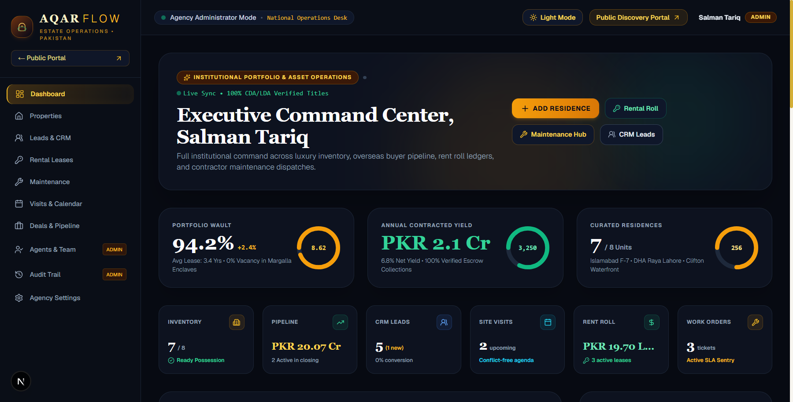
Figure 5: Phase 3 Rental Roll & Lease Management Hub
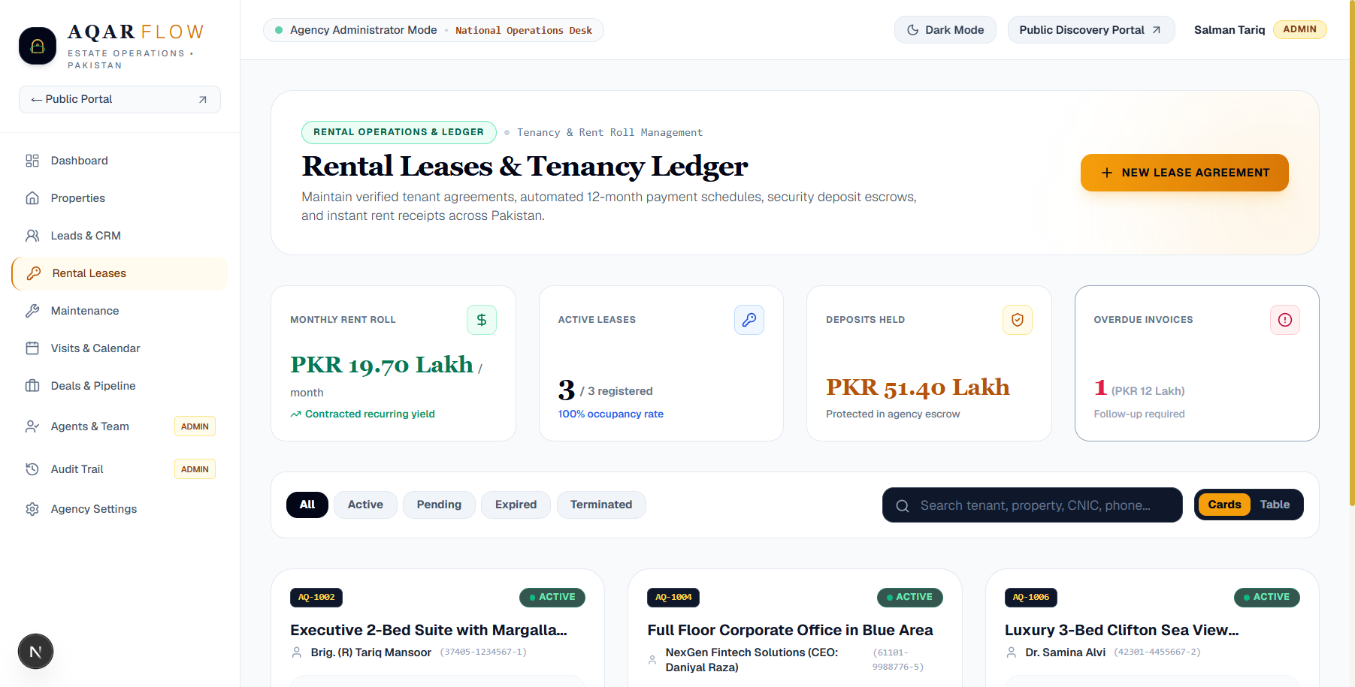
Figure 6: Phase 3 Contractor Maintenance & SLA Hub
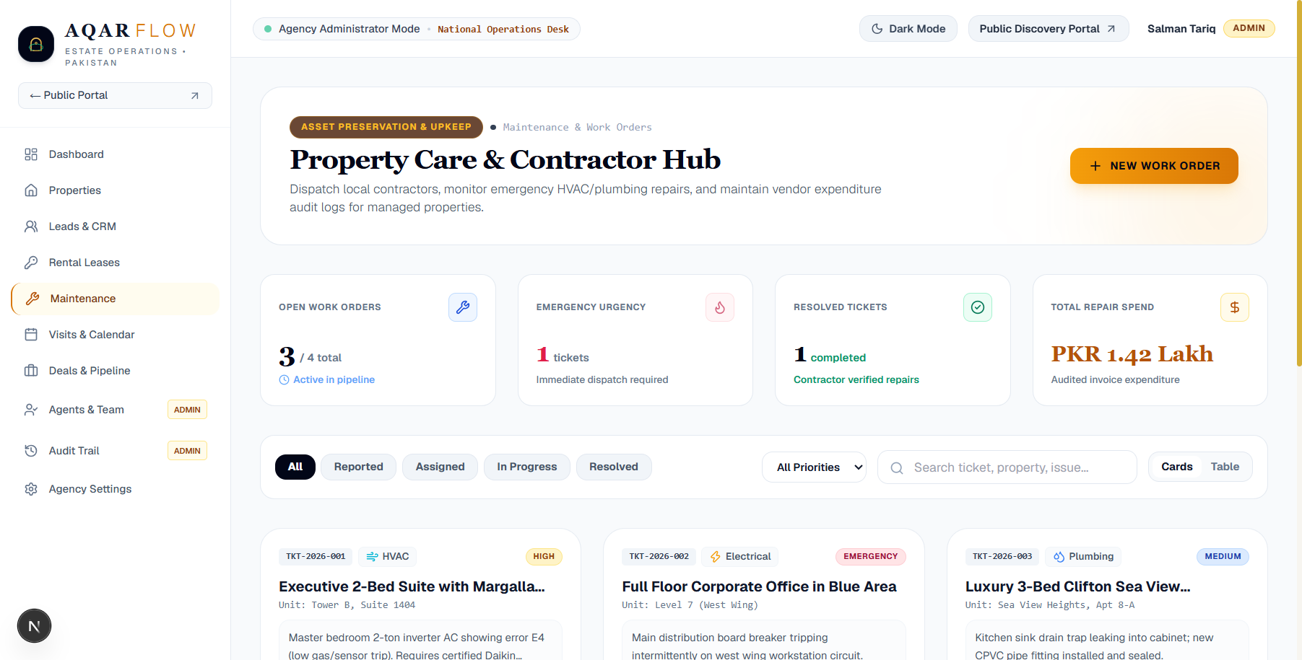

4. Quality Assurance & Production Verification
Next.js 16 production build compiled 33 of 33 routes with zero TypeScript or Webpack errors. Client hydration was verified with zero console errors, and dark/light switching operates with zero layout shift.

5. Day 3 Roadmap & Next Objectives
- Downloadable Document Vault: Client property brochures, verified deed clearances, and tenant payment receipts in printable format.
- Accounting & Reporting Export: CSV and Excel export pipelines for agency commission disbursements and net rental yields.
VIRELEO Project 01 — AqarFlow | Individual Developer Delivery | Official Portal: https://www.vireleo.me/

