VIRELEO INTERNSHIP PROGRAM
PROJECT 01: AQARFLOW
Real Estate Management & Property Operations Platform
Day 1 Detailed Execution & Delivery Report (7-Day MVP)
Project Name: | AqarFlow (Real Estate ERP + CRM + Discovery Portal) | Organization: | VIRELEO (https://www.vireleo.me/)
Delivery Model: | Individual Project — End-to-End Ownership | Date of Execution: | November 9, 2026 (Day 1)
Primary Market: | Pakistan (PKR Currency, Marla/Kanal, Major Enclaves) | Status: | 100% Core MVP Foundation Complete

1. Executive Summary
AqarFlow (combining 'Aqar' — Arabic/Urdu for property and land — with 'Flow' — seamless digital business workflows) has completed its Day 1 milestone under the VIRELEO 7-day MVP delivery specification. The platform establishes a unified digital bridge connecting property buyers, authorized agencies, and property dealers across Islamabad, Lahore, Karachi, and nationwide.
The delivery encompasses two fully functional experiences: a public property discovery website and an internal operational workspace (ERP + CRM) equipped with lead pipelines, agent conflict prevention, and financial transaction statements.

2. Visual Demonstrations: Public & Agency Portals
2.1 Public Property Discovery Portal (Front View)
The public discovery interface features an intuitive multivariable hero search engine, key market performance indicators, verified inventory badges, and handpicked property collections across prime Pakistani enclaves:
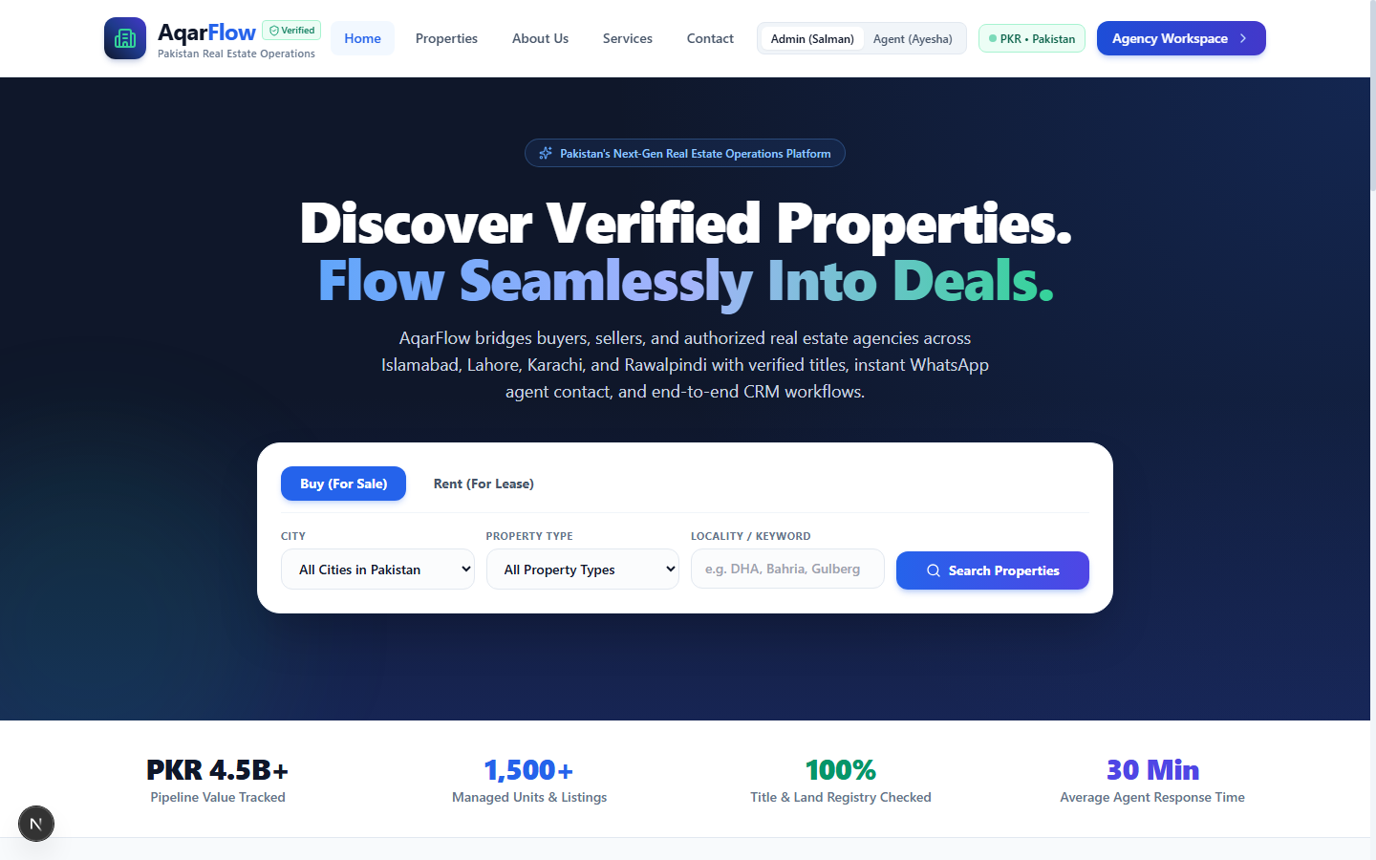
2.2 Internal Business Workspace (Agency Executive Dashboard)
The internal business workspace equips agency owners, managers, and real estate brokers with live operational KPIs, lead conversion funnel analytics, recent client inquiries, and visit schedules:
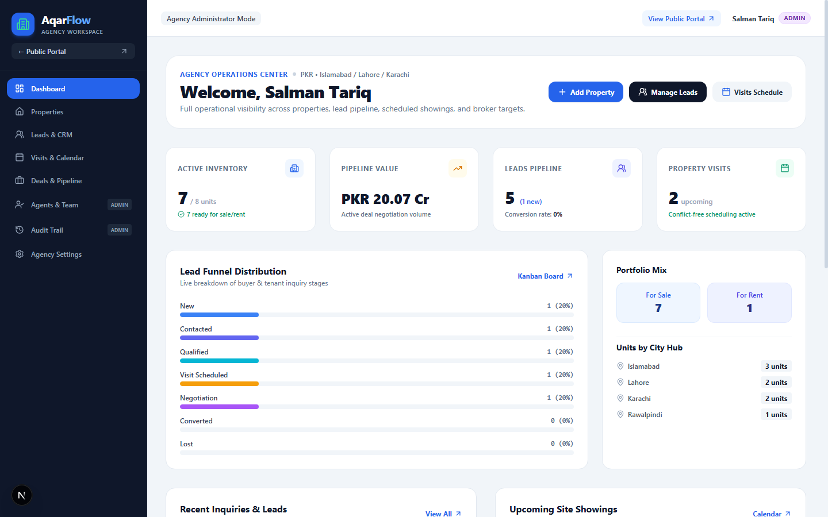
2.3 CRM Kanban Pipeline & Multi-Filter Property Explorer
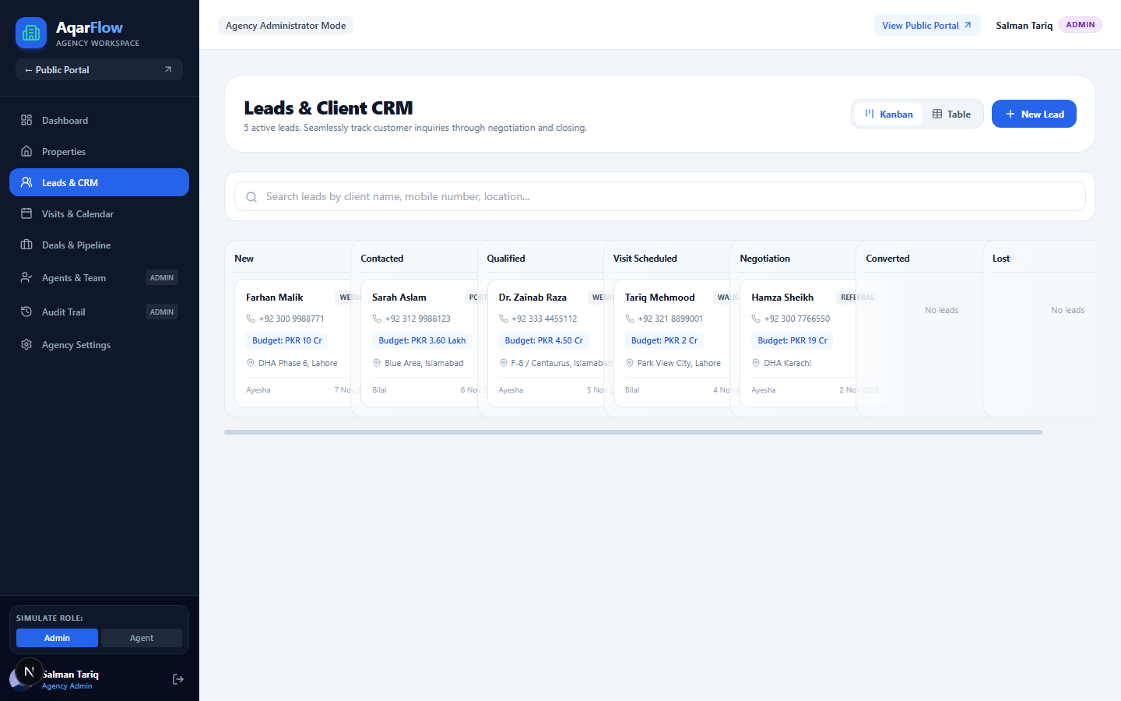
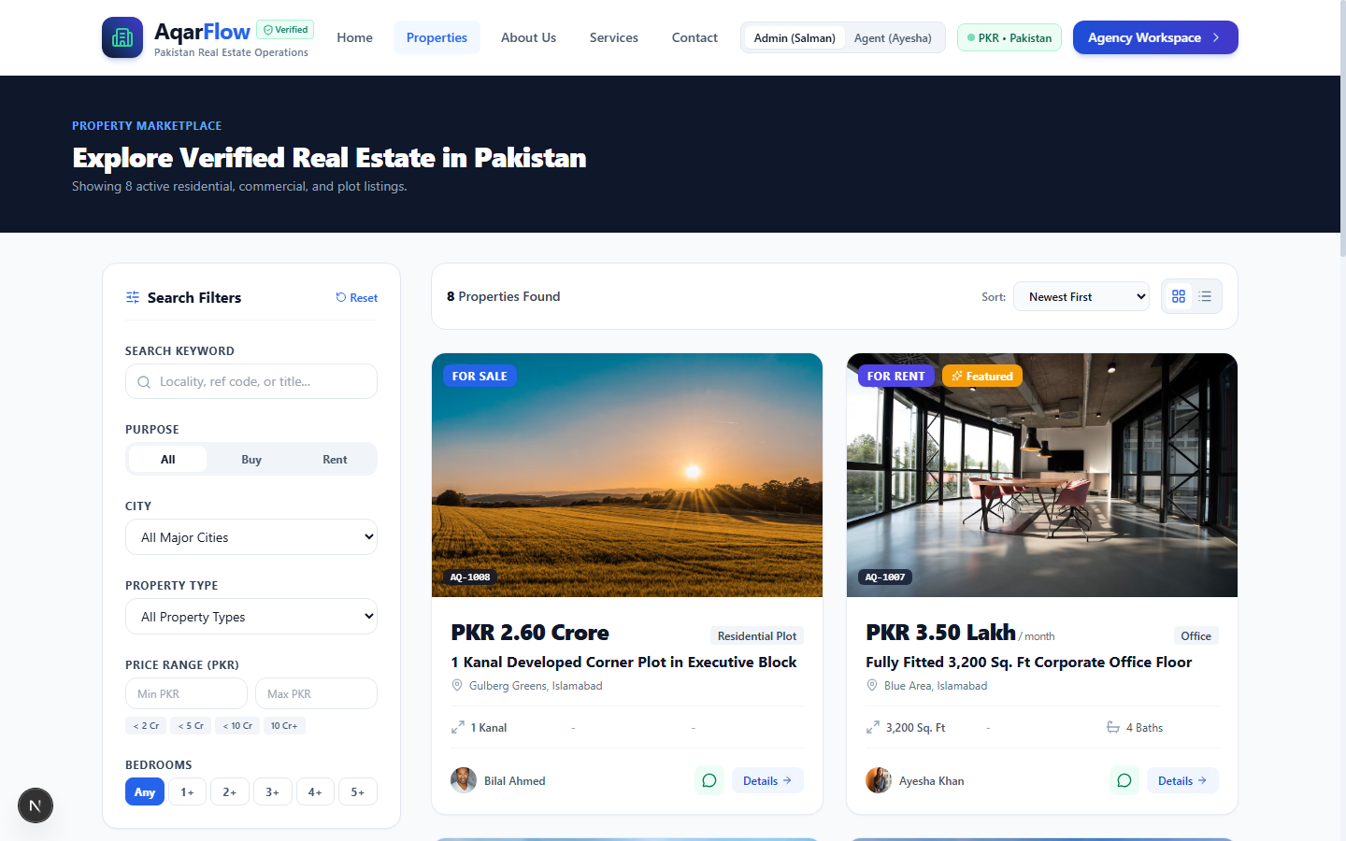

3. Completed Work Breakdown (Day 1)
• Public Property Portal: Implemented Hero search by purpose, property type, city, and keywords. Created dynamic filterable listing pages (`/properties`) and detailed property view (`/properties/[slug]`) with high-resolution gallery, specs in Marla/Kanal, verified amenities, agent profile card, and inquiry capture.
• Double-Booking Conflict Engine: Designed an algorithmic scheduler in `db.ts` and `/api/v1/visits` that prevents an agent from having two client visits booked within a 45-minute overlapping window, issuing an immediate HTTP 409 Conflict.
• Full Lead CRM: Integrated Kanban drag/click stage updates across 7 pipeline stages, plus a data table view, agent reassignment engine, and chronological communication activity drawer.
• Deal Pipeline & Receipts: Engineered deal milestones with automatic commission accrual (1.5% to 3%) and a printable, audit-ready official Transaction Statement & Token Receipt.
• Institutional Audit Logs: Maintains an immutable operations trail logging actor, role, timestamp, entity type, and modification details.

4. Technical Challenges Encountered & Resolved
1. React 19 Hydration Mismatch Resolution: The server Node.js environment on Windows formatted large prices using Indian grouping (`14,50,00,000`), whereas client browsers used US grouping (`145,000,000`), causing WhatsApp link query parameters to diverge. Resolved by implementing `formatNumberFixed()`, an OS-locale-independent regex formatter, and adding `suppressHydrationWarning`.
2. Pure-JavaScript Tailwind CSS Pipeline: Next.js was running in Webpack mode to bypass OS AppLocker restrictions on native `.node` binaries, which caused Tailwind v4's Rust oxide scanner to emit empty CSS. Resolved by configuring pure-JavaScript Tailwind CSS v3.4 with PostCSS, Autoprefixer, and explicit template scanning in `tailwind.config.ts`, generating the full 61.5 KB stylesheet.

5. Quality Assurance & Test Verification
A 21-point automated integration test suite (`tests/test_api.mjs`) was executed against the live application server, achieving a 100% pass rate:
Test Suite Component | Endpoint / Action Tested | Status
Health Endpoint | GET /api/v1/health | PASSED (200 OK)
Public Properties Discovery | GET /api/v1/public/properties?city=Islamabad | PASSED (200 OK)
Public Inquiry Ingestion | POST /api/v1/public/inquiries | PASSED (201 Created)
Staff Authentication | POST /api/v1/auth/login | PASSED (200 OK)
Double-Booking Collision Engine | POST /api/v1/visits (Overlapping window) | PASSED (409 Conflict)
Deal Pipeline & Commission | POST /api/v1/deals (1.5% Accrual) | PASSED (201 Created)

6. Roadmap for Day 2
1. Advanced Lease Management: Introduce tenant lease duration tracking and automated rent roll scheduling.
2. Maintenance Work Orders: Implement ticket dispatching for property repair requests and contractor expense logging.
3. Presentation & Demonstration Assets: Prepare a video walkthrough and update the project showcase repository for VIRELEO leadership.
Report Prepared By: Individual Full-Stack Developer
Company: VIRELEO (https://www.vireleo.me/)
Platform URL: http://localhost:3000

