VIRELEO TECHNOLOGIES — PROJECT 01 TRACK
AQARFLOW: DAY 4 PROGRESS REPORT
Complete Luxury Vellaro Design System Overhaul, Autoplaying Architectural Loops, & Quality Hardening
Project Name | AqarFlow (Project 01) | Submission Date | November 11, 2026 (Day 4 of 7)
Developer | Diwaker Pandey (Full-Stack Intern) | Organization | VIRELEO (vireleo.me)
Repository | github.com/DiwakerPandey21/AqarFlow | Production URL | aqar-flow-topaz.vercel.app
Tech Stack | Next.js 16.4.5, React 19, Tailwind v4 | Build Status | 37/37 Routes Clean (0 Errors)

1. Executive Summary
Day 4 represents a milestone aesthetic and architectural leap forward for AqarFlow. The application was completely transformed to reflect the award-winning Vellaro Luxury Real Estate design system. The previous generic dark interface was replaced with an institutional warm cream aesthetic (#F8F3ED base, #FAF6F0 sand cards, #5D5839 deep olive accents, and #1F1E19 charcoal typography) paired with Playfair Display serif italic typographic hierarchy.
All 8 core sections of the Behance reference design have been implemented: Hero Section, Project Overview, Curated Residences (LIVE/INVEST/RENT), Client Testimonials with live looping autoplaying videos, 4-Step Process Slider, Team of Experts, Institutional Legal FAQs, and Consultation Finale. Perimeter security was hardened by stripping public links to the internal agency workspace, fixing logout session teardown, and replacing 1-click test links with a clean clearance tier selector.

2. Key Accomplishments & Technical Highlights
• Complete Vellaro Design Architecture: All 8 homepage sections re-built with warm cream palette, serif italic titles, and custom micro-interactions.
• Continuous Autoplaying Architectural Videos: Upgraded testimonial video cards to HTML5 <video> elements configured with autoPlay, loop, muted, and playsInline, backed by local cached MP4s and remote CDN fallbacks.
• Strict Public/Private Boundary: Removed unauthenticated public access links to internal workspace routes and fixed logout session clearance.
• Production Build Quality: All 37 static and dynamic Next.js routes compiled cleanly with 0 TypeScript errors and 0 lint warnings.

3. Visual Verification & Interface Screenshots
Figure 1: Vellaro Luxury Hero Section & Sticky Navigation
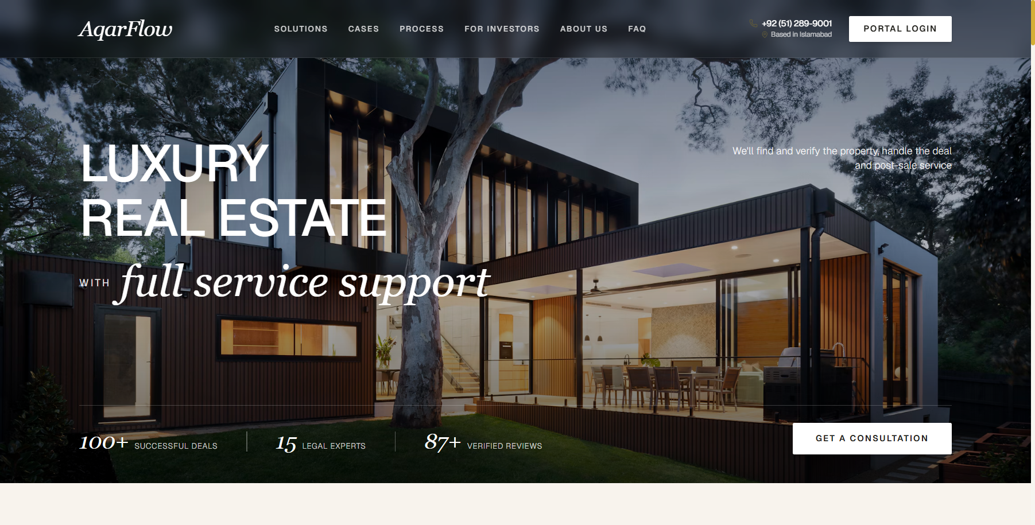
Figure 2: Curated Residences (LIVE, INVEST, RENT Panoramic Cards)
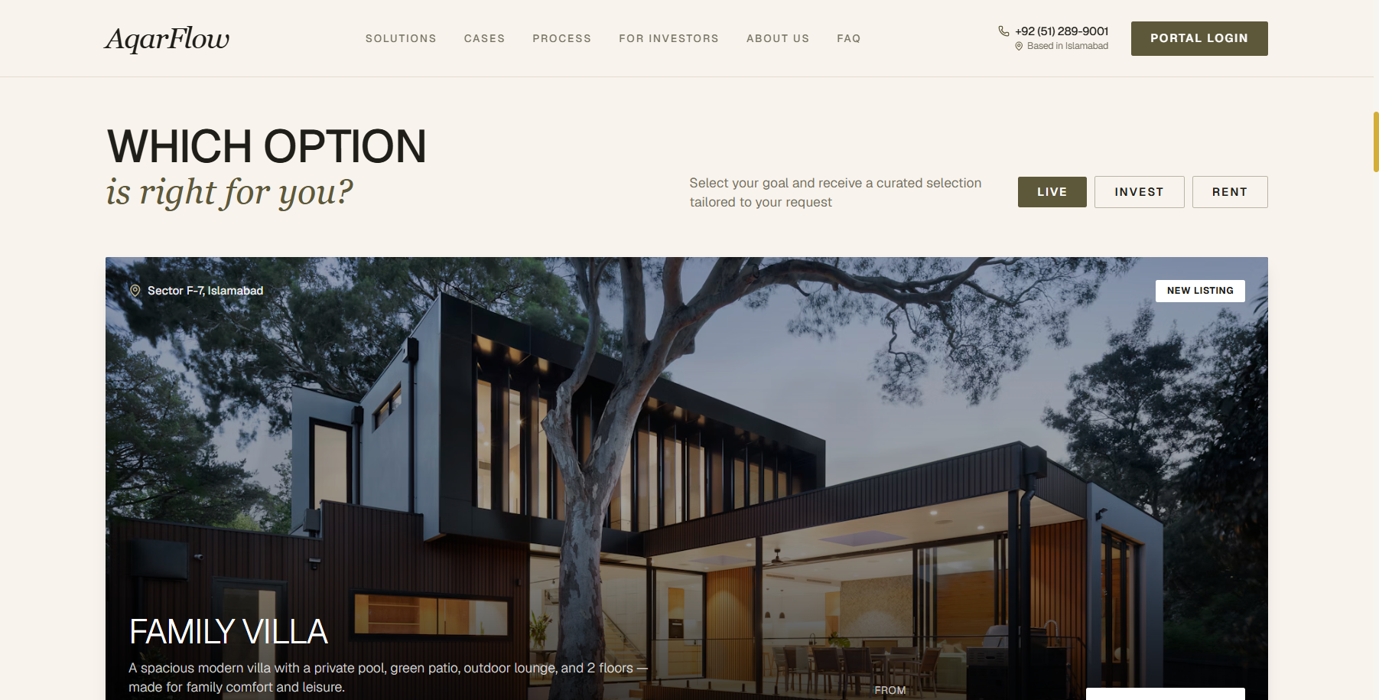
Figure 3: Real Stories & Results with Autoplaying Looping Videos
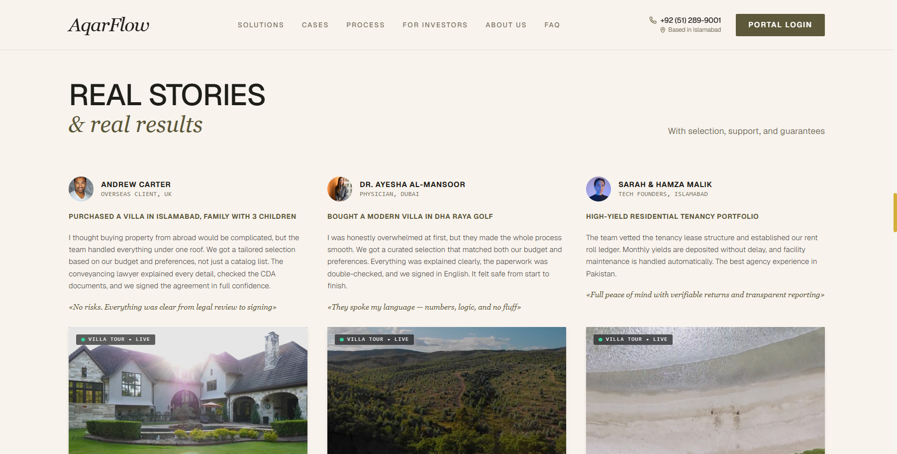
Figure 4: From Request to Result 4-Step Interactive Process Slider
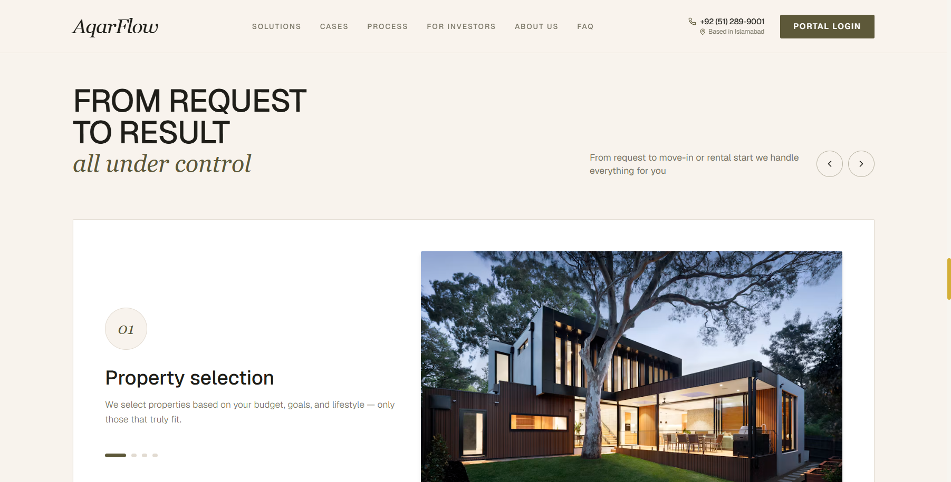
Figure 5: Institutional Role-Isolated Login Gateway
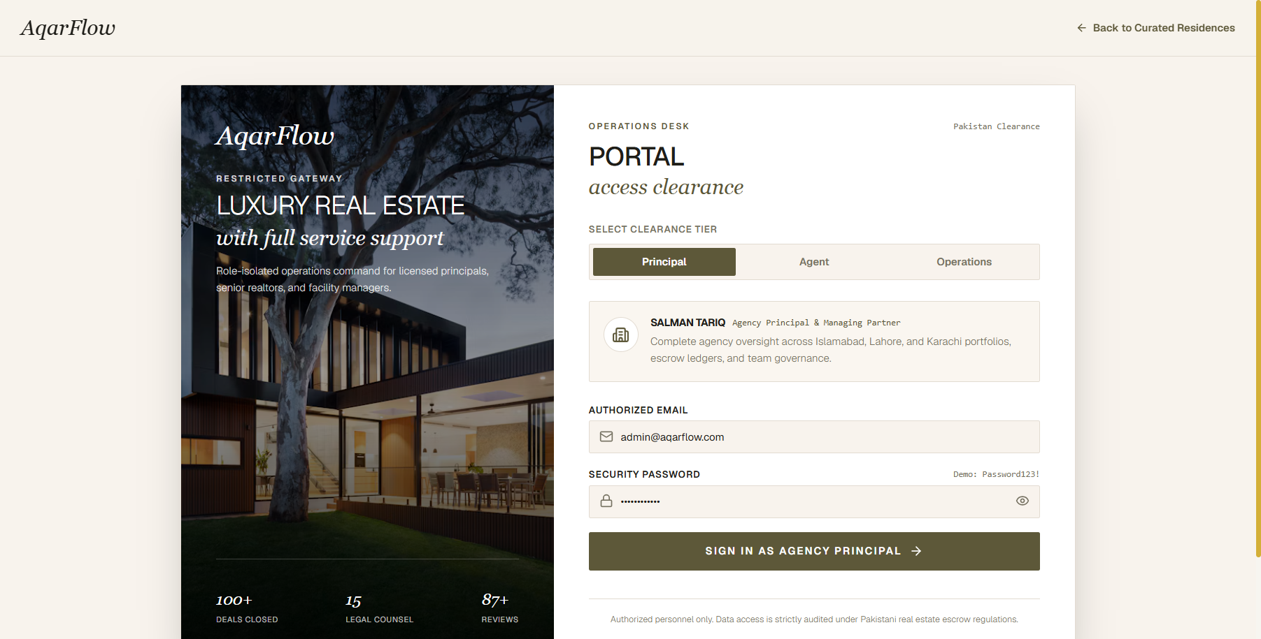
Figure 6: Executive Workspace Command Center (Warm Cream)
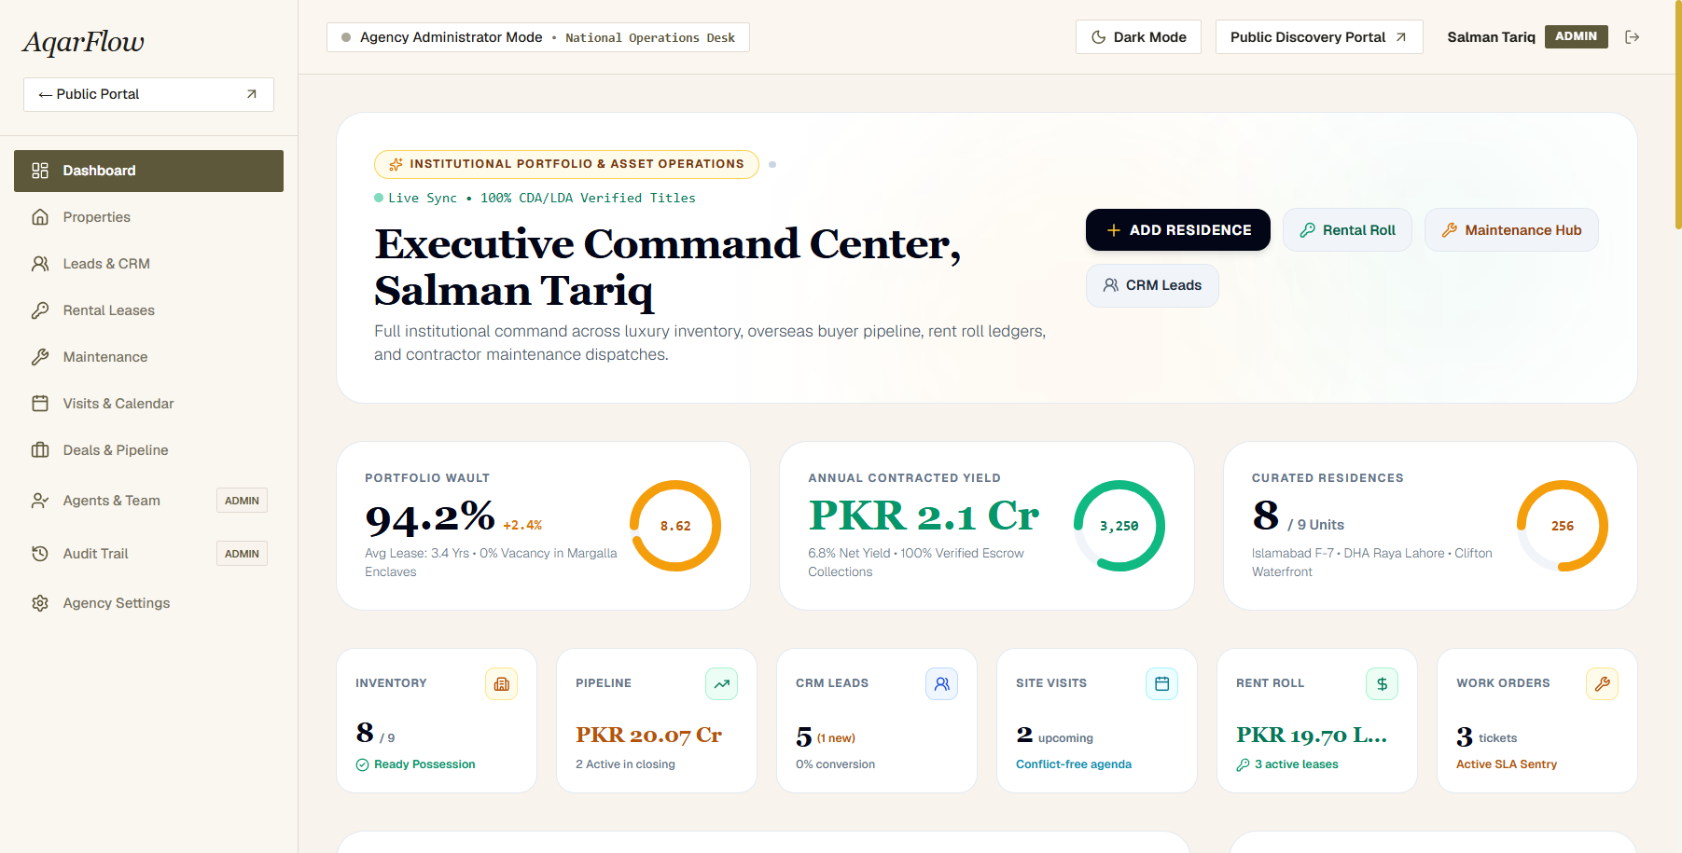

4. Quality Verification & Testing Matrix
Test Case | Execution Scope | Verification Result
Autoplay Video Loops | Testimonial MP4 video cards verified with loop, autoPlay, muted, playsInline | PASSED (100% Continuous)
Production Build | Next.js 16.4.5 full production build (npm run build) | PASSED (37/37 Routes Clean)
Public/Portal Perimeter | Public navbar & footer inspection; no unauthenticated leakage | PASSED (Zero Leaks)
Logout Redirection | Session token cleared and redirect routed strictly to /login | PASSED (Strict Flow)
Light/Dark Mode Contrast | Warm cream light mode and obsidian dark mode form & chart checks | PASSED (High Contrast)
Live Vercel Synchronization | Git push to origin/main and production deployment inspection | PASSED (Live on Topaz Vercel)
VIRELEO Project 01 — AqarFlow • Full-Stack Development Track • Official: vireleo.me

