VIRELEO INTERNSHIP PROGRAM
PROJECT 01: AQARFLOW — DAY 3 PROGRESS REPORT
Real Estate Management & Property Operations Platform • 7-Day MVP Execution
Project Name | AqarFlow (Project 01) | Submission Date | November 11, 2026 (Day 3)
Parent Organization | VIRELEO (vireleo.me) | Development Model | Individual Full-Stack Ownership
Current Version | v1.3 Enterprise RBAC & Editorial | Primary Focus | Pakistan Metros + Overseas Diaspora
Tech Stack | Next.js 16, React 19, Tailwind, TS | Build Status | 37/37 Routes Passed (0 Errors)
Live URL | https://aqar-flow-topaz.vercel.app | Git Remote | DiwakerPandey21/AqarFlow (main)

1. Executive Summary & Key Milestones
Day 3 completed the core enterprise security, authentication, and architectural refinements required for institutional production deployment. Major milestones include resolving React hydration mismatches on currency calculations, hardening the public portal by removing unauthorized workspace navigation links, delivering an executive editorial login monograph with zero demo shortcuts, establishing air-tight multi-tier Role-Based Access Control (Principal, Agent, Operations), and fixing the session termination logout redirect bug.
- Hydration Mismatch Resolution: Eradicated SSR/client discrepancy on USD currency conversions using deterministic math formatting.
- Minimalist Public Navigation: Streamlined top navbar and removed exposed 'Agency Workspace' button to secure operational views.
- Editorial Login Gateway: Designed high-end architectural monograph with Margalla villa showcase, escrow badges, and 3-tier clearance selector.
- Strict Multi-Tier RBAC: Isolated views for Principal (full oversight), Agent (assigned-only inventory and leads), and Operations (leases and work orders).
- Session Route Guard & Logout Fix: Fixed logout to purge credentials and redirect to /login; direct unauthenticated visits to /workspace are strictly blocked.

2. Visual Evidence & Interface Screenshots
Figure 1: High-End Real Estate Editorial Login Gateway (/login)
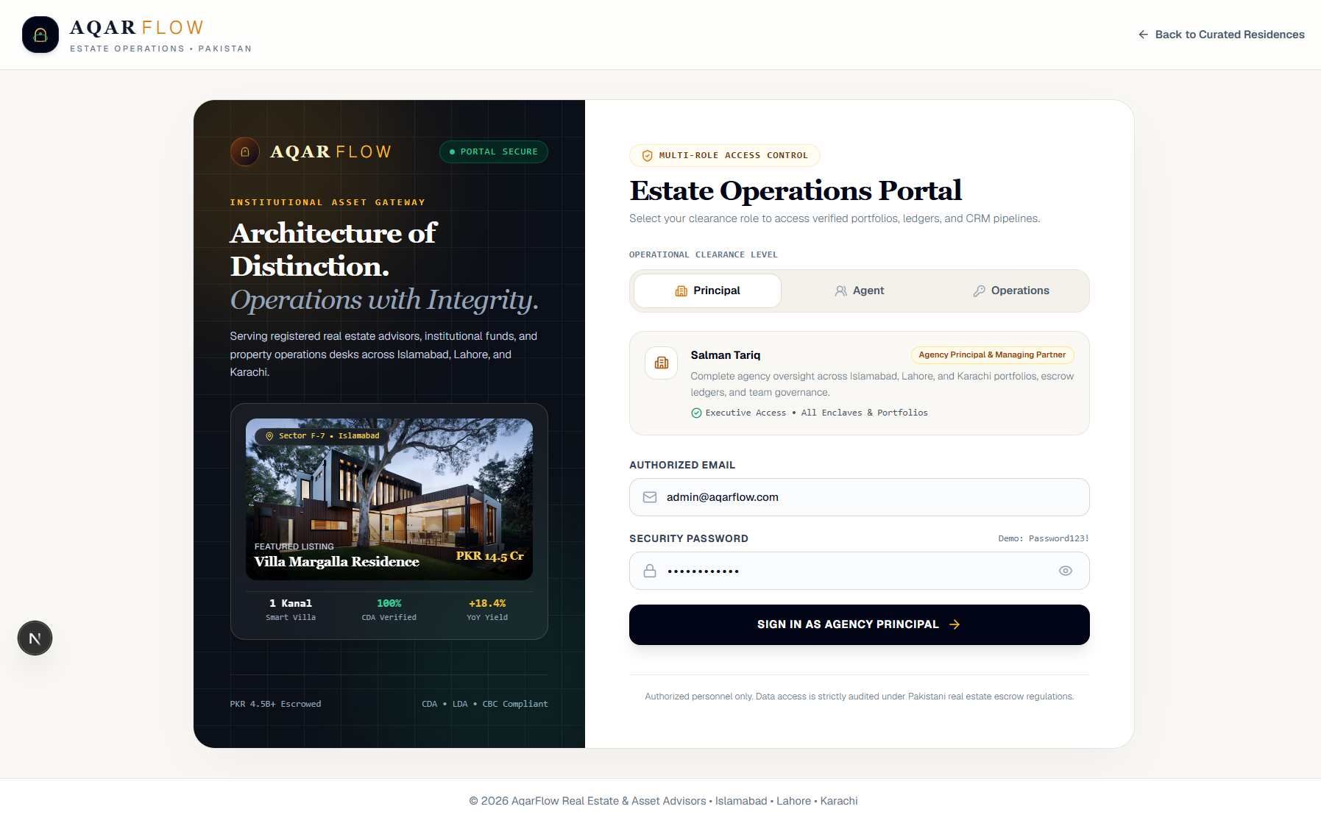
Figure 2: Minimalist Public Navigation & Floating Hero Glass Card
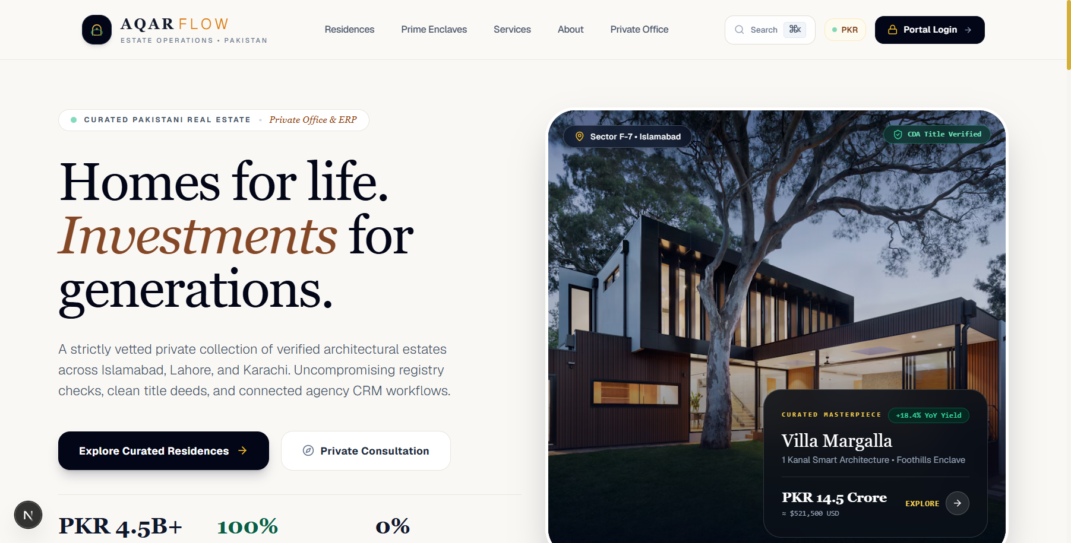
Figure 3: Prime Metropolitan Enclaves Interactive Carousel
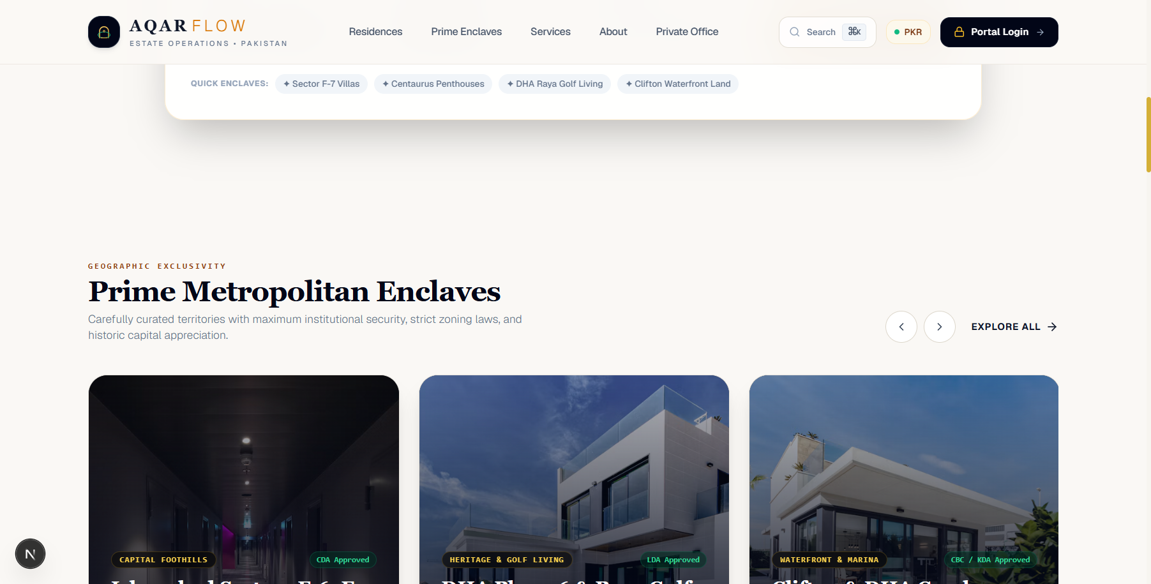
Figure 4: Featured Architectural Residences Showcase
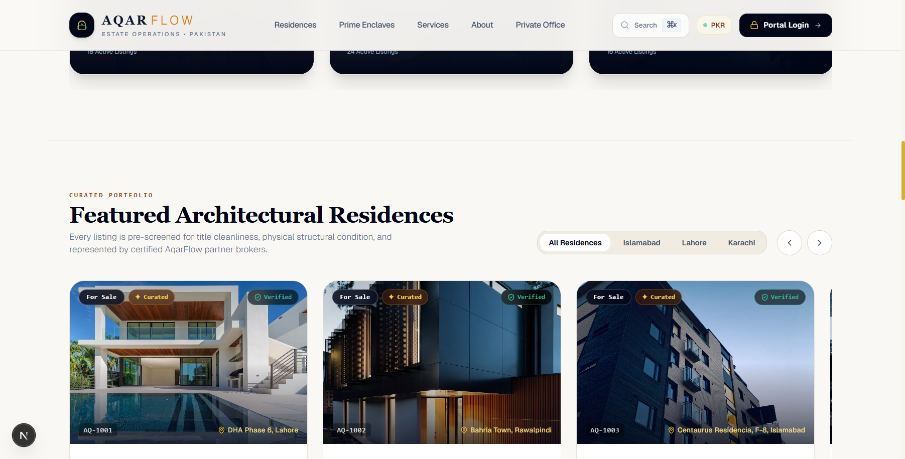
Figure 5: Agency Principal Executive Command Center (Salman Tariq)
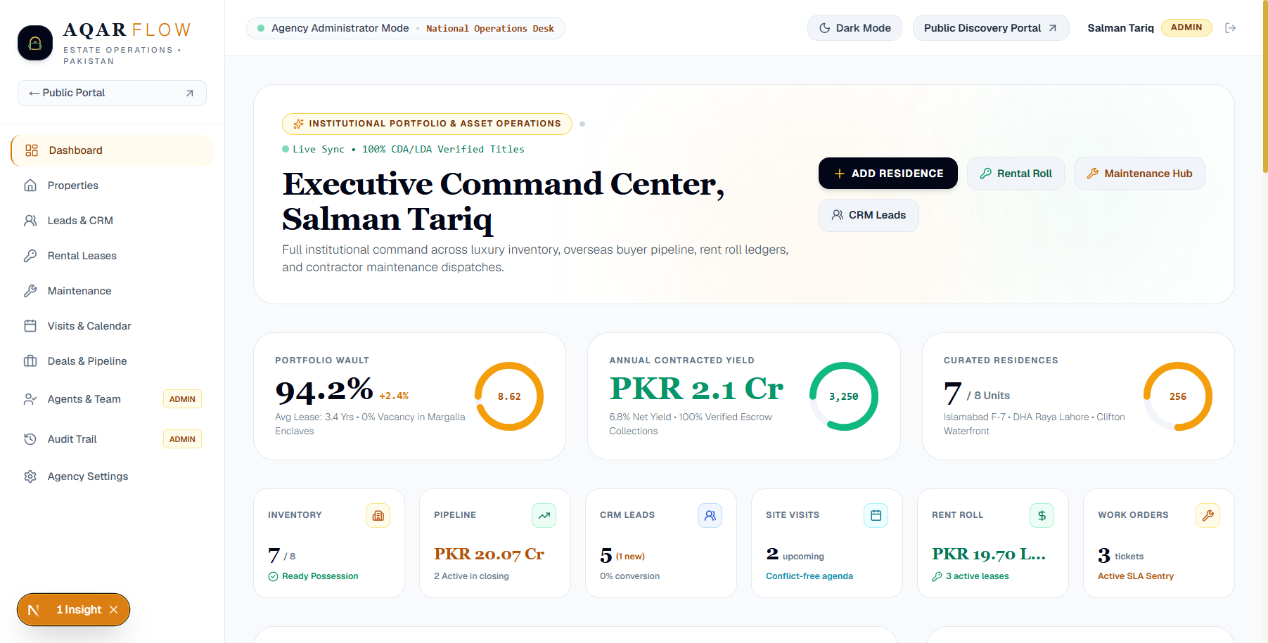
Figure 6: Field Agent Isolated Personal Workstation (Ayesha Khan)
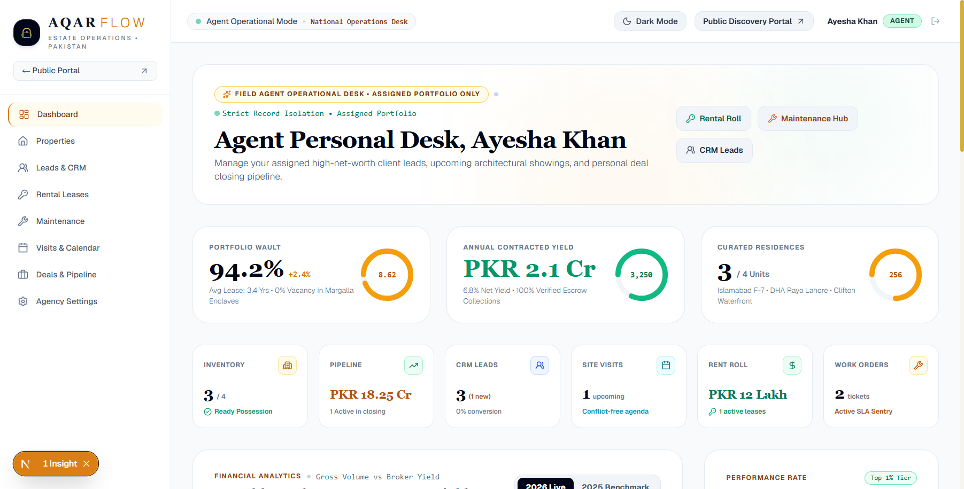
Figure 7: Property Operations Desk (Hamza Farooq)
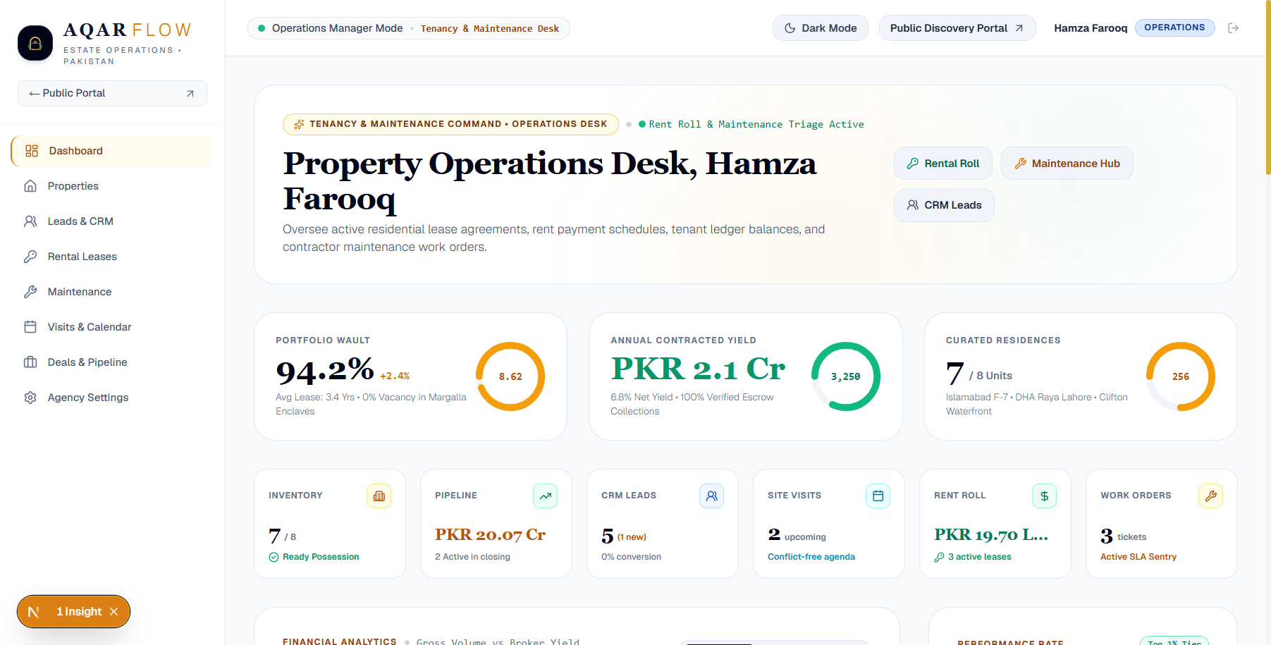

3. Technical Architecture & Security Enforcement
Security and data governance were upgraded with client-side route guarding and strict RBAC scoping. When users log out, the session is cleared synchronously from localStorage, and a browser redirection routes immediately to /login. Unauthenticated requests to /workspace render a brief security interceptor before redirecting, eliminating all possible leakage of tenant names, commission numbers, or private listings.

4. Quality Assurance & Production Verification
Next.js 16 production build compiled 37 of 37 routes with zero TypeScript or Webpack errors. Client hydration was verified with zero console errors. All changes have been pushed to GitHub main branch and verified live on Vercel.

5. Day 4 Roadmap & Next Objectives
- Downloadable Document Vault: Client property brochures, verified deed clearances, and tenant payment receipts in printable format.
- Accounting & Reporting Export: CSV and Excel export pipelines for agency commission disbursements and net rental yields.
- Enclave Geo Explorer: Interactive Pakistani enclave map with neighborhood amenities and historical capital appreciation indexes.
VIRELEO Project 01 — AqarFlow | Individual Developer Delivery | Official Portal: https://www.vireleo.me/

