twigfiddle.com functional requirements

|  |  |  |
| --- | --- | --- |
| **Changes** | | |
| **Date** | **Corp. Member** | **Summary** |
| 27/06/2014 | Alain | Initial specifications |
|  |  |  |
|  |  |  |
|  |  |  |
|  |  |  |
|  |  |  |
|  |  |  |
|  |  |  |

**Table of contents**

I. Context 3

II. General information 4

III. Site Map 5

IV. Fiddle Editor 6

A. Guest users editor 6

B. Registered users editor 7

C. Editor features description 7

1. Twig version 7

2. Run button 7

3. Save button 8

4. Share button 8

5. Samples menu 8

6. About button 8

7. Login menu (guest users only) 8

8. Fiddle revision 8

9. Fiddle title 9

10. Fiddle tags 9

11. Twig code pane 9

12. Context pane 9

13. Result pane 10

14. Fiddle’s visibility (registered users only) 10

15. Favorite fiddle icon (registered users only) 10

16. Home button (registered users only) 11

17. Logout button (registered users only) 11

V. About page 11

VI. Search Fiddles page 11

A. Layout 11

B. Features description 12

1. New fiddle button 12

2. Keyword search input 12

3. Tag filter input 12

4. Filter private fiddles only tic, 13

5. Filter favorite fiddles only tick 13

6. Edit fiddle’s tags and title 13

7. Fiddle title 13

8. Fiddle tags 13

9. Open fiddle 14

10. Favorite icon 14

11. Fiddles per page 14

12. Total number of results 14

13. Go to page 14

# Context

Twig (<http://twig.sensiolabs.org>) is a modern template engine for PHP, based on Django and Jinja syntaxes. It is an opensource product, released under the new BSD license (<http://twig.sensiolabs.org/license>) by Fabien Potencier.

As Twig becomes well known, being the main template engine used in the Symfony2 framework, a lot of questions are asked on Q/A websites, such as <http://stackoverflow.com>, and some answers could be more explicit with runnable examples.

A lot of websites exists to run code online:

* For JavaScript, there is jsfiddle.net
* For SQL, there is sqlfiddle.com
* For PHP, there is phpfiddle.org

Goal of twigfiddle.com is to provide a small development environment to develop, run, store and access Twig code online.

twigfiddle project is developed by Alain Tiemblo and will be released under the term of the MIT license (<http://opensource.org/licenses/MIT>).

# General information

Images and mockups in this documentation:

* Images used are samples; the Designer can create the ones he wants. I’m a developer and don’t have the artistic eye for this kind of stuffs.

Internationalization:

* The first release of twigfiddle will be exclusively available in English

Registration:

There are 2 kinds of visitors:

* Guest users are non-identified visitors, they haven’t logged-in.
* Registered users, they have been identified using OAuth

Note that administrators will use an external back-office.

# Site Map

There are 2 kinds of visitors:

* Guest users
* Registered users

This website is composed of:

* A twig code development environment, to create, edit and save fiddles
* A page where registered users can find fiddles and gather their favorite ones
* A page that describes what is this twigfiddle

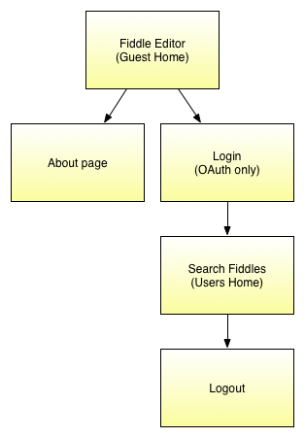

Minor changes will apply between guest and registered users within the twig fiddle editor, they will be detailed below.

# Fiddle Editor

The fiddle editor can be reached by those ways:

- by getting directly to the homepage without being logged in ( http://twigfiddle.com )

- by opening an existing fiddle ( http://twigfiddle.com/some_hash )

- by clicking « New fiddle » when users are registered

Please note that those mockups are samples to show features, web designer can dispose them with a better eye (see jsfiddle.net and sqlfiddle.com for example).

## Guest users editor

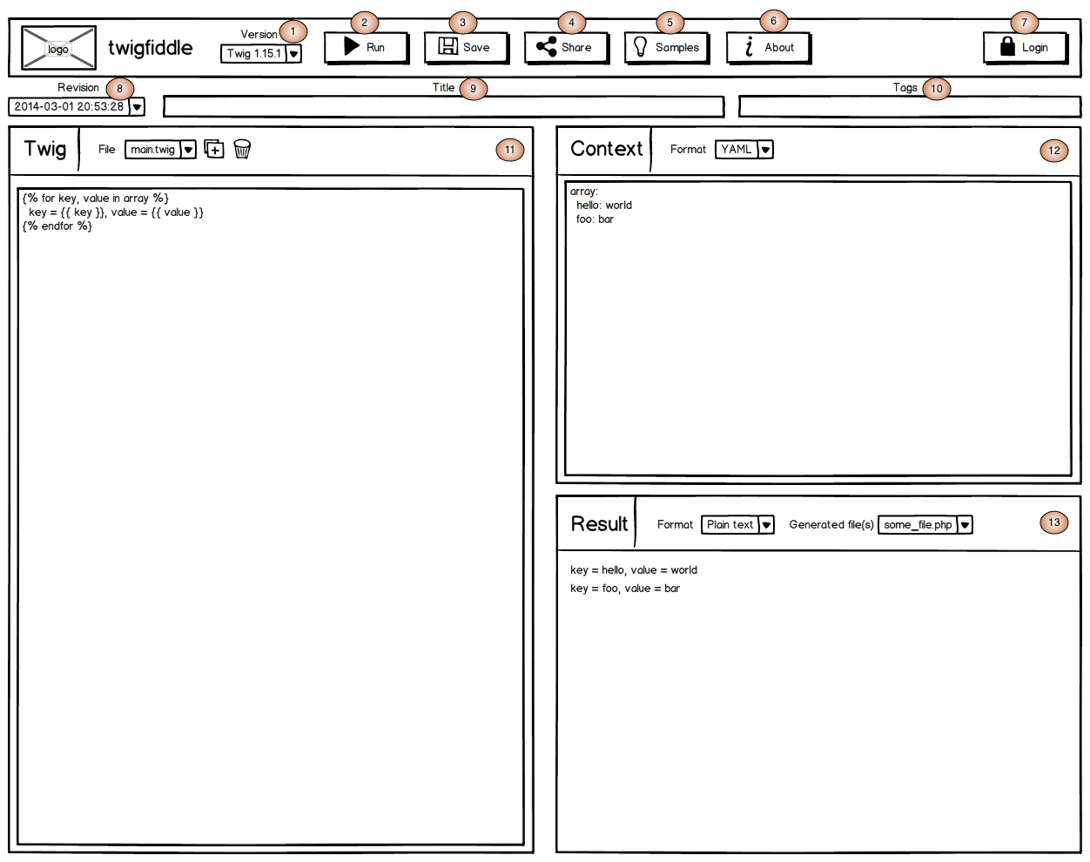

## Registered users editor

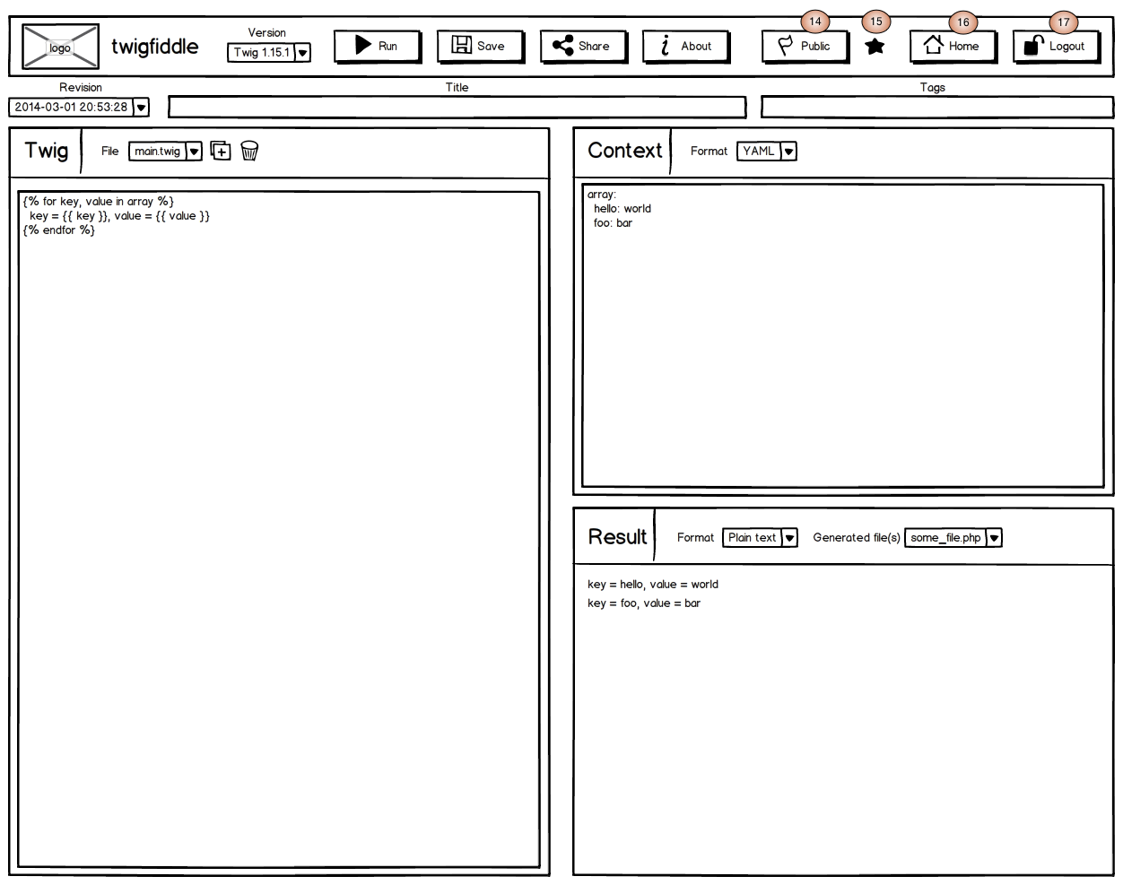

## Editor features description

### Twig version

Twigfiddle targets all twig users, so it should allow writing twig code whatever the twig version required.

### Run button

The “run” button should take all information provided in the editor and generate the result.

* During business, the whole editor should be locked, and a wait gif should be displayed in the middle of the screen.
* If there are “too many” clicks (such as, 3 runs in 10 secs), users will need to fill a captcha, displayed in a modal.

### Save button

The “save” button will save the editor content for future use.

* if the fiddle has not been saved yet, a new unique hash (8 chars randomly taken in a-zA-Z9-9) should be created and will identify the fiddle. It will be available at http://twigfiddle.com/<hash>
* If the fiddle has already been saved, a new revision of the fiddle will be saved (see annot. 8). It will be available at http://twigfiddle.com/<hash>/<revision_number>.

### Share button

The “Share” button will display a modal where the link is displayed, already selected and ready to be copied in the clipboard. We can also add a “Copy to clipboard” button for those who are used to click.

### Samples menu

The “Samples” menu should contain a bunch of existing fiddle links (from the simplest to the hardest, at the developer’s discretion). When clicking them, fiddles will be opened in a new tab. Simple, and enough.

### About button

The “About” button is a simple link that opens the “About” page. This page is detailed later in this documentation.

### Login menu (guest users only)

The login menu provides all ways to login.

We will use OAuth authorization protocol to login using Sensiolabs Connect, Google, Facebook and Twitter accounts. The menu will look like:



We will not create our own login system, this is useless for this website.

### Fiddle revision

A new revision of a fiddle is created each time this fiddle is saved. So, the first revision 0 (invisible in URLs) is created when “Save” button is clicked for the first time, and then revision 1, and so on. This dropdown menu allows switching between revisions of a fiddle.

### Fiddle title

Fiddle titles are optional and are mainly used when a user wants to put a fiddle into his favorites (see the Search Fiddle page below in the documentation). This is clearer to search and to display a title than a hash!.

### Fiddle tags

Favorite fiddles (see the Search Fiddles page below in the documentation) can be browsed using a search form, or using tags, about the same way (ok, less powerful ^^) as stackoverflow.com.

For example, if a registered user created some code generator, he will tag it specifically to find it quickly when needed.

This tags field will contain a comma-separated string, such as “php,generator,symfony2”, using this kind of UI: http://xoxco.com/projects/code/tagsinput/ (see below).



### Twig code pane

Twig language allows to include, extends, import… other twig files, so the twig pane should manage more than one file.

* A dropdown menu should allow to switch between all twig files; the main file should be displayed red (or at least, highlighted whatever the way) in this dropdown.
* A “add” button should allow to add a file (a modal asks for the file name, automatically suffixed by .twig).
* A “delete” button should allow to delete a file (the main file can’t be deleted).
* A “Set as main file” tick should allow to set the selected twig file as main (the one that is generated first). This tick can’t be unticked.
* The twig code area should be syntax-hlighighted (jinja2 mode in Codemirror, http://codemirror.net/mode/jinja2/)

There will be limitations in the number of files per fiddle, and the size per file.

### Context pane

The context contains all objects to give to the twig template, the “bodies that need dressing”.

* We need a format dropdown, because those objects can be given in several formats: we will first implement YAML, XML, JSON, INI and key/value pairs.
* The code area will be color-highlighted using the right mode corresponding to the selected file format.

There will be limitations in the size of the fiddle’s context.

### Result pane

Processing the twig code and its context can do 2 things:

* Generate a beautiful exception if something went wrong during the twig code execution.
* Create a result file, and one or several PHP templates resulting from the twig compilation. This is useful to access those generated PHP files to understand Twig’s internal behavior.

The result pane contains 2 dropdown menus, disabled if there were an exception during the code execution.

* The way to display the result:
  + As plain text (Twig does not necessarily generate web pages)
  + As HTML, only for the result, (iframed into another domain for security)
* The generated files:
  + The result (rendered twig file with its context)
  + The generated PHP template file(s)

### Fiddle’s visibility (registered users only)

This drop down menu let registered users choose their fiddle’s visibility, public or private.

* Visibility applies to a fiddle’s revision and not an entire fiddle.
* Users can only change visibility on a fiddle’s revision they own (so they need to save a fiddle once without changes to own it, and then they can put it private.
* Private fiddles are only available by the user who own it, in the search results, but also by direct access ( http://twigfiddle.com/(hash) )

### Favorite fiddle icon (registered users only)

I will personally use twigfiddle as a generator (I’ll just change the context and copy/paste some redundant stuffs). So, that will be a good thing to allow registered users to be able to save their favorite fiddles.

This icon will look like something like this:

-  for a non-favorite fiddle

-  for a favorite fiddle

### Home button (registered users only)

This is a simple link that points to the “Search Fiddles” page, which is registered user’s homepage. See the “Search Fiddles” page documentation below.

### Logout button (registered users only)

This classic button logs identified users out.

# About page

This is a static page describing what is twigfiddle, how to use it, who did it and with which technologies. To be clear, this page will be inspired from the great Jake Feasel SQLFiddle’s about page (http://sqlfiddle.com/about.html).

# Search Fiddles page

The Search Fiddles page allows registered users to search existing fiddles, and moreover search among those they marked as favorite.

## Layout

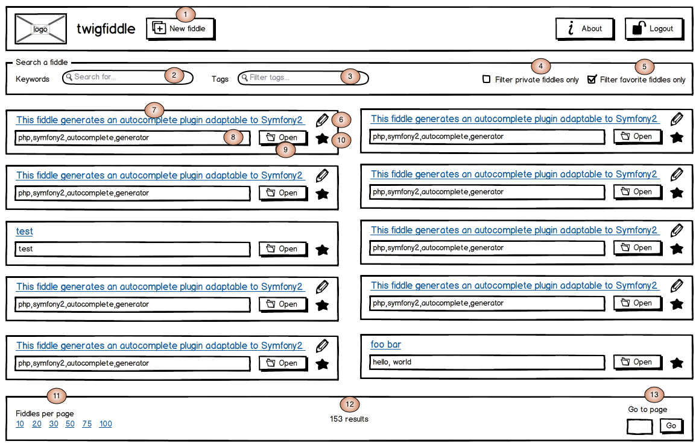

## Features description

### New fiddle button

This link put user to the classic fiddle editor, in « creation mode » (no hash given, as if a guest user reached http://www.twigfiddle.com without any hash).

### Keyword search input

This search input let users search keywords in fiddle titles.

Search rules:

* searched keywords will match as soon as they are contained in words. For example, “apple” will also match “apples” and “napples”.
* If several words are given, titles should match all words. For example, « this apple » will match « this is an apple » and « this stuff contains apples ».

Note that all search filters (keywords, tags…) are cumulative.

### Tag filter input

Tags are a cool way to browse content efficiently.

Tag filter rules:

* tags are case insensitive
* if one tag is entered, result should contain fiddles tagged at least by this tag
* if several tags are entered, result should contain fiddles tagged at least by all given tags.

Note that all search filters (keywords, tags…) are cumulative.

### Filter private fiddles only tic,

This tick (unchecked by default) let users search fiddles they marked as private.

Note that all search filters (keywords, tags…) are cumulative.

### Filter favorite fiddles only tick

This tick (checked by default) let users search fiddles they marked as favorites.

Note that all search filters (keywords, tags…) are cumulative.

### Edit fiddle’s tags and title

By default, titles and tags of resulting fiddles appear read-only. But, if user marked a fiddle as favorite, he can overwrite fiddle’s title and tags.

When clicking this icon, title and tags becomes writeable, and the icon changes to something such as a save icon, that saves changes and put the fiddle back to read-only with the overridden names.

### Fiddle title

This is one fiddle’s title, among fiddles found using the search criteria. This title is a link that sends users to the fiddle editor.

As registered users can rename their favorite fiddles, the title displayed can be:

* the one chosen by the registered user who favored this fiddle
* the one chosen by the fiddle creator:
  + if the fiddle is not favored
  + if the fiddle’s title has not been changed

### Fiddle tags

By default, non-filtered tags are clickable: when clicking a tag, it is automatically added to the “Filter tag” and the search becomes instantly thinner.

Tags are not clickable anymore in “edition mode” (see 5. above).

### Open fiddle

This button does the exact same as clicking on the title’s link: it opens the editor, preloaded for that fiddle, the same way as if an user accessed “http://twigfiddle.com/(hash)/(version)” directly.

### Favorite icon

This button let users put or remove a fiddle in their favorite fiddles.

This icon will look like something like this:

-  for a non-favorite fiddle

-  for a favorite fiddle

Note: if users overwritten original fiddle’s title or tags, those changes are lost.

### Fiddles per page

This filter is a classic on paginations. Preferences should be stored so users don’t need to set them each time.

### Total number of results

Total number of fiddles that matched all cumulated criterias.

### Go to page

This filter is a classic on paginations. Preferences should be stored so users don’t need to set them each time.