Experiment 8

Student Name: DIWANSH UID: 24BAI70294
Branch: CSE - AIML Section/Group: 24AIT_KRG 1B
Semester: 5 Date of Performance: 7/9/26
Subject Name: ADBMS Subject Code: 24CSP-310

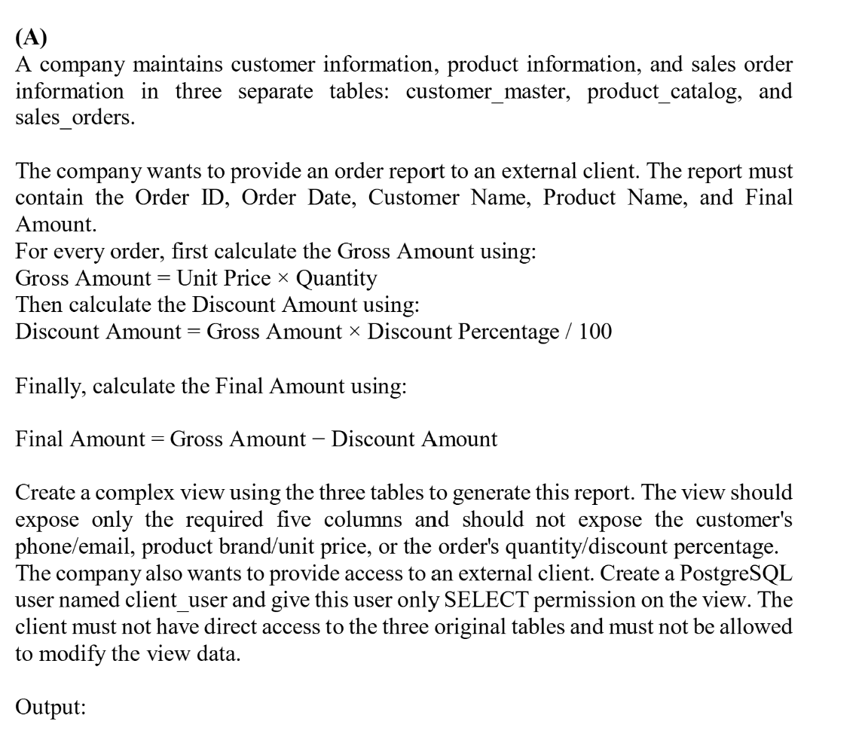

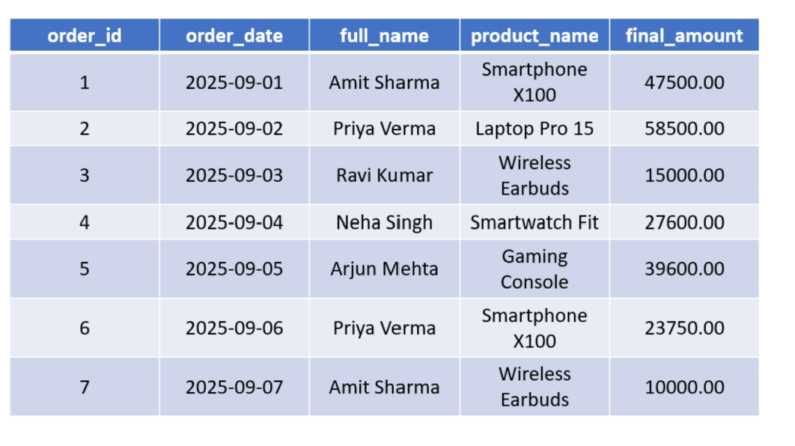

SOLUTION-

CREATE OR REPLACE VIEW VW_FINAL_AMOUNT_CALCULATION AS
SELECT
O.ORDER_ID,
O.ORDER_DATE,
C.FULL_NAME,
P.PRODUCT_NAME,
ROUND(
(P.UNIT_PRICE * O.QUANTITY)
- (P.UNIT_PRICE * O.QUANTITY * O.DISCOUNT_PERCENT / 100.0),
2
) AS FINAL_AMOUNT
FROM SALES_ORDERS AS O
JOIN PRODUCT_CATALOG AS P
ON O.PRODUCT_ID = P.PRODUCT_ID
JOIN CUSTOMER_MASTER AS C
ON O.CUSTOMER_ID = C.CUSTOMER_ID;

SELECT * FROM VW_FINAL_AMOUNT_CALCULATION;

CREATE USER CLIENT_1234
PASSWORD '12345';

GRANT SELECT
ON VW_FINAL_AMOUNT_CALCULATION
TO CLIENT_1234;

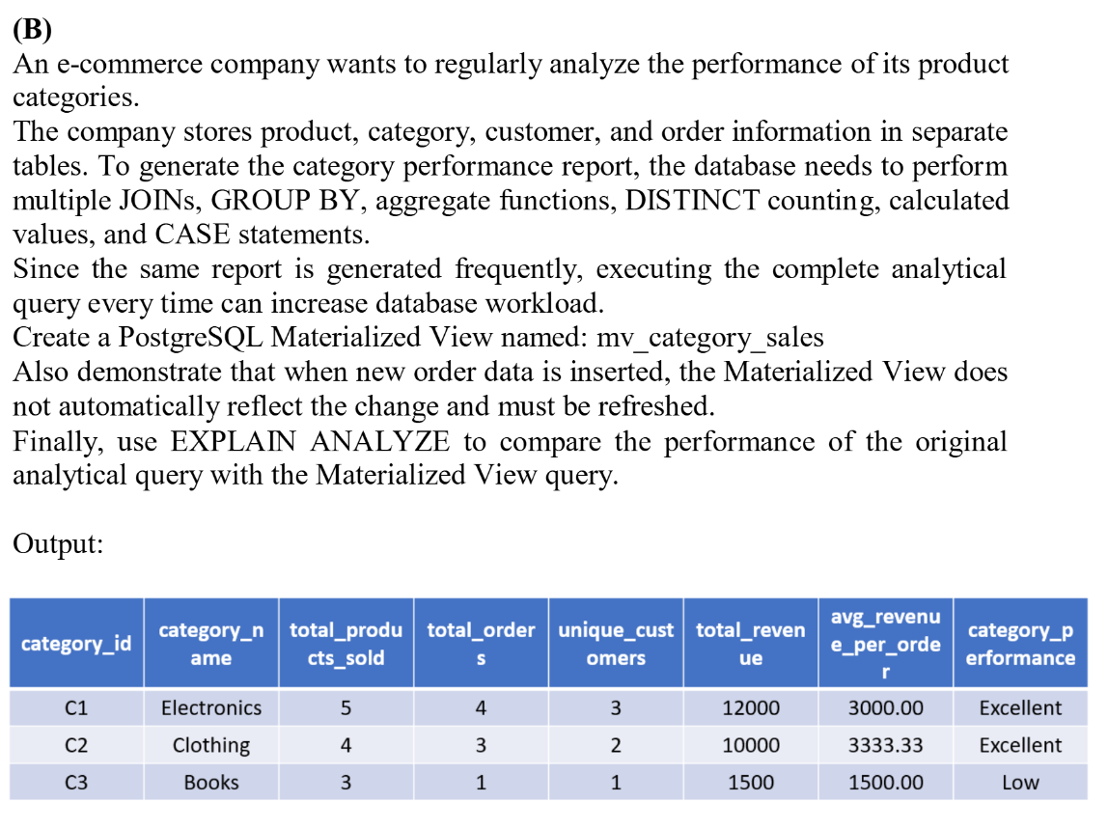

SOLUTION-

EXPLAIN ANALYZE
SELECT
CAT.CATEGORY_ID,
CAT.CATEGORY_NAME,
SUM(O.QUANTITY) AS TOTAL_PRODUCTS_SOLD,
COUNT(DISTINCT O.ORDER_ID) AS TOTAL_ORDERS,
COUNT(DISTINCT O.CUSTOMER_ID) AS UNIQUE_CUSTOMERS,
SUM(O.QUANTITY * O.UNIT_PRICE) AS TOTAL_REVENUE,
ROUND(
SUM(O.QUANTITY * O.UNIT_PRICE) /
COUNT(DISTINCT O.ORDER_ID),
2
) AS AVERAGE_REVENUE_PER_ORDER,
CASE
WHEN SUM(O.QUANTITY * O.UNIT_PRICE) >= 10000 THEN 'EXCELLENT'
WHEN SUM(O.QUANTITY * O.UNIT_PRICE) >= 6000 THEN 'GOOD'
WHEN SUM(O.QUANTITY * O.UNIT_PRICE) >= 3000 THEN 'AVERAGE'
ELSE 'LOW'
END AS CATEGORY_PERFORMANCE
FROM ORDER_DETAILS AS O
JOIN PRODUCT_MASTER AS P
ON O.PRODUCT_ID = P.PRODUCT_ID
JOIN CATEGORY_MASTER AS CAT
ON P.CATEGORY_ID = CAT.CATEGORY_ID
GROUP BY
CAT.CATEGORY_ID,
CAT.CATEGORY_NAME;

CREATE MATERIALIZED VIEW MV_CATEGORY_SALES AS
SELECT
CAT.CATEGORY_ID,
CAT.CATEGORY_NAME,
SUM(O.QUANTITY) AS TOTAL_PRODUCTS_SOLD,
COUNT(DISTINCT O.ORDER_ID) AS TOTAL_ORDERS,
COUNT(DISTINCT O.CUSTOMER_ID) AS UNIQUE_CUSTOMERS,
SUM(O.QUANTITY * O.UNIT_PRICE) AS TOTAL_REVENUE,
ROUND(
SUM(O.QUANTITY * O.UNIT_PRICE) /
COUNT(DISTINCT O.ORDER_ID),
2
) AS AVERAGE_REVENUE_PER_ORDER,
CASE
WHEN SUM(O.QUANTITY * O.UNIT_PRICE) >= 10000 THEN 'EXCELLENT'
WHEN SUM(O.QUANTITY * O.UNIT_PRICE) >= 6000 THEN 'GOOD'
WHEN SUM(O.QUANTITY * O.UNIT_PRICE) >= 3000 THEN 'AVERAGE'
ELSE 'LOW'
END AS CATEGORY_PERFORMANCE
FROM ORDER_DETAILS AS O
JOIN PRODUCT_MASTER AS P
ON O.PRODUCT_ID = P.PRODUCT_ID
JOIN CATEGORY_MASTER AS CAT
ON P.CATEGORY_ID = CAT.CATEGORY_ID
GROUP BY
CAT.CATEGORY_ID,
CAT.CATEGORY_NAME;

EXPLAIN ANALYZE
SELECT * FROM MV_CATEGORY_SALES;

REFRESH MATERIALIZED VIEW MV_CATEGORY_SALES;

