LAB MST

Student Name: DIWANSH UID: 24BAI70294
Branch: CSE - AIML Section/Group: 24AIT_KRG 1B
Semester: 5 Date of Performance: 28/9/26
Subject Name: ADBMS Subject Code: 24CSP-310

Q1

SELECT d.dept_name as Department , e.emp_name as Employee ,e.salary as Salary
FROM employee as e
JOIN department as d
ON e.dept_id=d.dept_id
WHERE salary>
(
SELECT avg(e1.salary)
FROM employee as e1
WHERE e1.dept_id=e.dept_id
)
AND e.dept_id IN (
SELECT dept_id
FROM employee
GROUP BY dept_id
HAVING COUNT(*) >= 3
);

OUTPUT

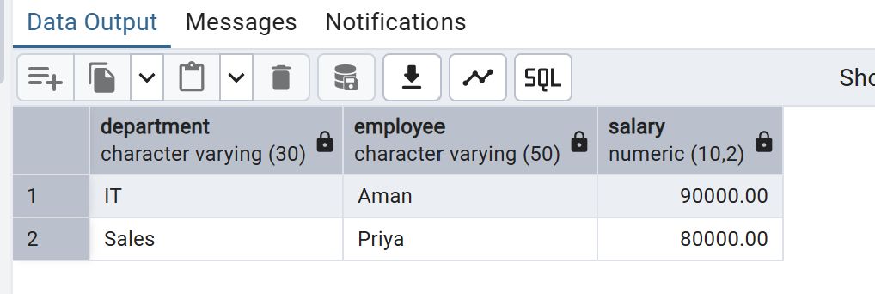

Q2

CREATE OR REPLACE FUNCTION log_customer_action()
RETURNS TRIGGER AS $$
BEGIN
IF (TG_OP = 'INSERT') THEN
INSERT INTO customer_audit (customer_id, customer_name, action, action_time)
VALUES (NEW.customer_id, NEW.customer_name, 'ADDED', CURRENT_TIMESTAMP);
RETURN NEW;
ELSIF (TG_OP = 'DELETE') THEN
INSERT INTO customer_audit (customer_id, customer_name, action, action_time)
VALUES (OLD.customer_id, OLD.customer_name, 'REMOVED', CURRENT_TIMESTAMP);
RETURN OLD;
END IF;
RETURN NULL;
END;
$$ LANGUAGE plpgsql;

CREATE TRIGGER customer_audit_trigger
AFTER INSERT OR DELETE ON bank_customer
FOR EACH ROW
EXECUTE FUNCTION log_customer_action();

INSERT INTO bank_customer (customer_id, customer_name, balance)
VALUES (3, 'Aman', 60000);

DELETE FROM bank_customer
WHERE customer_id = 1;

SELECT * FROM customer_audit;

OUTPUT

