Experiment 8

Student Name: Diwansh UID: 24BAI70294
Branch: CSE - AIML Section/Group: 24AIT_KRG G1
Semester: 4 Date of Performance: 27/3/26
Subject Name: DBMS Subject Code: 24CSH-298

Aim
To understand the design and implementation of stored procedures in PL/pgSQL (PostgreSQL), focusing on the use of parameter modes (IN, OUT, INOUT) to process employee data, encapsulate business logic, and return results efficiently.

Software Requirements
- Database Management System:
  - PostgreSQL
- Client Tool:
  - pgAdmin

Objectives
- To create and execute a parameterized stored procedure that counts employees based on gender.
- To demonstrate the use of IN, OUT, and INOUT parameters.
- To execute the procedure using an anonymous DO block.
- To display results using RAISE NOTICE.

Practical / Experiment Steps
- Table Creation: Created an employees table with appropriate data types and primary key.
- Data Insertion: Inserted sample employee records with different genders and salaries.
- Procedure Creation: Developed a stored procedure get_employee_count_by_gender.
- Parameter Usage:
  - IN → accepts gender input
  - OUT → returns employee count
  - INOUT → tracks execution status
- Query Logic: Used SELECT COUNT(*) INTO to store result in output variable.
- Anonymous Block: Used a DO block to call the procedure and print results.

Procedure
- Connected to PostgreSQL database using pgAdmin.
- Created the employees table with columns: emp_id, emp_name, gender, and salary.
- Inserted sample records into the table.
- Defined the procedure with proper parameter modes (IN, OUT, INOUT).
- Implemented logic to count employees based on gender.
- Updated the STATUS variable to 'SUCCESS' inside the procedure.
- Declared variables in an anonymous block (GEN, COUNT_OF_EMPLOYEES, STATUS).
- Called the procedure using the CALL statement.
- Displayed results using RAISE NOTICE.
- Verified correctness by comparing with table data.

Input/Output Analysis
SQL Input Queries

CREATE TABLE EMPLOYEES(
emp_id INT PRIMARY KEY,
emp_name VARCHAR(20),
gender VARCHAR(20),
salary NUMERIC(10, 2)
);

Output

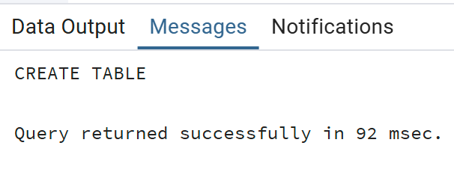

SQL Input Queries
INSERT INTO employees (emp_id, emp_name, gender, salary) VALUES
(101, 'Amit', 'Male', 30000),
(102, 'Sarah', 'Female', 55000),
(103, 'Riya', 'Female', 45000),
(104, 'Arjun', 'Male', 59000),
(105, 'Anjali', 'Female', 66000);

Output
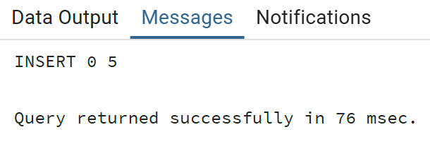

SQL Input Queries
CREATE OR REPLACE PROCEDURE get_employee_count_by_gender (
IN IN_GENDER VARCHAR(20),
OUT OUT_COUNT INT,
INOUT STATUS VARCHAR(20)
)
AS
$$
BEGIN
SELECT COUNT(*) INTO OUT_COUNT
FROM employees
WHERE gender = IN_GENDER;

STATUS := 'SUCCESS';
END;
$$ LANGUAGE PLPGSQL;

Output
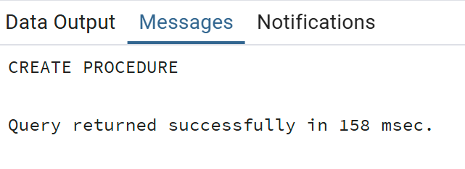

SQL Input Queries
DO
$$
DECLARE
GEN VARCHAR(20):='Female';
COUNT_OF_EMPLOYEES INT;
STATUS VARCHAR(20):='PENDING';

BEGIN
CALL get_employee_count_by_gender(GEN, COUNT_OF_EMPLOYEES, STATUS);

RAISE NOTICE 'COUNT OF % EMPLOYEES IS % AND STATUS IS %',
GEN, COUNT_OF_EMPLOYEES, STATUS;
END;
$$;

Output
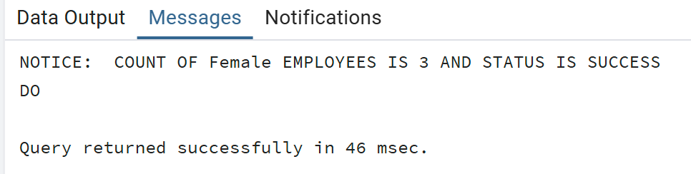

Learning Outcomes
- Understood how to encapsulate SQL logic into reusable procedures to improve code maintainability.
- Gained expertise in using IN, OUT, and INOUT modes to pass data into and retrieve results from stored subprograms.
- Learned to bridge SQL aggregate functions with PL/SQL variables using the INTO keyword.
- Developed skills in using status flags and notice alerts to track the success and results of procedural calls.

