Experiment 3

Student Name: Diwansh UID: 24BAI70294
Branch: CSE - AIML Section/Group: 24AIT_KRG G1
Semester: 4 Date of Performance: 28/1/26
Subject Name: DBMS Subject Code: 24CSH-298

AIM:
To understand the basic structure of a PL/SQL program by creating and executing a simple PL/SQL block that includes declaration and execution sections, performs calculations, and uses conditional statements to make decisions.

OBJECTIVES:
● To create a simple PL/SQL program demonstrating Declaration Section and Execution Section.
● To understand the use of conditional statements (IF–ELSE) in PL/SQL for decision-making operations.
● To perform salary-based calculations inside a PL/SQL block.

SOFTWARE REQUIREMENTS:
• Oracle FreeSQL

PRACTICAL / EXPERIMENT STEPS:
- The PL/SQL block is started using the DECLARE keyword to define required variables.
- Variables such as worker ID, worker name, and basic pay are declared with appropriate data types and initialized with values.
- A variable for House Rent Allowance (HRA) is declared to store the calculated value.
- Worker details like ID, name, and basic pay are displayed using the DBMS_OUTPUT.PUT_LINE procedure.
- HRA is calculated as 40% of the basic pay.
- An IF–ELSE conditional statement is used to check whether tax is applicable.
- If the basic pay is greater than 60000, tax is applicable; otherwise, it is not.
- The calculated HRA and tax status are displayed as output.
- The PL/SQL block ends successfully after execution.

PROCEDURE:
- Start the Oracle FreeSQL environment.
- Write the code to declare the required variables.
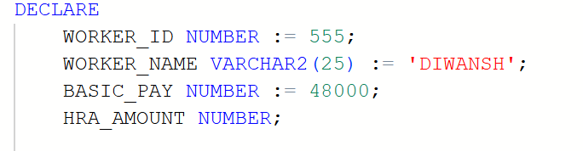

- Inside the BEGIN block, write the code to calculate HRA.
- Display the worker details using DBMS_OUTPUT.PUT_LINE.
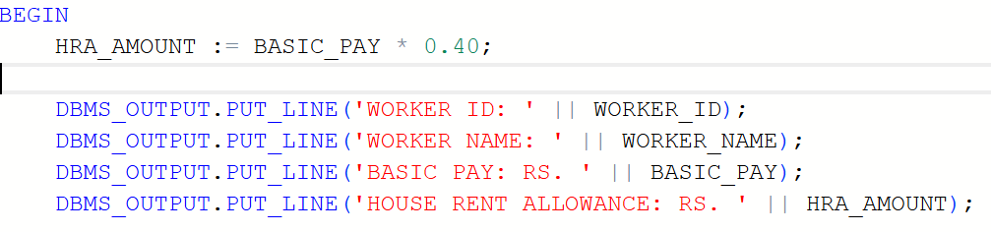
- Use the IF–ELSE statement to check tax applicability based on basic pay.
- Display the HRA and tax message.
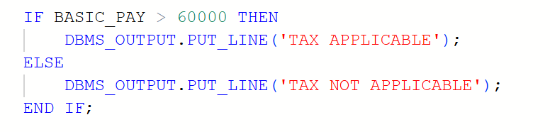
- End the PL/SQL block using the END; statement and execute the program.
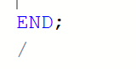
- Verify the output displayed on the screen.

CODE:

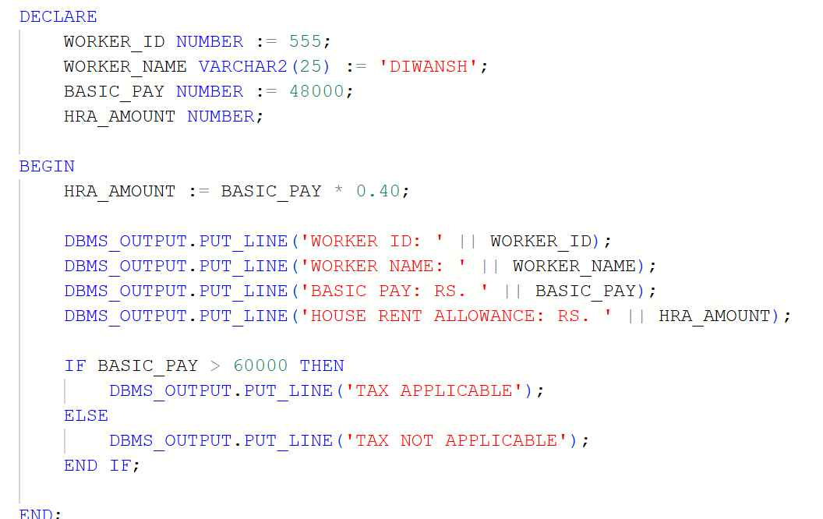

I/O ANALYSIS:
This PL/SQL program demonstrates the basic structure of a PL/SQL block. It declares variables for worker details in the DECLARE section and performs HRA calculation in the BEGIN section. The program calculates House Rent Allowance as 40% of basic pay and checks tax applicability using an IF–ELSE condition. Finally, it displays worker ID, name, basic pay, HRA amount, and tax status using DBMS_OUTPUT.PUT_LINE.
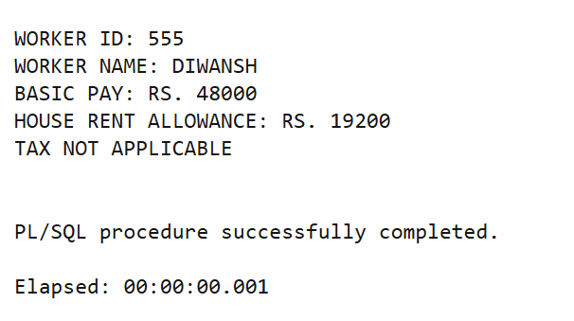

LEARNING OUTCOMES:
- Understand the basic structure of a PL/SQL block, including Declaration and Execution sections.
- Gain hands-on experience in declaring variables and performing calculations in PL/SQL.
- Learn to use conditional statements (IF–ELSE) for decision-making.
- Learn to display output using built-in PL/SQL procedures like DBMS_OUTPUT.PUT_LINE.

