Experiment 10

Student Name: Diwansh  UID: 24BAI70294  Branch: CSE - AIML  Section/Group: 24AIT_KRG G1 | Semester: 4  Date of Performance: 24/4/26  Subject Name: DBMS  Subject Code: 24CSH-298
AIM
To design a trigger in Oracle Database Express Edition that automatically generates primary key values using a sequence, ensuring unique identification of student records without manual intervention.

Software Requirements
Database Management System:
- Oracle Database Express Edition
- PostgreSQL
Database Administration Tool / Client Tool:
- Oracle SQL Developer (for Oracle XE)
- pgAdmin (for PostgreSQL)

Objectives
- To create a trigger that automatically generates unique primary key values.
- To use a sequence for reliable and sequential ID generation.
- To eliminate manual assignment of primary keys.
- To demonstrate trigger-based automation in database systems.

Problem Statement
In database systems, primary keys must be unique for each record. Manual entry of IDs can lead to duplication or errors.
Design a trigger that:
- Automatically generates a primary key (student_id) during insertion.
- Uses a sequence to ensure uniqueness.
- Demonstrates automated key generation functionality.

Practical / Experiment Steps
- Table Setup: Created the student table with student_id as the primary key.
- Sequence Creation: Created student_seq starting from 100 for generating unique IDs.
- Trigger Design: Designed a BEFORE INSERT trigger student_trigger.
- Auto-Key Assignment: Implemented logic to assign student_seq.NEXTVAL to :NEW.student_id if it is NULL.
- Insertion Testing: Inserted multiple records without specifying student_id.
- Output Verification: Verified that IDs are generated automatically and sequentially.

Procedure
- Connected to Oracle environment using SQL Developer.
- Created the student table with columns: student_id, name, and marks.
- Created a sequence student_seq starting from 100.
- Created a trigger student_trigger to auto-generate primary key values.
- Inserted records without providing student_id.
- Executed a SELECT query to verify automatic ID generation.

Input / Output Analysis
SQL Query: Table Creation
CREATE TABLE student (
student_id INT PRIMARY KEY,
name VARCHAR(50),
marks INT
);


SQL Query: Sequence Creation
CREATE SEQUENCE student_seq
START WITH 100
INCREMENT BY 1;


SQL Query: Trigger Creation
CREATE OR REPLACE TRIGGER student_trigger
BEFORE INSERT ON student
FOR EACH ROW
BEGIN
IF :NEW.student_id IS NULL THEN
SELECT student_seq.NEXTVAL INTO :NEW.student_id FROM dual;
END IF;
END;
/


SQL Query: Data Insertion
INSERT INTO student (name, marks) VALUES ('Riya', 85);
INSERT INTO student (name, marks) VALUES ('Karan', 78);
INSERT INTO student (name, marks) VALUES ('Anjali', 92);
INSERT INTO student (name, marks) VALUES ('Vikram', 88);


SQL Query: Verification
SELECT * FROM student;

Output
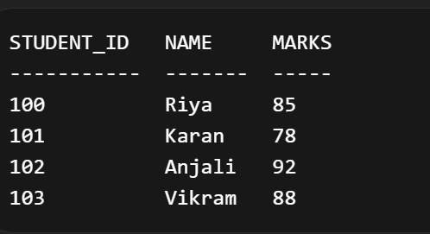

Learning Outcomes
- Understood the concept and working of database triggers.
- Learned how to automate primary key generation using sequences and triggers.
- Gained knowledge of ensuring data integrity without manual intervention.
- Developed skills in implementing real-world database automation techniques.

