Experiment 4

Student Name: Diwansh UID: 24BAI70294
Branch: CSE - AIML Section/Group: 24AIT_KRG G1
Semester: 4 Date of Performance: 4/2/26
Subject Name: DBMS Subject Code: 24CSH-298

Aim
To design and implement PL/SQL programs utilizing conditional control statements such as IF–ELSE, IF–ELSIF–ELSE, ELSIF ladder, and CASE constructs to control execution flow based on logical conditions and analyze decision-making capabilities in PL/SQL blocks.

Software Requirements
Database Management System: PostgreSQL
Database Administration Tool: pgAdmin

Objectives
• Implement control structures in PL/SQL blocks.
• Understand how conditional statements guide execution flow.

Problem Statement
Develop and execute PL/SQL programs demonstrating IF–ELSE, IF–ELSIF–ELSE, ELSIF ladder, and CASE statements to illustrate decision-making.

1. Problem Statement – IF–ELSE Statement
Write a PL/SQL program to determine whether a given day number represents a weekday or weekend using the IF–ELSE statement and display an appropriate message.

2. Problem Statement – IF–ELSIF–ELSE Statement
Write a PL/SQL program to check whether a number is positive, negative, or zero using IF–ELSIF–ELSE and display the result.

3. Problem Statement – ELSIF Ladder
Write a PL/SQL program to determine the category of a person based on age using an ELSIF ladder and display the appropriate category.

4. Problem Statement – CASE Statement
Write a PL/SQL program to determine the season based on a given month number using the CASE conditional statement.

Practical / Experiment Steps
• Designed multiple PL/SQL blocks to explore diverse conditional logic formats, including simple branching and multi-path evaluation.
• Utilised IF–ELSE to classify days as weekday or weekend.
• Applied IF–ELSIF–ELSE to categorize numbers as positive, negative, or zero.
• Used an ELSIF ladder to classify age groups into meaningful categories.
• Implemented the CASE statement to map month numbers to seasons efficiently.
• Integrated variable-driven output strings to provide real-time feedback.
• Validated the decision-making capabilities by testing different input values.

Procedure
• Enabled the server output environment to ensure results were visible.
• Constructed an IF–ELSE block to check if a day number represents weekend or weekday.
• Developed an IF–ELSIF–ELSE block to identify whether a number is positive, negative, or zero.
• Expanded the logic into an ELSIF ladder to categorize age into Child, Teenager, Adult, and Senior Citizen.
• Implemented a CASE statement to convert month numbers into seasons.
• Initialised various test values for validation.
• Executed each block and observed the DBMS output console.
• Verified outputs with expected logical results.

1. Problem Statement – IF–ELSE Statement
Write a PL/SQL program to determine whether a given day is a weekday or weekend.
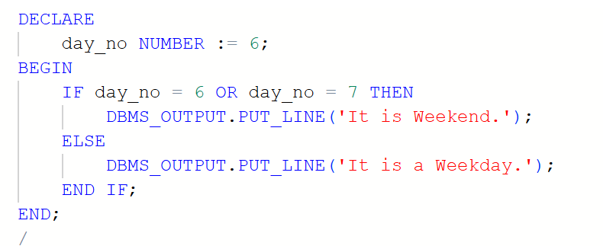Output:
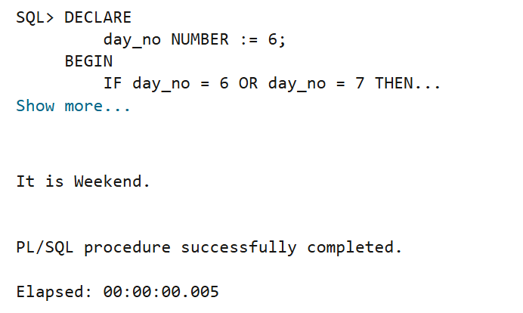

2. Problem Statement – IF–ELSIF–ELSE Statement
Write a PL/SQL program to check whether a number is positive, negative, or zero.
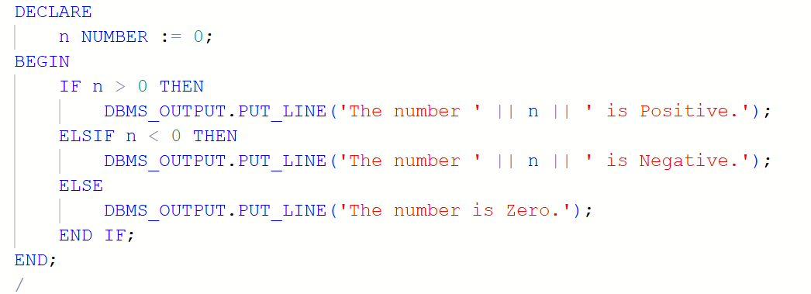Output:
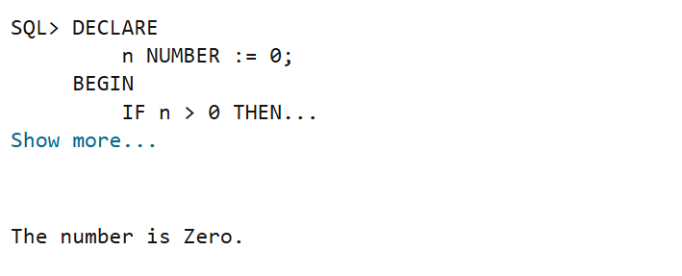

3. Problem Statement – ELSIF Ladder
Write a PL/SQL program to determine age category.
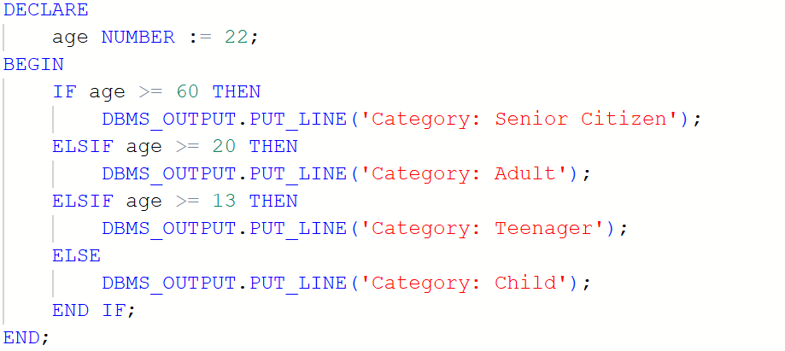Output:
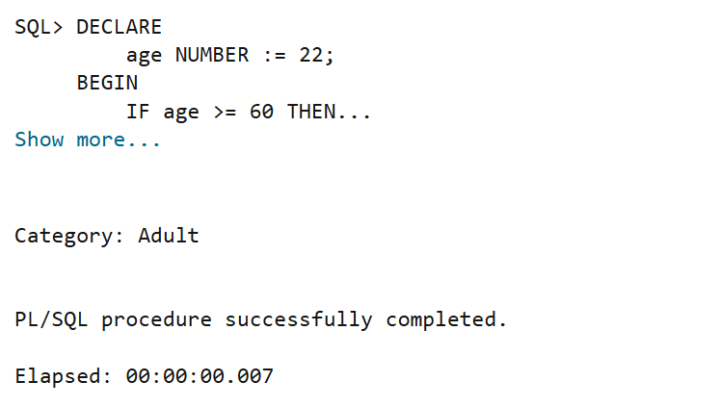

4. Problem Statement – CASE Statement
Write a PL/SQL program to determine season based on month number.
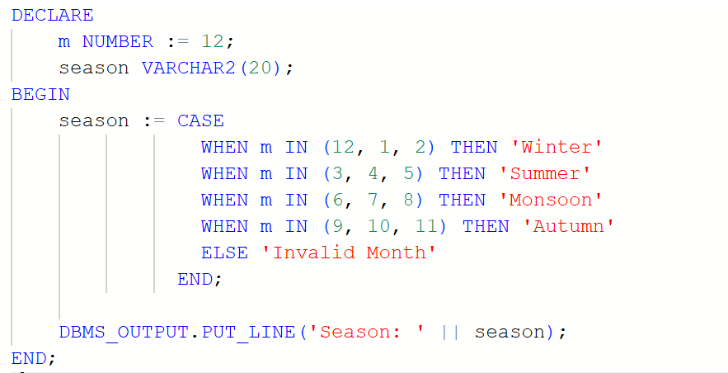Output:
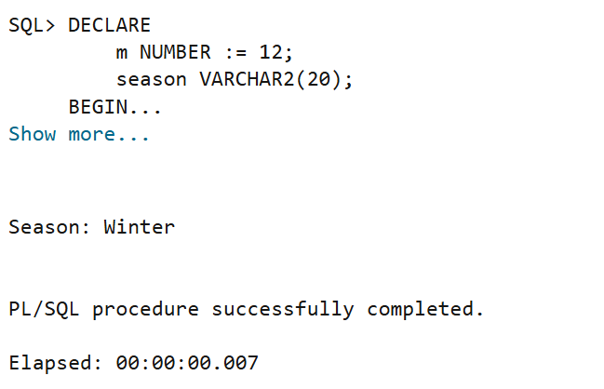

Learning Outcomes
• Learned to use IF–ELSE for binary decisions.
• Used IF–ELSIF–ELSE for multi-condition checks.
• Understood ELSIF ladder for range-based classification.
• Applied CASE for clean value mapping.

