Experiment 5

Student Name: Diwansh UID: 24BAI70294
Branch: CSE - AIML Section/Group: 24AIT_KRG G1
Semester: 4 Date of Performance: 11/3/26
Subject Name: DBMS Subject Code: 24CSH-298

Aim
To understand and apply conditional logic in SQL by using the modulus operator (%) to analyze employee salary values and classify them as Even Salary or Odd Salary using a CASE statement.

Software Requirements
Database Management System
- Oracle Database Express Edition (Oracle XE)
- PostgreSQL Database
Database Administration Tool / Client Tool
- Oracle SQL Developer (for Oracle XE)
- pgAdmin (for PostgreSQL)

Objectives
- To create an employees table in SQL.
- To insert employee records into the table.
- To use the modulus operator (%) to determine whether the salary is odd or even.
- To apply a CASE statement to display a new column indicating the salary type.

Practical / Experiment Steps
- Table Creation: Created the employees table with three attributes: emp_id, emp_name, and emp_sal. The emp_id column was defined as the Primary Key to uniquely identify each employee.
- Data Insertion: Inserted multiple employee records into the table with different salary values.
- Mathematical Operation: Used the modulus operator (%) on the emp_sal column to determine the remainder when divided by 2.
- Conditional Logic: Implemented a CASE statement to check whether the remainder is 0 or not.
- Classification: If the remainder is 0, the salary is classified as Even Salary; otherwise, it is classified as Odd Salary.
- Dynamic Column: Created a temporary column named salary_type in the query output to display the classification.

Procedure
- Open Oracle SQL Developer or pgAdmin.
- Create the employees table using the CREATE TABLE statement.
- Insert employee records using the INSERT INTO command.
- Write a SELECT query to retrieve all columns from the table.
- Apply the modulus operator (%) on the emp_sal column.
- Use a CASE statement to check if emp_sal % 2 = 0.
- Assign the label 'Even Salary' if the condition is true.
- Assign the label 'Odd Salary' if the condition is false.
- Execute the query and observe the output showing the salary_type column.

Input / Output Analysis
SQL Input Queries

CREATE TABLE employees(
emp_id INT PRIMARY KEY,
emp_name VARCHAR(20),
emp_sal INT
);

INSERT INTO employees VALUES(1, 'Aman', 11001);
INSERT INTO employees VALUES(2, 'Riya', 15000);
INSERT INTO employees VALUES(3, 'Karan', 12555);
INSERT INTO employees VALUES(4, 'Neha', 20000);
INSERT INTO employees VALUES(5, 'Arjun', 17531);

SELECT *,
CASE
WHEN emp_sal % 2 = 0 THEN 'Even Salary'
ELSE 'Odd Salary'
END AS salary_type

Output

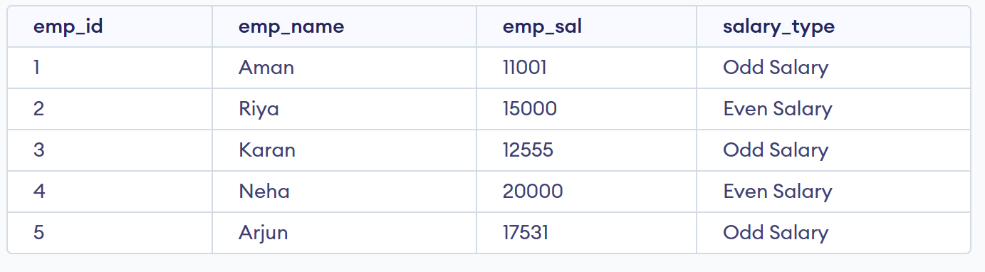

Learning Outcomes
- Learned how to create and populate a table in SQL.
- Understood how to use the modulus operator (%) for numerical analysis.
- Applied CASE statements to implement conditional logic in SQL queries.
- Generated a derived column (salary_type) to categorize employee salaries as odd or even.

