Experiment 6

Student Name: Diwansh UID: 24BAI70294
Branch: CSE - AIML Section/Group: 24AIT_KRG G1
Semester: 4 Date of Performance: 13/3/26
Subject Name: DBMS Subject Code: 24CSH-298

Aim
To understand the concept and working of cursors in PL/SQL for row-by-row data processing, and to analyse how implicit cursors, explicit cursors, and cursor attributes are used to implement business logic on multiple rows in a database table.

Software Requirements
• Database Management System:
o Oracle Database Express Edition (Oracle XE)
o PostgreSQL Database
• Database Administration Tool / Client Tool:
o Oracle SQL Developer (for Oracle XE)
o pgAdmin (for PostgreSQL)

Objectives
• To implement and analyse the use of implicit cursors, explicit cursors, and cursor attributes for processing multiple rows from a database table and applying business logic effectively.

Problem Statement
• In real-world applications, database queries often return multiple rows that need to be processed individually to apply specific business rules.

Practical/Experiment Steps
• Schema Provisioning: Created the Students table with attributes for student ID, name, course, and marks to simulate an academic database environment.
• Implicit Cursor Analysis: Implemented an anonymous PL/SQL block to perform a single-row UPDATE operation (increasing marks), utilizing the internal SQL cursor to monitor DML success.
• Explicit Cursor Design: Defined a named cursor (c_bca) to fetch records of students enrolled in the ‘BCA’ course for row-by-row processing.
• Attribute Integration: Used cursor attributes such as %FOUND, %NOTFOUND, %ROWCOUNT, and %ISOPEN to control execution flow.
• Business Logic Application: Applied logic to increase marks and display student-specific details, demonstrating how rules are applied to individual records.

Procedure
• Logged into the database and enabled SERVEROUTPUT to display results.
• Executed the CREATE TABLE and INSERT statements to create and populate the Students table.
• Ran a PL/SQL block using an implicit cursor to update marks of a specific student and verified using SQL%ROWCOUNT.
• Declared an explicit cursor to retrieve students belonging to the ‘BCA’ course.
• Opened the cursor and verified using %ISOPEN.
• Used a LOOP to fetch records into variables (v_name, v_course).
• Applied %NOTFOUND to terminate the loop after all rows were processed.
• Used %ROWCOUNT to display the number of records fetched.
• Closed the cursor and verified closure using NOT c_bca%ISOPEN.

Input/Output Analysis

SQL Input Queries

CREATE TABLE Students(
student_id NUMBER PRIMARY KEY,
name VARCHAR(20),
course VARCHAR(20),
marks NUMBER
);

Output
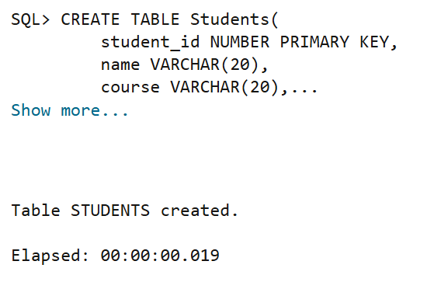

SQL Input Queries

INSERT INTO Students VALUES (1, 'Rahul', 'BCA', 70);
INSERT INTO Students VALUES (2, 'Anita', 'BBA', 65);
INSERT INTO Students VALUES (3, 'Karan', 'BCA', 80);
INSERT INTO Students VALUES (4, 'Neha', 'BBA', 75);
COMMIT;

Output
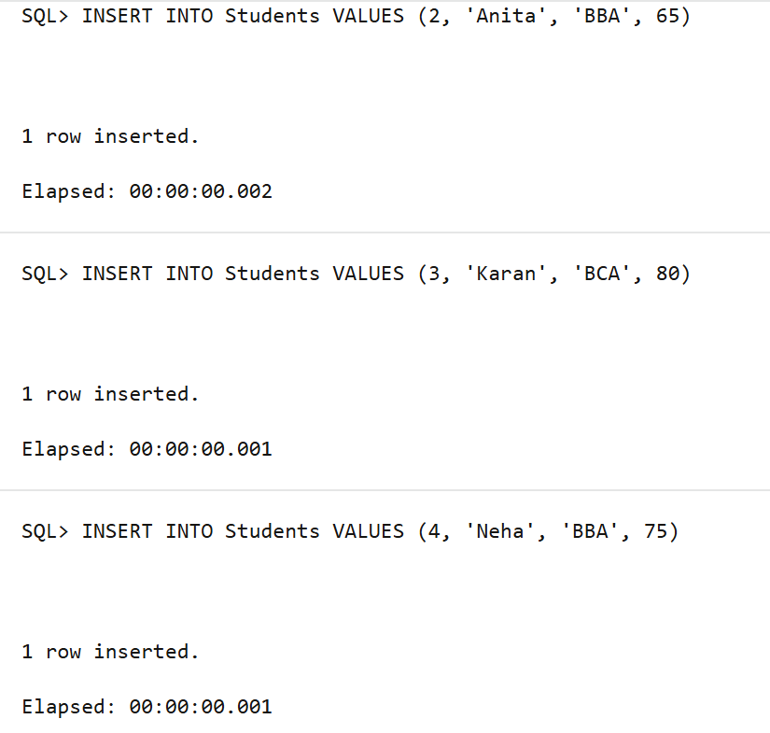

SQL Input Queries

SET SERVEROUTPUT ON;

DECLARE
v_target_id NUMBER := 1;

BEGIN
UPDATE Students
SET marks = marks * 1.05
WHERE student_id = v_target_id;

IF SQL%FOUND THEN
DBMS_OUTPUT.PUT_LINE('SQL%FOUND is TRUE');
DBMS_OUTPUT.PUT_LINE('Rows updated: ' || SQL%ROWCOUNT);
ELSE
DBMS_OUTPUT.PUT_LINE('No row updated');
END IF;

END;

Output
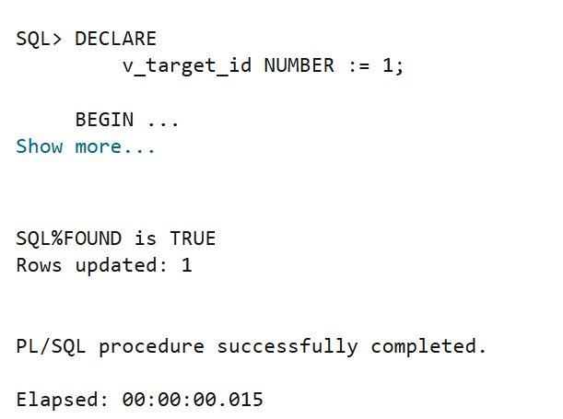

SQL Input Queries
DECLARE
CURSOR c_bca IS
SELECT name, course FROM Students WHERE course = 'BCA';

v_name Students.name%TYPE;
v_course Students.course%TYPE;

BEGIN

OPEN c_bca;

IF c_bca%ISOPEN THEN
DBMS_OUTPUT.PUT_LINE('Cursor is OPEN');
END IF;

LOOP
FETCH c_bca INTO v_name, v_course;

IF c_bca%NOTFOUND THEN
DBMS_OUTPUT.PUT_LINE('No more records');
EXIT;
END IF;

DBMS_OUTPUT.PUT_LINE('Student #' || c_bca%ROWCOUNT || ': '
|| v_name || ' | ' || v_course);

END LOOP;

CLOSE c_bca;

IF NOT c_bca%ISOPEN THEN
DBMS_OUTPUT.PUT_LINE('Cursor CLOSED successfully');
END IF;

END;

Output
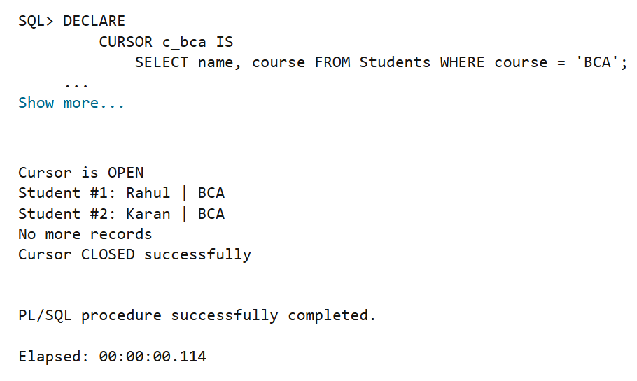

Learning Outcomes

• Gained understanding of implicit cursors used in DML operations.
• Learned how explicit cursors process multiple rows sequentially.
• Understood the use of %FOUND, %NOTFOUND, %ROWCOUNT, and %ISOPEN in controlling program flow.
• Learned the importance of OPEN, FETCH, and CLOSE operations for cursor management.
• Developed the ability to apply business logic to individual records in PL/SQL.

