**Advance Web Engineering**

Component -1

By Diwash Bhatta

# Development Choice –

Visual Studio Code

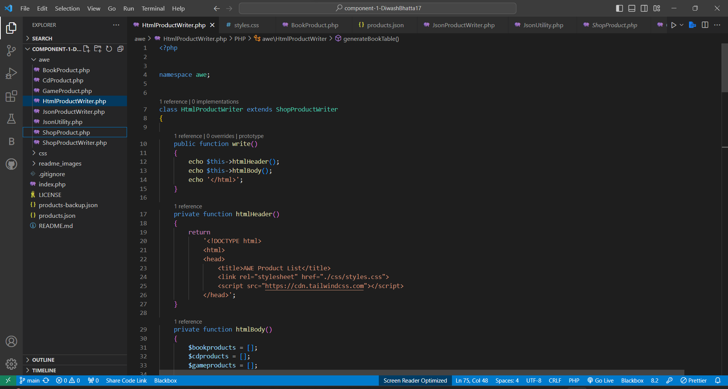

# PHP version used –

8.1.24

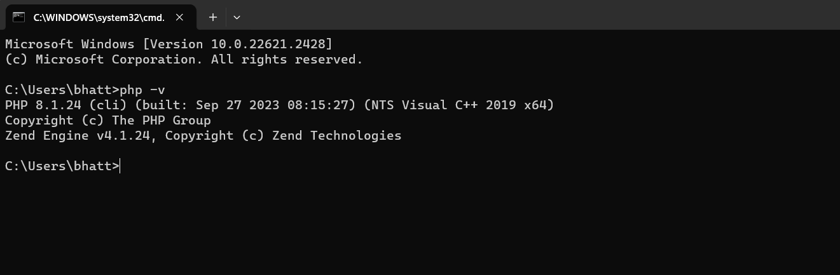

# GitHub Repository link –

Link - <https://github.com/tbc-bsc-l6/component-1-DiwashBhatta17.git>

# PHP Exercise Component 1 Completed ?

* Yes

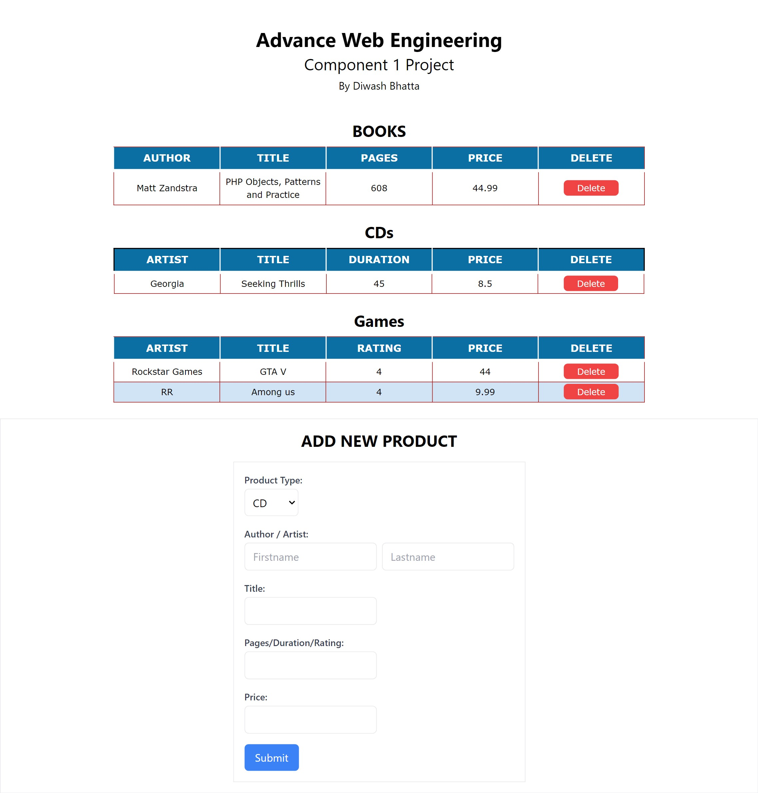

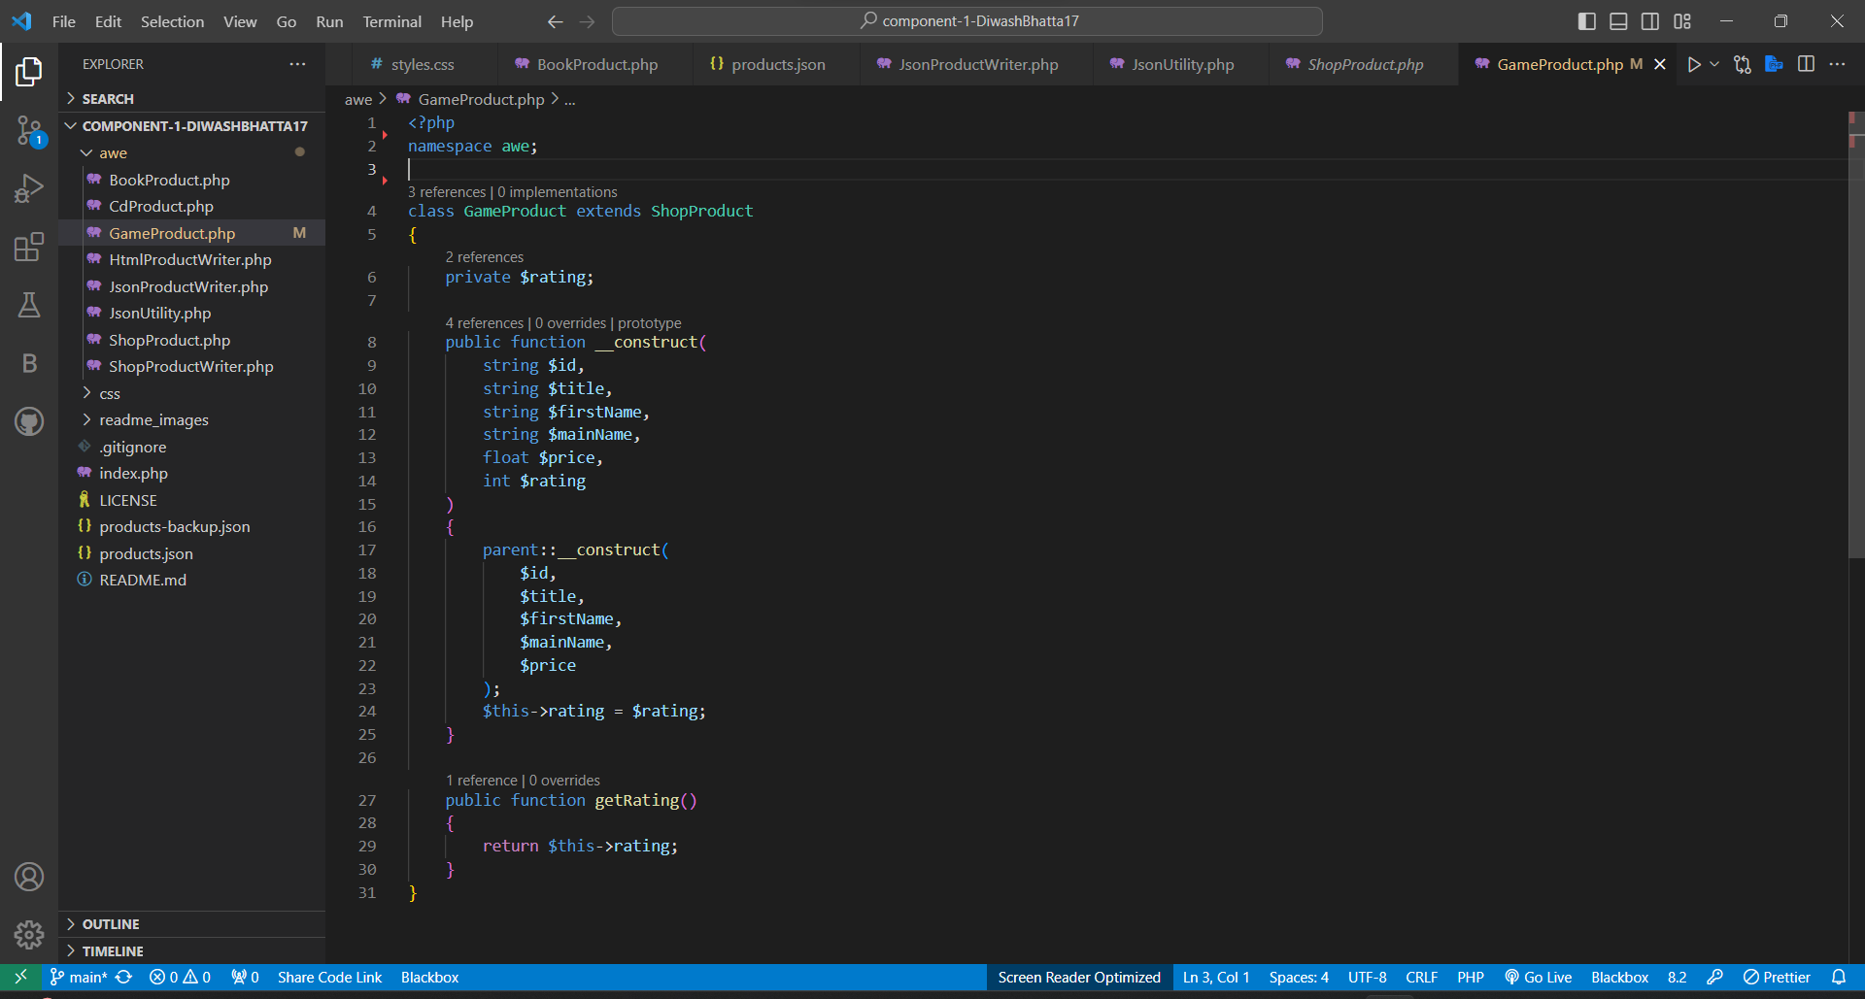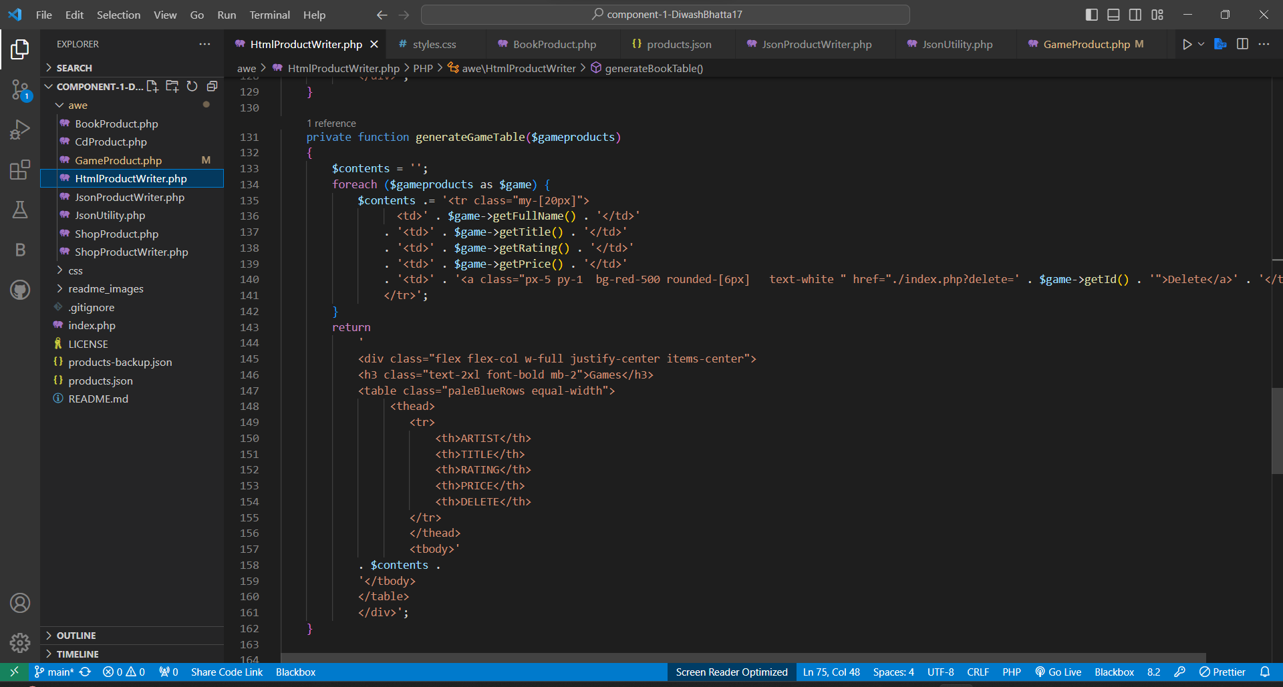

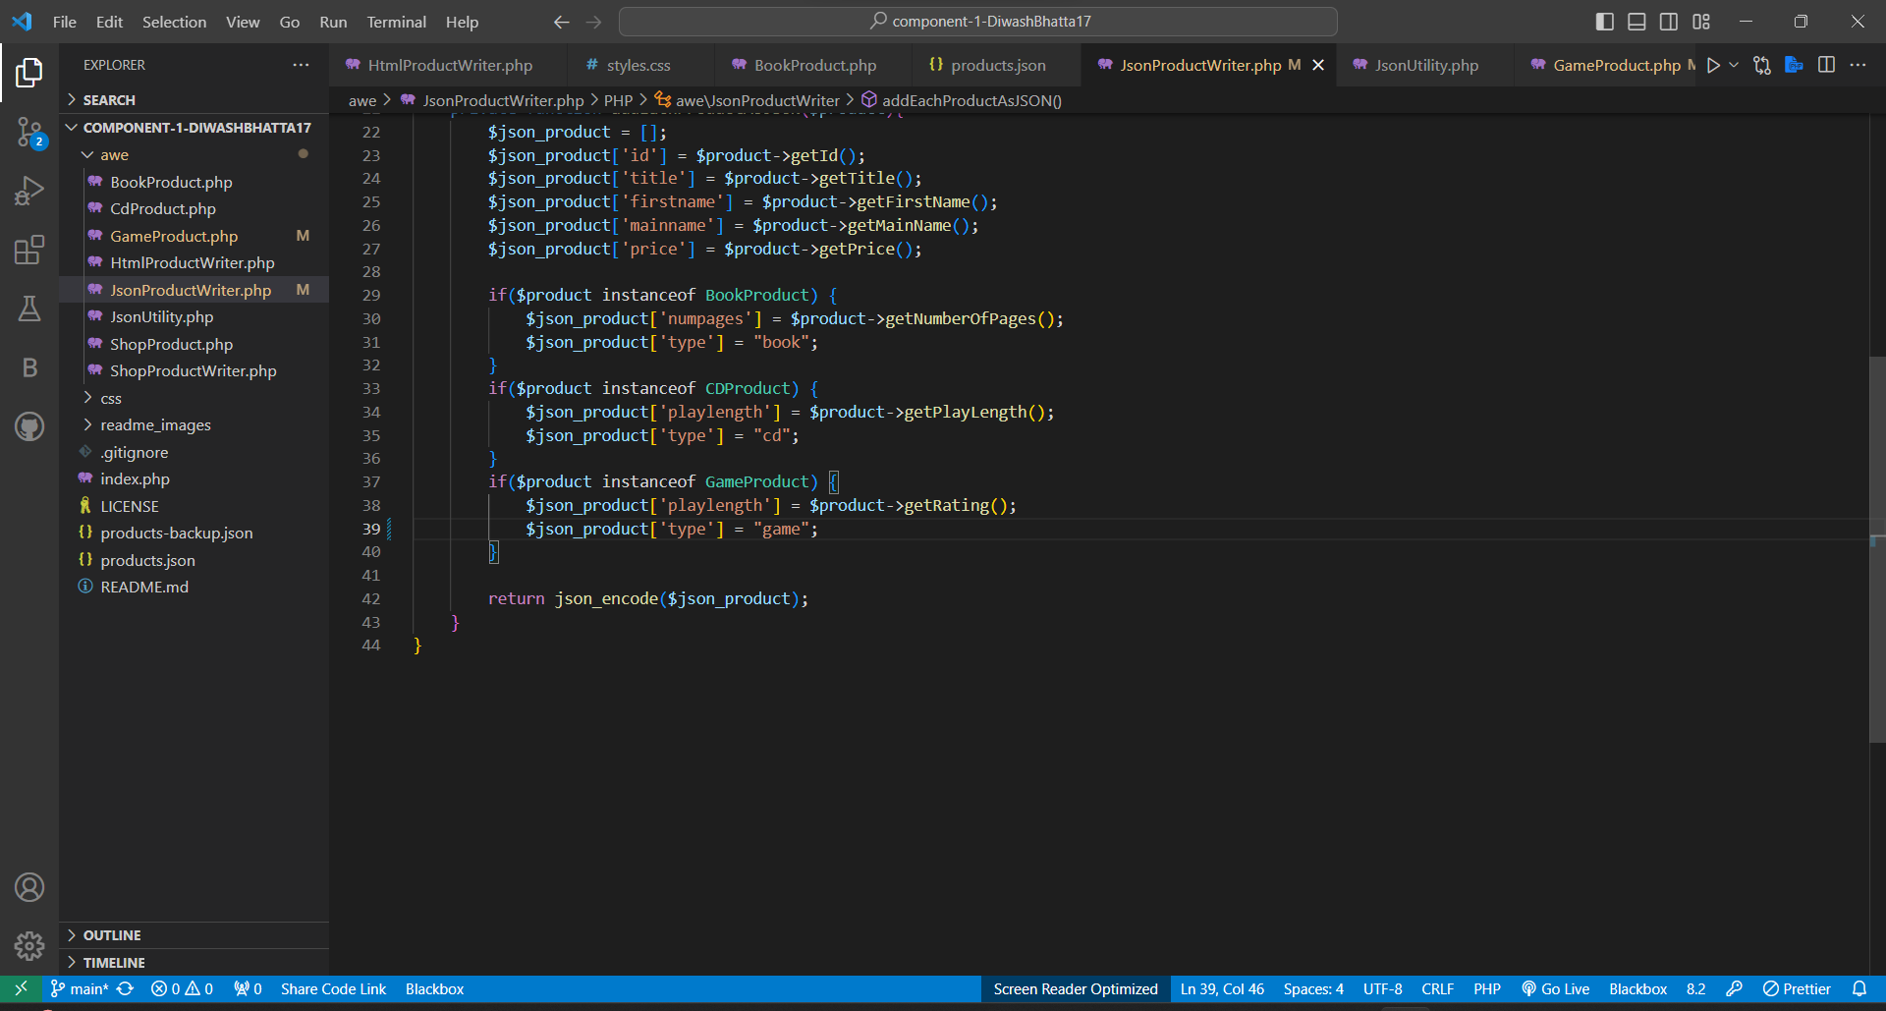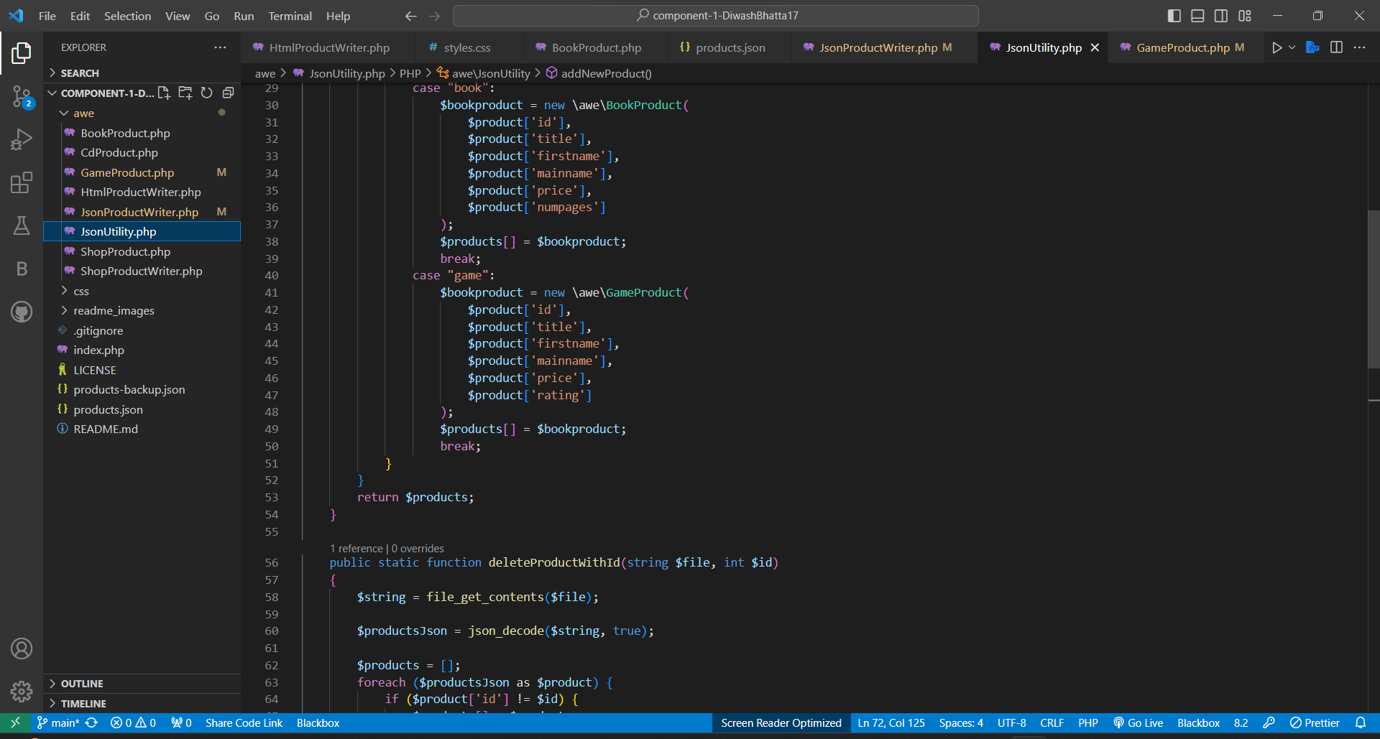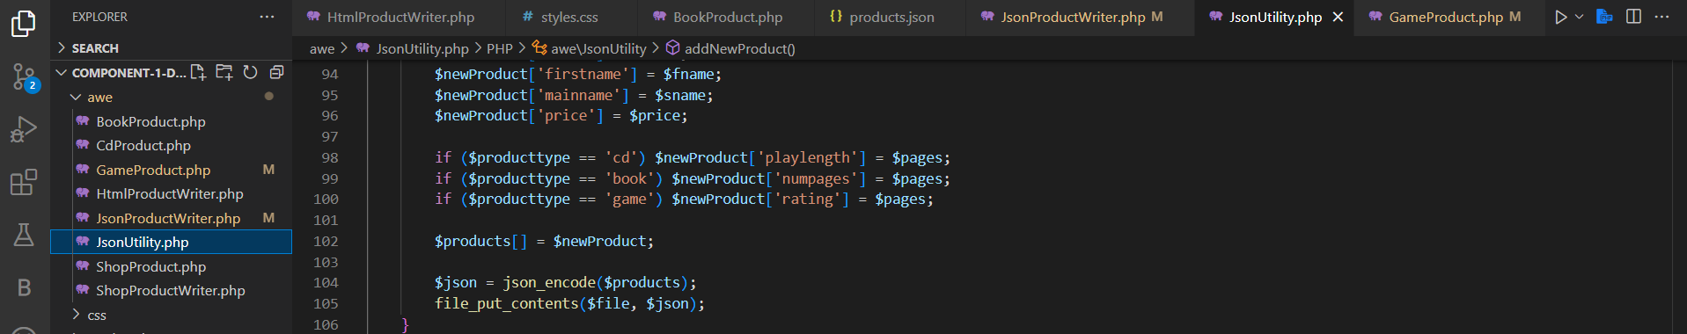

# PHP Xdebug Install Screenshot

