Earthquake Prediction Model Using Python

DIWAKAR. V

Abstract:

Deep learning and machine learning challenges can be solved with Python programming. This  explains how to resolve earthquake prediction issues using Python, a programming language that is supported by Jupyter Notebook and environment. It using the Keras package for Python. The following programming flow is the deep learning programming for our earthquake prediction system:preparation of data determining the keras model, compiling the keras model, and keras modelcorrection, evaluation of the Keras model, and development of a prediction system. the examinationthe outcomes of the Python-based earthquake prediction system,The outcomes are really pleasing. The simulation's outcomes demonstrate the impact of the DeepAfter 10,000 iterations of learning, the outcomes of MSE, RMSE, and the earthquake prediction system's b-value prediction procedure, and it gives better accuracy for the prediction model.

Design thinking:

**1.Data Source:**

We have gathered information about earthquake from a variety of DL&ML prediction models We also gathered data from website such askaggle, datahub.io etc... We need to gather accurate statistics categorized and organized. when we begin to address .Any machine learning issue must start with data require. The dataset must be valid or there willreason to analyze the data.

Dataset:**<https://www.kaggle.com/datasets/usgs/earthquake-database>.**

**\*Data Preprocessing:**

Our data is cleaned up at this step. Our dataset may contain values that are missing. Three methods exist to complete our missing values:

* Remove the data points that are missing.
* Remove the entire attribute.
* Set the value to a specific value, such as 0 or the median.

**2.Feature selection:**

Feature selection is a crucial step in building a good prediction model for earthquake prediction. It involves selecting the most relevant and informative features (also known as variables or attributes) from your dataset while discarding irrelevant or redundant ones. Effective feature selection can improve model performance, reduce overfitting, and make your model more interpretable.

Create new features if they are likely to provide additional information.

For example, It is well known that if a disaster occurs in one region, it is likely to happen again. Some regions have frequent earthquakes, but this is only a comparative amount compared to other regions.So, predicting the earthquake with date and time, latitude and longitude from previous data is not a trend that follows like other things, it happens naturally.

**3.Visualization:**

Creating a world map visualization to display earthquake frequency distribution requires using data and a data visualization tool or library. Here's a step-by-step method to creating such a visualization using Python and the popular data visualization library, Matplotlib and Basemap (or Cartopy):

Step 1: Install the required libraries

If you haven't already, you'll need to install Matplotlib and either Basemap or Cartopy. You can use the following commands to install them using pip:

pip install matplotlib

pip install basemap # or pip install cartopy

Step 2: Get earthquake data

You can obtain earthquake data from various sources like the USGS (United States Geological Survey) Earthquake Hazards Program. They provide earthquake data in various formats like CSV, JSON, or KML.

Step 3: Prepare your data**

Your earthquake data should include information about the earthquake's location, date, and magnitude. Ensure your data is in a suitable format, such as a CSV file.and then write python code for that.

The output should be expected like this:

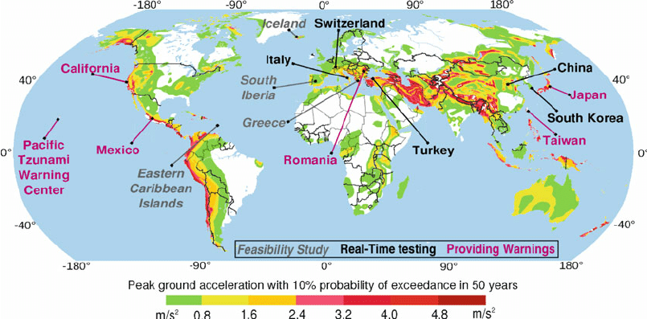

**4.Data Splitting:**

Splitting a dataset for earthquake prediction, like many other machine learning tasks, typically involves dividing your data into three main sets: training, validation, and testing. Here's a general process to split your dataset:

1.Collect and Prepare Your Data:

Gather earthquake-related data, including features (such as seismic sensor readings, location, depth, etc.) and labels (earthquake occurrence or intensity).

2. Data Splitting

a.Training Set:

This is the largest portion of your data and is used to train your machine learning model. It's typically around 70-80% of your dataset.

b.Validation Set:

This set is used for fine-tuning your model hyperparameters and monitoring its performance during training. It's typically around 10-15% of your dataset.

c.Test Set:

This set is used to evaluate your model's performance after training and hyperparameter tuning. It's kept separate from the training and validation data and is typically around 10-15% of your dataset.

3.Random Sampling:

Ensure that the data in each split (training, validation, and test) is randomly sampled to avoid any bias.

4.Data Splitting Libraries:

Python libraries like scikit-learn provide functions to help with dataset splitting, such as `train_test_split`. You can use these functions to split your data easily.

Remember that the specific split ratios and strategies may vary based on your dataset's size, distribution, and the machine learning algorithms you're using. Experiment with different splits and hyperparameters to find the best setup for your earthquake prediction task.

**5.Model Development:**

Building a neural network model for earthquake magnitude prediction involves using historical earthquake data to train a model that can predict the magnitude of future earthquakes. In this example, I'll provide a simple neural network using Python and TensorFlow/Keras. You would typically use a more extensive dataset for better accuracy, but this will serve as a starting point.

Steps Involved:

Step 1: Prepare the Data.

Step 2: Build the Neural Network Model.

Step 3: Train the Model.

Step 4: Evaluate the Model

**6.Training and Evaluation”**

Certainly! To train the neural network model on the training set and evaluate its performance on the test set, you can follow these steps:

Assuming you've already prepared the data and built the model as described in the previous response, you can proceed with training and evaluation.

Step 1: Train the Model

Step 2: Evaluate the Model**

After training, you can evaluate the model's performance on the test set using Mean Absolute Error (MAE) as a metric:

**7.Conclusion:**

It's important to note that earthquake prediction is a complex and challenging task, Therefore, continuous monitoring and improvement of the model are often necessary to achieve meaningful results in earthquake prediction.