Exercise_2

Diwei_Zhu

options(tinytex.verbose = TRUE)

library(readr)  
library(igraph)

## Warning: package 'igraph' was built under R version 4.1.3

##   
## Attaching package: 'igraph'

## The following objects are masked from 'package:stats':  
##   
## decompose, spectrum

## The following object is masked from 'package:base':  
##   
## union

library(ggraph)

## Warning: package 'ggraph' was built under R version 4.1.3

## Loading required package: ggplot2

## Create edge list

create the edges data frame and plot a undirected graph.

from_ <- c("1","2","3","3","3","3","3","4","5","5","6","6","D","D","B","B","A")  
to_ <- c("2","A","D","C","B","4","5","C","D","6","D","B","B","C","C","A","C")  
  
egde <- data.frame(from = from_, to=to_)  
g <- graph_from_data_frame(egde, directed=FALSE)  
g

## IGRAPH 40edd6b UN-- 10 17 --   
## + attr: name (v/c)  
## + edges from 40edd6b (vertex names):  
## [1] 1--2 2--A 3--D 3--C 3--B 3--4 3--5 4--C 5--D 5--6 6--D 6--B D--B D--C B--C  
## [16] B--A A--C

Plot the network with seat label next to each node.

plot(g, layout=layout.fruchterman.reingold,  
 vertex.size = 10,  
 vertex.label = V(g)$name, # Set the labels (Node)  
 vertex.label.cex = 0.8, # Slightly smaller font  
 vertex.label.dist = 1.5, # Offset the labels  
 vertex.label.color = "black",  
 vertex.color = "orange")

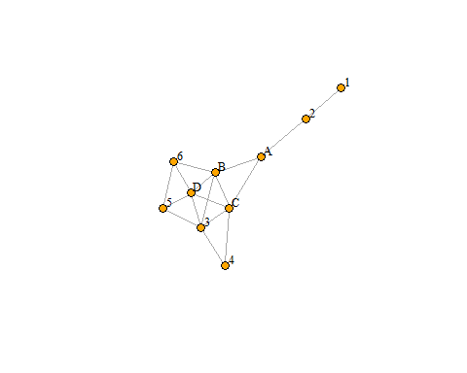

## Betweenness Centrality

Calculate betweenness centrality and display the values.

bc <- betweenness(g)  
bc

## 1 2 3 4 5 6 D   
## 0.0000000 8.0000000 4.6333333 0.0000000 0.5333333 0.9333333 3.2666667   
## B A C   
## 9.0333333 14.0000000 8.6000000

Plot the network graph with labels and betweenness centrality values.

V(g)$betweenness <- round(betweenness(g),4)  
label1 <- paste(V(g)$name,V(g)$betweenness,sep=":")  
   
plot(g, layout=layout.fruchterman.reingold,  
 vertex.size = 10,   
 vertex.label = label1, # Set the labels (Node:betweenness)  
 vertex.label.cex = 0.8,   
 vertex.label.dist = 2,   
 vertex.label.color = "black",  
 vertex.color = "darkolivegreen3")

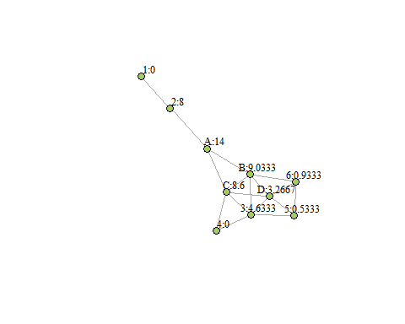

## Degree Centrality

Calculate degree centrality and display the values.

dc <- degree(g)  
dc

## 1 2 3 4 5 6 D B A C   
## 1 2 5 2 3 3 5 5 3 5

Plot the network graph with labels and degree centrality values.

V(g)$degree <- degree(g)  
label2 <- paste(V(g)$name,V(g)$degree,sep=":")  
   
plot(g, layout=layout.fruchterman.reingold,  
 vertex.size = 10,   
 vertex.label = label2, # Set the labels (Node:degree)  
 vertex.label.cex = 0.8,   
 vertex.label.dist = 2,   
 vertex.label.color = "black",  
 vertex.color = "rosybrown1")

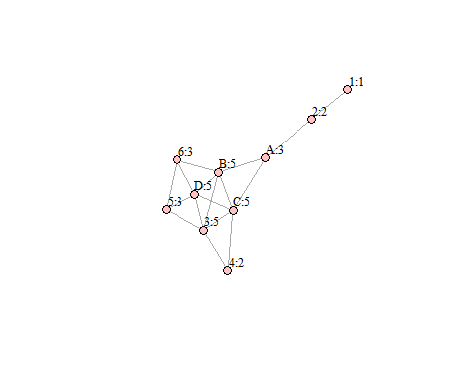

## Closeness Centrality

Calculate closeness centrality and display the values.

cc <- closeness(g)  
cc

## 1 2 3 4 5 6 D   
## 0.03333333 0.04545455 0.06250000 0.05000000 0.04761905 0.05263158 0.06250000   
## B A C   
## 0.07142857 0.06250000 0.07142857

Plot the network graph with labels and closeness centrality values.

V(g)$closeness <- round(closeness(g),4)  
label3 <- paste(V(g)$name,V(g)$closeness,sep=":")  
   
plot(g, layout=layout.fruchterman.reingold,  
 vertex.size = 10,   
 vertex.label = label3, # Set the labels (Node:closeness)  
 vertex.label.cex = 0.8,   
 vertex.label.dist = 2,   
 vertex.label.color = "black",  
 vertex.color = "slateblue1")

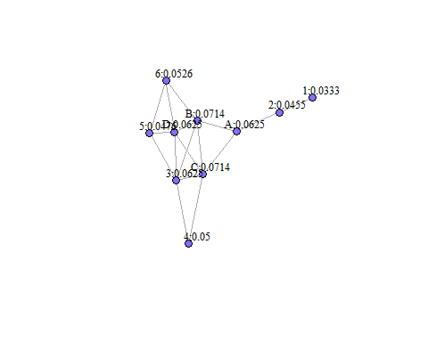

## Choice of seat

We will make decision based on the three measure of centrality we calculated.

1. Degree Centrality: B, C, and D have degree centrality equal to 5 while A has a lower degree centrality at 3. This means that if we sit on B, C, or D, there would be more people we can directly talk to.
2. Betweenness Centrality: A has an obviously higher betweenness centrality at 14, meaning that A is on most of the shortest paths between pairs of seats and has a influence on the flow of information in the bus. Among B, C, and D, B has the highest betweenness centrality value. However, it seems to be rare that the colleagues would pass on messages from seat to seat (sounds like what kids would do in the classroom).
3. Closeness Centrality: The higher the closeness centrality, the shorter the sum of shortest paths from a node to other nodes, and the closer the node to other nodes. B and C have the same highest closeness centrality.

To sum up, I will choose B if the passengers mainly talk to people who sit next to them, because seat B has the highest degree centrality and closeness centrality, as well as the second highest betweenness centrality. However, if passengers on the bus like to pass on messages from one to another even though the receiver is sitting next to the one who sent the message, I will choose seat A to capture more information.