Sri Lanka Institute of Information Technology

Data warehousing and Business Intelligence

Assignment 1



Student Registration No: IT19083742
Student Name: Vithana K.C.D
Step 1: Data Set Selection
This data set contains Health care analytics data of American hospital health camps. And These camps are organized in several cities with low work-life balance. They reach out to working people and ask them to register for these health camps. For those who attend, health camp provides them the facility to undergo health checks and tests.
These camps have been conducted 150 time over a period of 4 years and the Number of people taking tests at the camps is over 150,000. In the last 4 years, they have stored data of ~ 250,000 tests they have done. Patients need to register beforehand to participate in the health camps.
There are three stages of the health camp that each participant must attend. The patients’ attendance is methodically maintained. The first and second stage provides people with advice and drugs for any illness they are diagnosed with. The third stage provides participants with direction to do the tests for their diagnosed ailment.
This dataset contains Health camp details,
- Hospital Details
- Health Camp Details
- Department Details
- Attendance Details
- Attendance Fee Details
- Test Prices Details

- Patient Details
- Patient Addresses
- Registration Details
- Tests Details
Also, there are some added details to this database.
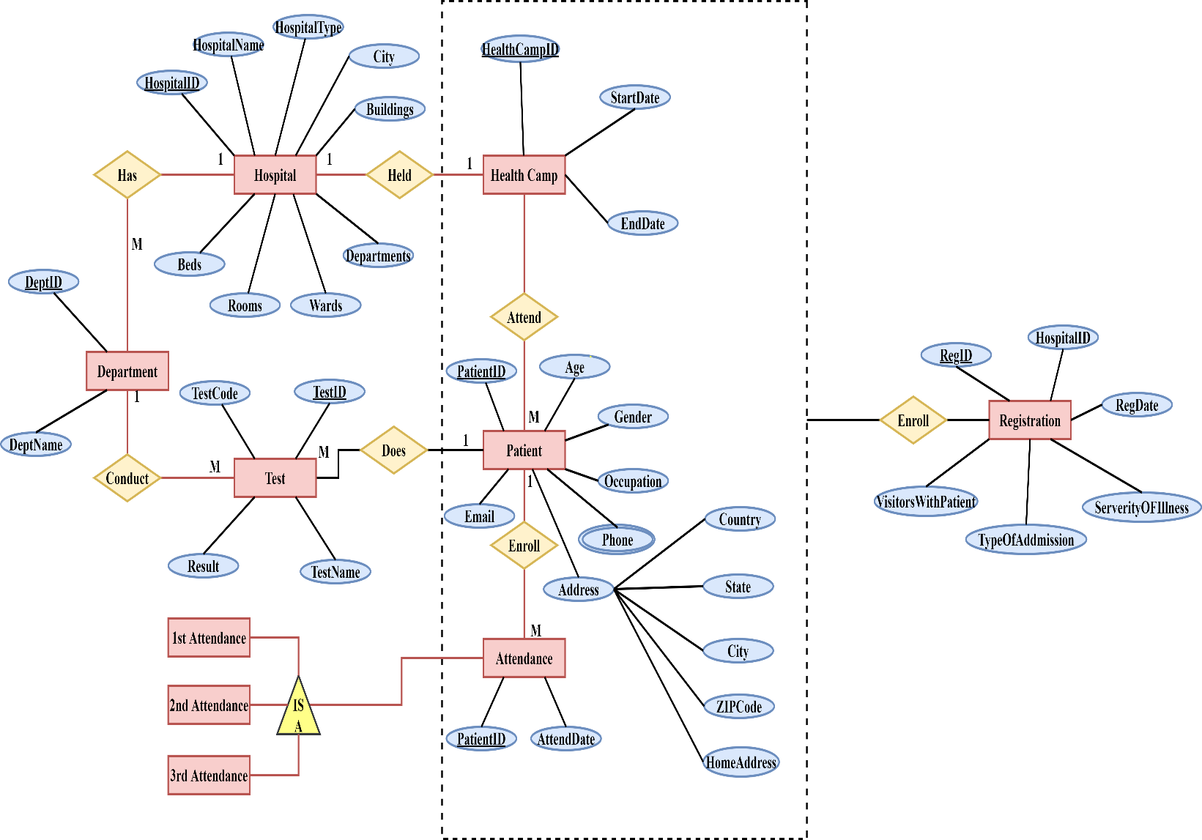
Following ER- diagram will describe the scenario of the selected dataset.

Step 2: Preparation of Data Sources
The whole of data was in ‘csv’ file type and they were separated into the following data sources, Database, Text, Excel and csv. And they were used to create the following,

1.Database(.bak)
Patient.txt, RegistrationFee.txt and Attendance.txt file was imported to the Patient Database. Test.txt and TestPrices.txt was imported to the Test Database. And both of those data were used as the DB source data.
2.Text(.txt)
PatientAddress.txt was used directly.
3.Excel(.xls)
HealthCamp.xls and Department.xls was used.
4.Comma Separated Values (.csv)
Hospital.csv and Regisgration.csv was used.

Data Source Type | Source Name | Column Name | Data Type | Description
Database  File (.bak) | Dbo.Patient | PatientID | int | Unique ID
Database  File (.bak) | Dbo.Patient | Gender | nvarchar(255) | Gender (Male/Female)
Database  File (.bak) | Dbo.Patient | Age | int | Age
Database  File (.bak) | Dbo.Patient | Occupation | nvarchar(255) | Patient’s Job
Database  File (.bak) | Dbo.Patient | Phone | nvarchar(255) | Phone Number
Database  File (.bak) | Dbo.Patient | Email | nvarchar(255) | Email Address
Database  File (.bak) | dbo.Attendance | PatientID | int | PatientID
Database  File (.bak) | dbo.Attendance | 1stCampID | int | 1st Health Camp ID
Database  File (.bak) | dbo.Attendance | 2ndCampID | int | 2nd Health Camp ID
Database  File (.bak) | dbo.Attendance | 3rdCampID | int | 3rd Health Camp ID
Database  File (.bak) | dbo.Attendance | RegDate | datetime | Registration Date
Database  File (.bak) | dbo.Attendance | RegID | int | Registration ID
Database  File (.bak) | dbo.RegistrationFees | PatientID | int | PatientID
Database  File (.bak) | dbo.RegistrationFees | HospitalID | int | HospitalID where patient registered
Database  File (.bak) | dbo.RegistrationFees | RegistrationFee | nvarchar(255) | Registration Fee
Database  File (.bak) | dbo.Test | TestID | int | Unique ID
Database  File (.bak) | dbo.Test | PatientID | int | Patient’s Unique ID
Database  File (.bak) | dbo.Test | TestName | nvarchar(255) | Test Name
Database  File (.bak) | dbo.Test | DepartmentID | int | ID of the Department which the test was done
Database  File (.bak) | dbo.Test | TestCode | nvarchar(255) | Test Code
Database  File (.bak) | dbo.Test | Result | nvarchar(255) | Test Result
Database  File (.bak) | dbo.TestPrices | PatientID | int | PatientID
Database  File (.bak) | dbo.TestPrices | TestID | int | Test ID
Database  File (.bak) | dbo.TestPrices | TestPrice | nvarchar(255) | Price of Test
Excel File | HealthCamp.xls | HealthCampID |  | Unique ID
Excel File | HealthCamp.xls | StartDate |  | Health Camp Start Date
Excel File | HealthCamp.xls | EndDate |  | Health Camp End Date
Excel File | HealthCamp.xls | HospitalID |  | Hospital ID which the Health Camp was held
Excel File | Department.xls | DepartmentID |  | Unique ID
Excel File | Department.xls | DepartmentName |  | Department Name
CSV File | Registration.csv | RegisterID | int | Unique ID
CSV File | Registration.csv | PatientID | int | Patient ID which was used to register in the health camp
CSV File | Registration.csv | HospitalID | int | Hospital ID which the Health Camp was held
CSV File | Registration.csv | RegDate | datetime | Registered Date
CSV File | Registration.csv | TypeOfAddmission | nvarchar(255) | Type of Admission
CSV File | Registration.csv | SeverityOfIllness | nvarchar(255) | Severity of Illness
CSV File | Registration.csv | VisitorsWithPatient | int | Visitors with Patient
CSV File | Hospital.csv | HospitalID | int | Unique ID
CSV File | Hospital.csv | HospitalName | nvarchar(255) | Hospital Name
CSV File | Hospital.csv | HospitalType | nvarchar(255) | Hospital Type
CSV File | Hospital.csv | City | nvarchar(255) | City where the hospital is located
CSV File | Hospital.csv | Buildings | nvarchar(255) | No of Buildings in the hospital
CSV File | Hospital.csv | Departments | nvarchar(255) | No of departments in the buildings
CSV File | Hospital.csv | Wards | nvarchar(255) | No of wards in the department
CSV File | Hospital.csv | Rooms | nvarchar(255) | No of rooms in the ward
CSV File | Hospital.csv | Beds | nvarchar(255) | No of beds in the room
Text File | PatientAddress.txt | PatientID | int | Unique ID
Text File | PatientAddress.txt | Country | nvarchar(255) | Patient’s Country
Text File | PatientAddress.txt | State | nvarchar(255) | Patient’s State
Text File | PatientAddress.txt | City | nvarchar(255) | Patient’s City
Text File | PatientAddress.txt | ZIP | nvarchar(255) | ZIP code of the Patient
Text File | PatientAddress.txt | Address | nvarchar(255) | Patient’s Address

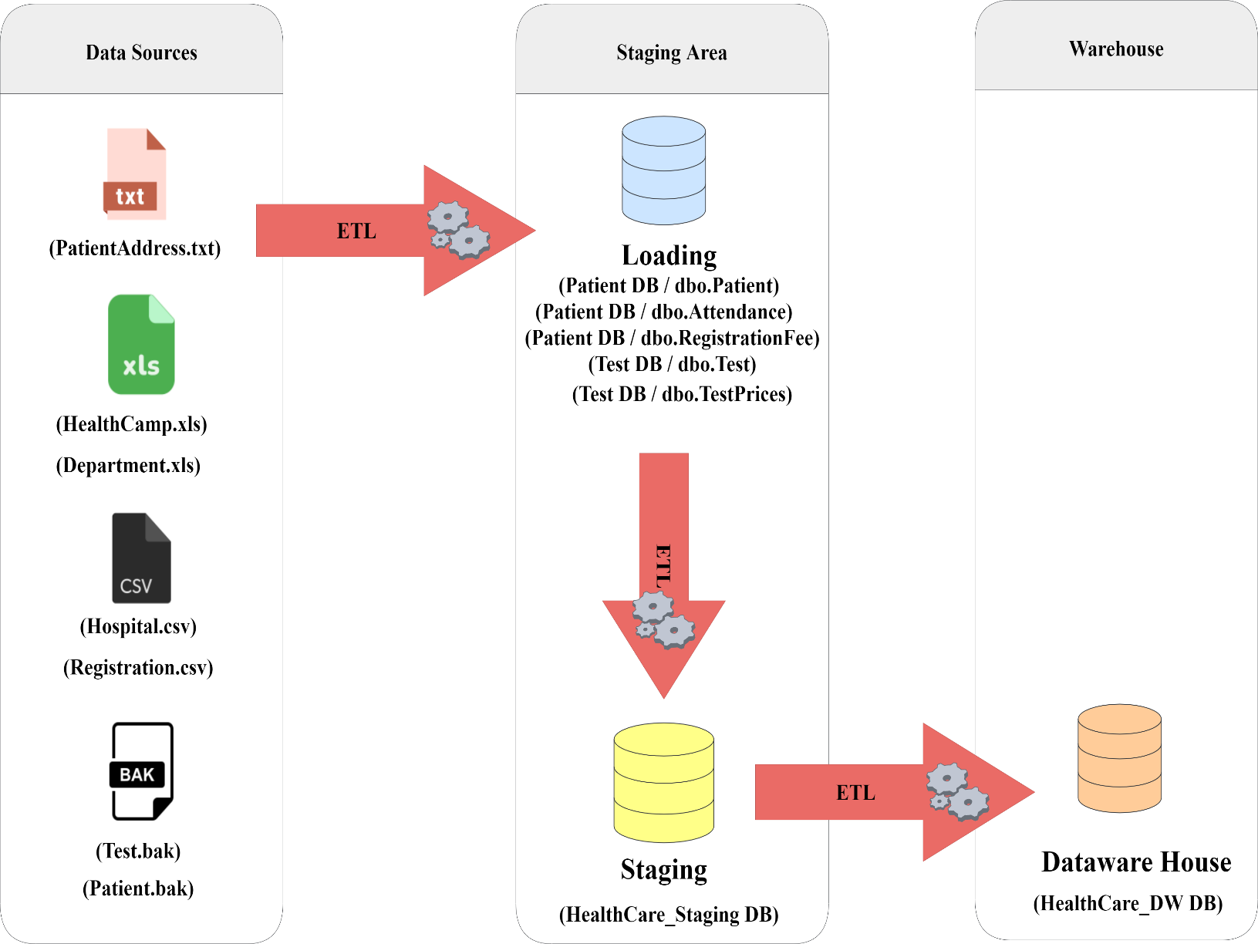
Step 3: Solution Architecture

Above architecture shows the high-level BI solution to the warehouse design.
Data Sources
‘.txt’ component represents Text files, ‘.xls’ component is used to represent Excel files, ‘.csv’ component is used to display Comma Separated files and ‘.bak’ component represents database files.
Staging Area
Loading DB component represents the process of the creating database tables. Test, Patient, TestPrices, AddmissionFees and Attendance text files was imported to the database and was used to create the tables. And these tables were used as the DB source data.
Staging DB component represents creating staging level tables through the ‘Extract’.
Data Warehouse
Data warehouse DB component is used display the cratering dimension tables in the warehouse using ‘Transform’ and ‘Load.’
Step 4: Data Warehouse Design & Development
Following figure will show how the fact table and dimension tables was combined in a rational manner.
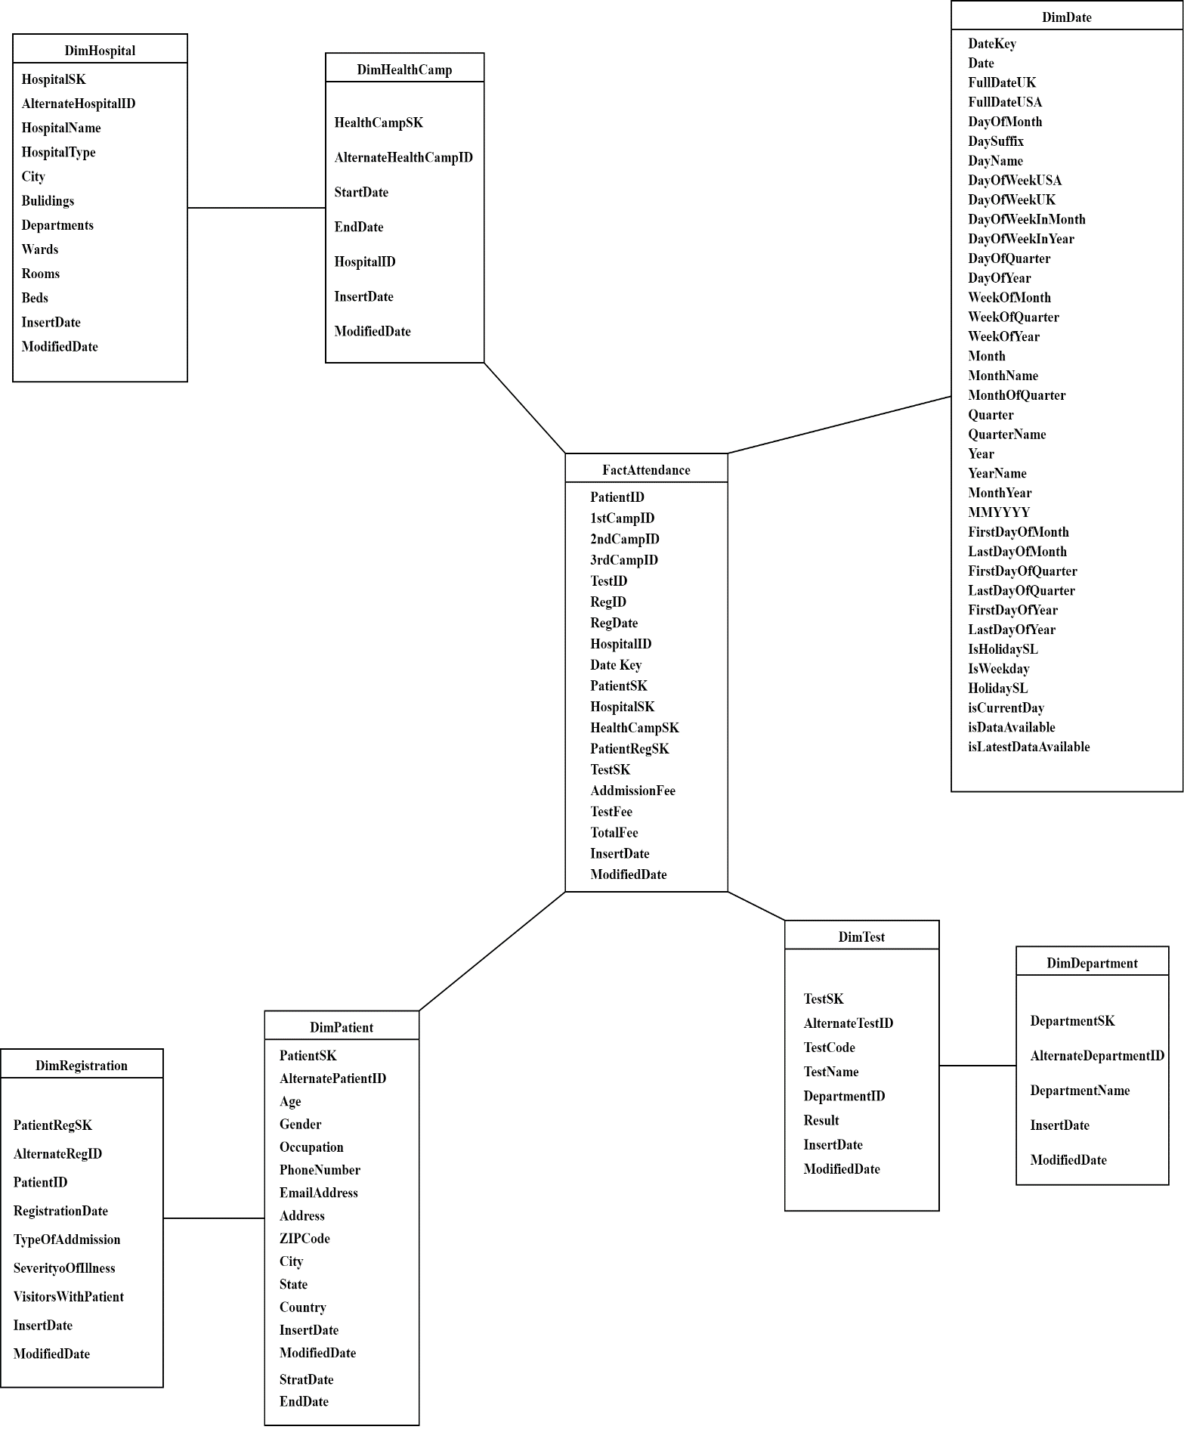

Schema Type
For this scenario, snowflake schema type was used.
Dimension Types
- Hierarchical Dimension
  - Date – all the hierarchies in date
  - Hospital – buildings departments ward rooms beds
  - Patient – country state city ZIP code address
- Slowly Changing Dimension
  - Patient – used type 2.
  - Following columns were set as changing attributes.
    - Address
    - Phone Number
    - Country
    - City
    - State
    - ZIP code
- Fact Table
  - Numbers – Test Price, Attendance Fee, Total Amount
  - FK - Patient ID, Health Camp ID, Test ID, Hospital ID, Date Key, Registration ID, Department ID
Assumptions
- Patient dimension was considered as a slowly changing dimension.
Step 5: ETL development
1.Extract
In this step, All the data sources were imported to the staging tables by using the relevant Data connection.
Flat file connection was used for text files and csv files, Excel file connections for excel file, DB source connection for DB file. All those tables were imported to the HealthCare_Staging DB, which contains the below tables,
- SgtHospital
- SgtHealthCamp
- SgtPatientAddress
- SgtPatient
- SgtRegistration
- SgtDepartment
- SgtTest
- SgtAttendance
- SgtTestPrices
- SgtAddmissionFee

- Snapshot of SSMS Staging Database

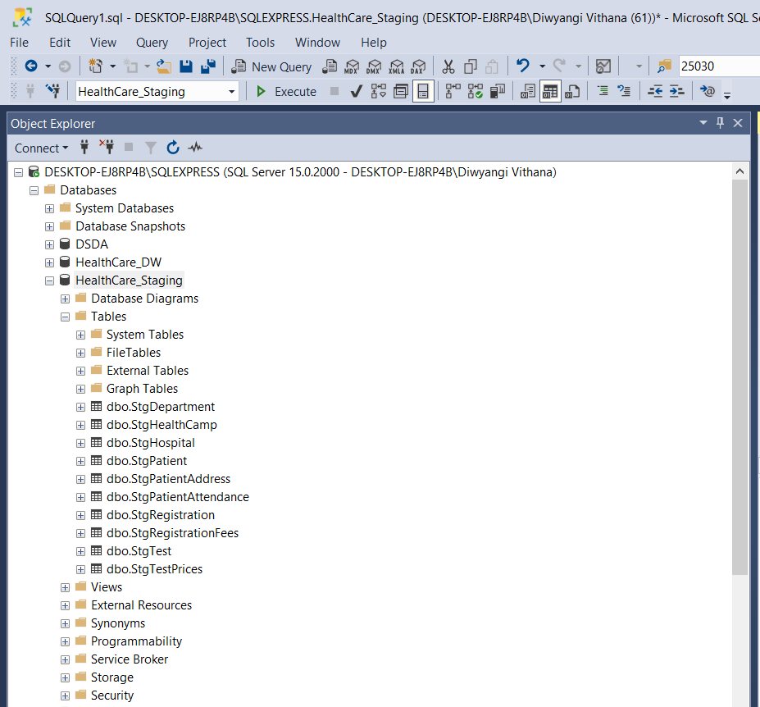

- Snapshot of Visual Studio Control Flow of Extract

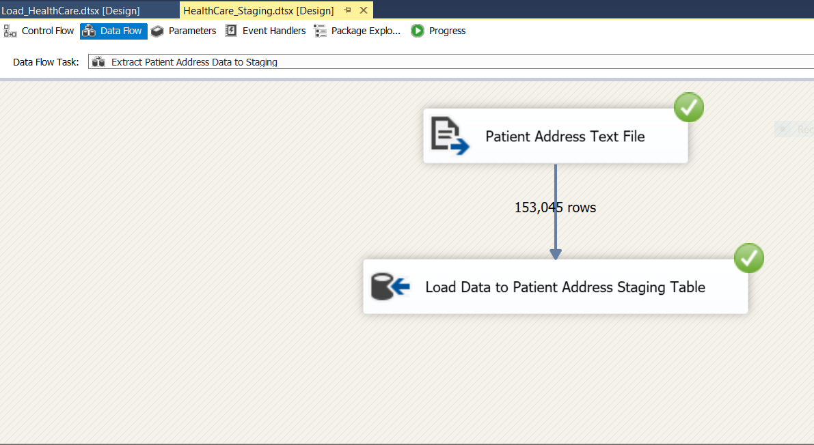
- Snapshots of several data types of Data Flows

Patient Address Data Staging

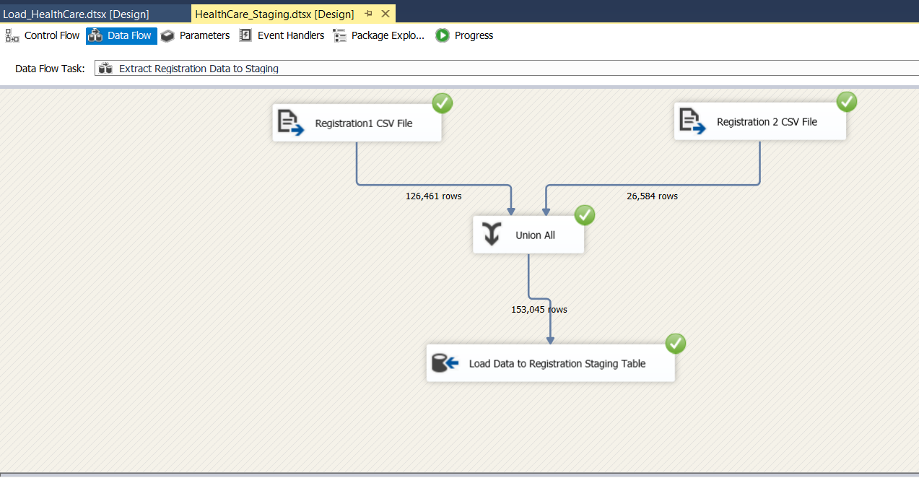

Registration
Data Staging

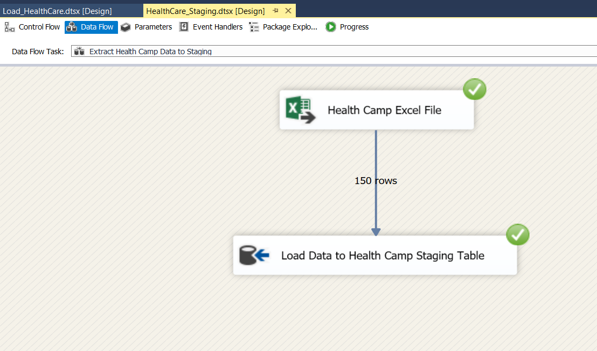

Health Camp Data Staging

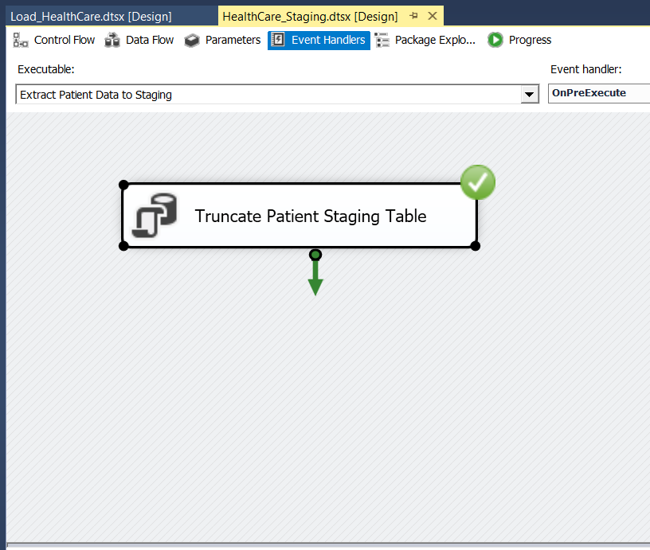
- Event Handling (Truncate Staging Data)

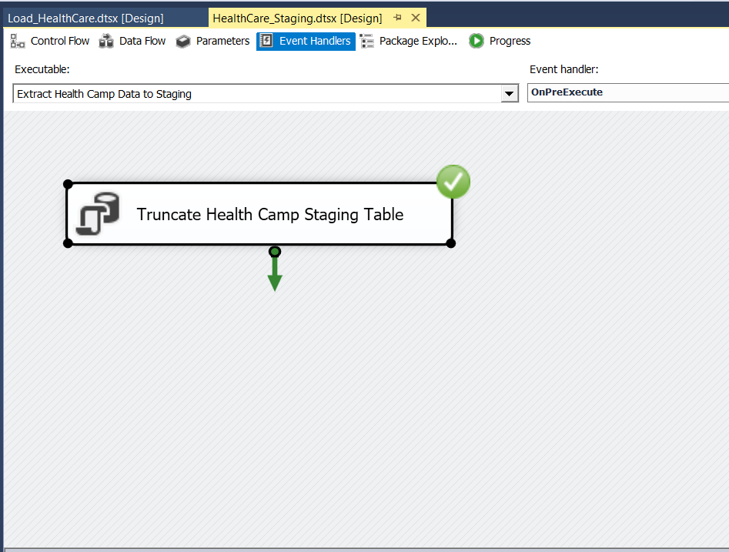

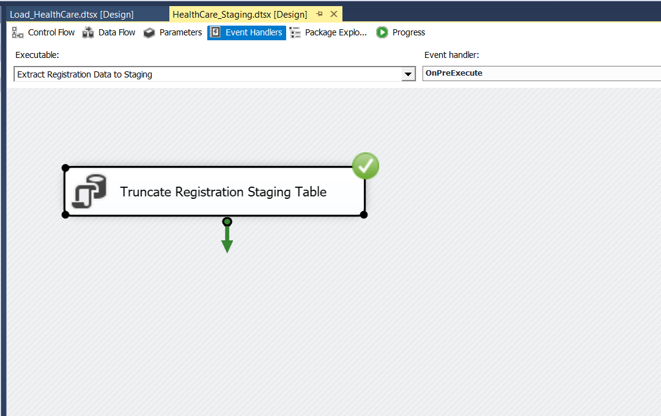

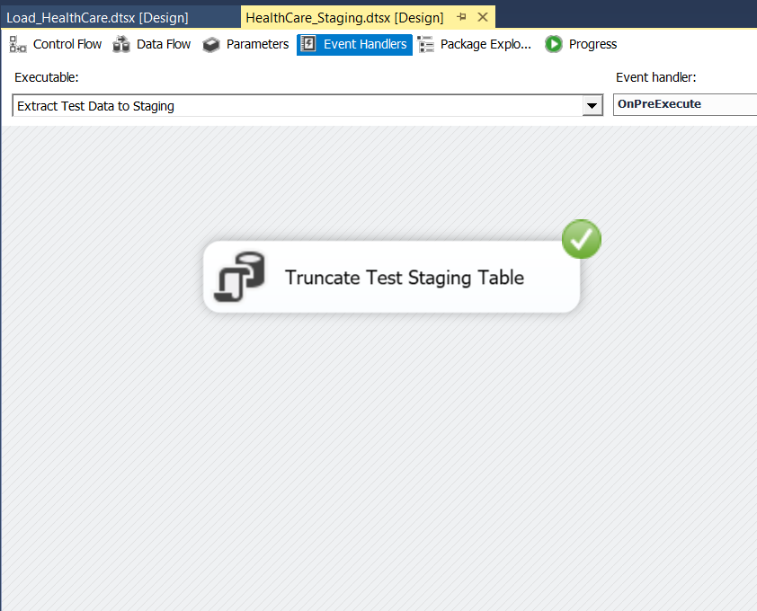

- Data profiling
Used Data_Profiling package to profiling the staging tables
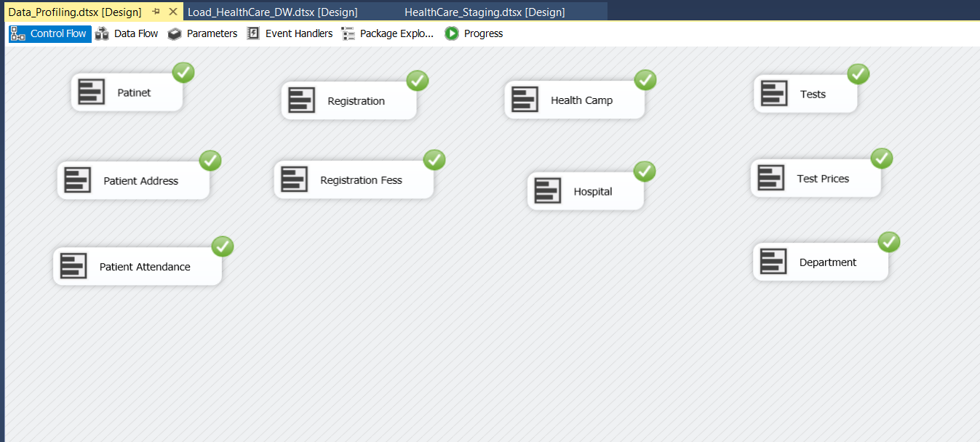

3.Transform & Load
In this step, both the ‘Transform’ and ‘Load’ are done. Firstly, The Dimension tables in the Datawarehouse DB data were created. Then, using the relevant components, data from the staging tables was loaded into the warehouse tables, HealthCare_DW, which contains the below tables,
- DimHospital
- DimHealthCamp
- DimPatient
- DimRegistration
- DimDepartment
- DimTest
- DimDate
- AttendanceFact

Used Transformation Tasks
- Lookups

Health Camps’ Hospital ID is looked when loading to the in-Health Camp DimTable using Hospital Table
Tests’ Department ID is looked when loading to the to the in Test DimTable using Department Table.

- Derived Columns

Replace Null Hospital Types in Hospital DimTable
Replace Null Gender Values in Patient DimTable

- Union
Union is used in the Extract step to combine and get all the data from both Patient Registration data csv files.
- Sort and Merge
‘Sort’ is used sort out the Patient and Registration data and they are merged ‘Merge’ using PatientID.

Update Functions
- Patient
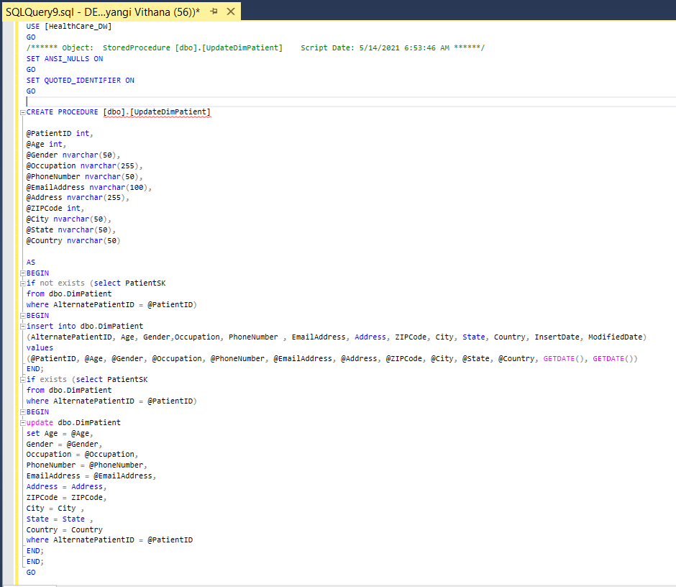

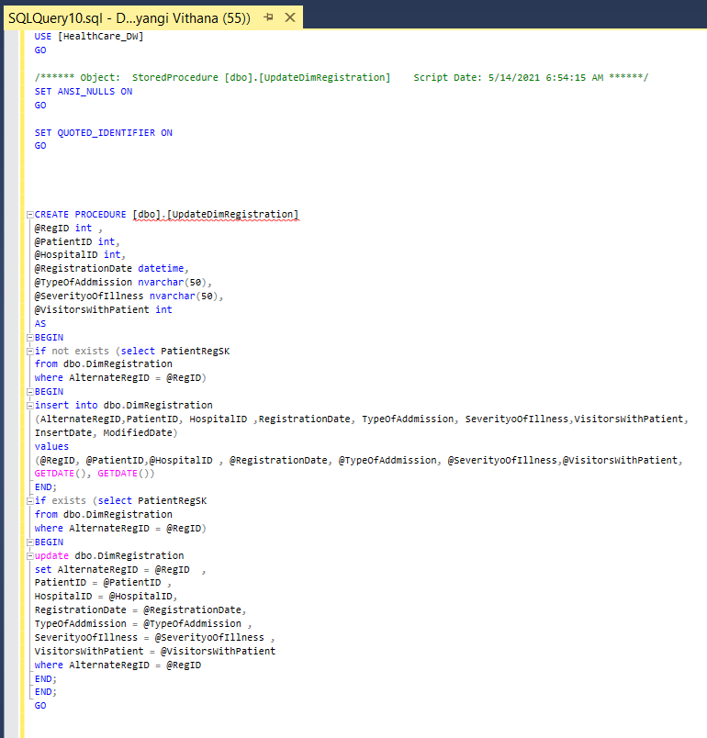
- Registration

- Hospital
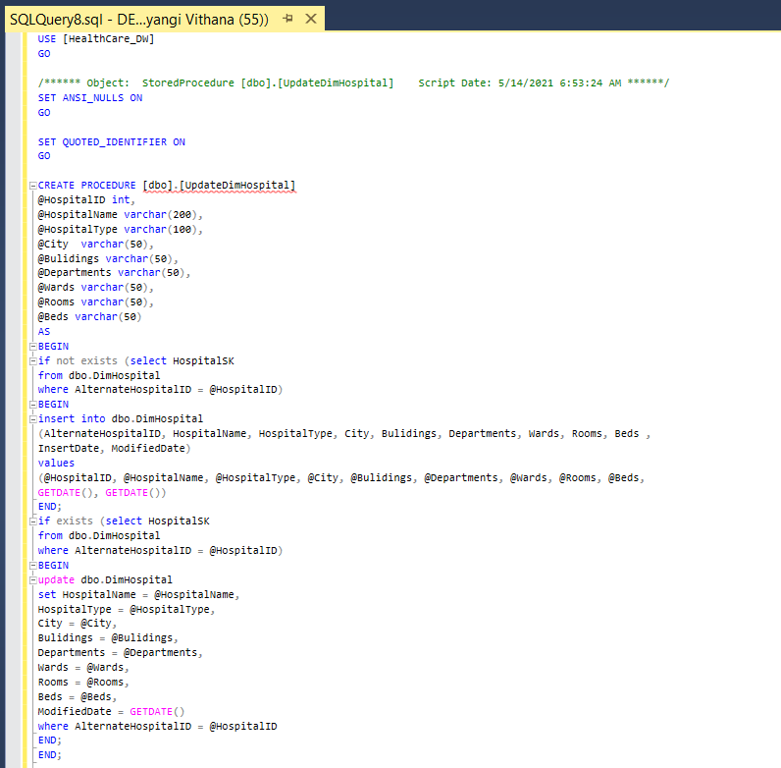

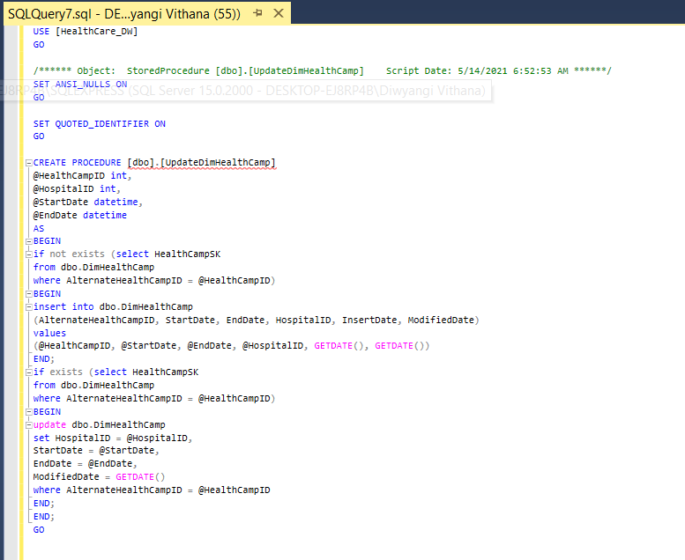
- Health Camp

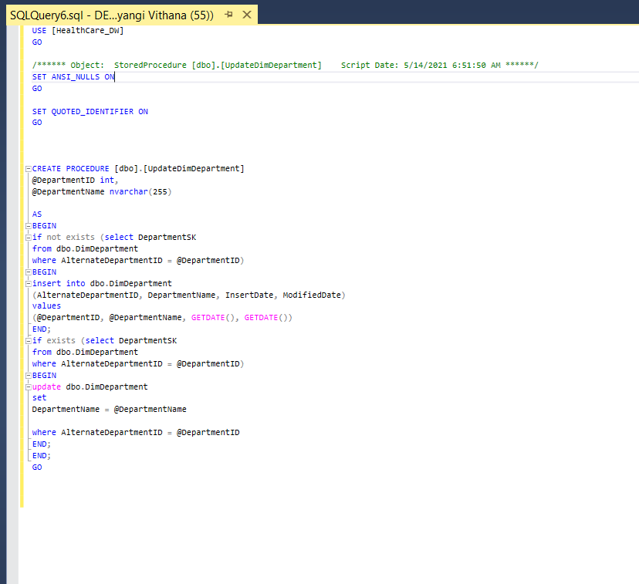
- Department

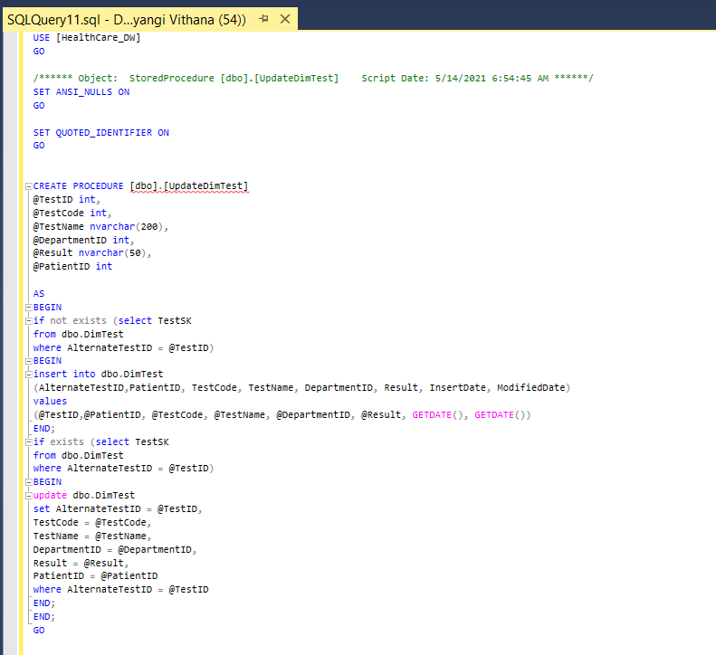
- Test

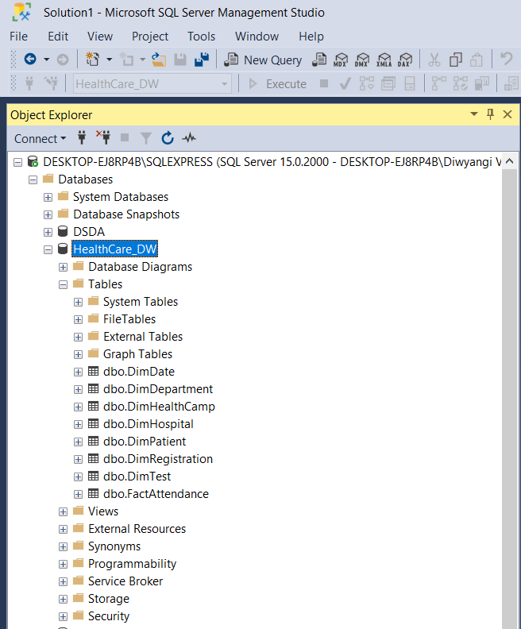
- Snapshot of SQL server Data warehouse Database

- Snapshot of Visual Studio Control Flow of Extraction

- Hospital Data Transform and Load
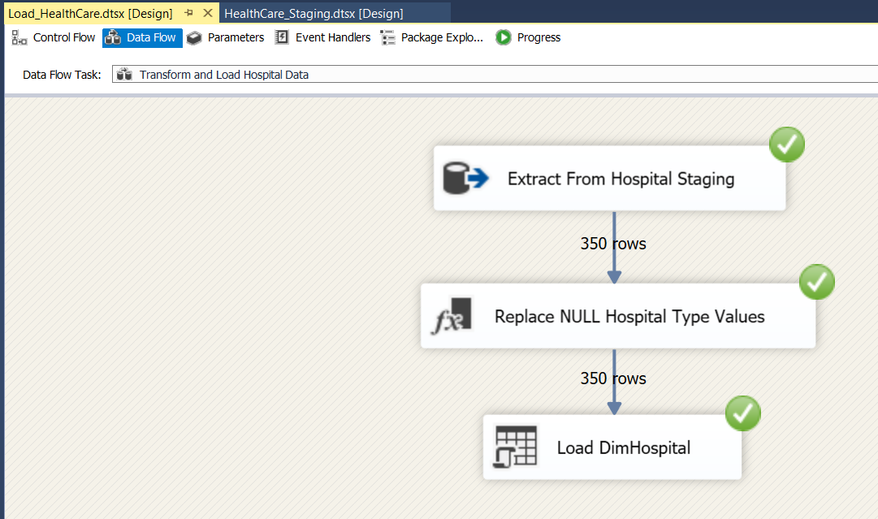

- Health Camp Data Transform and Load
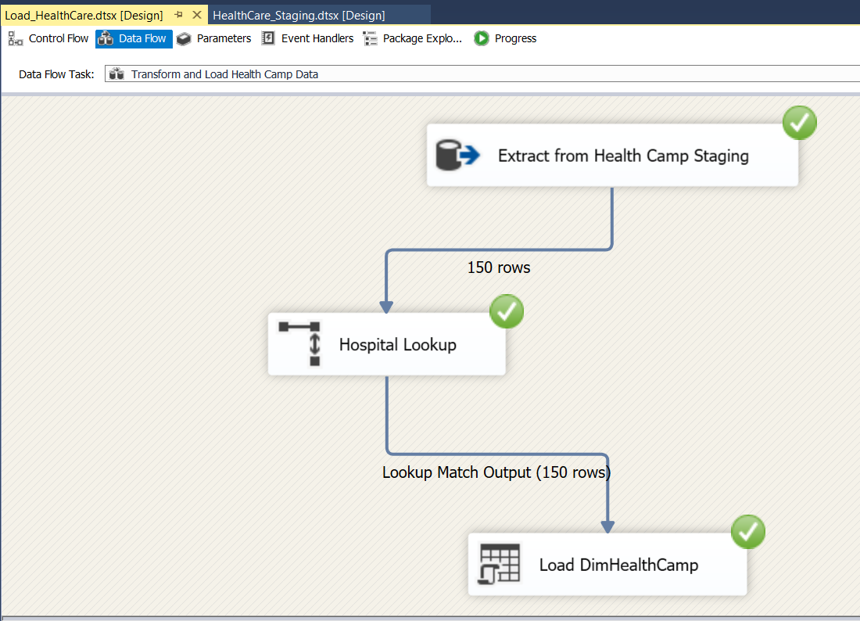

- Patient data Transform and Load

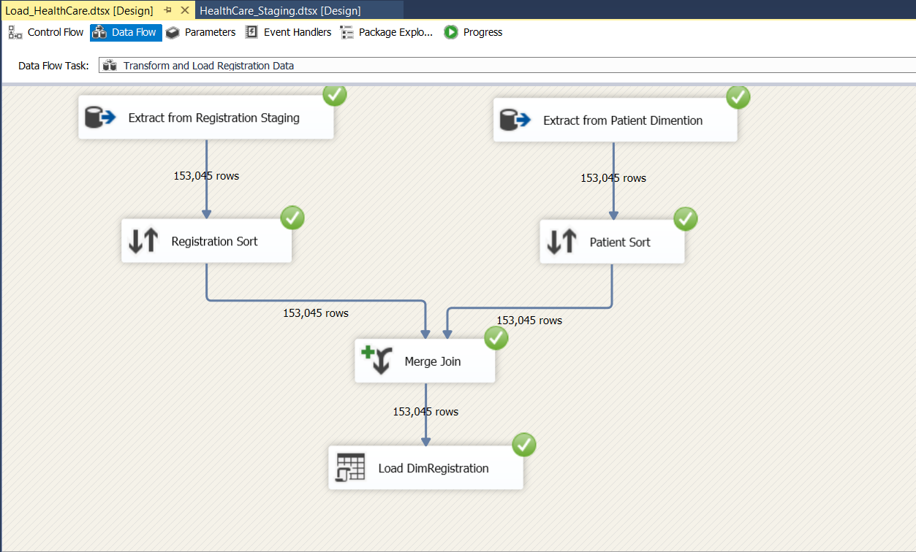
- Registration Data Transform and Load

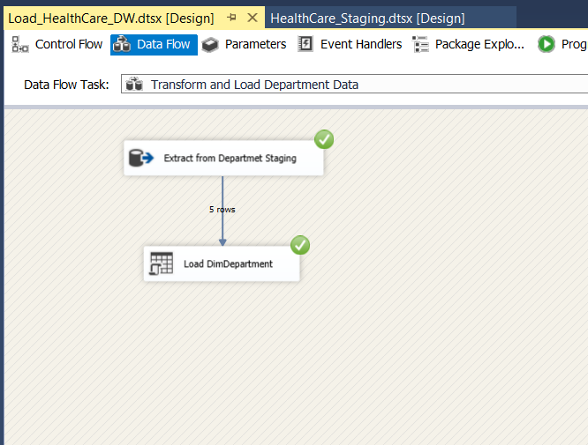
- Test and Department Data Transform and Load

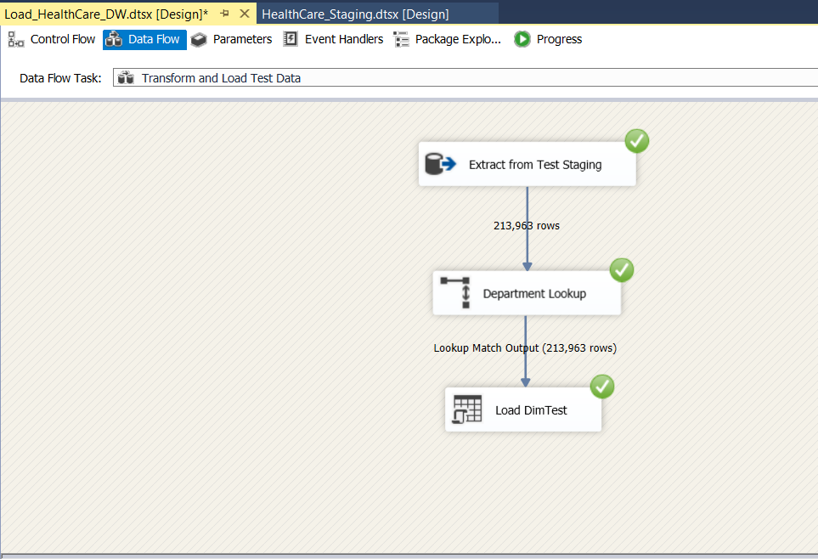

- Attendance Fact Table Transform and Load

