

**Program: ESE 4009**

**INSTRUCTOR:** Prof**.** Mike Aleshams

# Group# 4

|  |  |  |
| --- | --- | --- |
| Student Name | Student ID | Signature* |
| Dixaben Shah | 748229 | D.S |
| Jasmine | 748300 | J.K |
| Stephy Baby | 753812 | S.B |

*\*By signing above you attest that you have contributed to this submission and confirm that all work you have contributed to this submission is your own work. Any suspicion of copying or plagiarism in this work will result in an investigation of Academic Misconduct and may result in a “0” on the work, an “F” in the course, or possibly more severe penalties.*

**Project Proposal**

**Project Title:**

Home Security System.

**Description of the latest similar system:**

A home security system is a network of devices that all work together to secure your home. A typical system comes with a control panel, door and window sensors, motion detectors, a high decibel alarm, and signs for your yard and windows. Each of these components plays a part in keeping your home secure, with the control panel acting as the system’s primary control center.

* This project will help to secure places or things from theft by detecting theft right away and it spots the area where motion happened.
* A camera along with raspberry pi will help to take continuous images.
* An IR sensor present in the system will sense the motion and pass the sensed signal to the raspberry pi for finding the detected motion in the camera footage.
* Whenever motion is identified, the system makes use of image processing on the live video to detect theft. It stores the footages in a USB drive for the future reference.

**Limitations of the latest similar system:**

* In the existing system, Raspberry Pi is used that has less processing speed and don’t have built-in hard disk.
* IR Sensor is being used in existing system, which is suitable for shorter sensing range and even affected by hard objects.
* This project is only suitable for some limited areas like personal area surveillance such as personal office cabin.

**Solution 1:**

* **Block Diagram**

POWER

SUPPLY

LPC 2148

CLOUD

STORAGE

WI-FI

MODULE

BUZZER

LCD DISPLAY

CAMERA 2

CAMERA 1

PIR

SENSOR 2

RF RECEIVER

PIR

SENSOR 1

ESP 32

* **Features**
* **Features**

* LPC 2148 is used in spite of Raspberry Pi as a master Microcontroller.
* ESP 32 is considered as slave device.
* PIR Sensor is used instead of IR Sensors.
* **Hardware and Software Requirement**
* Hardware of a security system consisting of main control board which is driven by a LPC2148 microcontroller.
* ESP32 chip is used for WiFi connectivity.
* Proximity sensors for human motion detection.
* Wireless door / window sensors.

**Solution 2:**

* **Block Diagram**

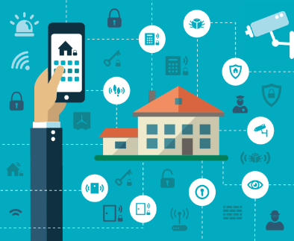

* **Features**

* ESP 32 has inbuilt programming memory, which makes ESP 32 as a master device while interfacing with the camera device.
* **Hardware and Software Requirement**
* Multiple PIR Sensors.
* More than one Wifi based wireless cameras.
* Hardware of a security system consisting of main control board which is driven by a ESP32 microcontroller.
* ESP32 also used to connect to the internet over WiFi.
* Android app support
* **References:**
* Home security. (2020, April 23). Retrieved from <https://en.wikipedia.org/wiki/Home_security>
* Aman Sharma. (2018, March). A Review paper on Smart Home Security System using GSM Module. Retrieved from <https://www.researchgate.net/publication/330498136_A_Review_paper_on_smart_Home_security_system_GSM_module>
* Umera Anjum & B. Babu. (2017). IOT Based Theft Detection using Raspberry Pi. Retrieved from

<https://www.ijariit.com/manuscripts/v3i6/V3I6-1188.pdf>

* Publication, I. A. E. M. E. (n.d.). AUTOMATED SECURITY SYSTEMS. Retrieved from <https://www.academia.edu/43060350/AUTOMATED_SECURITY_SYSTEMS>.
* **Milestones (Deliverables and Time Schedule)**

**Time - 4 Weeks, Total Milestones - 5**

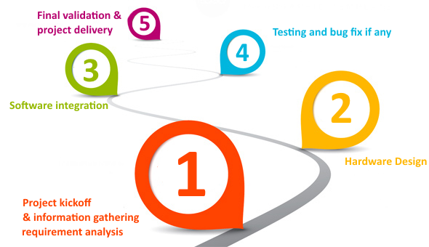

* **References:**

Home security. (2020, April 23). Retrieved from <https://en.wikipedia.org/wiki/Home_security>

**Instructor’s Remarks:**