**Covid-19 Crisis in India**

### Context

Coronaviruses are a large family of viruses which may cause illness in animals or humans. In humans, several coronaviruses are known to cause respiratory infections ranging from the common cold to more severe diseases such as Middle East Respiratory Syndrome (MERS) and severe acute respiratory syndrome (SARS). The most recently discovered coronavirus causes coronavirus disease COVID-19 - World Health Organization

The number of new cases is increasing day by day around the world. This dataset has information from the states and union territories of India at daily level.

State level data comes from [Ministry of Health & Family Welfare](https://www.mohfw.gov.in/)

Testing data and vaccination data comes from [covid19india](https://www.covid19india.org/). Huge thanks to them for their efforts!

Update on April 20, 2021: Thanks to the [Team at ISIBang](https://www.isibang.ac.in/~athreya/incovid19/), I was able to get the historical data for the periods that I missed to collect and updated the csv file.

### Content

COVID-19 cases at daily level are present in covid_19_india.csv file

State wise testing details in StatewiseTestingDetails.csv file

Travel history dataset by [@dheerajmpai](https://www.kaggle.com/dheerajmpai) - <https://www.kaggle.com/dheerajmpai/covidindiatravelhistory>

**State wise Testing details in India**

|  |  |
| --- | --- |
| **Top 10 states with highest number of Total Samples** | |
| **Row Labels** | **Sum of Total Samples** |
| Uttar Pradesh | 9155561731 |
| Bihar | 6121329928 |
| Maharashtra | 5703822545 |
| Karnataka | 5453628818 |
| Tamil Nadu | 5436042291 |
| Andhra Pradesh | 4127211823 |
| Gujarat | 3745364851 |
| Delhi | 3499131565 |
| Kerala | 3350897050 |
| Telangana | 2680729201 |

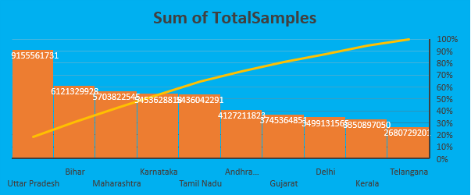

|  |  |
| --- | --- |
| **Bottom 10 states with highest number of Total Samples** | |
| **Row Labels** | **Sum of Total Samples** |
| Arunachal Pradesh | 132259016 |
| Meghalaya | 96858864 |
| Chandigarh | 79203122 |
| Andaman and Nicobar Islands | 72336655 |
| Mizoram | 64100385 |
| Nagaland | 42911316 |
| Ladakh | 27988511 |
| Sikkim | 23149220 |
| Lakshadweep | 12622334 |
| Dadra and Nagar Haveli and Daman and Diu | 6324267 |

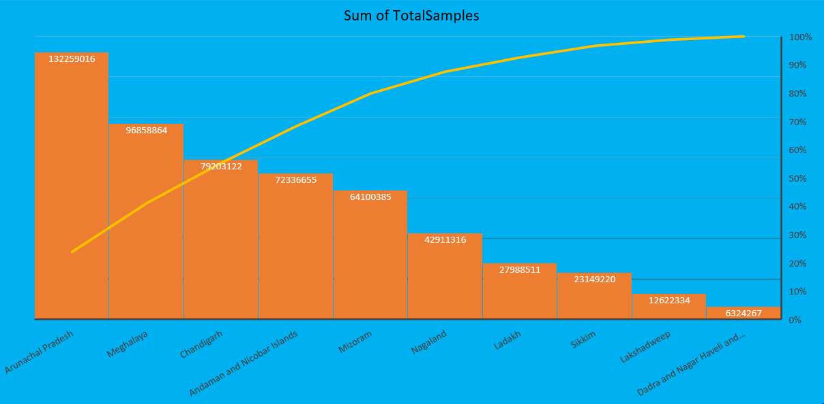

|  |  |
| --- | --- |
| **Top 10 states with highest number of Positive Case** | |
| **Row Labels** | **Sum of Positive** |
| Maharashtra | 96901583 |
| Kerala | 79723175 |
| Jharkhand | 46499325 |
| Tamil Nadu | 12772604 |
| Tripura | 10061637 |
| Gujarat | 8009517 |
| Delhi | 6848173 |
| Puducherry | 6287323 |
| Karnataka | 4701197 |
| Andhra Pradesh | 3859260 |

|  |  |
| --- | --- |
| **Bottom 10 states with highest number of Positive Case** | |
| **Row Labels** | **Sum of Positive** |
| Himachal Pradesh | 119494 |
| Manipur | 101501 |
| Nagaland | 90682 |
| Ladakh | 89027 |
| Chandigarh | 59195 |
| Arunachal Pradesh | 51245 |
| Meghalaya | 33904 |
| Mizoram | 19785 |
| Sikkim | 17644 |
| Lakshadweep |  |

|  |  |
| --- | --- |
| **Top 10 states with highest number of Negative cases** | |
| **Row Labels** | **Count of Negative** |
| Uttarakhand | 455 |
| Jammu and Kashmir | 454 |
| Himachal Pradesh | 452 |
| Jharkhand | 448 |
| Chandigarh | 444 |
| Puducherry | 430 |
| Arunachal Pradesh | 428 |
| Madhya Pradesh | 411 |
| Tripura | 409 |
| Andhra Pradesh | 405 |

|  |  |
| --- | --- |
| **Bottom 10 states with highest number of Negative cases** | |
| **Row Labels** | **Count of Negative** |
| Telangana | 30 |
| Delhi | 22 |
| Odisha | 13 |
| Mizoram | 2 |
| Goa | 2 |
| West Bengal | 1 |
| Andaman and Nicobar Islands | 1 |
| Bihar | 1 |
| Manipur |  |
| Lakshadweep |  |

**\*Active cases in India**

|  |  |
| --- | --- |
| **Top 10 states with highest number of Confirmed cases** | |
| **Row Labels** | **Sum of Confirmed** |
| Maharashtra | 1070657336 |
| Karnataka | 462620921 |
| Kerala | 427313974 |
| Tamil Nadu | 408786439 |
| Andhra Pradesh | 374631235 |
| Uttar Pradesh | 297247727 |
| Delhi | 274298085 |
| West Bengal | 249317376 |
| Chhattisgarh | 154749830 |
| Rajasthan | 153785608 |

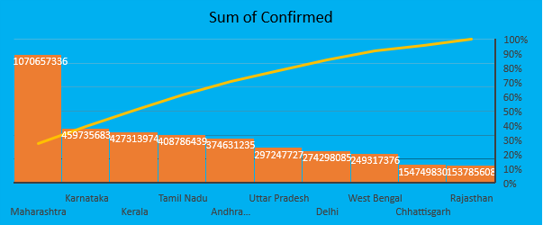

|  |  |
| --- | --- |
| **Bottom 10 states with Confirmed cases** | |
| **Row Labels** | **Sum of Confirmed** |
| Daman & Diu | 2 |
| Unassigned | 161 |
| Dadra and Nagar Haveli | 20722 |
| Himanchal Pradesh | 204516 |
| Cases being reassigned to states | 345565 |
| Lakshadweep | 823634 |
| Dadra and Nagar Haveli and Daman and Diu | 1842763 |
| Andaman and Nicobar Islands | 1870612 |
| Mizoram | 2594668 |
| Sikkim | 2938742 |

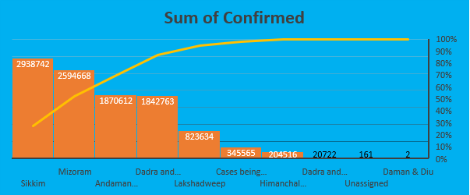

**\*Cured/ Discharged**

|  |  |
| --- | --- |
| **Top 10 states with highest number of Cured cases** | |
| **Row Labels** | **Sum of Cured** |
| Maharashtra | 969585013 |
| Karnataka | 416155734 |
| Kerala | 390311164 |
| Tamil Nadu | 381444416 |
| Andhra Pradesh | 352926995 |
| Uttar Pradesh | 276311742 |
| Delhi | 260720476 |
| West Bengal | 233983721 |
| Chhattisgarh | 142720847 |
| Odisha | 142222495 |

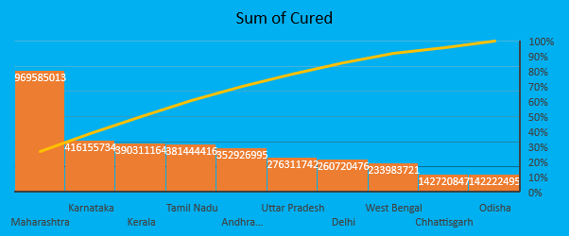

|  |  |
| --- | --- |
| **Bottom 10 states with highest number of Cured cases** | |
| **Row Labels** | **Sum of Cured** |
| Sikkim | 2530368 |
| Mizoram | 2109700 |
| Andaman and Nicobar Islands | 1781610 |
| Dadra and Nagar Haveli and Daman and Diu | 1746014 |
| Lakshadweep | 729839 |
| Himanchal Pradesh | 200040 |
| Dadra and Nagar Haveli | 20352 |
| Cases being reassigned to states | 0 |
| Unassigned | 0 |
| Daman & Diu | 0 |

**\*Deaths**

|  |  |
| --- | --- |
| **Top 10 states with highest number of Death cases** | |
| **Row Labels** | **Sum of Deaths** |
| Maharashtra | 22665169 |
| Karnataka | 5723143 |
| Tamil Nadu | 5608369 |
| Delhi | 4717732 |
| Uttar Pradesh | 3938519 |
| West Bengal | 3683145 |
| Andhra Pradesh | 2817970 |
| Punjab | 2638818 |
| Gujarat | 2128759 |
| Chhattisgarh | 1942099 |

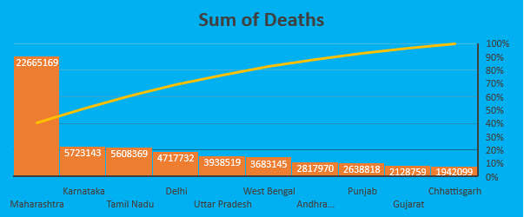

|  |  |
| --- | --- |
| **Bottom 10 states with highest number of Death cases** | |
| **Row Labels** | **Sum of Deaths** |
| Andaman and Nicobar Islands | 25975 |
| Arunachal Pradesh | 24646 |
| Mizoram | 8331 |
| Himanchal Pradesh | 3507 |
| Lakshadweep | 3457 |
| Dadra and Nagar Haveli and Daman and Diu | 978 |
| Dadra and Nagar Haveli | 8 |
| Unassigned | 0 |
| Daman & Diu | 0 |
| Cases being reassigned to states | 0 |

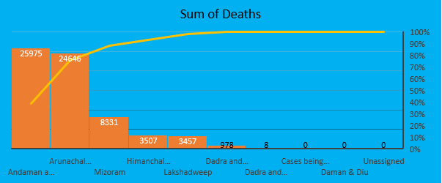

|  |  |  |  |
| --- | --- | --- | --- |
| **Top 10 states with highest percentage of Death** | | | |
| **Row Labels** | **Sum of Deaths** | **Sum of Confirmed** | **Death percentage** |
| Punjab | 2638818 | 94555404 | 2.80% |
| Maharashtra | 22665169 | 1070657336 | 2.10% |
| Uttarakhand | 919703 | 50059393 | 1.80% |
| Delhi | 4717732 | 274298085 | 1.70% |
| Himanchal Pradesh | 3507 | 204516 | 1.70% |
| Sikkim | 49983 | 2938742 | 1.70% |
| Himachal Pradesh | 459573 | 28166667 | 1.60% |
| Goa | 419386 | 26694923 | 1.60% |
| Gujarat | 2128759 | 135995074 | 1.60% |
| Puducherry | 295970 | 18973138 | 1.60% |

|  |  |  |  |
| --- | --- | --- | --- |
| **Bottom 10 states with highest percentage of Death** | | | |
| **Row Labels** | **Sum of Deaths** | **Sum of Confirmed** | **Death percentage** |
| Odisha | 734106 | 151269645 | 0.50% |
| Lakshadweep | 3457 | 823634 | 0.40% |
| Kerala | 1730808 | 427313974 | 0.40% |
| Arunachal Pradesh | 24646 | 6730183 | 0.40% |
| Mizoram | 8331 | 2594668 | 0.30% |
| Dadra and Nagar Haveli and Daman and Diu | 978 | 1842763 | 0.10% |
| Dadra and Nagar Haveli | 8 | 20722 | 0.00% |
| Unassigned | 0 | 161 | 0.00% |
| Daman & Diu | 0 | 2 | 0.00% |
| Cases being reassigned to states | 0 | 345565 | 0.00% |

**Covid_vaccine_state wise**

**\*Male and Female Vaccinated ratio for Covid19**

|  |  |
| --- | --- |
| **Sum of Male(Individuals Vaccinated)** | **Sum of Female(Individuals Vaccinated)** |
| 18579894484 | 16340809968 |

**\*Covaxin and Covishield Vaccination**

|  |  |
| --- | --- |
| **Sum of Total Covaxin Administered** | **Sum of Total CoviShield Administered** |
| 4408372879 | 36316339316 |

**\*Doses administered vs People Vaccinated**

|  |  |
| --- | --- |
| **Sum of Total Doses Administered** | **Sum of Total Individuals Vaccinated** |
| 40814304071 | 33503614338 |

### Acknowledgements

Thanks to Indian [Ministry of Health & Family Welfare](https://www.mohfw.gov.in/) for making the data available to general public.

Thanks to [covid19india.org](http://portal.covid19india.org/) for making the individual level details, testing details, vaccination details available to general public.

Thanks to [Wikipedia](https://en.wikipedia.org/wiki/List_of_states_and_union_territories_of_India_by_population) for population information.

Thanks to the [Team at ISIBang](https://www.isibang.ac.in/~athreya/incovid19/)

Photo Courtesy - <https://hgis.uw.edu/virus/>

### Inspiration

Looking for data-based suggestions to stop / delay the spread of virus