

**CUSTOMER RETENSION CASE STUDY**

**Name: Neha Dixit**

**Internship Batch: 16**

**Problem statement:**

Customer satisfaction has emerged as one of the most important factors that guarantee the success of online store; it has been posited as a key stimulant of purchase, repurchase intentions and customer loyalty. A comprehensive review of the literature, theories and models have been carried out to propose the models for customer activation and customer retention. Five major factors that contributed to the success of an e-commerce store have been identified as: service quality, system quality, information quality, trust and net benefit. The research furthermore investigated the factors that influence the online customers repeat purchase intention. The combination of both utilitarian value and hedonistic values are needed to affect the repeat purchase intention (loyalty) positively. The data is collected from the Indian online shoppers. Results indicate the e-retail success factors, which are very much critical for customer satisfaction.

**Problem Definition:**

Customer segmentation is a process where we divide the consumer base of the company into subgroups. We need to generate the subgroups by using some specific characteristics so that the company sells more products with less marketing expenditure. Before moving forward, we need to understand the basics, for example, what do I mean by customer base? What do I mean by segment? How do we generate the consumer subgroup? What are the characteristics that we consider while we are segmenting the consumers? Let's answers these questions one by one.

Basically, the consumer base of any company consists of two types of consumers:

1. Existing consumers
2. Potential consumers

Generally, we need to categorize our consumer base into subgroups. These subgroups are called segments. We need to create the groups in such a way that each subgroup of customers has some shared characteristics. Example

Suppose a company is selling baby products. Then, it needs to come up with a consumer segment (consumer subgroup) that includes the consumers who want to buy the baby products. We can build the first segment (subgroup) with the help of a simple criterion. We will include consumers who have one baby in their family and bought a baby product in the last month. Now, the company launches a baby product that is too costly or premium. In that case, we can further divide the first subgroup into monthly income and socio-economic status. Based on these new criteria, we can generate the second subgroup of consumers. The company will target the consumers of the second subgroup for the costly and premium products, and for general products, the company will target consumers who are part of the first subgroup.

When we have different segments, we can design a customized marketing strategy as well as customized products that suit the customer of the particular segment. This segment-wise marketing will help the company sell more products with lower marketing expenses. Thus, the company will make more profit. This is the main reason why companies use customer segmentation analysis nowadays. Customer segmentation is used among other domain such as the retail domain, finance domain, and in customer relationship management (CRM)-based products.

**Data Analysis:**

The key to success in an organisation is the ability to attract and retain top talents. It is vital for the Customer Retention case study project to identify the factors that keep employees and those who the first stage of this analysis is to describe the dataset, understand the meaning of each variable, detect possible patterns and perform the necessary adjustments to ensure that the data will be proceeded correctly during the Machine Learning process. each prompt them to leave. Organisations could do more to prevent the loss of good people.

**Total Columns**

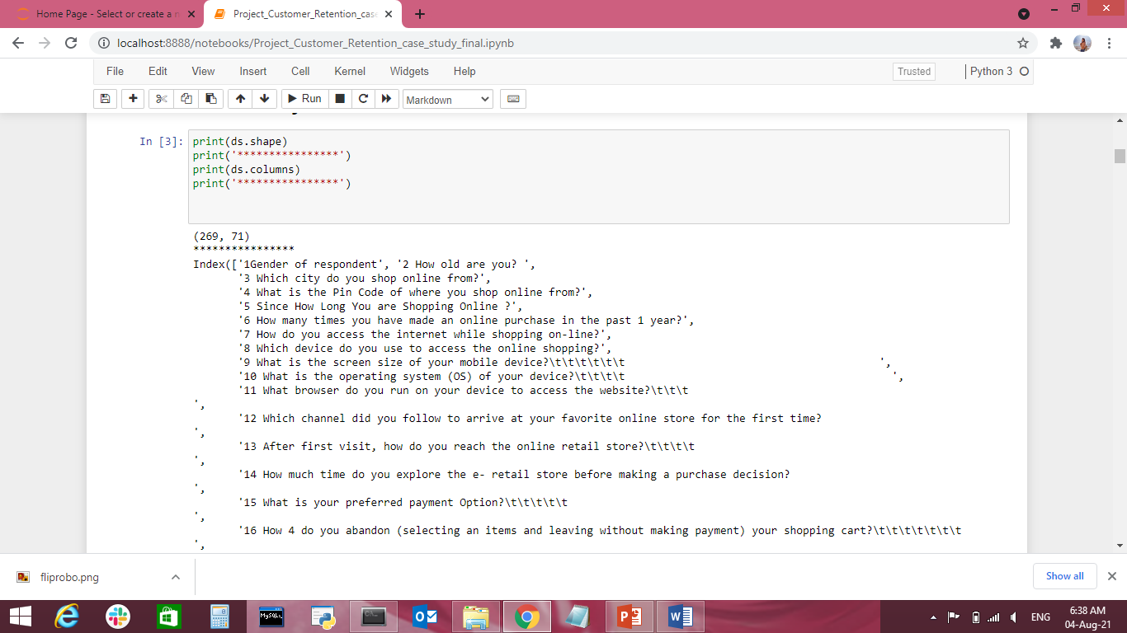

'1Gender of respondent', '2 How old are you? ',

'3 Which city do you shop online from?',

'4 What is the Pin Code of where you shop online from?',

'5 Since How Long You are Shopping Online ?',

'6 How many times you have made an online purchase in the past 1 year?',

'7 How do you access the internet while shopping on-line?',

'8 Which device do you use to access the online shopping?',

'9 What is the screen size of your mobile device?\t\t\t\t\t\t ',

'10 What is the operating system (OS) of your device?\t\t\t\t ',

'11 What browser do you run on your device to access the website?\t\t\t ',

'12 Which channel did you follow to arrive at your favorite online store for the first time? ',

'13 After first visit, how do you reach the online retail store?\t\t\t\t ',

'14 How much time do you explore the e- retail store before making a purchase decision? ',

'15 What is your preferred payment Option?\t\t\t\t\t ',

'16 How 4 do you abandon (selecting an items and leaving without making payment) your shopping cart?\t\t\t\t\t\t\t ',

'17 Why did you abandon the Bag, Shopping Cart?\t\t\t\t\t ',

'18 The content on the website must be easy to read and understand',

'19 Information on similar product to the one highlighted is important for product comparison',

'20 Complete information on listed seller and product being offered is important for purchase decision.',

'21 All relevant information on listed products must be stated clearly',

'22 Ease of navigation in website', '23 Loading and processing speed',

'24 User friendly Interface of the website',

'25 Convenient Payment methods',

'26 Trust that the online retail store will fulfill its part of the transaction at the stipulated time',

'27 Empathy (readiness to assist with queries) towards the customers',

'28 Being able to guarantee the privacy of the customer',

'29 Responsiveness, availability of several communication channels (email, online rep, twitter, phone etc.)',

'30 Online shopping gives monetary benefit and discounts',

'31 Enjoyment is derived from shopping online',

'32 Shopping online is convenient and flexible',

'33 Return and replacement policy of the e-tailer is important for purchase decision',

'34 Gaining access to loyalty programs is a benefit of shopping online',

'35 Displaying quality Information on the website improves satisfaction of customers',

'36 User derive satisfaction while shopping on a good quality website or application',

'37 Net Benefit derived from shopping online can lead to users satisfaction',

'38 User satisfaction cannot exist without trust',

'39 Offering a wide variety of listed product in several category',

'40 Provision of complete and relevant product information',

'41 Monetary savings',

'42 The Convenience of patronizing the online retailer',

'43 Shopping on the website gives you the sense of adventure',

'44 Shopping on your preferred e-tailer enhances your social status',

'45 You feel gratification shopping on your favorite e-tailer',

'46 Shopping on the website helps you fulfill certain roles',

'47 Getting value for money spent',

'From the following, tick any (or all) of the online retailers you have shopped from; ',

'Easy to use website or application',

'Visual appealing web-page layout', 'Wild variety of product on offer',

'Complete, relevant description information of products',

'Fast loading website speed of website and application',

'Reliability of the website or application',

'Quickness to complete purchase',

'Availability of several payment options', 'Speedy order delivery ',

'Privacy of customers information',

'Security of customer financial information',

'Perceived Trustworthiness',

'Presence of online assistance through multi-channel',

'Longer time to get logged in (promotion, sales period)',

'Longer time in displaying graphics and photos (promotion, sales period)',

'Late declaration of price (promotion, sales period)',

'Longer page loading time (promotion, sales period)',

'Limited mode of payment on most products (promotion, sales period)',

'Longer delivery period', 'Change in website/Application design',

'Frequent disruption when moving from one page to another',

'Website is as efficient as before',

'Which of the Indian online retailer would you recommend to a friend?'

**Null Values**

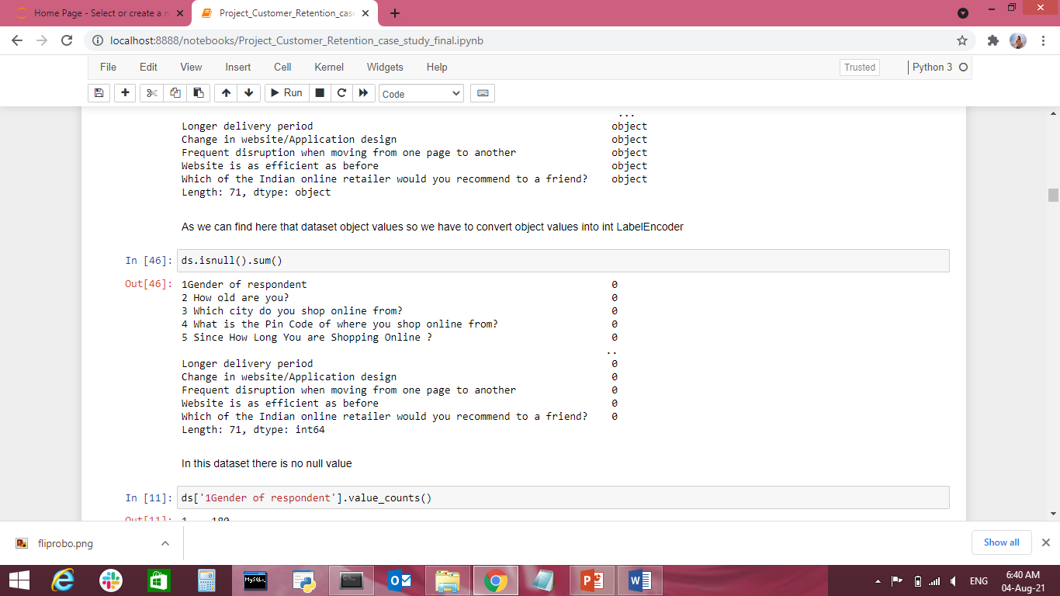

**Total Number of Gender:**

Female-180

Male-89

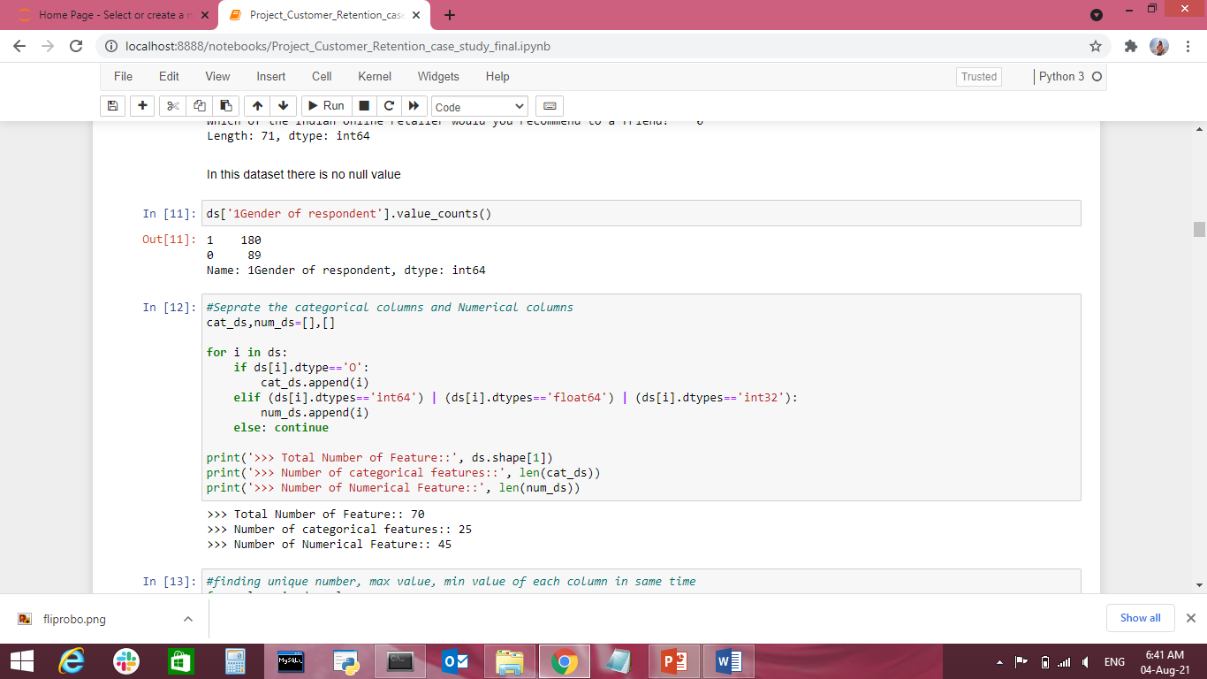

**Data Describe Mean, Std values:**

* Reading the CSV file and doing initial statistical analysis (shape, values etc)
* 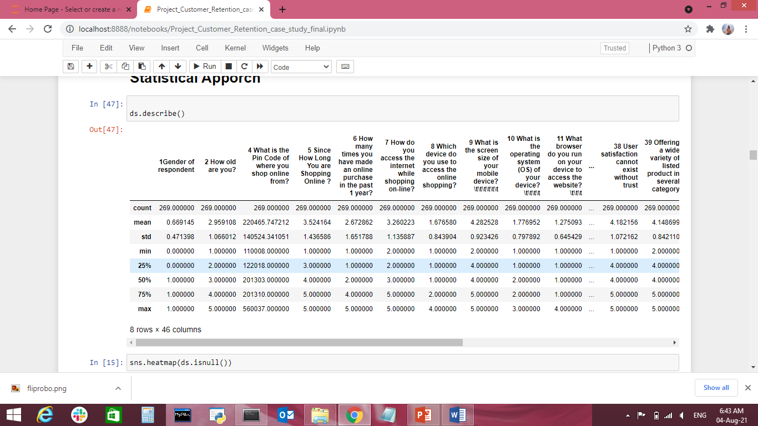
* Data Pre-processing: Reading the uniques values for each column and removing those which won’t be significant in the analysis further.
* Create a new data frame to proceed with the analysis further

**EDA Concluding Remarks:**

* Find patterns of data through visualization and reveal the hidden trends from data.
* Using both matplotlib and seaborn library to visualize the data

Finding relationships between features using bar graphs, histograms, box plots, heatmap

plt.figure(figsize=(25,8))

sns.countplot(ds['1Gender of respondent'])

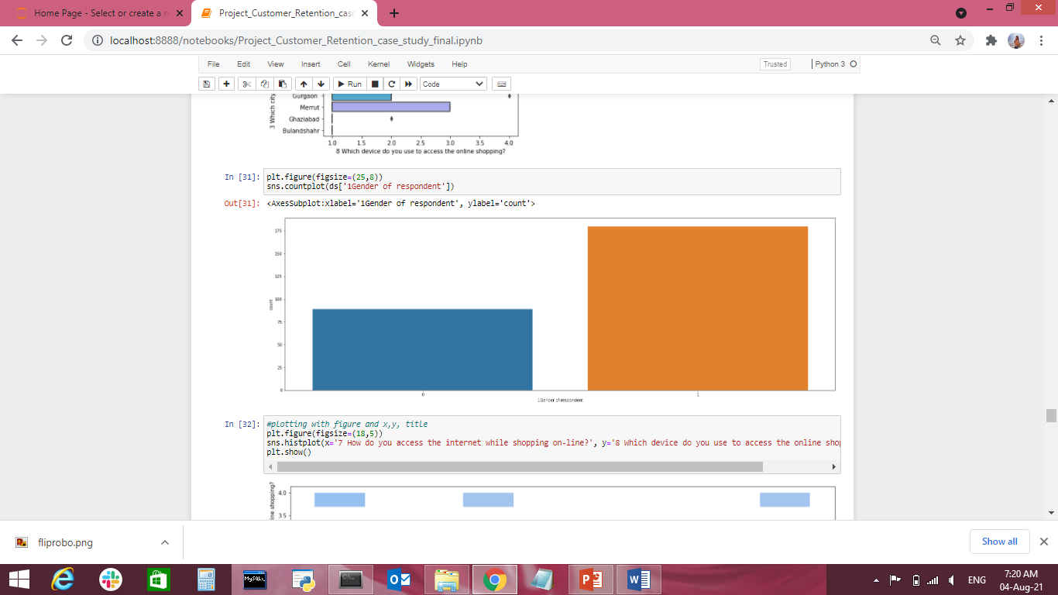

Female no- 180

Male- 89

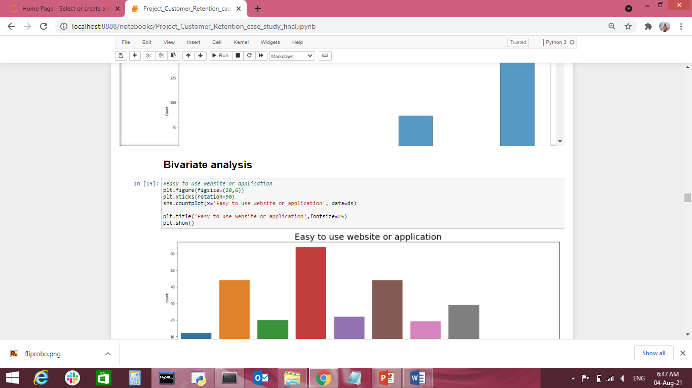

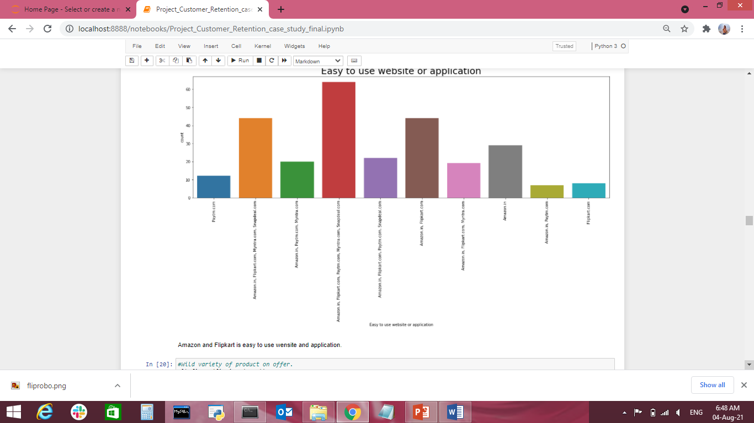

Amazon and Flipkart are easy to use website and application

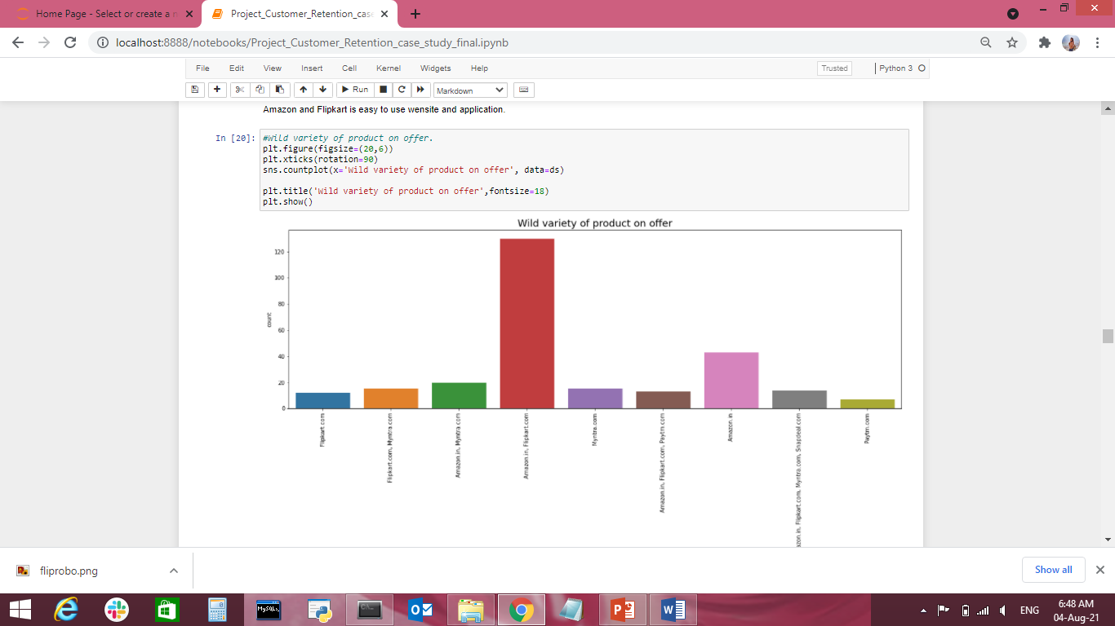

Amazon has very high variety of products on offer

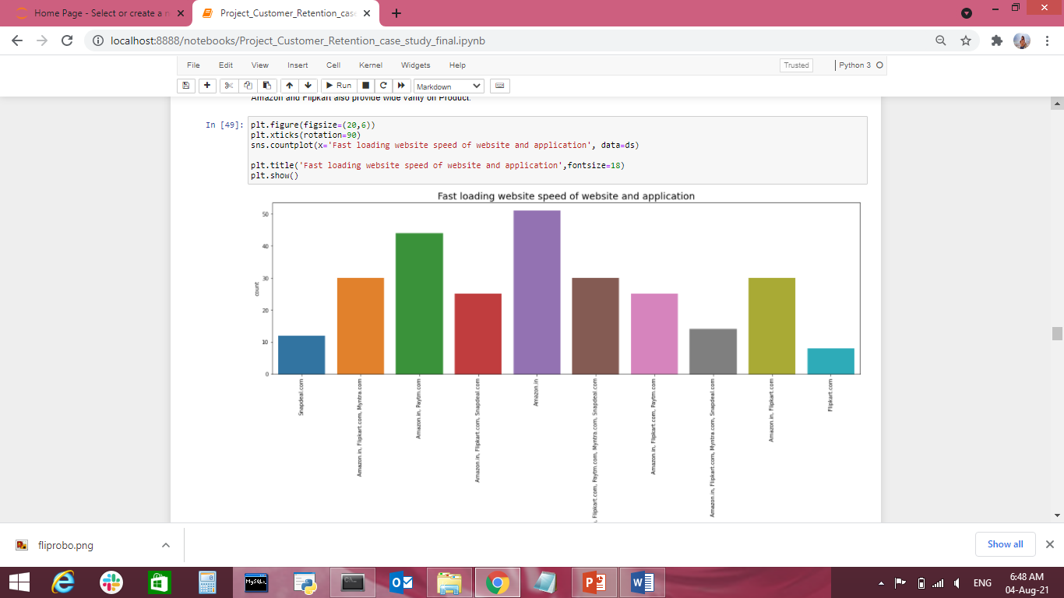

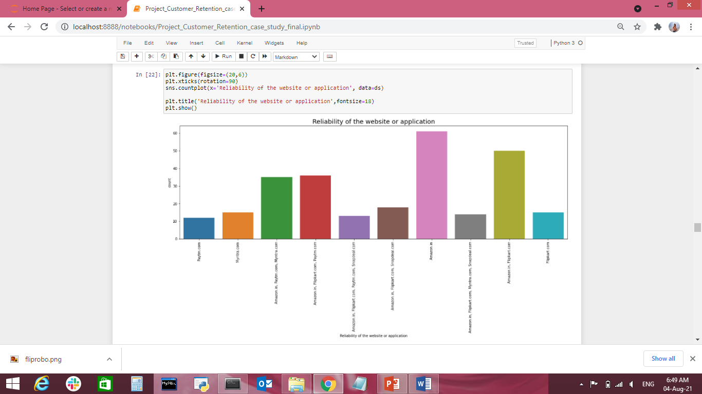

Amazon and Flipkart is Most Reliabilty of the Application

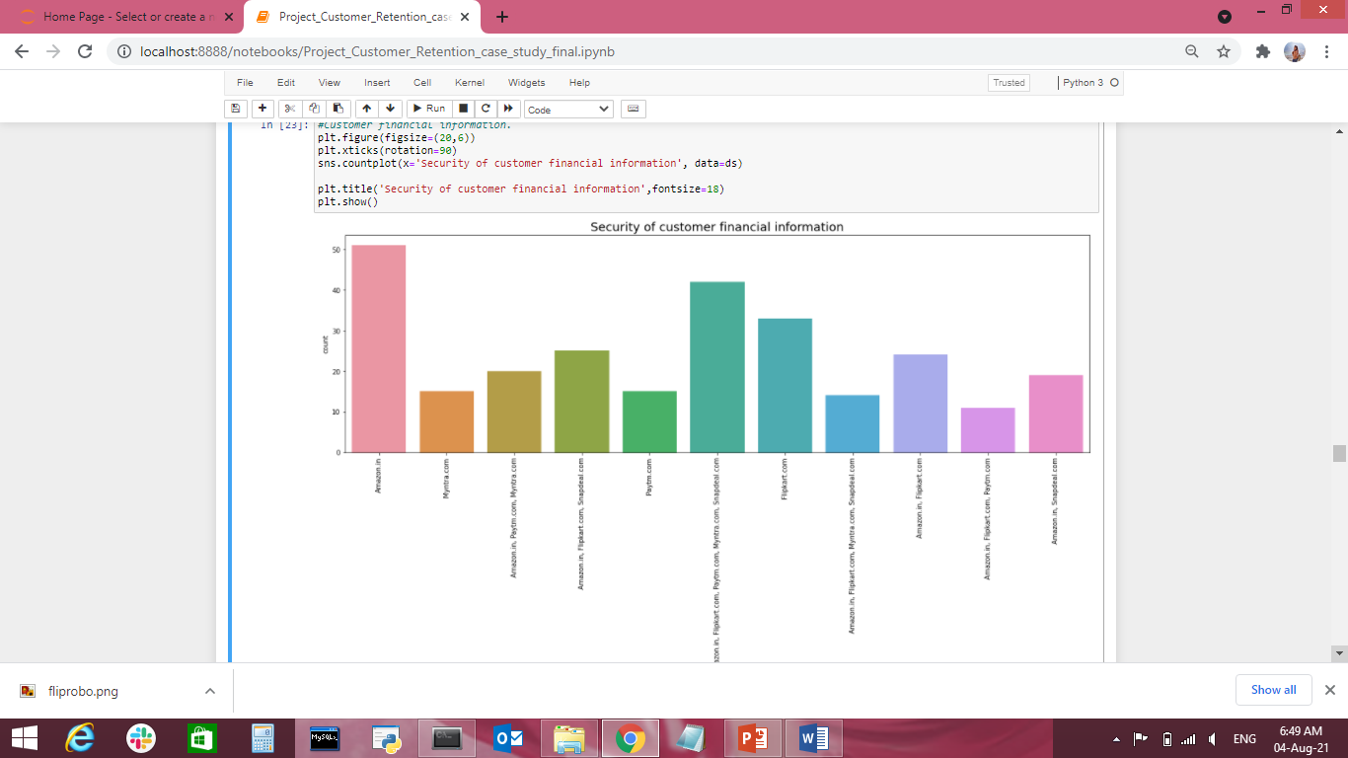

Customer Financial Information is more secure in Amazon.

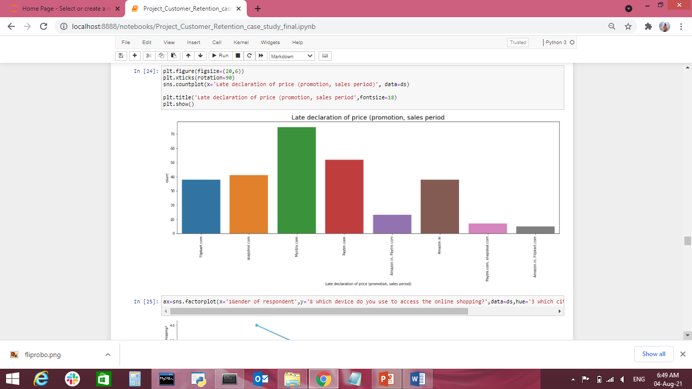

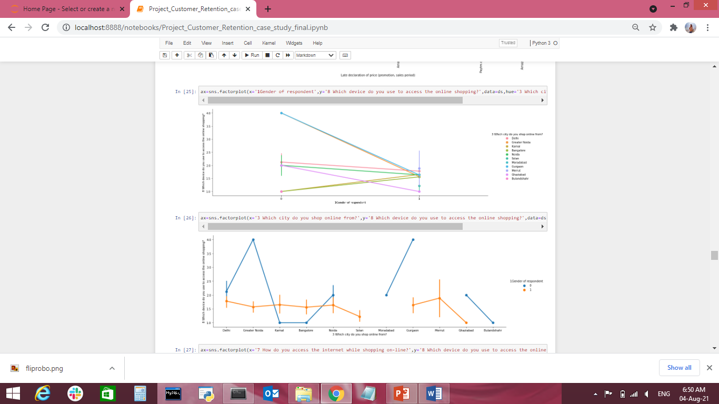

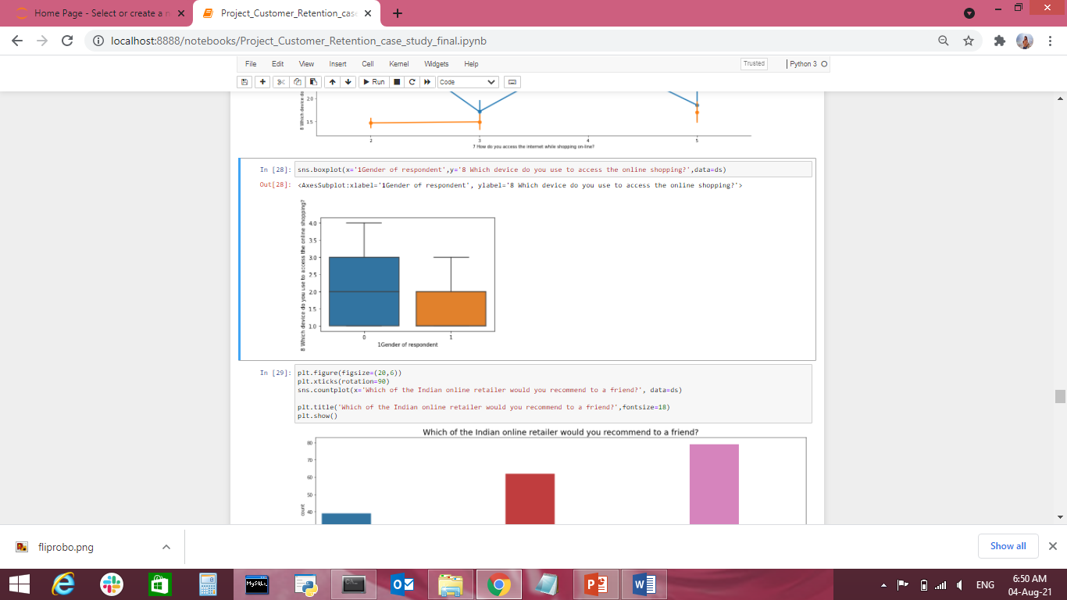

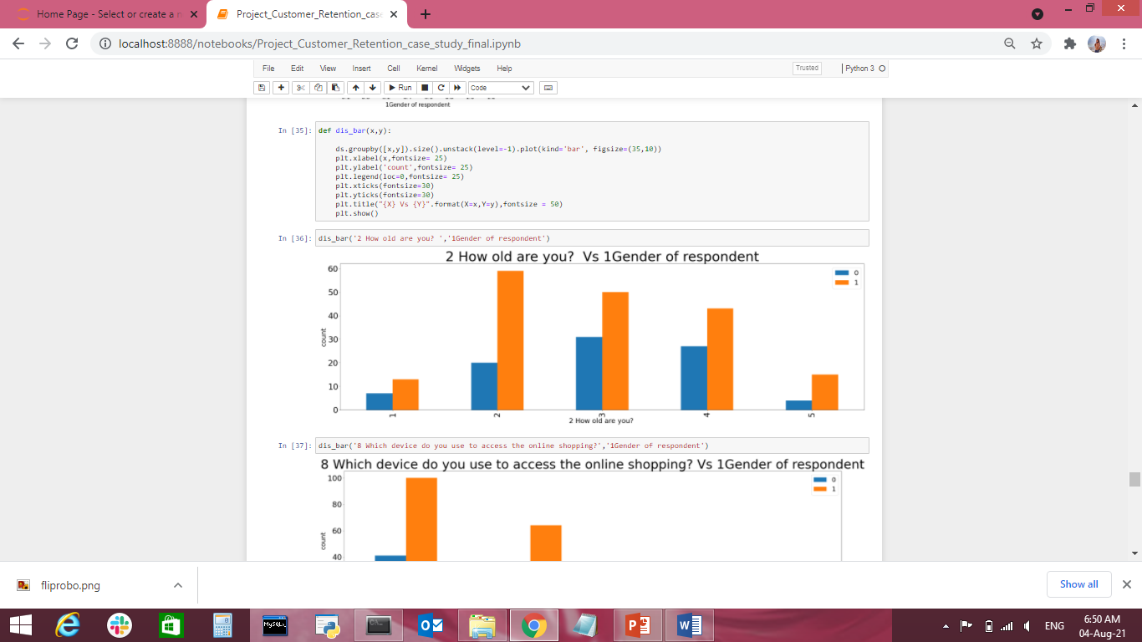

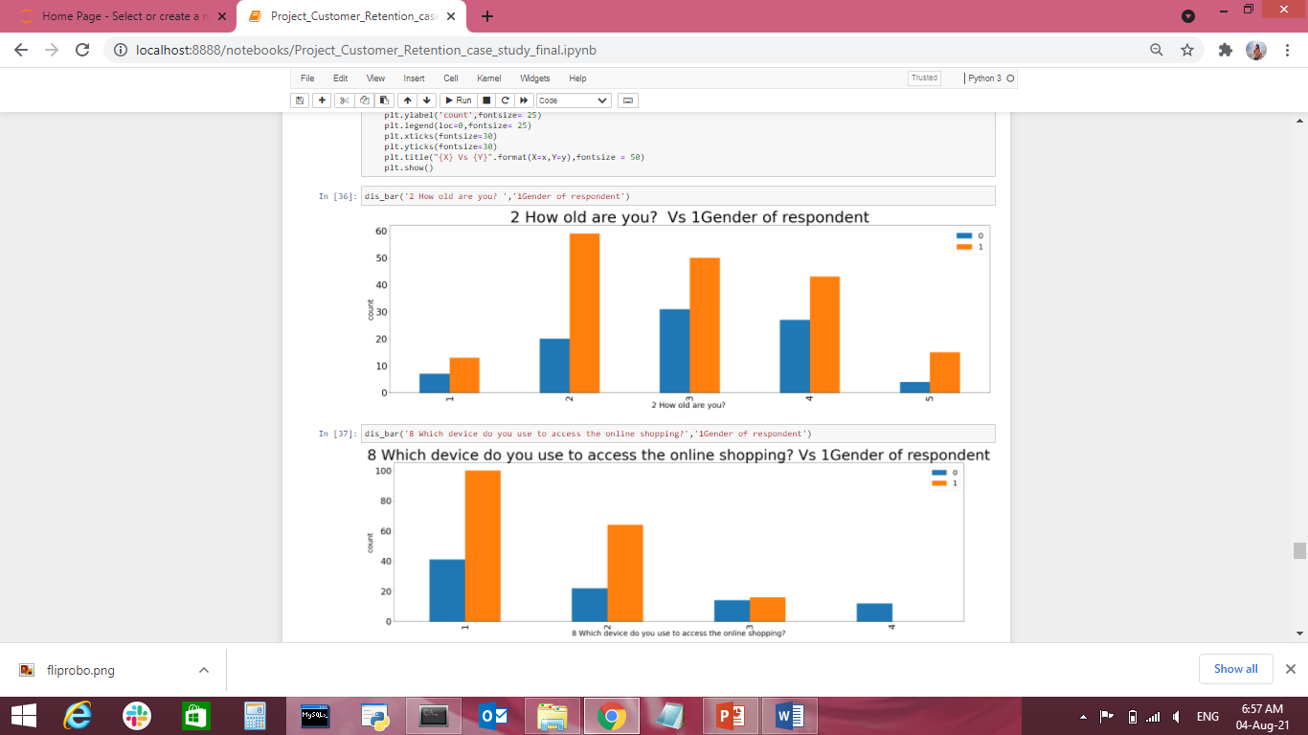

Analyzing both the numerical and the categorical columns separately

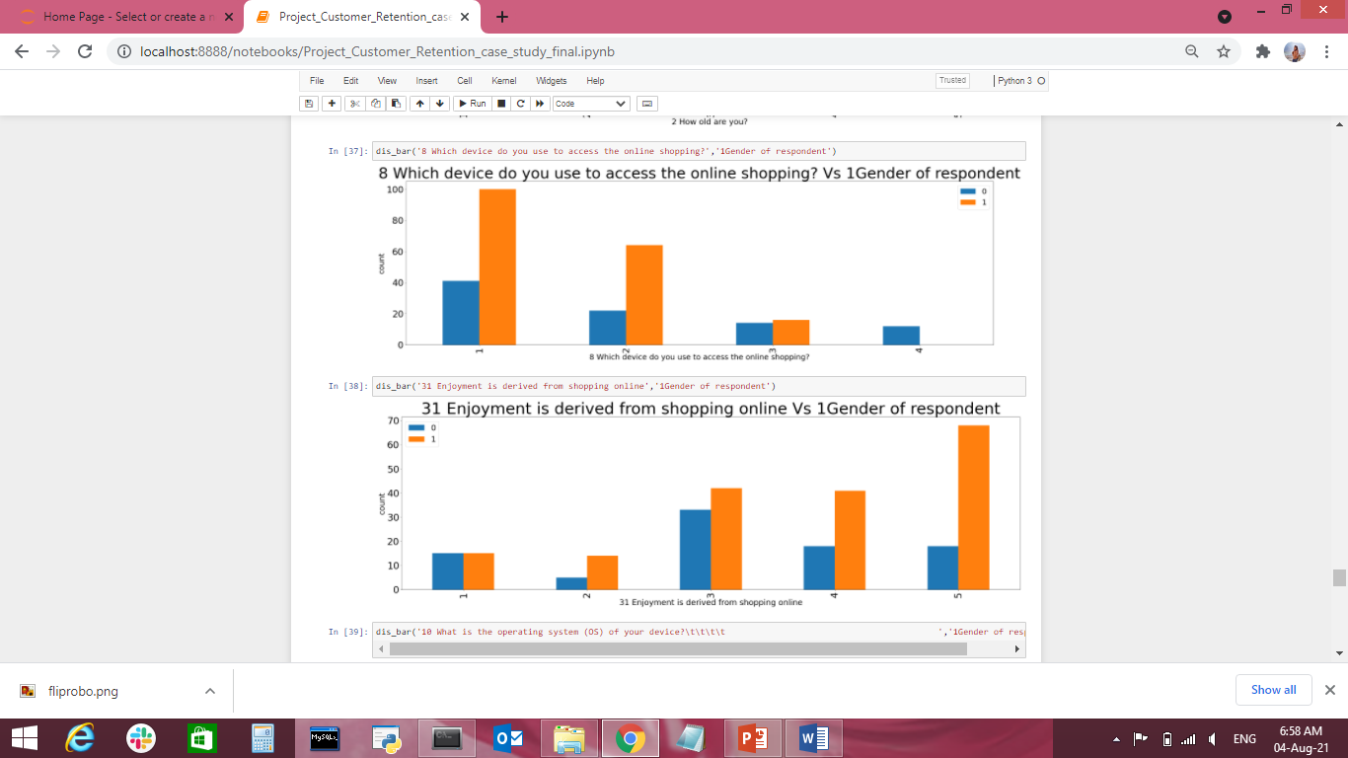

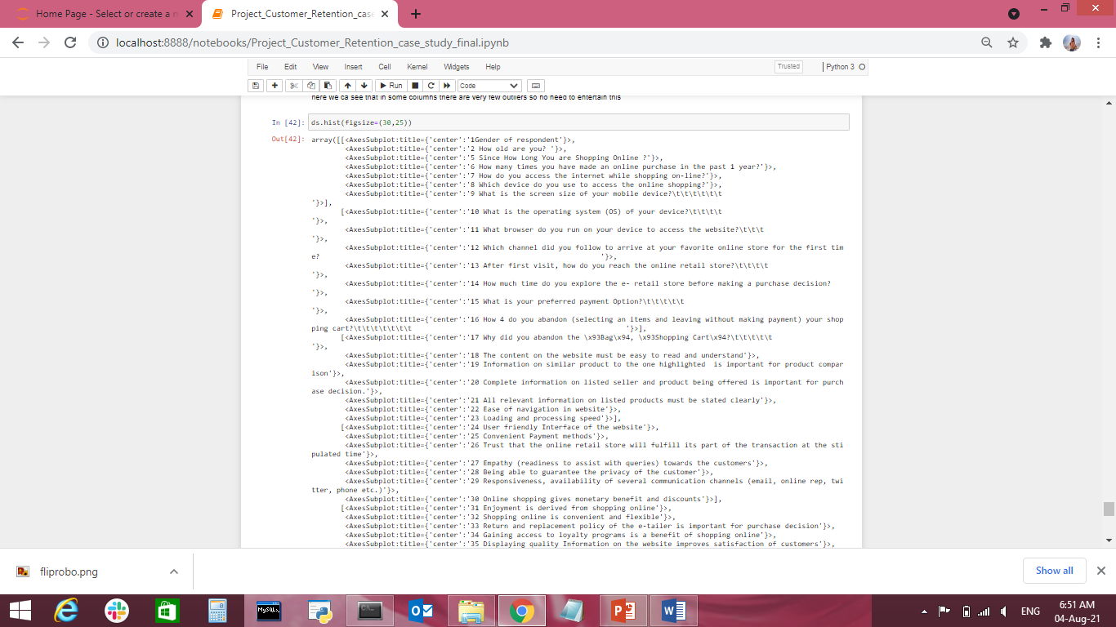

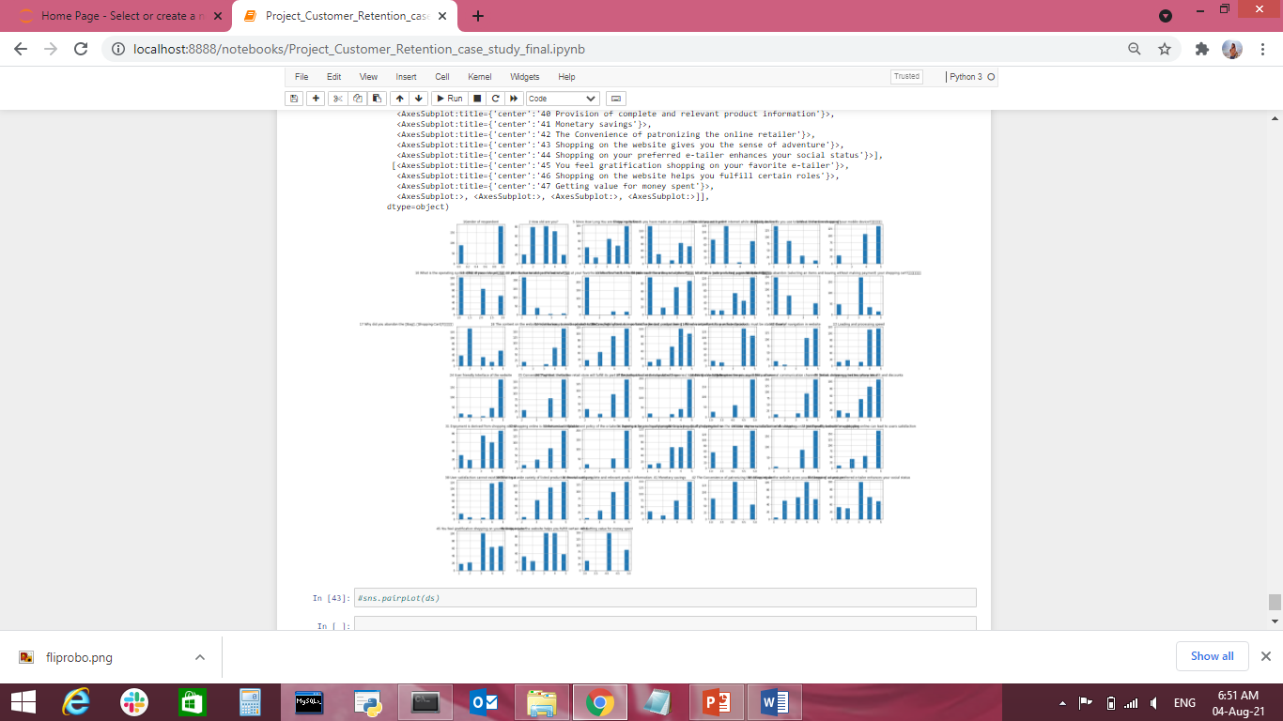

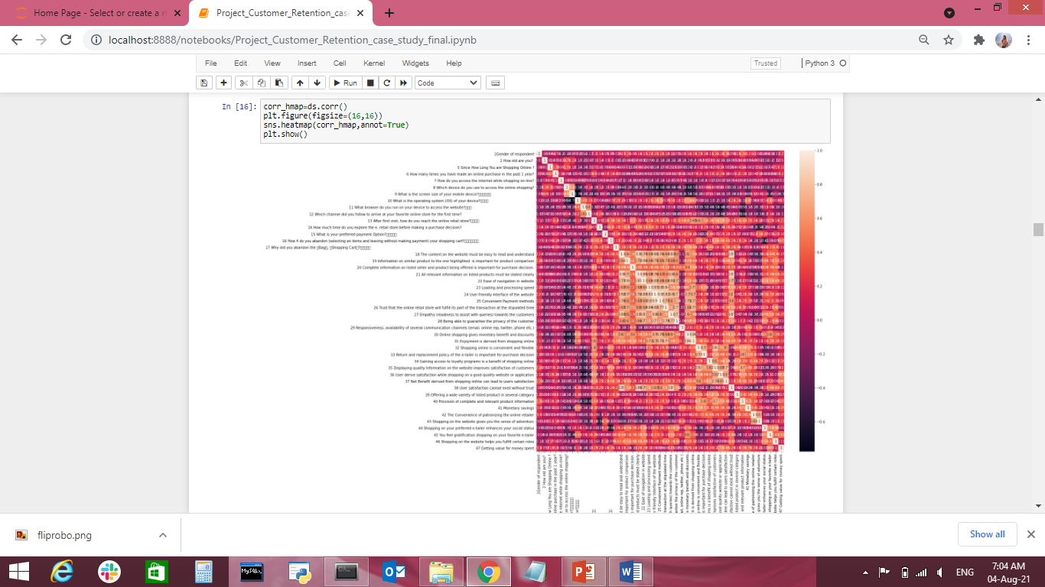

Observation:

1. Female is more than male in Dataset.
2. Age between 21 to 50 is more buy online product or sserching buying online product.
3. Delhi on metropolition city for online shop is maximum but in Gurgaon online shop is less than Ghaziabad.
4. More than 4 year for Shopping online is maximum in the dataset.
5. Online puchase is less than 10 product is maximum means in the offer day and reqirement of the product than buy the product.
6. 30 to 40 item purchase online in the dataset is also more means generally maximum person go for online product.
7. Using moblile phone internet for shopping online prodcut is more and Dial Up is very less.
8. Smart Phone and Laptip is maxium time using for online shopping.
9. Windows operating system based mobile and laptop is used for online shop.
10. Google Chrome broser is maximum time to access the website as compare to other broser.

Concluding Remarks:

Customer retention case study is gaining traction in organisations that embrace digital transformation. The scope has expanded from analytics of employee work performance to providing insights so that decisive improvements can be made to organisational processes. While some level of attrition is inevitable, it should be kept at the minimal possible level.

This model will allow the company to calculate the probability of an employee to leave the company and to act on key-factors to avoid departures. The satisfaction of employees and the amount of workload they have to bear seem to be important causes of withdrawals. A particular attention on the work-life balance would be crucial to improve the turnover rate.

**Thank You**