**MODULE: 1 (SDLC) Answer**

1. What is software? What is software engineering?

ANS : - **Software** is a set of instructions, data or programs used to operate computers and execute specific tasks. It’s make easy life of human.

**Software engineering** is the process of designing, developing, testing, and maintaining software. It is a systematic and disciplined approach to software development that aims to create high-quality, reliable, and maintainable software. Software engineering includes a variety of techniques, tools, and methodologies, including requirements analysis, design, testing, and maintenance.

1. Explain types of software?

ANS : - There are different types of software based on their classification.

• System Software

• Application Software

**System Software**

System software is usually defined as a set of various programs that help to control the hardware devices connected to the computer and other important resources of the system. Specifically, it helps in making the working of the computer efficient, enables faster performance in a secure manner. In addition, the system software also establishes a platform to run the application software.

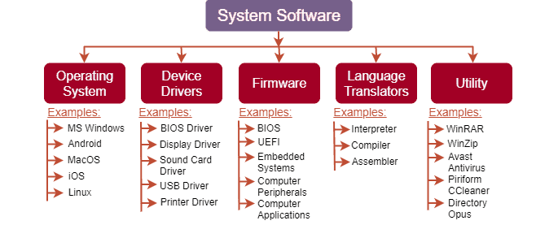

**Application Software**

Application software refers to a set of programs and instructions that help perform specific tasks, on a computer system. It is mainly designed to meet certain requirements of a particular environment. Application software can be downloaded and installed manually on the computer system and these software have nothing to do with the system core functions.

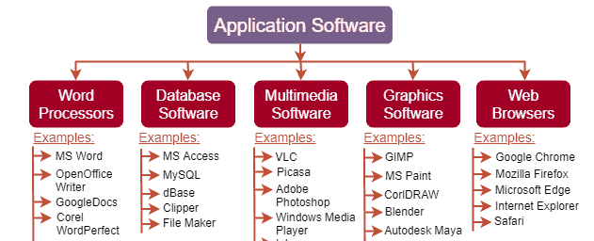

**3**.What is SDLC? Explain each phase of SDLC.

ANS : - The Software Development Life Cycle (SDLC) refers to a methodology with clearly defined processes for creating high-quality software.

The SDLC typically includes the following phases:

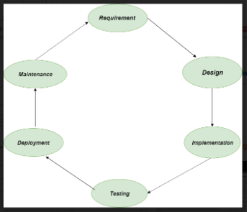

**1. Requirements gathering and analysis:**

This phase involves gathering information about the software requirements from stakeholders, such as customers, end-users, and business analysts.

2. **Design**:

In this phase, the software design is created, which includes the overall architecture of the software, data structures, and interfaces. It has two steps:

* High-level design (HLD): It gives the architecture of software products.
* Low-level design (LLD): It describes how each and every feature in the product should work and every component.

3. **Implementation or coding**:

The design is then implemented in code, usually in several iterations, and this phase is also called as Development.

Things you need to know about this phase:

* This is the longest phase in SDLC model.
* This phase consists of Front end + Middleware + Back-end.
* In front-end: Development of coding is done even SEO settings are done.
* In Middleware: They connect both the front end and back end.
* In the back-end: A database is created.

4. **Testing**:

The software is thoroughly tested to ensure that it meets the requirements and works correctly.

5. **Deployment**:

After successful testing, the software is deployed to a production environment and made available to end-users.

 6. **Maintenance**:

This phase includes ongoing support, bug fixes, and updates to the software.

**4**. What is DFD? Create a DFD diagram on Flipkart.

ANS : -A Data Flow Diagram is a traditional visual representation of the information flows within a system. A neat and clear DFD can depict the right amount of the system requirement graphically. It can be manual, automated, or a combination of both. It shows how data enters and leaves the system, what changes the information, and where data is stored.

The objective of a DFD is to show the scope and boundaries of a system as a whole. It may be used as a communication tool between a system analyst and any person who plays a part in the order that acts as a starting point for redesigning a system. The DFD is also called as a data flow graph or bubble chart.

DFD diagram of Flipkart:-

Zero level DFD :-

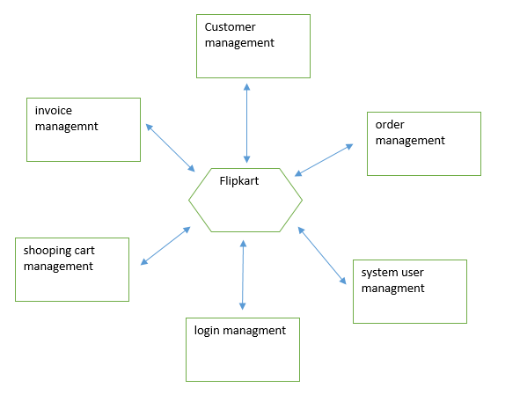

**5**. What is Flow chart? Create a flowchart to make addition of two numbers.

ANS : - Flowchart is a diagrammatic representation of sequence of logical steps of a program. Flowcharts use simple geometric shapes to depict processes and arrows to show relationships and process/data flow.

Following flowchart to make addition of two numbers:

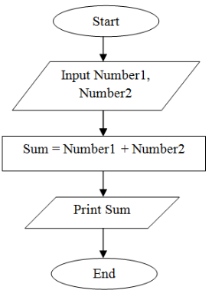

**6**. What is Use case Diagram? Create a use-case on bill payment on paytm.

ANS : - A use case diagram is a graphical depiction of a user's possible interactions with a system. A use case diagram shows various use cases and different types of users the system has and will often be accompanied by other types of diagrams as well. The use cases are represented by either circles or ellipses. The actors are often shown as stick figures.

