EMAIL SPAM CLASSIFICATION

The goal of this study is to evaluate traditional machine learning models against a transformer-based deep learning model in terms of performance metrics and computational efficiency.

1) Methodology

a) Data Preprocessing

The dataset used consists of email messages labelled as either "ham" or "spam." The preprocessing steps applied include:

* Removal of missing values ( here, there were no missing values)
* Dropping the last row (cause invalid, so df[:-1])
* Converting text to lowercase
* Removing numerical values
* Removing punctuation

These steps ensure that the models focus only on meaningful textual patterns.

b) Feature Extraction

TF-IDF ( for logistic regression and Naïve Bayes):
For traditional models, text data was converted into numerical feature vectors based on word frequency using TF-IDF (Term Frequency-Inverse Document Frequency). A maximum of 5000 features was used to limit dimensionality while retaining important information.

Tokenizer ( for DistilBERT):
DistilBERT uses a pretrained tokenizer and embedding layer to automatically generate contextual representations of text. This eliminates the need for manual feature engineering and allows the model to capture semantic meaning more effectively.

c) Model Selection

Three models were implemented:

Logistic Regression: A linear model suitable for binary classification tasks. It estimates the probability that a given input belongs to a particular class.

Naive Bayes: A probabilistic classifier based on Bayes’ theorem with an assumption of feature independence. Particularly effective for text classification problems.

DistilBERT: A lightweight transformer-based model derived from BERT. It captures contextual relationships in text and is well-suited for sequence classification tasks.

2) Design Decisions

- Train-Test Split: 80-20 split with stratification to preserve class distribution
- stratify=y, Stratified sampling was used to preserve class distribution, ensuring fair evaluation across both spam and ham categories.
- The TF-IDF feature space was limited to 5000 features to balance computational efficiency and model performance. A maximum sequence length of 128 tokens was used to standardize input size and optimize memory usage.
- Text Preprocessing: Manually cleaned the text in traditional model whereas in transformer model, it automatically processed raw text using tokenizer.
- Freezing Layers: DistilBERT’s base layers were frozen to reduce training time. With freezing layer, the training loop took around 20 min, and without it, it would take more time.
- Batch Size: Mini-batch training was implemented with a batch size of 16 to balance computational efficiency and training stability.
- Epochs: Limited to 3 to balance performance, i.e., no overfitting and training time.
- df[:-1] manually removed the last row as it contained invalid texts.
- The AdamW optimizer was used due to its effectiveness in training transformer-based architectures.
- A low learning rate of 2e-5 was chosen to ensure stable fine-tuning of the pretrained model.
- Training time was recorded to evaluate computational efficiency alongside predictive performance.

These design decisions were made to ensure a balance between model performance, computational efficiency, and fairness in comparison.

3) Experimental Setup

The experiments were carried out using Python with libraries such as pandas, scikit-learn, PyTorch, and transformers. The dataset of labeled emails was split into training and testing sets in an 80–20 ratio, using stratified sampling to maintain class balance.
For Logistic Regression and Naive Bayes, the text was preprocessed and converted into numerical features using TF-IDF with a maximum of 5000 features. For DistilBERT, raw text was used and tokenized with a pretrained tokenizer, with a maximum sequence length of 128.
The DistilBERT model was trained for 3 epochs using the AdamW optimizer and a batch size of 16. Its base layers were frozen to reduce training time.
All models were evaluated on the same test set using accuracy, precision, recall, and F1-score. Training time was also recorded to compare efficiency.

4) Results

Traditional Models

Both Logistic Regression and Naive Bayes performed well on the dataset. Naive Bayes, being specifically suited for text data, showed competitive performance with faster training time.

Logistic Regression demonstrated balanced precision and recall, making it a reliable baseline model.

DistilBERT Model

DistilBERT achieved strong performance due to its ability to understand contextual relationships in text. However, its training time was significantly higher compared to traditional models, even with frozen layers.

The training loss curve showed a steady decrease across epochs, indicating effective learning.

5) Comparative Discussion

Performance vs Efficiency:
There is a clear trade-off between model performance and computational cost:
Naive Bayes: Fastest but lower performance. If we check the graph, in terms of accuracy, recall, f1-score it is not on the level of the other 2.
Logistic Regression: Similar speed as Naïve Bayes but have more stable results.
DistilBERT: It has the best performance but the highest computational cost. While other 2 model takes time in seconds, DistilBERT take time around 20 minues.

Interpretability: Traditional models such as Logistic Regression and Naive Bayes are more interpretable because their decisions are based on explicit word weights or probabilities, making it easier to understand the reasoning behind predictions. In contrast, DistilBERT operates as a black-box model, where predictions are derived from complex internal representations that are not easily interpretable.

Scalability: For large-scale applications, Naive Bayes and Logistic Regression are more scalable due to lower resource requirements. DistilBERT is better suited for high-accuracy applications where resources are available.

Conclusion
This study demonstrates that while transformer-based models like DistilBERT provide superior performance, traditional machine learning models remain highly competitive, especially when computational efficiency is a concern.
For real-world deployment:
Use Naive Bayes or Logistic Regression for lightweight, fast systems
Use DistilBERT when accuracy is critical and computational resources are sufficient

Visualizations:
Classification Report
Logistic Regression –
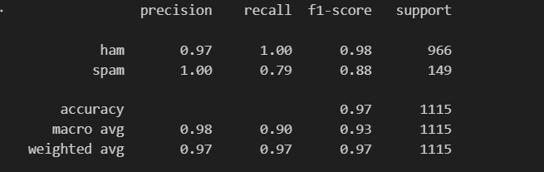
Naïve Bayes –
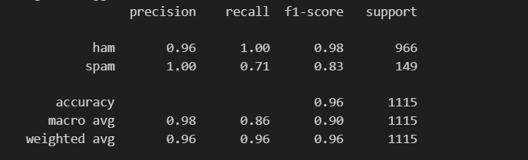
DistilBERT
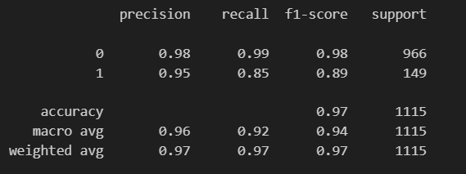

Model Comparisons:
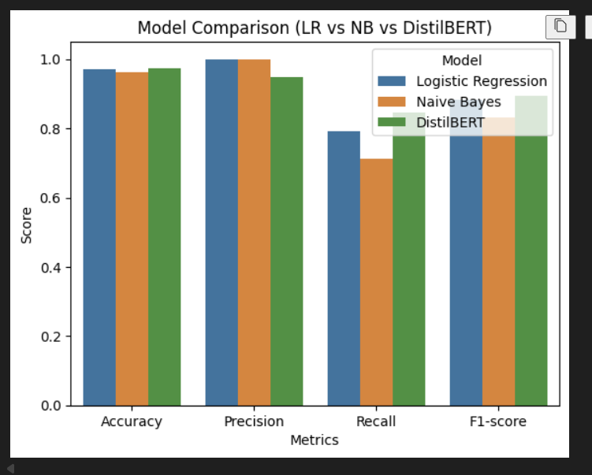

Confusion Matrix:
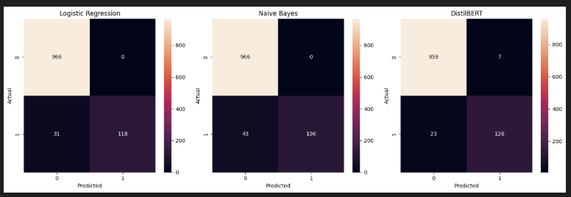

Training Time comparison:
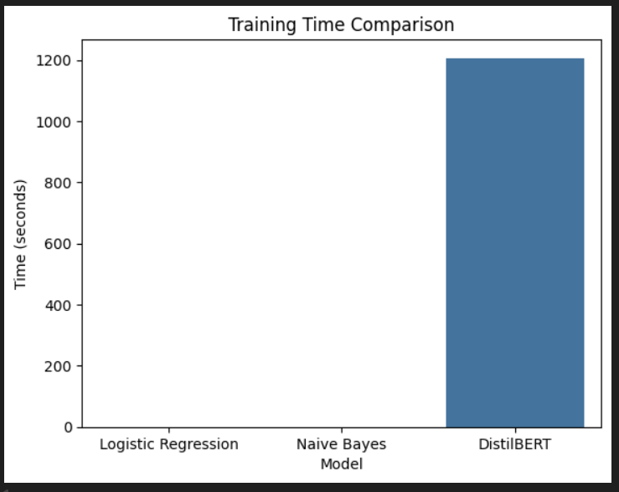

Limitations:
While the project demonstrates effective email classification using both traditional and deep learning models, there are several limitations that open up opportunities for further improvement.

One key limitation is that the DistilBERT model was not fully fine-tuned. Instead, its base layers were frozen to reduce training time. While this makes the model faster and more efficient, it also prevents it from fully adapting to the specific dataset. Fine-tuning the entire model could potentially improve performance by allowing it to learn task-specific patterns more effectively.

Another limitation lies in the preprocessing approach used for traditional models. The preprocessing was relatively simple, involving lowercasing and removal of punctuation and numbers. More advanced techniques such as stopword removal, stemming, or lemmatization could further improve the quality of features and enhance model performance.

Additionally, hyperparameter tuning was not extensively performed. Default parameters were used for most models, which may not be optimal. Systematic tuning of parameters such as learning rate, batch size, and regularization strength could lead to improved results.

Another limitation is the dataset size and diversity. If the dataset is relatively small or lacks variety, the models may not generalize well to real-world email data. Using a larger and more diverse dataset would make the results more robust and reliable.

Finally, interpretability remains a challenge, especially for the DistilBERT model. While it performs well, understanding its decision-making process is difficult. Incorporating explainability techniques such as attention visualization or model interpretation tools could make the system more transparent and trustworthy.

SUBMITTED BY:
DIYA JIJU

