Applied Data Science 1
Assignment 2:
Statistics and Trends

Economic Growth Trends

Abstract:
This report examines economic growth trends across five countries—Germany, United Kingdom, Egypt, Spain, and Pakistan using data from world bank. Report helps to analyse and explore some of the economic indicators over some years. The results will help in shaping economic health of each country. It can also enhance employment opportunities thereby increasing economic growth.

By
Diya Amith Kodappully
(22071849)
GitHub Link : https://github.com/Diya-Amith/Final-Assignment-2.git

Introduction:
The data set is chosen from the world bank. Five countries are chosen from dataset to study about the trends and its statistics. Selected Countries are Germany, United Kingdom, Egypt, Spain, Pakistan. Indicators chosen are employment rate, GDP, Tax revenue, population. Years are filtered from 2000 to 2008. Report also helps to find the correlations between the indicators thereby to understand how each indicator relates to other.
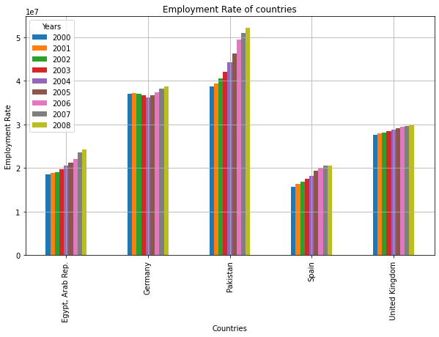

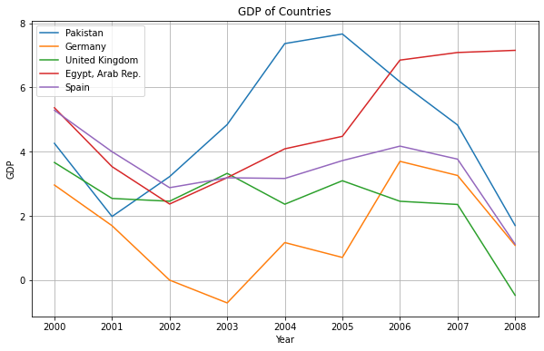
The employment rate gives us the proportion to which how people are involved in labour force. From the above plot, employment rate of 4 countries (Egypt, Pakistan, Spain, United Kingdom) have increased over the years. Whereas in Germany employment rate is slightly decreasing till 2004 and afterwards there is an increase in the rates. Pakistan and Egypt shows a markable increase in their rates. The increase in the employment rate shows a strong economic growth. Whereas decrease in the rate shows the unemployment issues and economic challenges faced by the country.
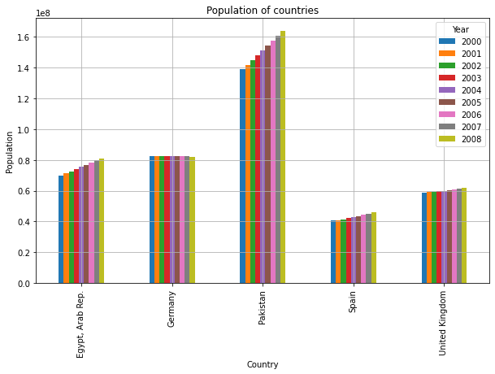

The above graph represents the population rate of the same countries over same period of time. It shows the change in the distribution and composition of country’s inhabitants. When we see both graphs, we can notice a similar growth visualisation. Population of each country is getting increased.
Thereby we can say that the increase in the population may results in the increase in employment rate (but not applicable in every case). It is clear that when the population is increasing, it helps in the growth of the economy which increases the demand for the goods thereby increasing the employment opportunities. But when the population is getting increased without proper employment opportunities, it may result in decline of economic growth because of the unemployment issues

The above graph shows the Gross Domestic Product of the chosen countries. GDP reflects the economic health of a nation. From the graph Pakistan and Egypt show more fluctuations in their rate of GDP. Over some period, they have a good growth in their GDP and afterwards there was a decline and fluctuations in their rate. This may be due to some economic factors such as price of the goods or other political factors or so on.
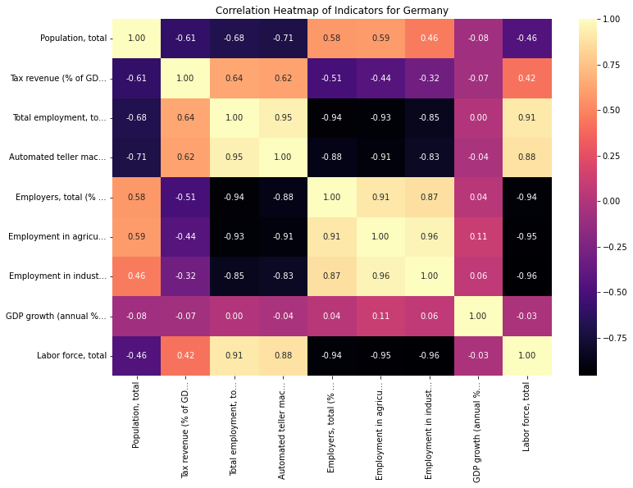
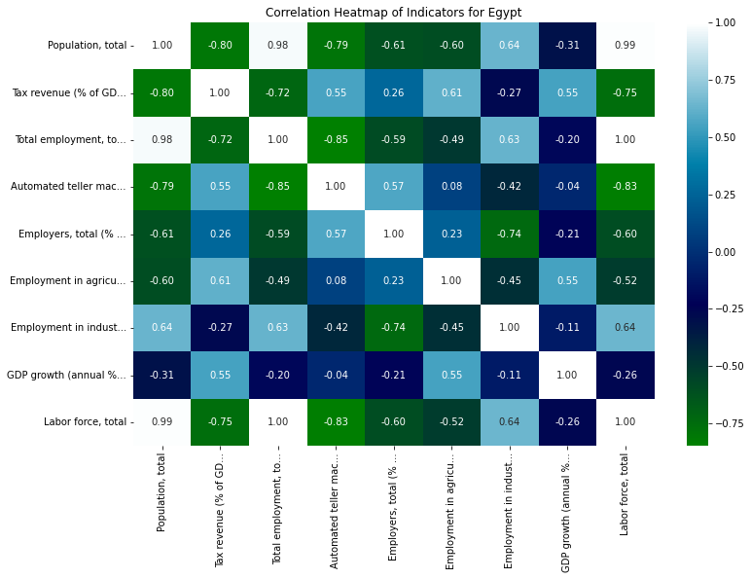

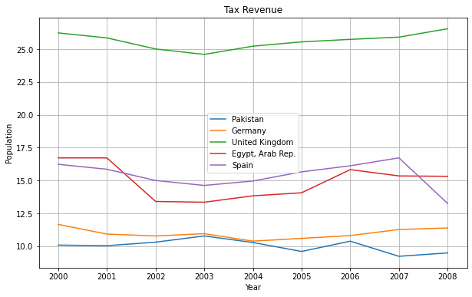
When we plotted a correlation heatmap for Egypt we can understand that there is a strong correlation between Population and the labour force. This suggests that when the population number is increasing, the number of labour force also may get increased. Also map shows a positive correlation between GDP and Tax revenue. The economic growth of the country results in higher tax revenue or vice versa. We can plot a graph for tax revenue these countries to understand more.

From this graph, we will get a clear understanding how does Egypt have a strong correlation between tax and GDP. But when we come to Germany, it shows a increase in tax revenue. But GDP rate of Germany shows minor fluctuations in their rates. So, let’s Analyse correlation heatmap for Germany.
Results:
From the above analysis we came to know about how various indicators depends on the economic factors of a different countries. This will help to resolve each problem and improve economic stability of the countries. This study can only resolve some problems. For further solutions we need to take more data and much more deep analysis have to be done

From the above heatmap of Germany we can get that there is a strong correlation between total population and the labour force. Which indicates that in Germany the increase in population expands the labour force. Most population may be coming under working age. Because those are the population who will contribute to the labour force.
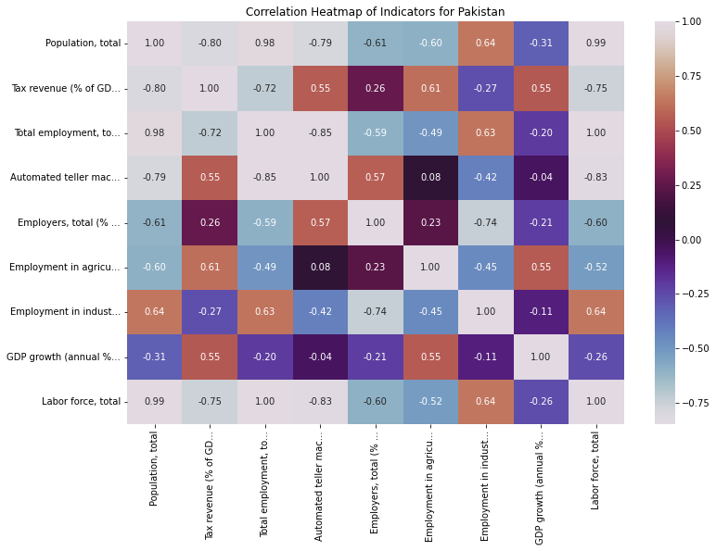

Similarly, above given is heatmap of Pakistan. Pakistan shows a strong correlation between population comparing to labour force and employment like in Germany. Heat map helps us to understand correlation between various economic factors in the country. These findings help to increase the economy.

