Coding Project
Fundamentals Of Data Science
Diya Amith Kodappully
(22071849)
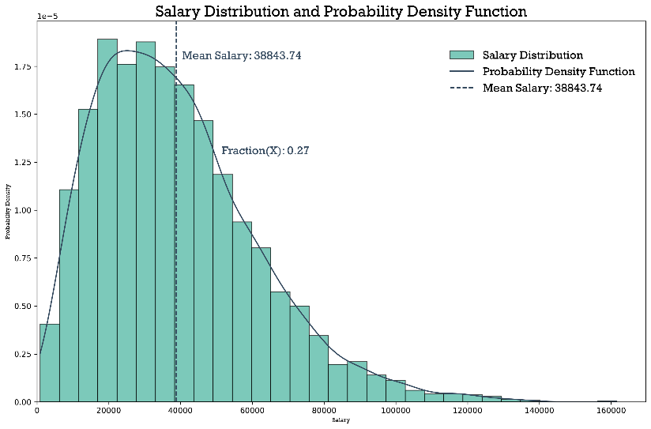
Data: The dataset provided contains information about annual salaries. Each entry in the dataset corresponds to an individual's annual salary. The data is represented as a single column, labelled 'Salary'. The objective is to analyse the distribution of these salaries and calculate specific statistical measures.
Distribution: By plotting a histogram and probability density function (PDF), it becomes clear that the salary distribution is approximately normal. The PDF, generated through a kernel density estimate, illustrates the likelihood of different salary values occurring. This normal distribution assumption facilitates further statistical analysis.
Mean Value (W̃): The mean annual salary is calculated using the formula:

where N is the total number of observations and represents each individual salary.
X Calculation: The value X represents the fraction of the population with salaries between 80% and 120% of the mean salary (W̃). Mathematically, it is expressed as:

For the provided dataset, the calculated value of X is approximately 0.27. This indicates the proportion

Statistical Properties: Additional statistical properties were analysed, including the mode, median, kurtosis, and skewness of the salary distribution.
- Mode: The mode represents the most frequently occurring salary value. The calculated mode is 43104
- Median: The median is the middle value. The calculated median is 35390.0
- Kurtosis: Kurtosis measures the tail heaviness of the distribution. The calculated kurtosis is 1.0904644346123011
- Skewness: Skewness quantifies the asymmetry.
The calculated skewness is 0.9421150541277348
Conclusion: The analysis of the salary data reveals valuable insights into the distribution and key statistical properties, aiding in a more informed understanding of the dataset.

