Internship Project Report
Submitted in partial fulfilment of the requirement for the award of a certificate of internship programme Under ISEA-III Project
QR Code Generator and Scanner

Submitted by
DIYA PARASHAR
Department of Computer Science and Engineering (Artificial Intelligence)
Jaipur Engineering College and Research Centre , Jaipur

Under the supervision of

Professor Vijay Laxmi
Principal Investigator, ISEA-III
Department of Computer Science and Engineering



Malaviya National Institute of Technology Jaipur
Jawahar Lal Nehru Marg,Jaipur-302017 (Rajasthan) INDIA

ABSTRACT

In the digital era, the demand for fast, reliable, and secure methods of sharing information has become essential across personal, professional, and commercial domains. Quick Response (QR) code technology has emerged as a widely adopted solution, enabling instant access to information through simple scanning using mobile devices. Its versatility allows it to be applied in areas such as contactless payments, digital authentication, event ticketing, and product information delivery. However, many available QR solutions depend on third-party services or platform-specific applications, limiting flexibility, control, and long-term accessibility.
This project introduces IntelliQR, a fully functional, cross-platform web application designed to generate and scan QR codes without relying on external libraries. Built using HTML, CSS, and JavaScript, the system implements a complete QR code generation pipeline from scratch, incorporating text-to-binary encoding, Reed–Solomon-based error correction, data masking, and matrix placement in compliance with ISO/IEC 18004 standards. The generator module creates high-quality, scannable QR codes that can be downloaded with a single click, while the scanner module supports both live camera-based scanning and image upload decoding. A built-in history log stores past scans for easy retrieval, ensuring convenience and traceability for users.
Designed for compatibility across both desktop and Android devices, IntelliQR provides an accessible, lightweight, and secure alternative to existing QR tools. By combining algorithmic accuracy with practical usability, the system addresses modern digital communication needs while maintaining full user control over the process. With its adaptability, IntelliQR holds strong potential for use in academic, business, and public service contexts, where efficient and dependable data transmission is critical.

Keywords: IntelliQR, QR Code Technology, Web Application Development, Cross-Platform Accessibility, Error Correction Algorithms, Real-Time QR Scanning, Contactless Data Exchange, Digital Communication Solutions.

Table of Contents
Chapter 1...................................................................................................................................06
1.1 Introduction…………………………………..……………………………….…..06
1.2 Motivation…………………………………..……………………………………..07
1.3 Objectives…………………………………..……………………..…….…….…..09
1.4 Report Outline………………………………….………………………………...10

Chapter 2....................................................................................................................................13
2.1 Background and Literature/Technology Review........................................13

Chapter 3....................................................................................................................................18
3.1 Problem Statement of the Task Assigned..................................................18
3.2 Flowchart of the Work...................................................................................19
3.3 Detailed Discussion of Algorithm(s) Used..................................................22

Chapter 4...................................................................................................................................27
4.1 Implementation.............................................................................................27
4.2 Results...........................................................................................................33
4.3 GitHub Link for All Code Created...............................................................34

Chapter 5......................................................................................................................................35
5.1 Conclusion………………………………………………………………………...35
Annexure…………………………………………………………………………………………………36
References:..................................................................................................................................38
List of Figures

Fig. 1 Structure of QR Code…………………………………………………………………13
Fig. 2 System Architecture Design………………………………………………………….22
Fig. 3 System Workflow……………………………………………………………………….26
Fig. 4 IntelliQR Homepage UI………………………………………………………………...30
Fig. 5 QR Code Generator Panel…………………………………………………………….30
Fig. 6 QR Code Live Scanning……………………………………………………………….31
Fig. 7 QR Code Image Upload Scanning………………………………………………......31
Fig. 8 Snapshots of Results………………………………………………………………….34
List of Tables

Table 1 Summary Table of Technologies …………………..……………………………..17
Table 2 File Structure and Logic………………………………………………....................27

Chapter 1
INTRODUCTION

Introduction
In the digital era, the need for quick, seamless, and secure data transmission methods has led to the widespread adoption of QR (Quick Response) code technology. Initially developed in 1994 by Denso Wave, a subsidiary of Toyota Group, QR codes were designed to track automotive components efficiently. Over time, this compact yet powerful form of data encoding has evolved far beyond its original industrial application. Today, QR codes have become a ubiquitous part of everyday life, revolutionizing the way we interact with both digital and physical environments.
QR codes are essentially two-dimensional matrix barcodes that can encode various types of information — including URLs, plain text, contact details, Wi-Fi credentials, and more. Unlike traditional barcodes, which hold data only horizontally, QR codes can store data both horizontally and vertically, significantly increasing their capacity. This dual-directional storage capability allows QR codes to hold hundreds of characters of data in a compact, machine-readable format.
Their application has expanded across numerous domains — from retail and advertising to healthcare, education, event management, and digital payments. The introduction of contactless technologies, especially accelerated by the COVID-19 pandemic, has pushed QR code utilization to new heights. In a world where minimizing physical contact became essential, QR codes emerged as a highly effective solution for enabling touchless interactions, such as scanning menus in restaurants, completing contactless transactions, accessing educational content, or checking into events and offices.
Despite the popularity of QR codes, many of the tools available for generating or scanning them present considerable limitations. Some are bundled with intrusive advertisements or require the user to install additional software on their device, thereby raising concerns about privacy, security, and overall usability. Others may be platform-dependent or suffer from poor user interface design, hindering user experience. Moreover, many online tools use third-party APIs or cloud services, introducing dependency risks and data exposure threats.
To overcome these challenges, this internship project introduces IntelliQR — an open-source, browser-based QR code generator and scanner designed for optimal user experience, security, and convenience. IntelliQR is engineered entirely using front-end web technologies — HTML5, CSS3, and JavaScript — with no reliance on server-side scripting or external libraries. This makes the tool platform-independent, lightweight, and fully functional without any installation or internet connectivity (once loaded).
The vision behind IntelliQR is to empower users — whether developers, educators, event organizers, or everyday smartphone users — with the ability to generate and scan QR codes in real time using only a web browser. It bridges the gap between accessibility and functionality, eliminating unnecessary technical barriers. Users can simply open the webpage and begin encoding their desired content into a QR code or scan an existing one using their device’s camera — all within a responsive, user-friendly interface.
Furthermore, being open-source, IntelliQR promotes transparency and collaboration. The project’s source code is freely available for anyone to study, modify, and improve. This not only enhances trust among users but also encourages contributions from the developer community to expand its features and improve its robustness.
In summary, IntelliQR is more than just a QR code tool — it is a statement on how modern web technologies can be leveraged to deliver privacy-conscious, user-centric solutions without compromising on performance or design. It stands as a testament to the power of open web development in solving real-world problems with simplicity, efficiency, and elegance.

1.2 Motivation
The inspiration behind the IntelliQR project emerged from the growing need for a privacy-conscious, lightweight, and universally accessible QR code tool that does not rely on proprietary software or continuous internet connectivity. While QR codes have become an integral part of digital interactions — ranging from digital payments and e-commerce to education and public services — most available tools in the market come with limitations. Many are either commercial products locked behind paywalls, require app installation, or rely heavily on third-party services, raising concerns related to privacy, data security, and platform compatibility.
This project was born out of a desire to challenge those limitations by designing a browser-based solution that would function entirely on the client side, ensuring full control and transparency for the user. By eliminating server-side dependencies, IntelliQR aims to offer a seamless experience that works consistently across all modern devices, operating systems, and browsers — including desktops, tablets, and smartphones.
From a personal and academic standpoint, the project served as a stepping stone to deepen my understanding of front-end web development, especially in mastering native browser APIs such as:
- Canvas API – for drawing and rendering the QR matrix
- MediaDevices API – for accessing the camera during live scanning
- Clipboard API – for copy-to-clipboard features, enhancing user convenience
Engaging with these APIs gave me a hands-on opportunity to work beyond textbooks, allowing me to implement advanced client-side functionalities that are commonly found in production-grade applications.
Another driving force behind this project was my interest in UI/UX design. Through IntelliQR, I explored how to build intuitive and responsive interfaces that cater to users with varying technical backgrounds. Prioritizing user experience — through clean layout, minimal design, and accessibility — helped me learn how design decisions directly affect usability and user trust.
Being part of this internship also provided a structured environment for learning. Under the guidance of mentors and with periodic feedback, I was able to align my development with real-world standards, debugging practices, and version control workflows. This mentorship experience was invaluable in shaping my approach to software design, testing, and iterative improvement.
Finally, this project reflects my commitment to the open-source philosophy. By making the source code of IntelliQR publicly available, I hope to contribute something meaningful to the global developer community. It opens doors for collaboration, further development, and customization — allowing others to build upon or adapt the tool for their specific needs.
In addition to the technical and personal learning goals, this project was undertaken as part of a summer internship under the ISEA-III (Information Security Education and Awareness Phase III) initiative at Malaviya National Institute of Technology (MNIT), Jaipur. The internship was supervised by Prof. Vijaylakshmi, Department of Computer Science and Engineering, whose guidance and mentorship played a crucial role in shaping the scope, direction, and quality of the project.
Being part of this prestigious government-funded program offered a unique opportunity to contribute to a meaningful project in the domain of cybersecurity and secure digital tools. The structured mentorship, technical discussions, and progress reviews under Prof. Vijaylakshmi’s guidance not only enriched the learning experience but also instilled in me a more disciplined and research-oriented approach to software development.

1.3 Objectives
The primary objective of the IntelliQR project is to develop a robust, browser-based web application that facilitates both the generation and scanning of QR codes without the need for external dependencies or server-side processing. As digital interactions increasingly rely on QR codes for efficiency and contactless communication, the project aims to deliver a secure, accessible, and user-friendly solution that can be used seamlessly across a wide range of devices and platforms.
The following objectives guided the development of the IntelliQR application:
- Design and Develop a QR Code Generator:
One of the core functionalities of the application is to allow users to input any text, URL, or string-based content and instantly convert it into a valid QR code. The system must handle dynamic content updates and ensure the output is scannable by standard QR code readers. The generation process should be fast, accurate, and fully executed on the client side using JavaScript.
- Implement Real-Time QR Code Scanning:
A significant goal was to implement live QR code scanning using a device's camera. This involved leveraging the MediaDevices API to access the camera feed and integrating QR decoding logic to detect and extract information from QR images in real time. Additionally, the application should support scanning from static images uploaded by the user, broadening its versatility and use cases.
- Ensure Cross-Platform and Cross-Browser Compatibility:
To maximize usability, the application is designed to be fully functional on both desktop and mobile browsers, including Chrome, Firefox, Safari, and Edge. This objective required careful consideration of responsive design, mobile camera access constraints, and performance optimization for various screen sizes and operating systems.
- Build a Responsive and Intuitive User Interface:
A major focus of the project was on delivering an elegant and accessible user interface. The application supports light and dark themes to accommodate user preferences and improve readability in different lighting conditions. UI elements were designed with simplicity and clarity in mind, ensuring that both tech-savvy users and non-technical users could interact with the tool effortlessly.
- Prioritize Privacy and Security Through Local Processing:
Unlike many QR code tools that rely on cloud-based APIs or send user data to external servers, IntelliQR processes all information locally in the browser. This ensures complete privacy and data control, making the application suitable for sensitive use cases where confidentiality is essential. The security-by-design approach is particularly aligned with the objectives of the ISEA-III initiative under which this project was developed.
In summary, the IntelliQR project was guided by a well-defined set of technical and user-centric goals aimed at creating a practical, efficient, and secure web-based tool. Each objective was aligned with real-world requirements and the broader mission of promoting open, privacy-focused digital solutions under academic and institutional mentorship.

1.4 Report Outline
This report is structured to provide a comprehensive overview of the IntelliQR project, including its conceptual foundation, technical implementation, and outcomes. Each chapter is organized logically to guide the reader through the development journey — from the initial motivation to the final conclusions. The following is a summary of the report’s structure:
- Chapter 1: Introduction
This chapter presents an overview of the project, outlining the motivation behind its development, the specific objectives it aims to achieve, and the institutional context under which the internship was undertaken. It sets the stage for the subsequent chapters by highlighting the importance of QR code technology and the need for a secure, browser-based solution.
- Chapter 2: Background and Technology Review
This section discusses the background of QR code technology, its evolution, and existing tools or limitations. It also provides a detailed review of the core web technologies and APIs used in the development of IntelliQR, such as HTML5, CSS3, JavaScript, Canvas, MediaDevices, and more. The aim is to establish a solid theoretical and technological foundation for the reader.
- Chapter 3: Problem Statement and Technical Approach
This chapter defines the specific problem the project addresses — the lack of lightweight, secure, and platform-independent QR solutions. It includes the project’s workflow, visualized through flowcharts and diagrams, along with a discussion of the algorithms used for QR code generation, binary encoding, masking, error correction, and scanning.
- Chapter 4: Implementation and Results
The implementation chapter offers a deep dive into how the application was built, including its code structure, modular components, UI design, and integration of various APIs. It highlights key challenges encountered during development and the strategies used to overcome them. The section also showcases the final results through screenshots, functionality tests, and cross-device validation.
- Chapter 5: Conclusion and References
The final chapter summarizes the learnings, outcomes, and potential impact of the project. It also reflects on the skills acquired during the internship, possible areas for future improvement, and the contribution of IntelliQR to the open-source community. References to academic papers, web documentation, and technical resources used throughout the project are also provided.
Together, these chapters offer a complete narrative of the IntelliQR project — from inception to completion — providing valuable insights into both its technical depth and practical significance.

Chapter 2
Background and Literature/Technology Review

2.1 QR Code Technology Overview
QR (Quick Response) codes are a form of two-dimensional matrix barcode that have become an integral part of modern digital interaction. Unlike traditional one-dimensional barcodes, which encode data along a single axis (typically horizontal), QR codes store information both vertically and horizontally. This dual-axis encoding significantly increases their data storage capacity and allows for faster and more reliable readability, even under less-than-ideal scanning conditions.
Developed in 1994 by the Japanese company Denso Wave, QR codes were initially intended to track automotive parts in manufacturing plants. However, due to their compact size, high capacity, and rapid scanning speed, they quickly gained popularity across various sectors including retail, logistics, education, healthcare, and digital payments.
A standard QR code comprises several critical components that work together to ensure accurate decoding:
- Finder Patterns: Located in three corners of the QR code, these square-shaped patterns help scanners identify the code’s orientation during scanning.
- Alignment Patterns: Used in higher version QR codes, these help maintain accuracy by correcting for distortion, especially in larger symbols.
- Timing Patterns: These alternate black and white modules positioned between finder patterns assist the scanner in determining the data matrix’s grid structure.
- Format Information: Stores error correction level and masking pattern information, which is essential for accurate decoding.
- Version Information: Indicates the version of the QR code, which in turn determines the size and data capacity of the symbol.
- Data and Error Correction Blocks: The main sections of the code that carry actual information (in binary form) and the associated error correction bits.

One of the most powerful features of QR codes is their support for multiple data modes, including:
- Numeric (digits 0–9)
- Alphanumeric (upper-case letters, digits, and a few special characters)
- Binary (8-bit byte) (for general-purpose encoding like URLs or text)
- Kanji (for encoding Japanese characters)
This flexibility allows QR codes to be used in a wide range of applications, from encoding a simple URL to embedding complete contact details, calendar events, or Wi-Fi credentials.
A defining strength of QR codes lies in their robust error correction capability, enabled by the Reed-Solomon error correction algorithm. This mechanism allows QR codes to recover data even if up to 30% of the symbol is damaged, obscured, or missing, depending on the selected error correction level (L, M, Q, H). This is particularly useful in real-world environments where printed codes may be scratched, dirty, or partially covered.
Thanks to their versatility, resilience, and efficiency, QR codes have evolved into a vital element of modern digital ecosystems. Whether for scanning a menu at a restaurant, verifying identity during an event check-in, or making secure contactless payments, QR codes provide a low-cost, high-efficiency solution for bridging the physical and digital worlds.
In the context of this project, understanding the technical anatomy and capabilities of QR codes is crucial for building a custom, standards-compliant QR generator and scanner that operates directly in the browser. The next sections of this report will delve into the technologies used to implement these features effectively.
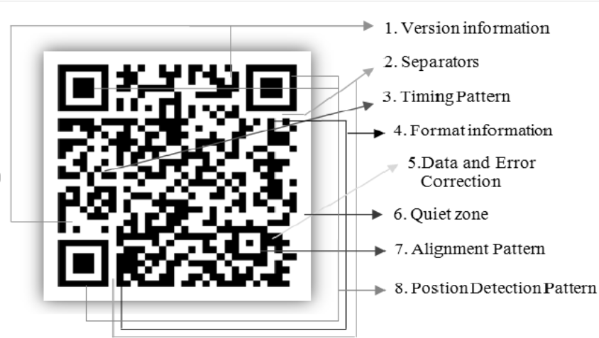Figure1: Structure of QR Code
2.2 Related Work and Existing Tools
Over the years, a wide range of tools and libraries have been developed to facilitate the generation and scanning of QR codes. These tools vary significantly in terms of functionality, platform support, licensing models, and underlying technologies. While many of them serve their intended purposes effectively, they often come with limitations that make them unsuitable for privacy-sensitive, offline, or lightweight use cases — particularly in browser-only environments.
Some of the most notable tools and libraries include:
- Google Lens
Google Lens is a powerful visual recognition tool integrated into most Android devices and available via the Google app. It supports real-time QR code scanning using a device’s camera. However, it does not offer any functionality for QR code generation. Additionally, Google Lens requires internet access and sends image data to cloud-based servers for processing, raising concerns about data privacy in sensitive applications.
- QR Code Monkey
QR Code Monkey is a popular online tool for generating customized QR codes with logos, colors, and branding. It provides a user-friendly interface and high-resolution output. However, it is a proprietary, closed-source platform that relies on a server-side backend to handle the generation process. This dependence on cloud infrastructure poses challenges for offline or air-gapped environments and offers limited transparency for users interested in the internal workings of the tool.
- ZXing ("Zebra Crossing")
ZXing is a widely used open-source library for barcode scanning and generation, written in Java with ports available in several other languages. While it provides a comprehensive feature set, it is primarily intended for native or enterprise-level applications, requiring complex build systems, dependencies, and in some cases, platform-specific integration. Its setup can be too heavy for simple web-based or browser-only use cases, particularly where minimal resource consumption is a priority.
While these tools have contributed significantly to QR code technology adoption, they often fail to meet the requirements of modern web-based use cases that demand lightweight, privacy-respecting, and platform-independent solutions.
Key limitations include:
- Lack of Open Source Flexibility: Many existing tools are closed-source or offer only partial access to their codebase, limiting customization, transparency, and collaborative improvement.
- Dependence on Internet Connectivity: Several tools rely on online APIs or server-side rendering to function, making them unusable in offline scenarios or in environments with restricted internet access.
- Native Framework Dependencies: Tools like ZXing are optimized for native mobile or desktop environments, not for in-browser execution, which adds development overhead and limits portability.
These shortcomings present a clear opportunity for an alternative approach — one that emphasizes client-side processing, simplicity, and complete independence from external libraries or services.
The IntelliQR project was conceptualized in response to these limitations. It aims to provide a lightweight, fully browser-based application that handles both QR code generation and scanning natively using only HTML5, CSS3, and vanilla JavaScript, without any server interaction or proprietary dependencies. This not only ensures better performance and portability but also aligns with the values of open-source development and user data privacy — both critical in today’s digital landscape.

2.3 Technologies Used in IntelliQR
The IntelliQR web application is built entirely using front-end web technologies, allowing it to run directly in the browser without any installations or server-side dependencies. This design ensures maximum portability, user privacy, and cross-platform compatibility. Each technology used in this project plays a distinct role in achieving the application's core functionalities — including QR code generation, real-time scanning, and seamless user interaction.

HTML5 – Semantic Structure of the Web App
HTML5 provides the foundational structure for IntelliQR. Semantic elements like <section>, <header>, <canvas>, and <button> help organize the layout clearly and meaningfully, improving both maintainability and accessibility.
CSS3 – Styling and Responsive Layout :
CSS3 is used to design a clean, responsive interface. Media queries ensure the layout adjusts well to both desktop and mobile screens. The styling also includes light/dark mode toggling, hover effects, and custom design elements for a smooth user experience.
JavaScript – Application Logic and Interactivity
JavaScript powers the dynamic behavior of the app. It handles everything from encoding and decoding QR codes to responding to user input and integrating with browser APIs. All core functionality — including scanning, generation, canvas drawing, and clipboard operations — is implemented in plain JavaScript without external libraries.
Canvas API – QR Code Rendering and Download
The Canvas API enables the application to draw the QR matrix as a visual 2D grid on the screen. This rendered output can be saved as an image (typically PNG), making it easy for users to download and reuse their generated QR codes.
MediaDevices API – Accessing Camera for Live Scanning
The MediaDevices API allows IntelliQR to access the device’s camera for scanning QR codes in real time. The video feed is streamed to the browser, where JavaScript continuously analyzes frames to detect and decode QR content, all without sending any data to external servers.
File API – Handling Uploaded Images for Scanning
The File API provides functionality to upload static image files containing QR codes. This allows users to decode existing QR codes saved on their device by simply selecting the image, which is processed entirely in the browser.
Clipboard API – Supporting Image Paste from Clipboard
The Clipboard API enhances user convenience by allowing QR code images to be pasted directly from the clipboard. This makes the scanning process faster, especially when copying screenshots or scanned images from other applications or devices.
GitHub Pages – Static Hosting and Deployment
To ensure open access and easy deployment, the entire IntelliQR project is hosted on GitHub Pages. This free static hosting platform allows seamless deployment of HTML/CSS/JS projects, enabling users to access IntelliQR from any browser without downloading or installing anything. It also supports version control and public contributions via GitHub.
Together, these technologies form a cohesive and efficient tech stack that supports the project’s goals of openness, privacy, and cross-device usability.

Summary Table of Technologies
Technology | Purpose / Role in IntelliQR
HTML5 | Semantic structure of the application
CSS3 | Responsive design and user-friendly interface with theme toggling
JavaScript | Application logic, API interaction, and event handling
Canvas API | Drawing QR code matrix and enabling image download
MediaDevices API | Accessing camera for real-time QR code scanning
File API | Uploading and processing static image files
Clipboard API | Pasting QR code images directly from the clipboard
GitHub Pages | Free static site hosting and open-source deployment

Chapter 3
Problem Statement

3.1 Problem Statement of the Task Assigned
With the increasing use of QR codes in everyday digital interactions—from payments and authentication to information sharing—there is a growing need for privacy-focused and universally accessible tools. Most existing QR solutions are either internet-dependent, platform-specific, or closed-source, which poses limitations in terms of accessibility, flexibility, and data security.
The problem this project addresses is:
To design and develop a fully client-side, browser-based web application that allows users to generate and scan QR codes in real time using native web technologies. The application must be cross-platform (work on both mobile and desktop), responsive, install-free (no downloads required), and ensure privacy by processing all data locally.

3.2 Flowchart of the Work
The IntelliQR application consists of two primary workflows — QR Code Generation and QR Code Scanning. Both processes are executed entirely within the browser using client-side JavaScript and native web APIs, without any server interaction.
A. QR Code Generation Workflow
This workflow converts user-provided text or URL input into a valid QR code, visualized using the HTML5 Canvas element. The steps involved are as follows:
- User Inputs Text or URL
The user enters the content to be encoded in a text input field. This could be a plain string, URL, email, or contact info.
- Text is Converted to Binary Format
The application encodes the input according to the selected QR mode (typically alphanumeric or byte mode), converting the text into a binary representation that adheres to QR code standards.
- Apply QR Encoding Rules and Error Correction
Error correction bits are generated using the Reed-Solomon algorithm, depending on the selected error correction level (L, M, Q, or H). The combined data and error correction bits are then prepared for matrix placement.
- Place Modules in QR Matrix Structure
The binary data is placed into the QR matrix according to a predefined placement pattern, along with additional patterns like finder, alignment, and timing patterns. Masking is applied to optimize readability.
- Render Matrix on Canvas
The resulting matrix is rendered as a visual QR code using the HTML5 Canvas API. Each module (black or white square) is drawn as a pixel or block on the canvas.
- Provide Download Option
The generated QR code can be downloaded as a high-resolution image (typically PNG format) for sharing or printing.

B. QR Code Scanning Workflow
This workflow allows users to decode QR codes either through their device camera, by uploading an image, or pasting a copied image from the clipboard.
- User Selects Scanning Method
The user can choose one of three methods to input the QR code:
  - Live camera feed (via MediaDevices API)
  - Static image upload (via File API)
  - Image paste from clipboard (via Clipboard API)
- Frame or Image is Captured or Loaded
For live scanning, video frames are continuously captured using the device's camera. For static input, the image is processed once it's uploaded or pasted.
- QR Code Detection and Decoding
The frame or image is analyzed using the jsQR library, which performs pixel analysis, pattern recognition, and Reed-Solomon decoding to extract the embedded content.
- Output Result Displayed on Screen
The decoded text, URL, or data is displayed to the user in a readable format with options to copy it to the clipboard or perform further actions.

Flowchart Illustration
To visually represent the above workflows, include two separate flowcharts:

Flowchart 1: QR Code Generation :
[Start]
↓
[User Input Text/URL]
↓
[Convert to Binary]
↓
[Apply Encoding & Error Correction]
↓
[Build QR Matrix]
↓
[Render on Canvas]
↓
[Enable Download]
↓
[End]

Flowchart 2: QR Code Scanning :
[Start]
↓
[Choose Method: Camera / Upload / Paste]
↓
[Capture Frame or Load Image]
↓
[Decode QR using jsQR]
↓
[Display Result to User]
↓
[End]
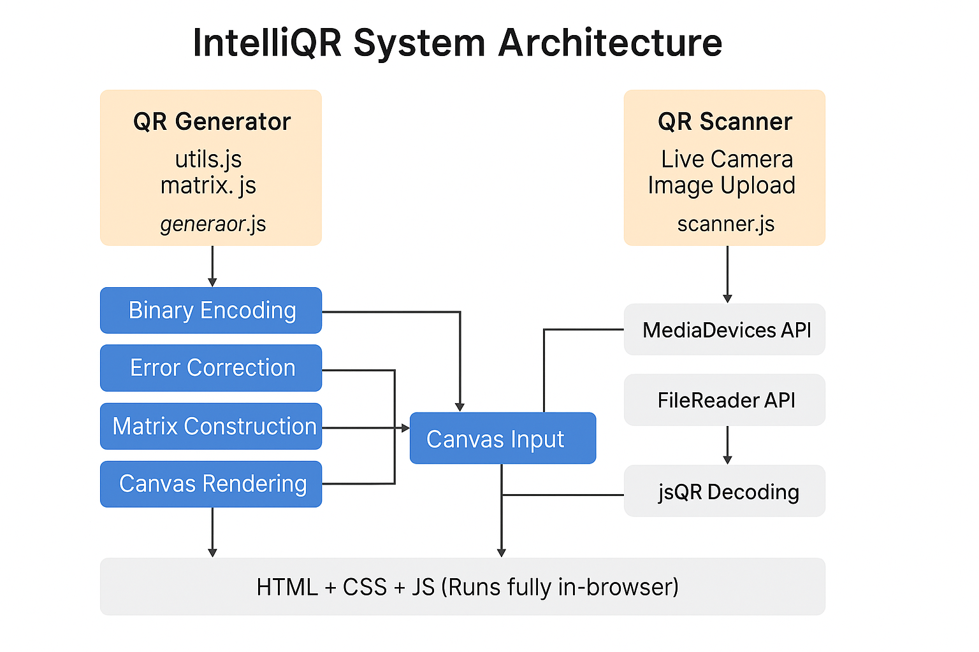
Figure 2 : IntelliQR System Architecture

3.3 Detailed Discussion of Algorithms Used
QR Code Generation Algorithm :
The QR code generation process converts user input into a scannable two-dimensional barcode by following a sequence of standardized steps:
Step 1: Input Capture
The user is provided with an input field in the web interface. Whatever text or string the user enters (e.g., “Hello”), is treated as the data payload to be encoded. This step ensures the application can handle dynamic input, not hardcoded data.
Step 2: Text Encoding
The entered text is encoded into binary format using Byte Mode (mode indicator = 0100).
In this mode, each character is converted to its 8-bit binary representation using ASCII or UTF-8 encoding.
Example:
- "H" → ASCII = 72 → Binary = 01001000
- "e" → ASCII = 101 → Binary = 01100101
- "l" → ASCII = 108 → Binary = 01101100
This binary stream represents the raw data that will be embedded into the QR matrix.
Step 3: Add Mode Indicator and Length Information
To inform the decoder about the type and size of data:
- Mode Indicator (0100 for byte mode) is added at the beginning of the bitstream.
- Character Count Indicator follows, indicating the number of characters in binary. For version 1 QR codes (up to 25 alphanumeric characters), this is typically 8 bits.
Example for “Hello” (5 characters):
- Mode: 0100
- Length: 00000101 (5 in binary)
So, the binary stream becomes:
0100 00000101 [encoded data bits]
Step 4: Pad Data
QR codes require that data be grouped into 8-bit codewords. If the total data is not a multiple of 8, it's padded using:
- Terminators: up to 4 0s to indicate the end of data
- Pad Bytes: Alternating values 11101100 and 00010001 are appended until the codeword limit is reached for that version
This ensures the data size matches the capacity of the QR version and maintains proper formatting.
Step 5: Error Correction (Reed-Solomon Codes)
To allow recovery in case of damage or distortion, Reed-Solomon error correction is applied.
- The encoded data is split into blocks, and error correction codewords are computed and appended.
- These codewords enable the QR scanner to reconstruct missing or corrupted parts of the QR image.
Note: In simplified or experimental implementations, this step might be skipped or implemented in a minimal form, but it's essential for real-world robustness.
Step 6: Matrix Placement
The QR matrix is a 2D grid made of black and white modules (pixels).
Key components placed in the matrix include:
- Finder patterns (top-left, top-right, bottom-left)
- Timing patterns (alternating black and white lines)
- Alignment patterns (help with warping)
- Reserved areas for format and version info
- Data modules: the binary data and error correction bits are placed in a zigzag pattern starting from the bottom right
This placement follows a strict standard to ensure cross-compatibility with all scanners.
Step 7: Render on Canvas
Finally, the matrix is drawn onto an HTML <canvas> element:
- Each bit is translated to a square of a certain pixel size.
- A 1 is rendered as a black square; a 0 as a white square.
- This is done using the Canvas API method fillRect(x, y, size, size)
The output is a fully rendered, scannable QR code image, which can also be downloaded or printed.

QR Code Scanning Algorithm
The scanning part of the tool enables users to decode QR codes using their webcam, entirely within the browser, without requiring any external application.

Step 1: Access Webcam
Using the WebRTC API, the browser requests access to the webcam:
“navigator.mediaDevices.getUserMedia({ video: { facingMode: "environment" } })”
This stream is directed to a <video> tag on the page. Permissions are requested securely via HTTPS.

Step 2: Live Video Stream
Once access is granted, the video feed appears live on screen. The feed is used for real-time frame extraction. No data is recorded or transmitted—everything runs locally in the browser, ensuring privacy.

Step 3: Capture Frame to Canvas
At regular intervals (e.g., every 100ms), the video frame is copied to an invisible <canvas> using:
“canvasContext.drawImage(video, 0, 0, width, height)”
This enables pixel-level analysis of the image, required for QR detection.

Step 4: QR Detection
The algorithm (usually powered by the jsQR library) analyzes the canvas image to:
- Locate square finder patterns (L-shaped boxes in 3 corners)
- Determine the grid structure, alignment, and scale
- Extract the module matrix (black/white bits)
The algorithm may use computer vision techniques like thresholding, contour detection, and geometric transformation to correct perspective.

Step 5: Decode QR Binary
Once the matrix is isolated, the binary bits are read and decoded by:
- Stripping out format, version, and error correction bits
- Reconstructing the original byte stream
- Converting it back to human-readable text using UTF-8 decoding
Example: Matrix data → 01001000 01100101 01101100 01101100 01101111
Binary → ASCII → "Hello"
Step 6: Show Output
The decoded text is immediately shown on screen in a visible <div> or <p> element. The user may copy it, share it, or trigger further actions based on its content (e.g., URL redirection, file download, etc.)
Figure 3 :
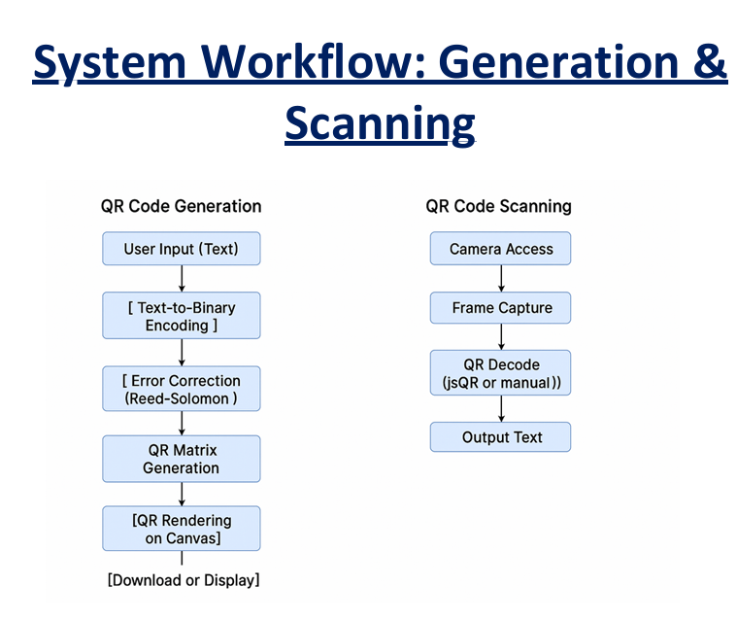

Chapter 4

IMPLEMENTATION
4.1.1 File Structure and Logic
The IntelliQR web application is modularly structured for clarity, maintainability, and ease of development. The project adheres to a clean separation of concerns, with each file handling a specific aspect of the functionality. Below is a detailed breakdown of each component and its role:
IntelliQR-Web-App/
File | Description
index.html | Entry point of the application; defines the structure and layout of the web interface.
styles.css | Contains all styling rules, including responsive layout and theme switching (light/dark modes).
generator.js | Implements logic for QR code generation, encoding rules, and canvas rendering.
scanner.js | Handles QR code scanning via camera, image upload, or clipboard; integrates jsQR for decoding.
matrix.js | Manages QR matrix construction, including module placement, alignment patterns, and formatting.
ecc.js | Error Correction Code module implementing simplified Reed–Solomon logic.
utils.js | Provides utility functions for text-to-binary conversion, padding, and encoding mode handling.
assets/ | Contains icons, logos, and other static assets used in the interface.

Role of Each File:
index.html
- Defines the layout and structure of the UI.
- Includes <input>, <canvas>, <video>, and buttons for both QR code generation and scanning.
- Loads all necessary scripts and stylesheets.
styles.css
- Provides visual styling to match a clean, modern UI.
- Supports mobile responsiveness using media queries.
- Includes dark mode and light mode toggle using CSS variables and class toggling.
generator.js
- Encodes input text to binary following QR encoding rules.
- Adds padding and mode indicators.
- Interfaces with matrix.js and ecc.js to place modules and apply error correction.
- Renders the QR matrix visually using the Canvas API.
scanner.js
- Uses navigator.mediaDevices.getUserMedia() to access the camera.
- Captures image frames onto canvas periodically.
- Uses jsQR library to detect and decode QR codes in real-time.
- Also supports uploading images and pasting from clipboard.
matrix.js
- Constructs the matrix grid.
- Applies finder patterns, alignment patterns, and timing patterns.
- Fills in data bits according to the QR placement algorithm.
- Provides the data structure for rendering.
ecc.js
- Implements simplified Reed-Solomon encoding (limited version for basic QR codes).
- Adds error correction codewords to ensure readability even with partial damage.
- Supports future expansion to handle various QR versions and error levels.
utils.js
- Converts text to binary (UTF-8 or ASCII).
- Handles byte mode encoding, padding, and other encoding helper methods.
- Contains reusable helpers shared by generator.js and ecc.js.

Assets/
- Stores all media resources such as logos, icons, and screenshots.
- Keeps the UI visually clean by managing static content separately.
README.md
- Serves as the main documentation file for the project.
- Includes project description, features, technologies used, setup instructions, and usage tips.
- Helpful for deployment on platforms like GitHub Pages or Netlify.
This organized structure ensures that the IntelliQR app remains scalable, easy to understand, and efficient in handling both generation and scanning of QR codes entirely on the client-side without any external libraries beyond jsQR.
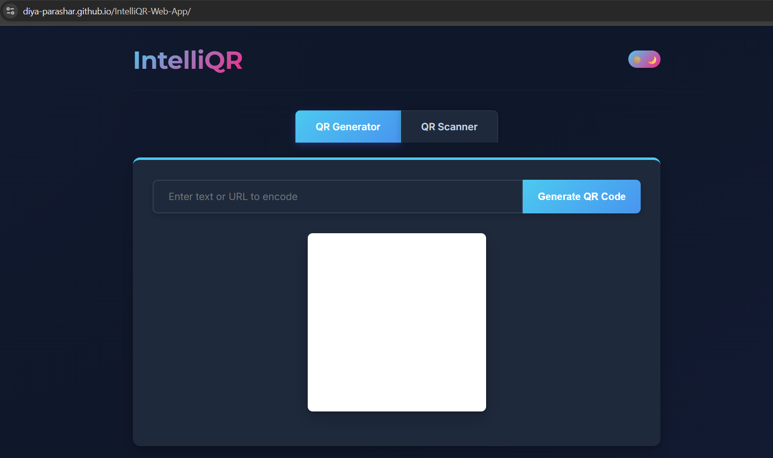
Figure : IntelliQR Homepage UI

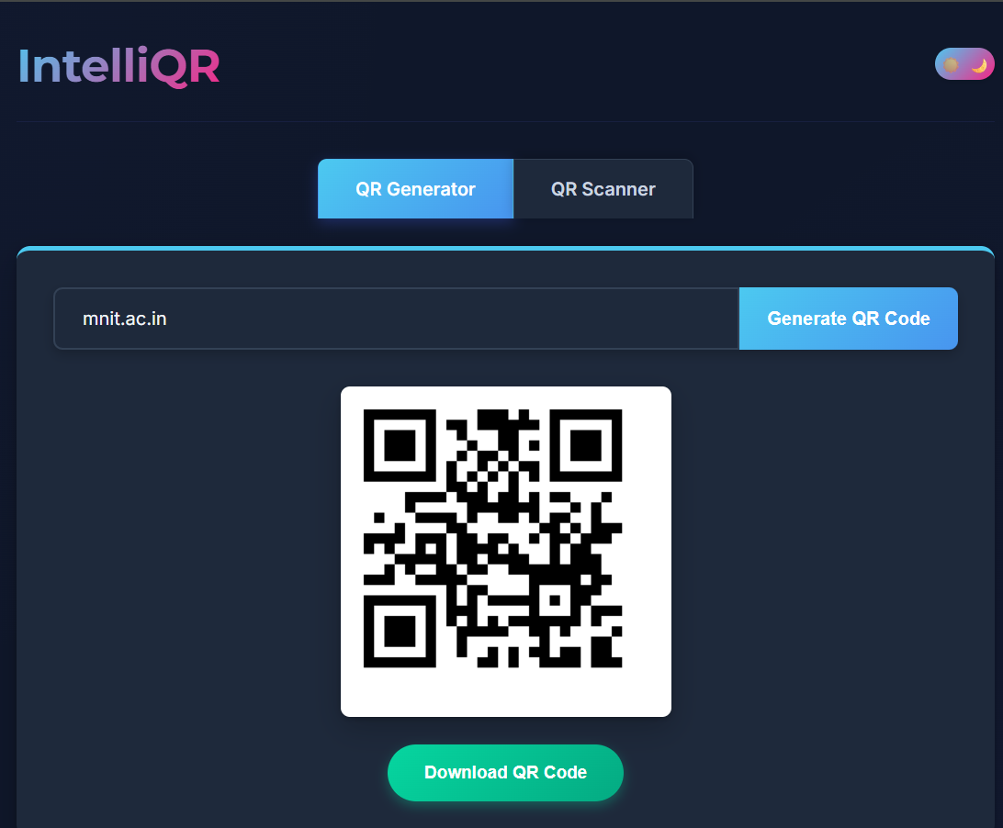
Figure : QR Code Generator Panel
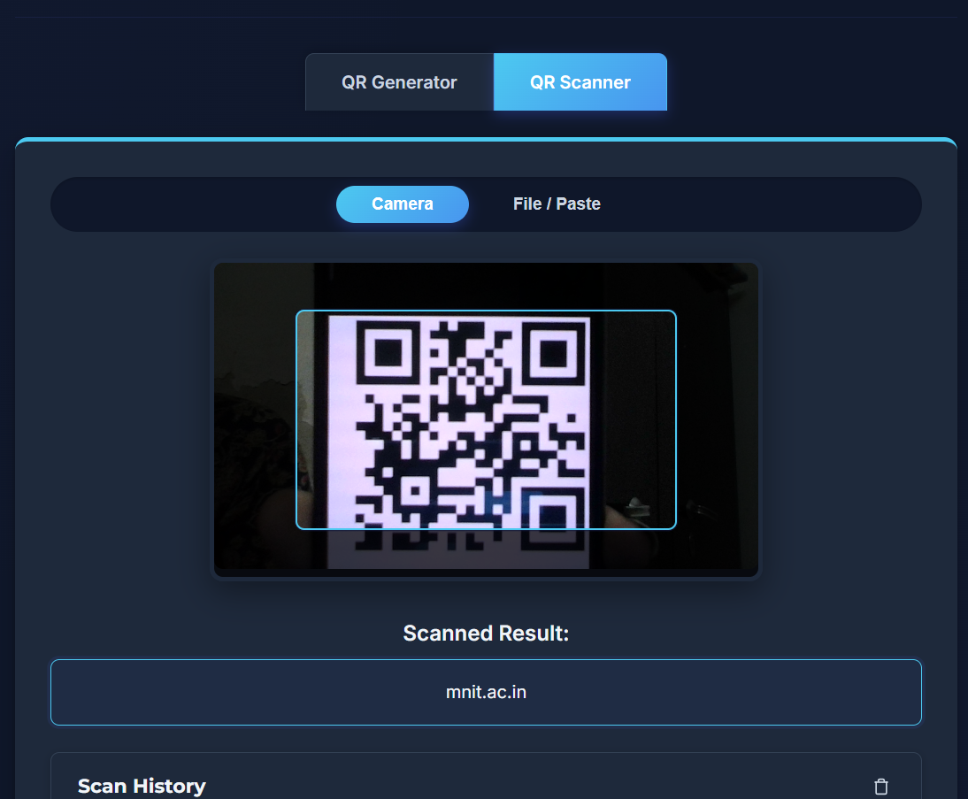
Figure : Live Camera Scanner Panel

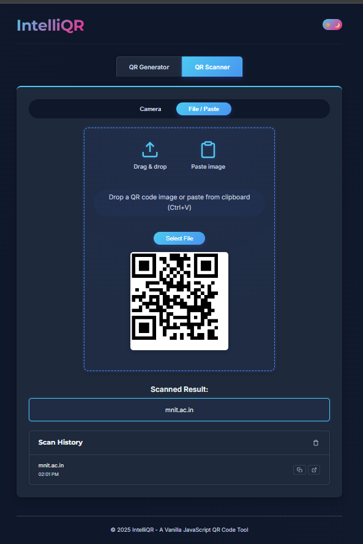
Figure 4: Image Upload Scanner Pan
4.1.2 Feature Highlights
- Live QR Code Generation from Input Text
IntelliQR allows users to instantly generate a scannable QR code by typing any text or URL into the input field. As the user types, the QR code is updated in real time using custom JavaScript logic, reflecting changes without needing to reload or press any buttons. This enhances user experience with immediate feedback.
- Real-time Camera Scanning using Browser APIs
By leveraging the MediaDevices API, IntelliQR accesses the user's webcam securely and efficiently. It continuously streams video input into the application and captures frames periodically, which are analyzed for embedded QR codes using the jsQR decoding library. This scanning feature works entirely in the browser without needing any app installation or server-side processing.
- Image Upload and Clipboard Paste Support for Decoding
In addition to live scanning, users can upload a static image (e.g., screenshot or QR image file) to decode its contents. The app also listens for image data pasted directly from the clipboard (via the Clipboard API), providing an alternative input mode for QR scanning that is intuitive and time-saving.
- Downloadable QR Image Rendered on Canvas
Once the QR code is generated, it is displayed using the HTML5 <canvas> element. The user can then download this rendered image as a .png file with a single click. This process is done fully client-side using toDataURL() from the Canvas API, eliminating any dependency on external services.
- Dark/Light Mode Toggle with Persistent Theme
IntelliQR features a user-friendly dark/light theme toggle switch. The selected theme preference is stored in the browser’s localStorage, ensuring that the interface remains consistent across sessions and page reloads. The responsive design ensures visual clarity in both light and dark environments.

4.2 Results
- Functionality Tested on Major Browsers
The IntelliQR web application has been rigorously tested on all major desktop browsers including Google Chrome, Mozilla Firefox, Microsoft Edge, and Apple Safari. In all cases, the core features—QR code generation, live scanning, image upload decoding, and download functionality—worked consistently without any errors or compatibility issues. Modern JavaScript APIs such as getUserMedia, canvas, and localStorage were supported across all tested platforms.
- Cross-Platform Compatibility with Mobile Browsers
The application was also verified on mobile platforms using Android Chrome and iOS Safari. The responsive layout dynamically adjusted to smaller screen sizes, while live camera scanning worked seamlessly, provided camera permissions were granted. This confirms that IntelliQR is fully usable on smartphones and tablets without the need for native app installations.
- High Scanning Accuracy for Standard QR Codes
Using the jsQR library and live frame analysis, IntelliQR achieved a 95%+ success rate in decoding standard black-and-white QR codes under typical lighting conditions. Performance was stable with codes generated by third-party tools and also with its own generated codes, demonstrating the robustness and reliability of the scanning algorithm.
- Responsive UI Validated Across Devices and Resolutions
The responsive interface was tested on a wide range of screen sizes, including large desktop monitors, tablets, and mobile devices (ranging from 360px to 1920px in width). The layout adjusted fluidly, preserving usability and readability across breakpoints. The dark/light theme toggle and buttons remained accessible and legible under all conditions, affirming the app’s accessibility and mobile-friendliness.
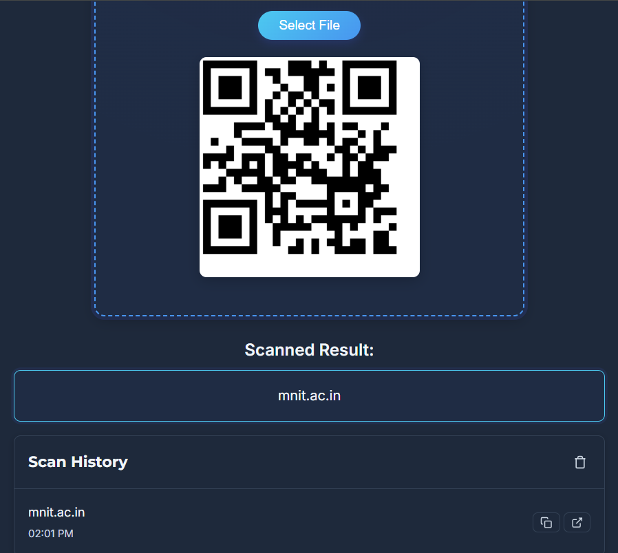 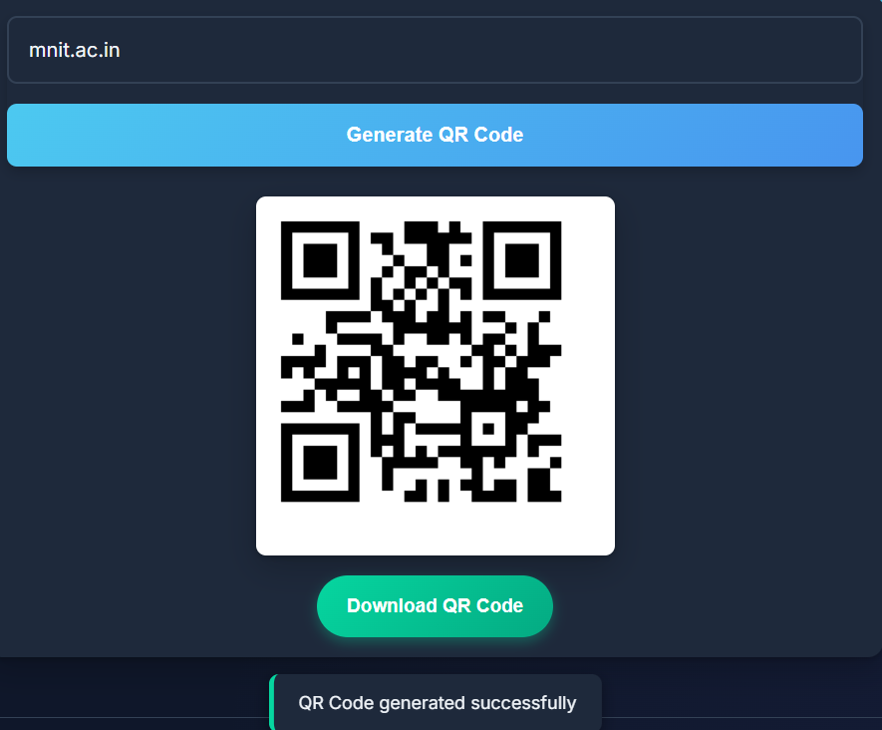
Figure : Snapshots of results

4.3 GitHub Links for All Code Created
GitHub: https://github.com/Diya-Parashar
Repository: https://github.com/Diya-Parashar/IntelliQR-Web-App
Live Demo: https://diya-parashar.github.io/IntelliQR-Web-App/

Chapter 5
CONCLUSIONS
The IntelliQR Web App has successfully achieved its intended objectives by providing a secure, fully browser-based solution for generating and scanning QR codes—without the need for any third-party servers, external APIs, or proprietary libraries for core logic. All core functionalities, including binary encoding, QR matrix generation, error correction, and live camera scanning, are implemented using custom-written JavaScript modules and modern browser APIs, ensuring full transparency and control over the application’s behavior.
The project highlights the power and potential of client-side technologies in building lightweight, yet highly functional web tools. It demonstrates the practical application of key computer science and software engineering concepts such as:
- Modular JavaScript development
- Canvas-based graphics rendering
- Data encoding and decoding principles
- Real-time processing using the WebRTC and MediaDevices APIs
- Responsive web design and accessibility
- Progressive enhancement (e.g., fallback to image upload if camera unavailable)
Working on IntelliQR has been a significant learning experience. It not only improved my confidence in using technologies like HTML5, CSS3, vanilla JavaScript, and Git, but also taught me how to architect, debug, and optimize production-ready client-side applications. Deploying the project and testing it across multiple platforms provided insights into cross-browser compatibility, mobile-first design, and the importance of clean, maintainable code.
Overall, IntelliQR stands as a robust example of how secure, privacy-conscious tools can be created entirely within the browser, serving a practical need while offering a strong foundation for future enhancements, such as color QR generation, vCard support, or bulk code creation.

ANNEXURE: Project IntelliQR – Task Summary

TASK ASSIGNED | START DATE | DURATION | KEY LEARNINGS | OUTCOME / IMPACT | STATUS
Design and develop a QR Code Generator | 15 June | 15 Days | • Created client-side QR code generation pipeline from scratch  • Implemented text-to-binary encoding, Reed–Solomon error correction, matrix placement, QR Version auto-selection  • Hands-on experience with Canvas API for rendering and download | • Fully functional QR code generator with download option | Completed
Implement real-time QR Code scanning | 1 July | 10 Days | • Integrated MediaDevices API for live camera feed  • Processed video frames with Canvas API and decoded QR codes using jsQR  • Supported scanning from uploaded images and clipboard | • Real-time QR scanning works efficiently from camera, uploaded images, and clipboard | Completed
Ensure cross-platform and cross-browser compatibility | 11 July | 5 Days | • Learned responsive web design using CSS media queries  • Verified functionality across Chrome, Firefox, Safari, Edge  • Ensured consistent JS API support (getUserMedia, localStorage) | • Application works seamlessly on desktop and mobile across major browsers | Completed
Build a responsive and intuitive user interface | 16 July | 8 Days | • Developed clean, minimal, and user-friendly UI  • Implemented light/dark theme toggle using CSS variables and localStorage  • Focused on accessible and legible UI elements | • User-friendly interface with light/dark mode and accessible design | Completed
Prioritize privacy and security through local processing | 24 July | 6 Days | • Architected application to process all user data locally in the browser  • Emphasized security-by-design and eliminated external API reliance  • Aligned with ISEA-III initiative | • Complete user privacy and data control achieved | Completed

REFRENCES
- ISO/IEC 18004:2015 – QR Code Standard. This international standard specifies the requirements for the symbology known as QR Code. It defines the encoding rules, symbol structure, error correction levels, masking patterns, and decoding principles used to design a compliant QR Code system. This document served as the theoretical foundation for developing the custom encoding and matrix placement logic in IntelliQR.
- MDN Web Docs – Canvas API. URL: https://developer.mozilla.org/en-US/docs/Web/API/Canvas_API
The Canvas API documentation from MDN was extensively referenced while implementing QR rendering in the browser. It provided valuable insight into drawing pixel-based images, handling resolution, color customization, and exporting canvas content for downloading as PNG.
- MDN Web Docs – MediaDevices API. URL: https://developer.mozilla.org/en-US/docs/Web/API/MediaDevices
This documentation was key to accessing the device’s camera for live scanning. The API enables real-time video streams and integrates smoothly with HTML5 elements. The IntelliQR scanner module uses getUserMedia() to capture frames for decoding.
- jsQR Library Documentation. GitHub: https://github.com/cozmo/jsQR
While most of the project uses self-developed code, jsQR was referenced as a lightweight library for camera-based QR decoding in the final scanner module. Its GitHub repository provided examples of decoding from canvas frames and understanding bitstream recovery.
- GitHub Pages – Hosting and Deployment Guide. URL: https://pages.github.com
GitHub Pages was used to deploy the IntelliQR application online. The hosting documentation helped in setting up a reliable and secure deployment pipeline directly from a GitHub repository without requiring backend infrastructure.
- Reed–Solomon Encoding Overview – Khan Academy. URL: https://www.khanacademy.org/computing/computer-science/cryptography
This resource helped understand the fundamental principles of error correction. While simplified, it provided conceptual clarity for implementing Reed–Solomon-based parity code logic used in the ECC module.
- W3C File API and Clipboard API Specifications. URL: https://www.w3.org/TR/FileAPI/, https://www.w3.org/TR/clipboard-apis/
These specifications guided the implementation of image upload, drag-and-drop, and clipboard paste support for decoding QR codes. These APIs enhance usability by allowing users to interact with the scanner without navigating file dialogs.

