Python Code to demonstrate SVM
import numpy as np  import matplotlib.pyplot as plt  from sklearn.svm import SVC  # 1) Create sample dataset  np.random.seed(42)  # Class 0 points  X0 = np.random.randn(30, 2) + np.array([-2, -2])  y0 = np.zeros(30)  # Class 1 points  X1 = np.random.randn(30, 2) + np.array([2, 2])  y1 = np.ones(30)  # Combine dataset  X = np.vstack((X0, X1))  y = np.hstack((y0, y1))  # 2) Train Linear SVM  svm = SVC(kernel="linear", C=1.0)  svm.fit(X, y)  # -----------------------------  # 3) Extract hyperplane  # -----------------------------  w = svm.coef_[0] # weights  b = svm.intercept_[0] # bias  # Create x values for plotting decision boundary  x_min, x_max = X[:, 0].min() - 1, X[:, 0].max() + 1  xx = np.linspace(x_min, x_max, 200)  # Decision boundary: w0*x + w1*y + b = 0 => y = -(w0*x + b)/w1  yy = -(w[0] * xx + b) / w[1]  # Margin lines: w0*x + w1*y + b = ±1  yy_margin1 = -(w[0] * xx + b - 1) / w[1]  yy_margin2 = -(w[0] * xx + b + 1) / w[1]  # -----------------------------  # 4) Plot points, hyperplane, margins  # -----------------------------  plt.figure(figsize=(9, 6)) | # Plot data points  plt.scatter(X0[:, 0], X0[:, 1], label="Class 0", marker="o")  plt.scatter(X1[:, 0], X1[:, 1], label="Class 1", marker="s")  # Plot decision boundary  plt.plot(xx, yy, "k-", label="Hyperplane (Decision Boundary)")  # Plot margins  plt.plot(xx, yy_margin1, "k--", label="Margin +1")  plt.plot(xx, yy_margin2, "k--", label="Margin -1")  # Highlight support vectors  plt.scatter(svm.support_vectors_[:, 0], svm.support_vectors_[:, 1],  s=120, facecolors='none', edgecolors='k', label="Support Vectors")  plt.title("SVM Demonstration (Hyperplane + Margins + Support Vectors)")  plt.xlabel("Feature 1")  plt.ylabel("Feature 2")  plt.legend()  plt.grid(True)  plt.show()  Output:  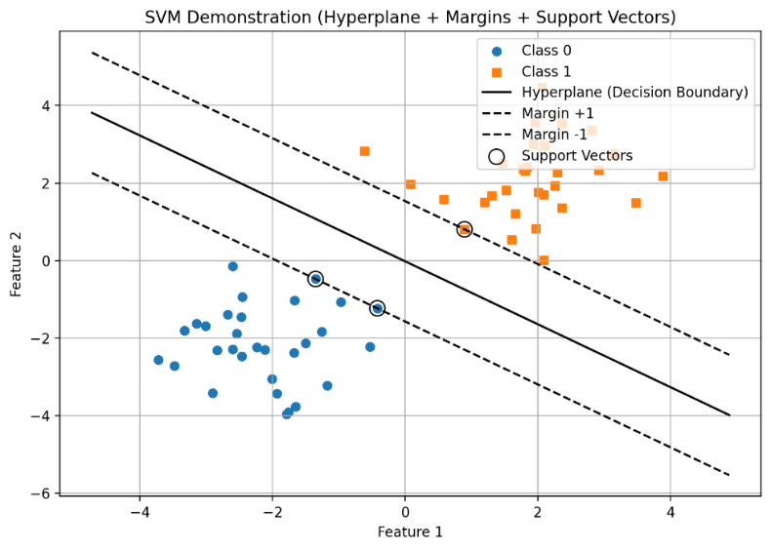

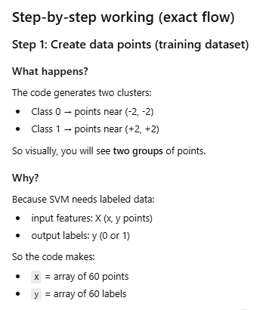 | 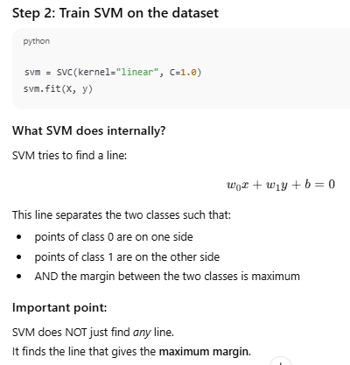
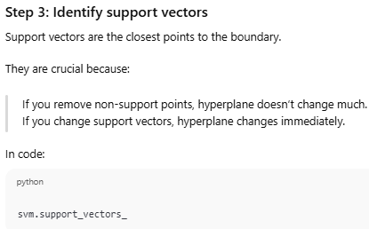 | 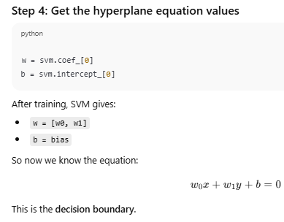
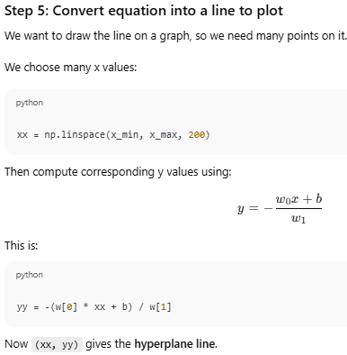 | 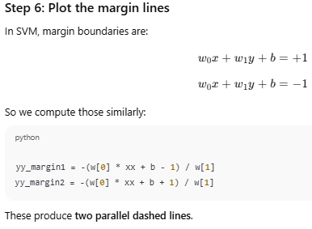  Step 7: Plot everything  - Scatter plot of class 0 and class 1 points  - Plot hyperplane  - Plot margin lines  - Highlight support vectors  So output shows:  - Points  - Decision boundary  - Margin lines  - Support vectors

Simple analogy:
Imagine two groups of students standing in a field:
- Group A (class 0)
- Group B (class 1)
You want to put a rope line between them.
SVM chooses the rope position such that:
- It separates both groups
- The rope is placed so that the minimum distance from rope to nearest student is maximum
(this distance is the margin)
The nearest students are the support vectors.

Breast Cancer Prediction using SVM
We will predict whether cancer is Benign or Malignant using historical data about patients diagnosed with cancer. This data includes independent attributes such as tumor size, texture, and others. To perform this classification, we will use an SVM (Support Vector Machine) classifier to differentiate between benign and malignant cases effectively.

#code
from sklearn.datasets import load_breast_cancer
import matplotlib.pyplot as plt
from sklearn.inspection import DecisionBoundaryDisplay
from sklearn.svm import SVC

cancer = load_breast_cancer()
X = cancer.data[:, :2]
y = cancer.target

svm = SVC(kernel="linear", C=1)
svm.fit(X, y)

DecisionBoundaryDisplay.from_estimator(
svm,
X,
response_method="predict",
alpha=0.8,
cmap="Pastel1",
xlabel=cancer.feature_names[0],
ylabel=cancer.feature_names[1],
)

plt.scatter(X[:, 0], X[:, 1],
c=y,
s=20, edgecolors="k")
plt.show()

Explanation:

1. Importing required libraries
from sklearn.datasets import load_breast_cancer
import matplotlib.pyplot as plt
from sklearn.inspection import DecisionBoundaryDisplay
from sklearn.svm import SVC

What each import does:
- load_breast_cancer
Loads a built-in real medical dataset (Wisconsin Breast Cancer Dataset).
- matplotlib.pyplot
Used for plotting (though here the plotting is handled indirectly).
- DecisionBoundaryDisplay
A utility to visualize the decision boundary of a classifier (very useful for SVM explanation).
- SVC (Support Vector Classifier)
The SVM model used for classification.

2. Loading the breast cancer dataset
cancer = load_breast_cancer()
This loads a dataset with:
- 569 samples
- 30 numerical features (mean radius, texture, smoothness, etc.)
- Binary target
  - 0 → malignant
  - 1 → benign
Internally, it creates a dictionary-like object containing:
- cancer.data
- cancer.target
- cancer.feature_names
- cancer.target_names

3. Selecting features and target
X = cancer.data[:, :2]
y = cancer.target

What’s happening here?

X = cancer.data[:, :2]
- cancer.data has 30 features
- You are selecting only the first two features
  - Feature 0 → mean radius
  - Feature 1 → mean texture
✅ Why only 2 features?
Because decision boundaries can only be visualized in 2D.
This is purely for illustration, not for best accuracy.

y = cancer.target
- This is the class label:
  - 0 = malignant
  - 1 = benign

4. Creating the SVM model
svm = SVC(kernel="linear", C=1)

Understanding the parameters:

kernel="linear"
- The model tries to find a straight line (hyperplane) that separates the two classes.
- Equation form:
w1x1+w2x2+b=0w_1x_1 + w_2x_2 + b = 0w1​x1​+w2​x2​+b=0

C=1
- Regularization parameter
- Controls the trade-off between:
  - Large margin
  - Misclassification
C value | Effect
Small C | Wider margin, more errors allowed
Large C | Narrow margin, fewer errors

Here, C=1 is a balanced default choice.

5. Training the SVM model
svm.fit(X, y)
This is where learning happens.

Internally, SVM:
- Finds support vectors (critical data points closest to boundary)
- Maximizes the margin between classes
- Learns the optimal separating hyperplane
After this step, the model knows how to classify:
malignant vs benign tumors using 2 features

6. Visualizing the decision boundary
DecisionBoundaryDisplay.from_estimator(
svm,
X,
response_method="predict",
alpha=0.8,
cmap="Pastel1",
xlabel=cancer.feature_names[0],
ylabel=cancer.feature_names[1],
)
This line draws the classification regions.

Key parameters explained:

from_estimator(svm, X)
- Uses the trained SVM model
- Evaluates predictions across the feature space

response_method="predict"
- Uses class labels (0 or 1) instead of probabilities

alpha=0.8
- Controls transparency of the plot

cmap="Pastel1"
- Color scheme for malignant vs benign regions

Axis labels:
xlabel = "mean radius"
ylabel = "mean texture"
These correspond to the two selected features.

7. What the final plot shows
The plot displays:
- Two colored regions → predicted classes
- A straight decision boundary → linear SVM
- Each region represents where the model predicts:
  - Benign
  - Malignant
👉 Points close to the boundary are support vectors (most influential).

8. Important academic notes (exam / viva ready)
- This is binary classification
- SVM works well for:
  - High-dimensional data
  - Medical diagnosis
- Using only 2 features:
  - ❌ Not optimal for real diagnosis
  - ✅ Excellent for conceptual understanding

9. If you want improvements (optional)
For better accuracy:
X = cancer.data # use all 30 features
For nonlinear separation:
SVC(kernel="rbf")
For model evaluation:
from sklearn.metrics import accuracy_score

