

**ASSIGNMENT-1**

1. **Are the HTML tags and elements the same thing?**

* No, HTML tags and elements are not the same, although they are closely related.
* HTML Tags: In HTML, we use “tags” to define elements on a webpage. There’s an opening tag that marks the end. These tags are like commands and are enclosed in angle brackets[<>]. For example , <p> is an opening tag for a paragraph, and </p> is the closing tag.
* HTML Elements: An HTML elements consists of an opening tag, content, and a closing tag. The opening tag indicates the beginning of the elements, and the closing tag marks the end. The content is the information placed between the opening and closing tags. For example, in the html element <p> Hello World </p>. <p> is opening tag , “Hello World” is the content and </p> is the closing tag.

1. **What are tags and attributes in HTML?**

* **HTML tags** are like keyword which defines that how web browser will format and display or show the content. HTML tags contain three main ports, opening tag, content and closing tag but some hatml tags are unclosed tags they are also called standalone or singular tag. **For Ex., <title> <p> <h1>**
* **HTML Attribute** :
* All HTML elements can have **attributes**
* Attributes provide **additional information** about elements
* Attributes are always specified in **the start tag**
* Attributes usually come in name/value pairs like: **name="value"**

1. **What are void elements in HTML?**

* A void element is an element whose content model never allows it to have contents under any circumstances. Void elements can have attributes. The following is a complete list of the void elements in HTML: area , br ,, hr , img , input , link , param , source

1. **What are HTML Entities?**

* Some characters are reserved in HTML. If you use the less than (<) or greater than (>) signs in your HTML text, the browser might mix them with tags. Entity names or entity numbers can be used to display reserved HTML characters.

1. **What are different types of lists in HTML?**

* Order List
* A, a, I, I, number
* Unorder List
* Circle, square, disk
* Description List

1. **What is the ‘class’ attribute in HTML?**

* The **class** attribute specifies one or more class names for an element.
* The **class** attribute is mostly used to point to a class in a style sheet. However, it can also be used by a JavaScript (via the HTML DOM) to make changes to HTML elements with a specified class.

1. **What is the difference between the ‘id’ attribute and the ‘class’ attribute of HTML elements?**

* the difference between Class and ID: A Class name can be used by multiple HTML elements, while an ID name must only be used by one HTML element within the page.

1. **What are the various formatting tags in HTML?**

* <b> - Bold text
* <strong> - Important text­
* <i> - Italic text
* <em> - Emphasized text
* <mark> - Marked text
* <small> - Smaller text
* <del> - Deleted text
* <ins> - Inserted text
* <sub> - Subscript text
* <sup> - Superscript text

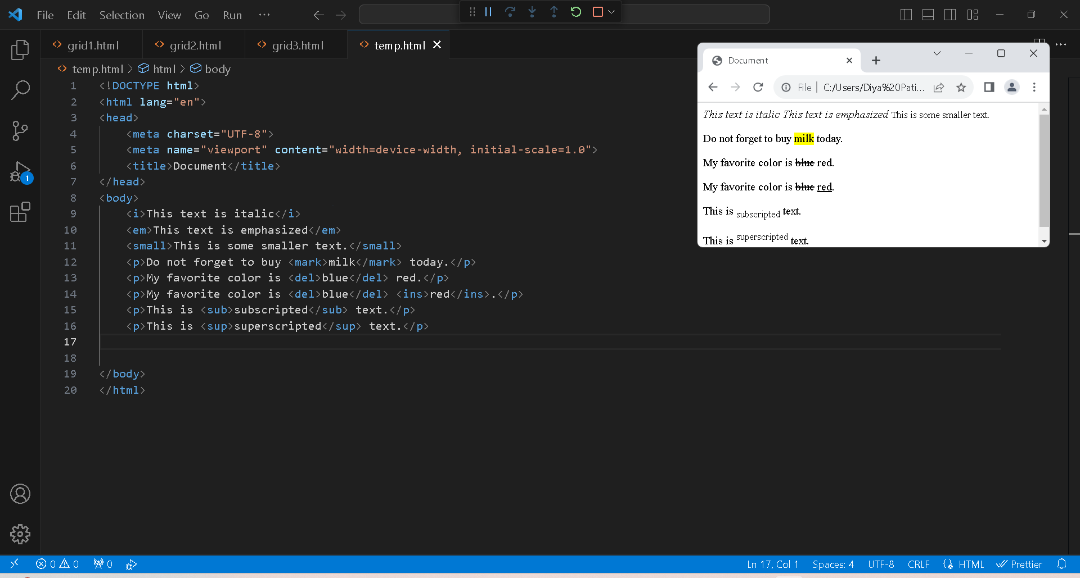

1. **How is Cell Padding different from Cell Spacing?**

* Cellpadding:

Cellpadding specifies the space between the border of a table cell and its contents (i.e) it defines the whitespace between the cell edge and the content of the cell.

Syntax:

<table cellpadding="value" >.....</table>

* **Cellspacing:**

Cellspacing specifies the space between cells (i.e) it defines the whitespace between the edges of the adjacent cells.

**Syntax:**

**<table cellspacing="value" >.....</table>**

1. **How can we club two or more rows or columns into a single row or column in an HTML table?**

* It can be done by using the rowspan and colspan attribute in HTML. The rowspan is used to merge or combine the number of cells in a row whereas the colspan is used to merge column cells in a table.

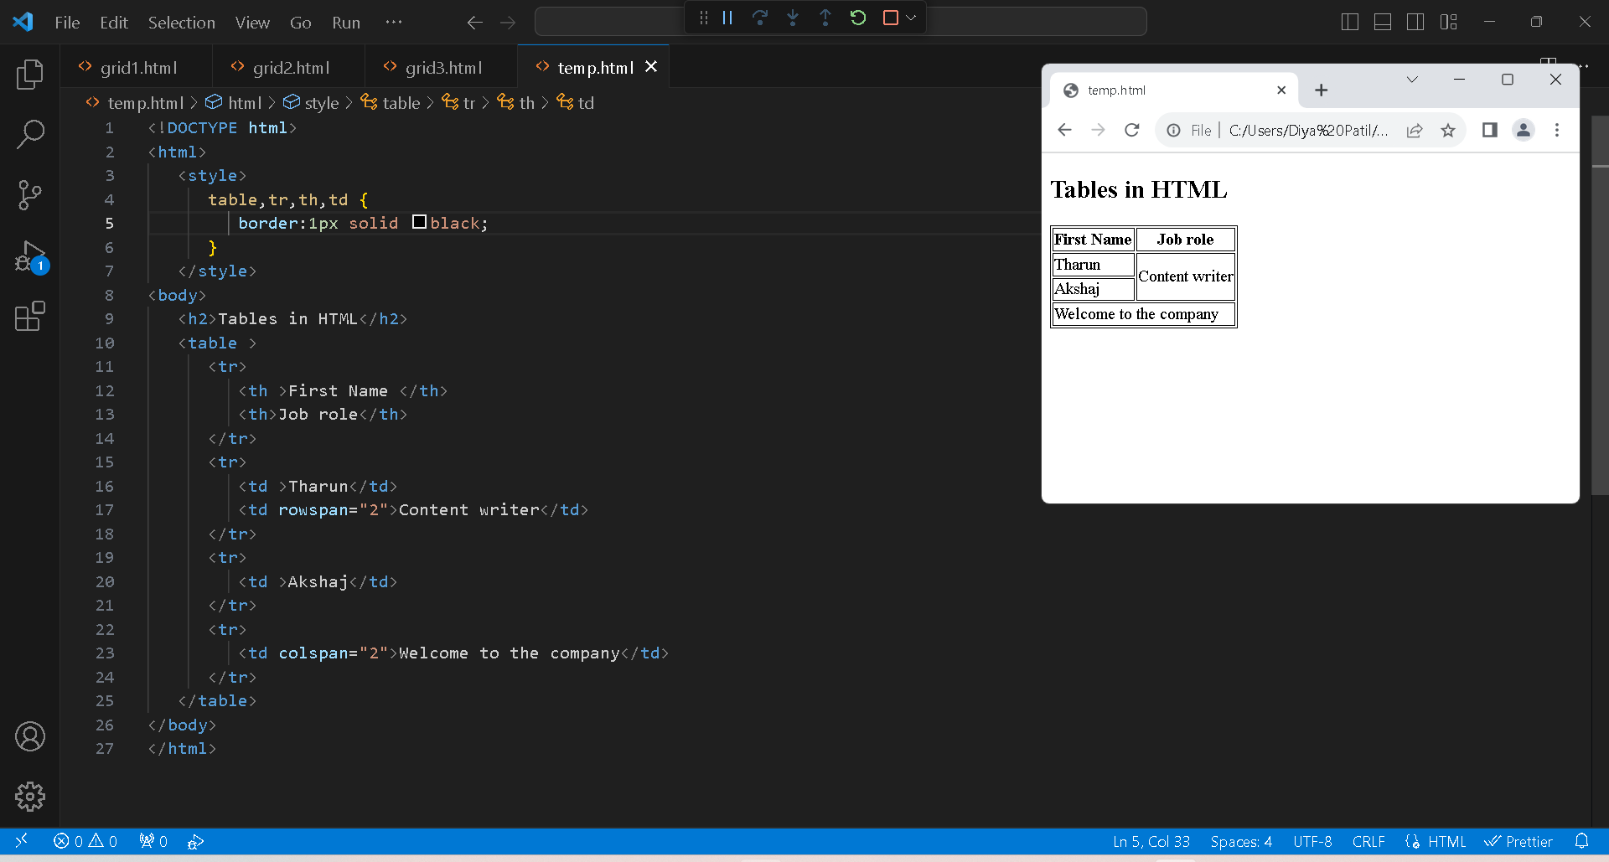

1. **What is the difference between a block-level element and an inline element?**

* Block elements cover space from left to right as far as it can go. Inline elements only cover the space as bounded by the tags in the HTML element. Block elements have top and bottom margins. Inline elements don't have a top and bottom margin.

1. **How to create a Hyperlink in HTML?**

* The Anchor tag is used to add links to an existing content inside an html page.
* **Href** :This attribute specifies the destination URL to which the link points.
* **Syntax:**

**< a href=**[**https://google.com**](https://google.com)**> click me </a>**

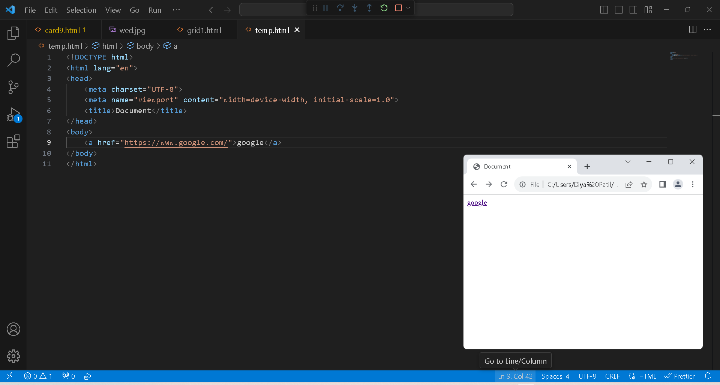

1. **What is the use of an iframe tag?**

* The **< iframe>**(inline frame) tag in HTML is used to embed another HTML document or external content within the current HTML document. It creates a rectangular frame that displays the specified content,
* <iframe src="https://www.example.com"></iframe>

1. **What is the use of a span tag? Explain with example?**

* The **<Span>**tag in HTML is an inline container element used to group and apply styles or scripting to a specific section of text within a document.

ss

<span class="s1">HTML</span>

<span class="s1">CSS</span>

1. **How to insert a picture into a background image of a web page?**

* The background-image property specifies an image to use as the background of an element. By default, the image is repeated so it covers the entire element.

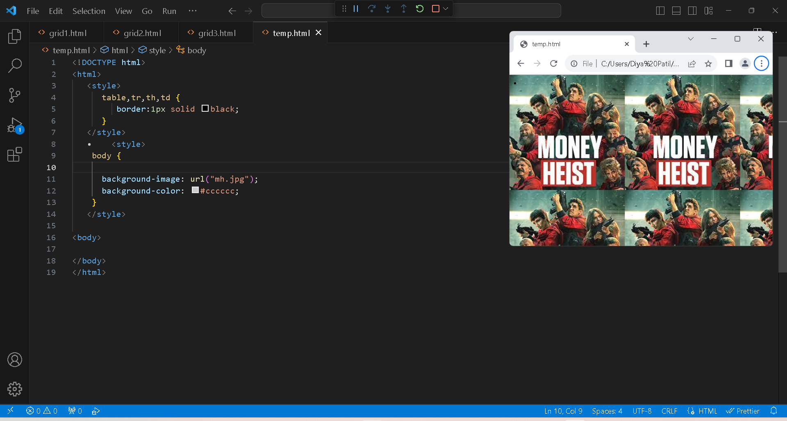

1. **How are active links different from normal links?**

* Active links are hyperlinks that are currently being interacted with by the user. This can happen when the user hovers over the link with their mouse cursor, clicks on it, or right-clicks on it. Normal links are hyperlinks that have not been interacted with.

<html>

<head>

   <title>Difference between normal links and active links</title>

   <style>

      a:hover {

         color: red;

         background-color: transparent;

         text-decoration: underline;

      }

      a:active {

         color: yellow;

         background-color: transparent;

         text-decoration: underline;

      }

   </style>

</head>

<body>

   <h3>Click here to visit

<a href="https://www.google.com/">Google</a>

   </h3>

</body>

</html>

1. **What are the different tags to separate sections of text?**
2. <p> : stands for paragraph. It is used to define paragraph of text

<p>This is a paragraph of text.</p>

1. <h1> to <h6> : these tags define heading of different levels, with <h1> being the highest and <h6> being the lowest.

<h1>Main Heading</h1>

<h2>Subheading</h2>

1. <div> : stands for division. It is a container that is mostly used to group and structure content.

<div>

    <p>Text in a division.</p>

</div>

1. <hr> : Stands for horizontal line. It is used to create a horizontal line, often used to create separate sections.
2. **What is SVG?**

* SVG stands for Scalable Vector Graphics
* SVG is used to define vector-based graphics for the Web
* SVG defines the graphics in XML format

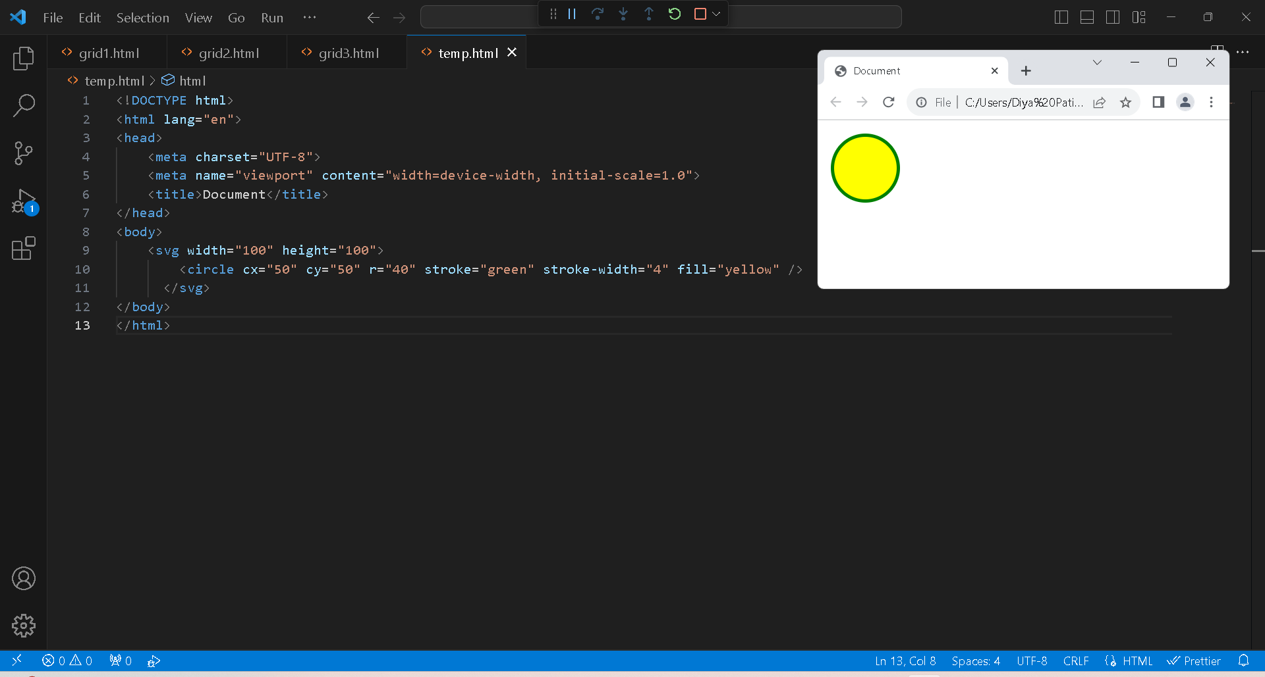

1. **What is difference between HTML and XHTML?**

* HTML (Hypertext Markup Language): it is the standard markup language for creating and designing web pages. It structures content on the web and is supported by web browsers.
* XHTML (Extensible Hypertext Markup Language): It is stricter, more XML-based version of HTML. It follows XML rules and syntax, promoting well formed documents.

1. **What are logical and physical tags in HTML?**

* In HTML the formatting tags are divided into two categories: Physical tag: These tags are used to provide the visual appearance to the text. Logical tag: These tags are used to add some logical or semantic value to the text.