**UNIT=3:**

**SQL:**

* SQL:
* SQL stands for Structured Query Language. It is used for storing and managing data in relational database management system (RDMS). In RDBMS data stored in the form of the tables.
* It is a standard language for Relational Database System. It enables a user to create, read, update and delete relational databases and tables.
* All the RDBMS like MySQL, Informix, Oracle, MS Access and SQL Server use SQL as their standard database language.
* SQL allows users to query the database in a number of ways, using English-like statements.
* SQL is mostly used by engineers in software development for data storage.
* **SQL follows the following rules:**

1. Structure query language is not case sensitive. Generally, keywords of SQL are written in uppercase.
2. Every SQL statements should ends with a semicolon.
3. Statements of SQL are dependent on text lines. We can use a single SQL statement on one or multiple text line.
4. Using the SQL statements, you can perform most of the actions in a database.
5. SQL depends on tuple relational calculus and relational algebra.

* 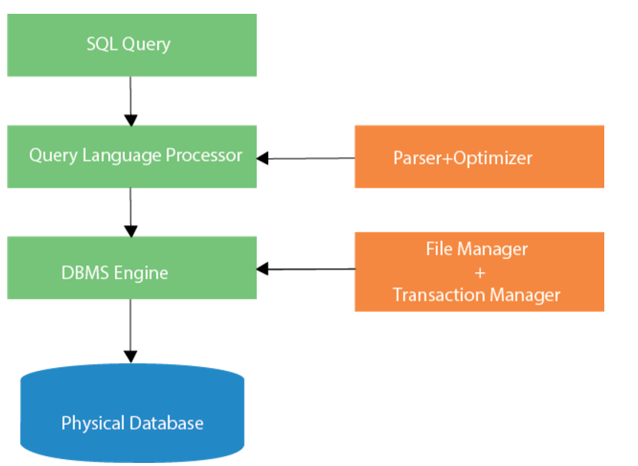
* Characteristics of SQL

1. SQL is easy to learn.
2. SQL is used to access data from relational database management systems.
3. SQL can execute queries against the database.
4. SQL is used to describe the data.
5. SQL is used to define the data in the database and manipulate it when needed.
6. SQL is used to create and drop the database and table.
7. SQL is used to create a view, stored procedure, function in a database.
8. SQL allows users to set permissions on tables, procedures, and views.

# Advantages of SQL

### **High speed**

* Using the SQL queries, the user can quickly and efficiently retrieve a large amount of records from a database.

### **No coding needed**

* In the standard SQL, it is very easy to manage the database system. It doesn't require a substantial amount of code to manage the database system.

### **Well defined standards**

* Long established are used by the SQL databases that are being used by ISO and ANSI.

### **Portability**

* SQL can be used in laptop, PCs, server and even some mobile phones.

### **Interactive language**

* SQL is a domain language used to communicate with the database. It is also used to receive answers to the complex questions in seconds.

### **Multiple data view**

* Using the SQL language, the users can make different views of the database structure.
* Datatypes in SQL:
* SQL Datatype is used to define the values that a column can contain.
* Every column is required to have a name and data type in the database table.

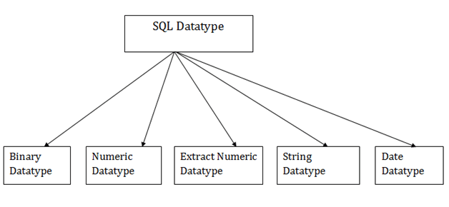

1. **Binary Datatypes**

* 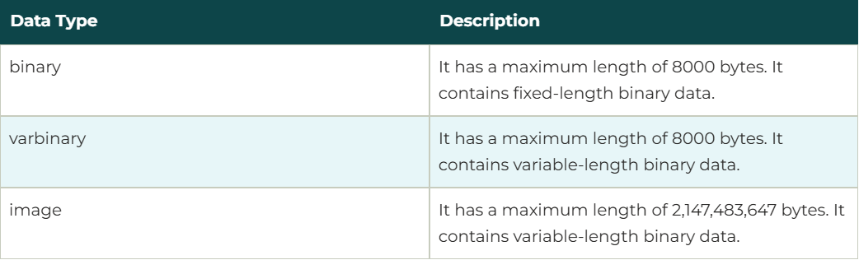

### **Approximate Numeric Datatype**

* 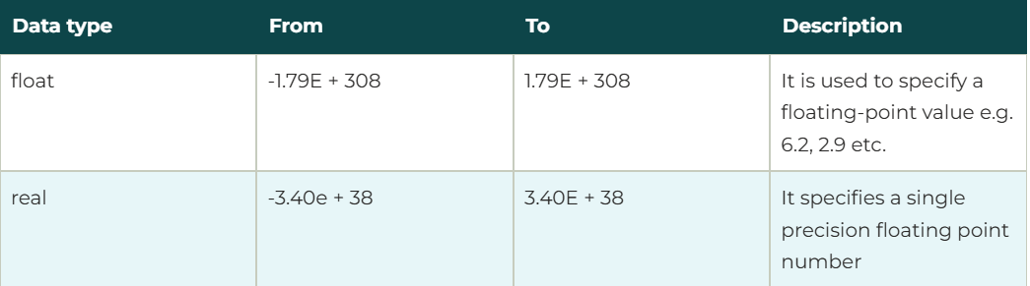

### **Exact Numeric Datatype**

* 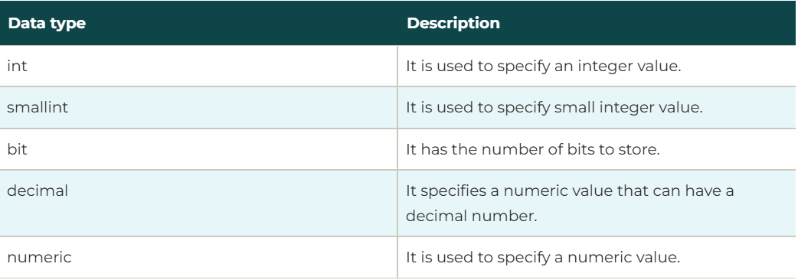

### **Character String Datatype**

* 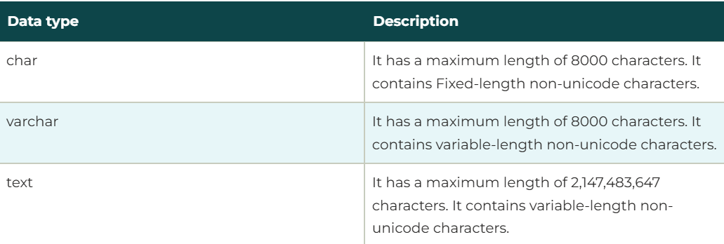

### **Date and time Datatypes**

* 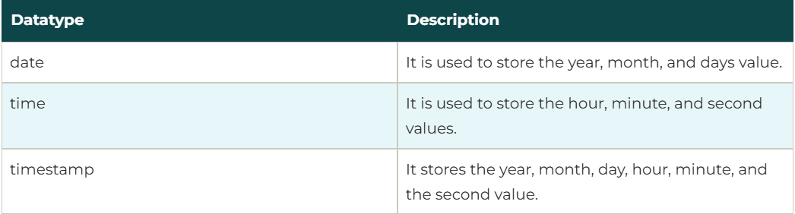
* Sql commands:
* create database GU;
* USE GU;
* CREATE TABLE Student(GU_Id Int primary key,Name varchar(50),Age int not null);
* insert into Student values(1, "manish", 31);
* insert into Student values(12, "manish", 31);
* SELECT * FROM Student;