Offline LLM Performance Report
Comparing Gemma 4 12B QAT | Qwen 3.5 9B | Ministral 3 3B
On NEET UG 2019, 2022, 2025 and JEE Main 2025 Question Papers
Prepared by: Diya Arora (Intern) | June 2026

Section 1: About the Models
Three small offline language models were tested using LM Studio, a free application that runs AI models locally on your computer without needing the internet. These models are much smaller than cloud AI like ChatGPT or Gemini, which is why their performance on tough exam questions is interesting to study.

1.1 Model Specifications

Feature | Gemma 4 12B QAT | Qwen 3.5 9B | Ministral 3 3B | Notes
Made by | Google DeepMind | Alibaba Cloud | Mistral AI | All free and open source
Parameters | 12 Billion | 9 Billion | 3 Billion | More = smarter but slower
Format | GGUF (Q4_0) | GGUF (Q4_K_M) | GGUF (Q4_K_M) | Quantized for efficiency
Context window | 2000 tokens (set) | 8192 tokens | 8192 tokens | How much text it can read
GPU Memory | 3.20 GB | 6.31 GB | 3.23 GB | RAM used on graphics card
Total Memory | 7.31 GB | 7.21 GB | 3.23 GB | Including system RAM
GPU Offload layers | 21 layers | 27 layers | 26 layers | How much runs on GPU
Run via | LM Studio | LM Studio | LM Studio | lmstudio.ai

Note: Gemma 4 12B had its context window set to only 2000 tokens in this test, which is much lower than its maximum supported 262,144 tokens. This may have hurt its performance on longer questions. Qwen and Ministral were both set to 8192 tokens.

Section 2: How the Test Was Done
Six questions were selected from each of six exam papers: three NEET UG papers (Biology, Physics, Chemistry) and three JEE Main papers (Physics, Chemistry, Maths). That means 36 questions were tested in total per model, with 3 models. Each model was asked these questions separately using LM Studio offline.

The JEE questions came from real JEE Main 2025 papers available on esaral.com. The NEET questions came from official NEET UG 2019, 2022, and 2025 papers.

Detail | NEET Papers | JEE Papers | Both Combined
Number of papers | 3 | 3 | 6
Questions per paper | 6 | 6 | 12
Total questions | 18 | 18 | 36
Subjects covered | Physics, Chem, Bio | Physics, Chem, Maths | 5 subjects
Models tested | 3 | 3 | 3
Years | 2019, 2022, 2025 | Jan 22, Jan 24, Apr 06 (2025) | 2019 to 2025

Section 3: NEET Results (Paper by Paper)
Red cells mean the model got it wrong. Green cells mean the model got it right. Questions not listed as wrong were counted as correct.

3.1 NEET 2022
Gemma got 1/6 wrong | Qwen got 2/6 wrong | Ministral got 2/6 wrong

Question | Type | Gemma 4 12B | Qwen 3.5 9B | Ministral 3B
Q3 Physics | MCQ/Diagram | Correct | Wrong | Correct
Q5 Physics | Calculation | Correct | Correct | Correct
Q27 Physics | MCQ/Assertion-Reason | Wrong | Correct | Correct
Q60 Chemistry | MCQ/Matching | Correct | Correct | Wrong
Q54 Chemistry | MCQ | Correct | Wrong | Wrong
Q147 Biology | MCQ/Diagram | Correct | Correct | Correct

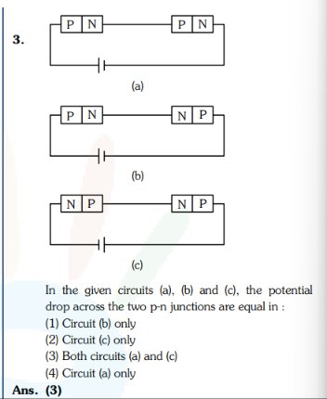
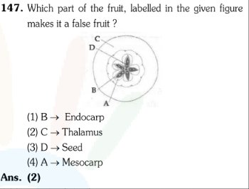
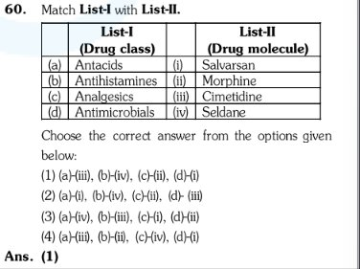

3.2 NEET 2019
Gemma got 2/6 wrong | Qwen got 3/6 wrong | Ministral got 3/6 wrong

Question | Type | Gemma 4 12B | Qwen 3.5 9B | Ministral 3B
Q17 Physics | Calculation | Correct | Wrong | Correct
Q25 Physics | MCQ | Correct | Wrong | Wrong
Q53 Chemistry | Calculation | Wrong | Correct | Wrong
Q62 Chemistry | Calculation | Wrong | Wrong | Wrong
Q107 Biology | MCQ | Correct | Correct | Correct
Q114 Biology | MCQ | Correct | Correct | Correct
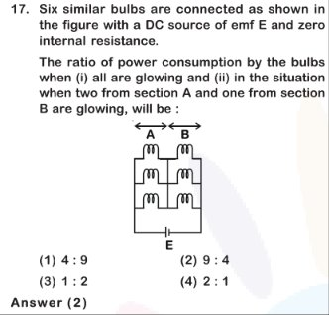
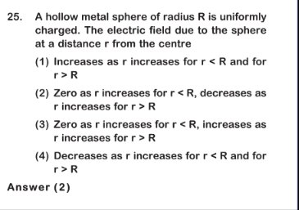
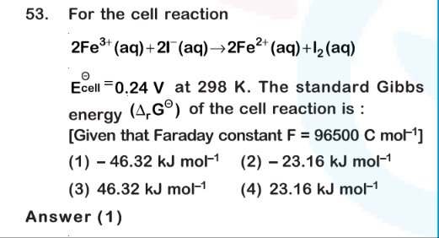
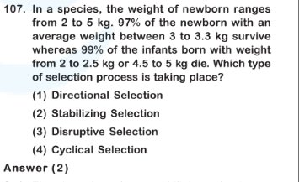
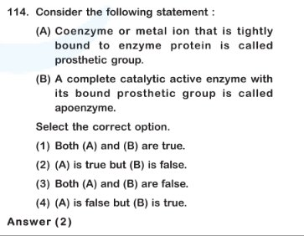

3.3 NEET 2025
Gemma got 4/6 wrong | Qwen got 6/6 wrong | Ministral got 3/6 wrong

Question | Type | Gemma 4 12B | Qwen 3.5 9B | Ministral 3B
Q1 Physics (first) | MCQ/Diagram | Correct | Wrong | Correct
Q6 Physics | Calculation/Diagram | Wrong | Wrong | Correct
Q46 Physics | Calculation | Wrong | Wrong | Wrong
Q48 Chemistry | MCQ/Matching | Wrong | Wrong | Wrong
Q65 Chemistry | MCQ/Diagram | Wrong | Wrong | Wrong
Q102 Biology | MCQ/Assertion-Reason | Correct | Wrong | Correct
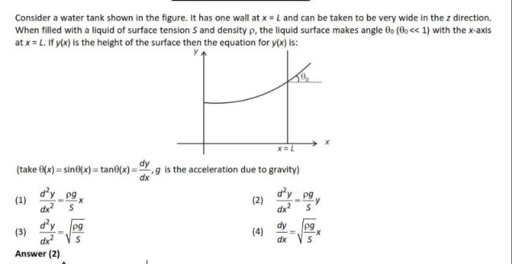
Question screenshot: Q6 Physics (Current Passing Through)
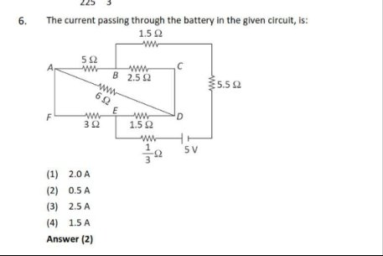
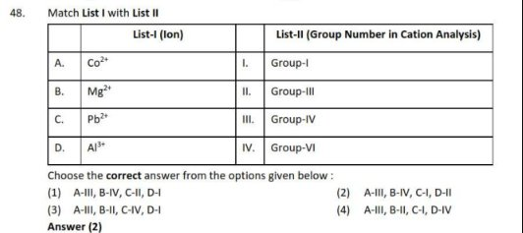
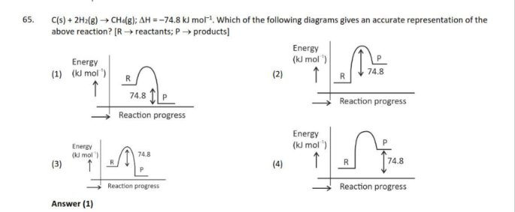
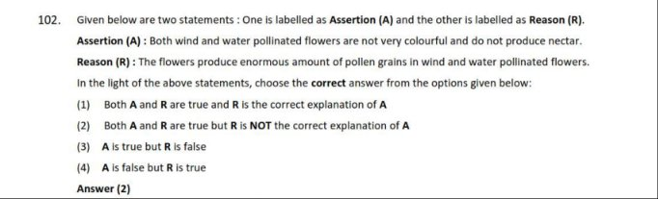

Section 4: JEE Main Results (Paper by Paper)
JEE questions came from three different 2025 sessions. These questions include Maths which NEET does not have.

JEE 2025 (06 Apr, Shift 1)
Gemma got 5/6 wrong | Qwen got 4/6 wrong | Ministral got 5/6 wrong

Question | Type | Gemma 4 12B | Qwen 3.5 9B | Ministral 3B
Q18 Maths | Calculation | Wrong | Wrong | Wrong
Q2 Maths | Calculation | Wrong | Wrong | Wrong
Q6 Physics | Calculation | Wrong | Wrong | Wrong
Q10 Physics | Calculation | Wrong | Correct | Wrong
Q7 Chemistry | Calculation | Wrong | Wrong | Wrong
Q13 Chemistry | MCQ/Matching | Correct | Correct | Correct
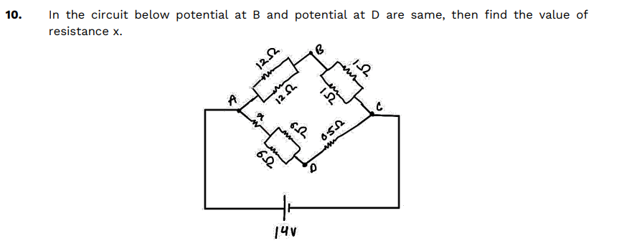
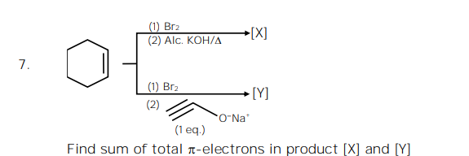
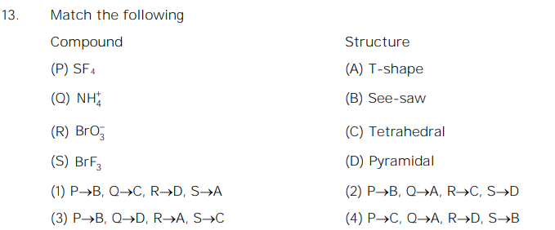

JEE 2025 (22 Jan, Shift 1)
Gemma got 5/6 wrong | Qwen got 5/6 wrong | Ministral got 5/6 wrong

Question | Type | Gemma 4 12B | Qwen 3.5 9B | Ministral 3B
Q3 Physics | MCQ/Diagram | Wrong | Wrong | Wrong
Q17 Physics | Calculation | Wrong | Wrong | Wrong
Q14 Chemistry | MCQ | Correct | Wrong | Wrong
Q24 Chemistry | Calculation | Wrong | Wrong | Wrong
Q8 Maths | MCQ/Calculation | Wrong | Wrong | Correct
Q10 Maths | MCQ | Wrong | Correct | Wrong
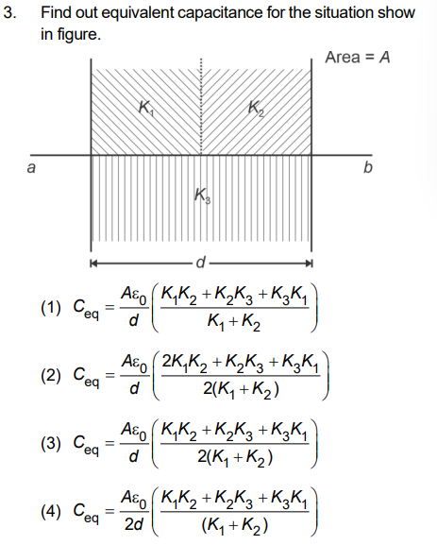
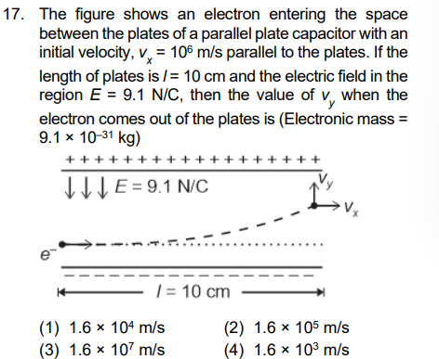
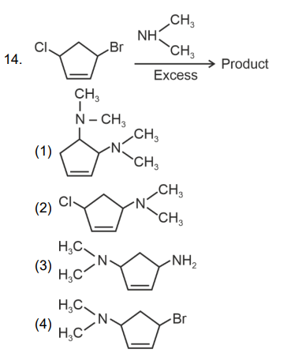
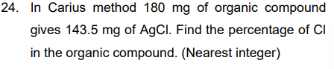
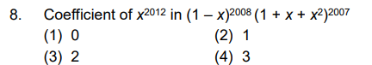
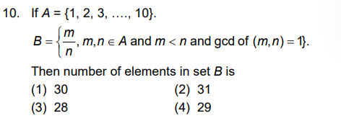

JEE 2025 (24 Jan, Shift 2)
Gemma got 2/6 wrong | Qwen got 4/6 wrong | Ministral got 4/6 wrong

Question | Type | Gemma 4 12B | Qwen 3.5 9B | Ministral 3B
Q6 Physics | Calculation | Correct | Wrong | Correct
Q8 Physics | MCQ | Correct | Correct | Wrong
Q3 Chemistry | MCQ | Wrong | Wrong | Wrong
Q5 Chemistry | MCQ | Correct | Wrong | Wrong
Q8 Maths | MCQ | Correct | Wrong | Correct
Q21 Maths | Calculation | Wrong | Correct | Wrong
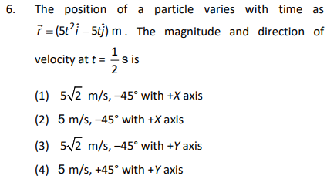
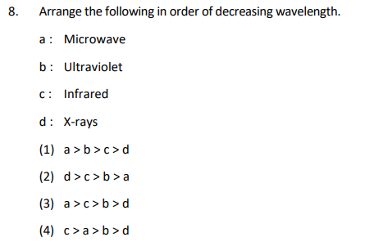
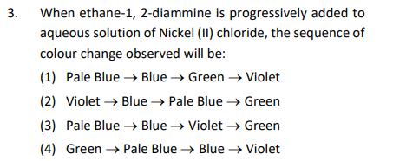
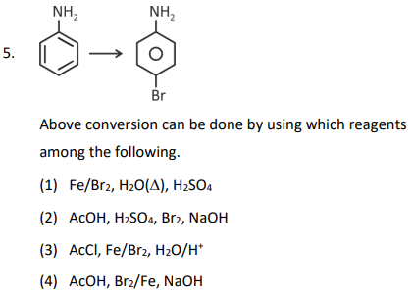
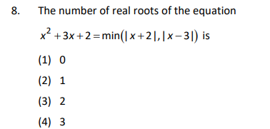
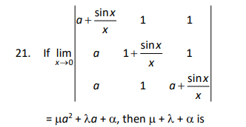

Section 5: Overall Summary

5.1 NEET Paper-wise Summary

Paper | Gemma Wrong | Qwen Wrong | Ministral Wrong | Total Qs
NEET 2022 | 1/6 | 2/6 | 2/6 | 6
NEET 2019 | 2/6 | 3/6 | 3/6 | 6
NEET 2025 | 4/6 | 6/6 | 3/6 | 6

5.2 JEE Paper-wise Summary

Paper | Gemma Wrong | Qwen Wrong | Ministral Wrong | Total Qs
JEE 2025 (06 Apr, Shift 1) | 5/6 | 4/6 | 5/6 | 6
JEE 2025 (22 Jan, Shift 1) | 5/6 | 5/6 | 5/6 | 6
JEE 2025 (24 Jan, Shift 2) | 2/6 | 4/6 | 4/6 | 6

5.3 Grand Total Across All 6 Papers

Model | Wrong Answers | Correct Answers | Accuracy
Gemma 4 12B QAT | 19 / 36 | 17 / 36 | 47%
Qwen 3.5 9B | 24/ 36 | 12 / 36 | 33%
Ministral 3 3B | 22 / 36 | 14 / 36 | 39%
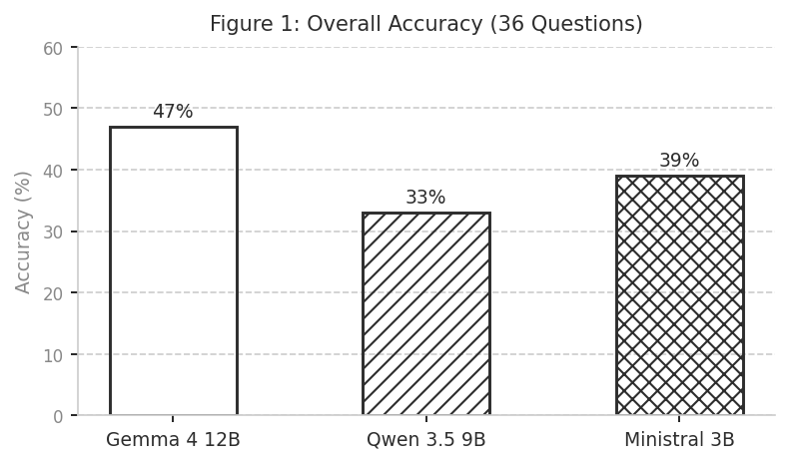
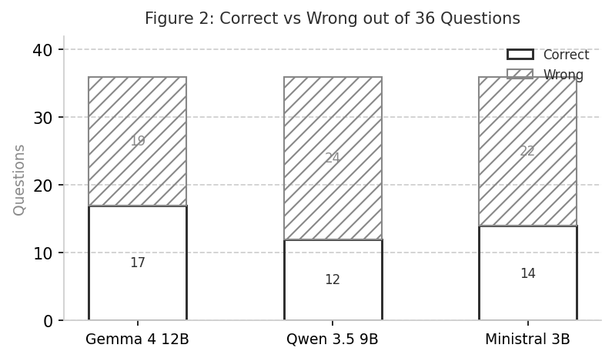

Section 6: Subject-wise Analysis
This section breaks down how each model performed in each subject across all papers.

Subject | Total Qs | Gemma Wrong | Qwen Wrong | Ministral Wrong
Physics | 14 | 7/14 | 10/14 | 7/14
Chemistry | 12 | 7/12 | 9/12 | 11/12
Biology | 4 | 0/4 | 1/4 | 0/4
Maths | 6 | 5/6 | 4/6 | 4/6

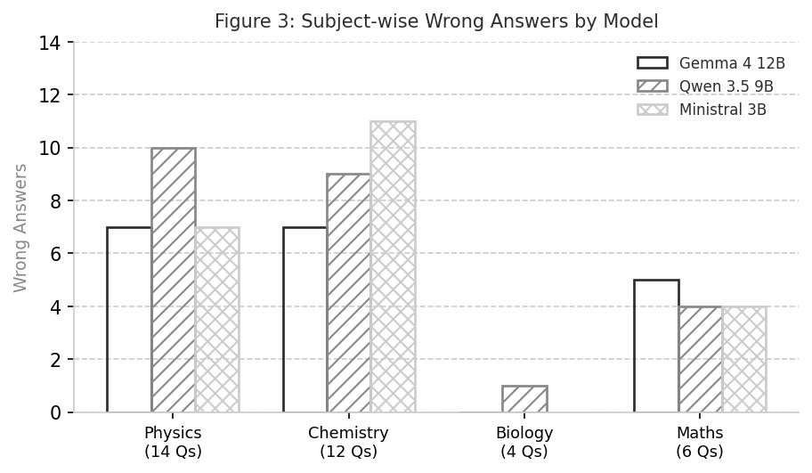

Section 7: Question Type Analysis
Questions in the test were of different types. Some required pure calculation (like finding a number), some required reading diagrams, some were simple MCQ choices, and some were Assertion-Reason type where you judge if two statements are true.

Question Type | Total Qs | Gemma Wrong | Qwen Wrong | Ministral Wrong
Diagram (MCQ & Calc) | 8 | 4/8 | 6/8 | 3/8
Calculation (Pure) | 15 | 12/15 | 11/15 | 11/15
Standard MCQ | 8 | 1/8 | 5/8 | 6/8
Matching | 3 | 1/3 | 1/3 | 2/3
Assertion-Reason | 2 | 1/2 | 1/2 | 0/2

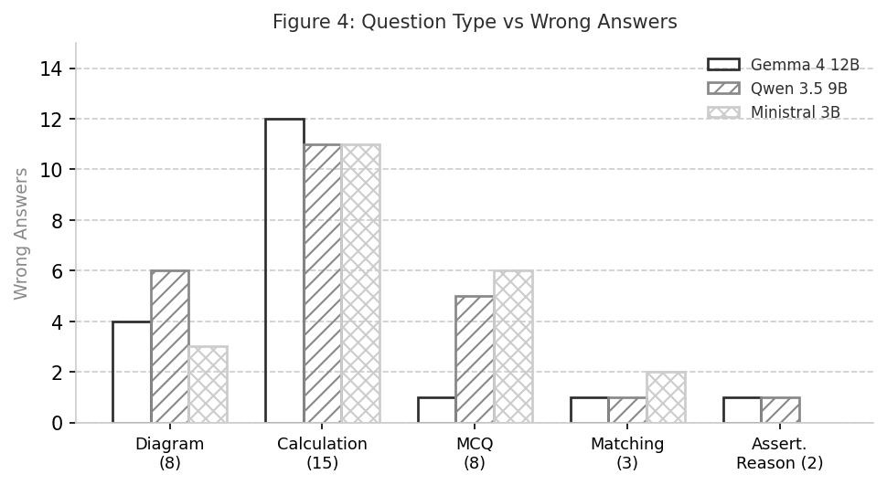

Section 8: Key Findings and Observations

8.1 Which Model Was Best Overall?
Based on total correct answers across all 36 questions:

1st Place: Gemma 4 12B QAT with 17/36 correct (47% accuracy)
2nd Place: Ministral 3 3B with 14/36 correct (39% accuracy)
3rd Place: Qwen 3.5 9B with 12/36 correct (33% accuracy)

8.2 Where All Three Models Struggled Together
Some questions were so hard that all three models got them wrong at the same time. This happened on:

- NEET 2019: Q62 Chemistry (Ksp of Ca(OH)2 from pH)
- NEET 2025: Q46 Physics (Wavelength ratio H atom transitions)
- NEET 2025: Q48 Chemistry (Cation group matching)
- JEE 2025 (06 Apr, Shift 1): Q18 Maths (Area under curves)
- JEE 2025 (06 Apr, Shift 1): Q2 Maths (Geometry (circle in triangle))
- JEE 2025 (06 Apr, Shift 1): Q6 Physics (Pulley system mechanics)
- JEE 2025 (06 Apr, Shift 1): Q7 Chemistry (Pi electrons in product)
- JEE 2025 (22 Jan, Shift 1): Q3 Physics (Equivalent capacitance)
- JEE 2025 (22 Jan, Shift 1): Q17 Physics (Electron in capacitor)
- JEE 2025 (22 Jan, Shift 1): Q24 Chemistry (Carius method % Cl)
- JEE 2025 (24 Jan, Shift 2): Q3 Chemistry (Colour change with en-complex)

8.3 JEE vs NEET: Where Models Did Better
On NEET (18 questions): Gemma got 8 wrong, Qwen got 10 wrong, Ministral got 7 wrong.
On JEE (18 questions): Gemma got 12 wrong, Qwen got 13 wrong, Ministral got 14 wrong.

JEE Maths questions involving complex calculations (like area under curves, limits, and geometry) were harder for all models than NEET questions. This makes sense because JEE Maths questions require multi-step reasoning with exact numbers.

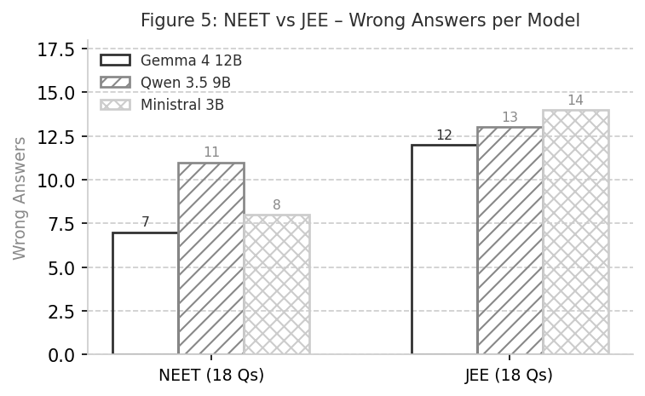

8.4 The Chemistry Problem
Chemistry was a weak area for all three models, especially when questions involved calculation (like finding Ksp from pH, or Carius method percentage). The question about Ca(OH)2 solubility product (Q62 NEET 2019) was wrong for all three models, suggesting this type of ionic equilibrium calculation is challenging for small language models.

8.5 Effect of Context Window on Gemma
Gemma was tested with a very small context window of only 2000 tokens compared to 8192 for the other two models. A smaller context window means the model can only read a smaller amount of text before it starts forgetting earlier parts of the question. This could be a reason for some of its wrong answers, especially on questions with longer descriptions or multiple parts. If Gemma had been set to its full 262,144 token context window, it may have performed differently.

8.6 Biology: The Easiest Subject for Models
Biology questions in NEET were generally easier for these models. This is likely because biology questions in NEET involve memorization of facts and concepts that appear in text form, making them easier for language models to answer compared to Physics and Chemistry which require calculation and formula application.

Section 9: Conclusion
This experiment tested three small offline AI models on real NEET UG and JEE Main exam questions. Here is a plain language summary of what was found:

- All three models are small, free, and run entirely offline on a regular computer. They do not have access to the internet when answering.
- No model scored perfectly. Even the best model made multiple mistakes. This is expected because these are extremely small models compared to large cloud AI.
- Maths (JEE) and Chemistry (both exams) were the hardest subjects. Physics was mixed. Biology was the easiest.
- Calculation type questions (where you need to arrive at a specific number) caused the most errors.
- Diagram and circuit-based questions also caused frequent errors because the models cannot see the actual images.
- Gemma had a limited context setting (2000 tokens) which may have affected performance. It still performed reasonably.
- Qwen 3.5 9B (9 billion parameters) was the largest model tested and generally competitive.
- Ministral 3B is the smallest model at 3 billion parameters and used the least memory.
- These models should not be used as a replacement for proper exam preparation or expert teachers. They are useful tools for general help but not reliable for tough competitive exam questions.

End of Report

