Construction Project Initiation Workflow — Analysis
Code-verified analysis of how a construction project is set up and moves into execution in this codebase. Confirmed findings are cited with file paths and line numbers; anything not directly observable in the code is called out under Assumptions / Missing Information rather than presented as fact.

Project Understanding Summary
Management Platform FE is an Angular 19 / PrimeNG 19 web application for managing construction projects end‑to‑end — from the initial commercial agreement with a client, through contractor/supplier/material setup, to on‑site execution, financial tracking (expenses, advances, owner payments) and reporting. It is bilingual (English/Arabic, RTL‑aware) and talks to a .NET backend (http://62.84.178.178:8102) through a fully generated HTTP client (src/nswag/api-client.ts).
The system is built around two cooperating "master" records:
- Agreement — the commercial/contractual record (client, land, payment terms, milestones, contracts, suppliers, materials, quantity bill, attachments), created through an 8‑step wizard.
- Project — the execution record, which must reference an existing Agreement, and is where day‑to‑day site management happens (stages, BOQ, contractor duties, expenses, advances, owner payments, timeline).
Primary users are internal staff of a construction/engineering firm: a Project Manager who sets up agreements and projects, an Admin with full access, an Accountant role that is defined but not yet wired up, and a read‑only Viewer. There is no client-facing portal — the whole app sits behind a login (AuthGuard).
This report is based entirely on the current code (verified with file/line citations) and a handful of docs/*.md files that turned out to be partially stale relative to the actual implementation (confirmed by cross‑checking against code and recent commits) — discrepancies are called out explicitly rather than presented as fact.

Main Modules
Module | Route | Purpose
Dashboard | /dashboard | Landing page, summary widgets (mock data)
Agreement Wizard | /agreement-wizard | 8‑step wizard that creates the commercial  Agreement  (client, contract, milestones, contractors, suppliers, materials, BOQ, attachments) —  app.routes.ts:54-82
Project Management | /projects | Creates a  Project  linked to an Agreement; hosts the full execution lifecycle (stages, BOQ, contractor duties, expenses, advances, owner payment, timeframe/Gantt) —  app.routes.ts:84-97
Constructor  (Contractors) | /constructor | Master data for contractors/constructors and their type —  app.routes.ts:99-117
Supplier | /supplier | Master data for material/service suppliers —  app.routes.ts:119-137
Material | /materials | Hierarchical catalog: Category → SubCategory → Material —  app.routes.ts:139-142
Analytics / Theme showcase | /analytics  ,  /theme-showcase | Secondary/demo screens
Auth | /auth/login | Mock-backed login (  environment.auth.useMock  )

Sidebar navigation only exposes 5 of these (Dashboard, Project Management, Constructors, Suppliers, Materials) — the Agreement Wizard link is commented out of the sidebar, even though its route is fully active (sidebar.component.html). Today, an agreement is therefore reached only via direct URL or as a step the create‑project flow depends on.

Key Roles
Defined in auth.models.ts:108-155:
Role | Has a mock account? | Typical permissions
Admin | Yes | All permissions (  projects.*  ,  agreements.*  ,  constructors.*  ,  suppliers.*  ,  materials.*  ,  users.*  )
ProjectManager | Yes | View/create/edit (not delete) on projects & agreements; view‑only on constructors/suppliers/materials
Accountant | No  — defined in the  Roles  constant but no mock user, no permission set, no usage anywhere in the app | Unknown / not yet designed
Viewer | Yes | View‑only everywhere

Two important findings on enforcement:
- Routes carry no role/permission guards — only a blanket AuthGuard/GuestGuard (app.routes.ts:15, :35). Any authenticated user can reach any screen.
- The *appHasPermission / *appHasRole directives exist (has-permission.directive.ts, has-role.directive.ts) but a codebase‑wide search found zero usages outside their own definition files — they are not applied to any button, menu item, or form in the project/agreement flow today.
Beyond these four account roles, two domain roles appear as data, not as login accounts:
- Resident Engineer — a person record used only inside the Advances feature (advance.model.ts:99-103), with a code comment noting the backend has no real lookup for it yet.
- Client / Contact Person / Representative — captured as free‑text fields inside Agreement Step 1, not a standalone "Client" master‑data module.
There is no "Consultant" role or module anywhere in the codebase.

Construction Project Initiation Workflow

High-Level System Flow
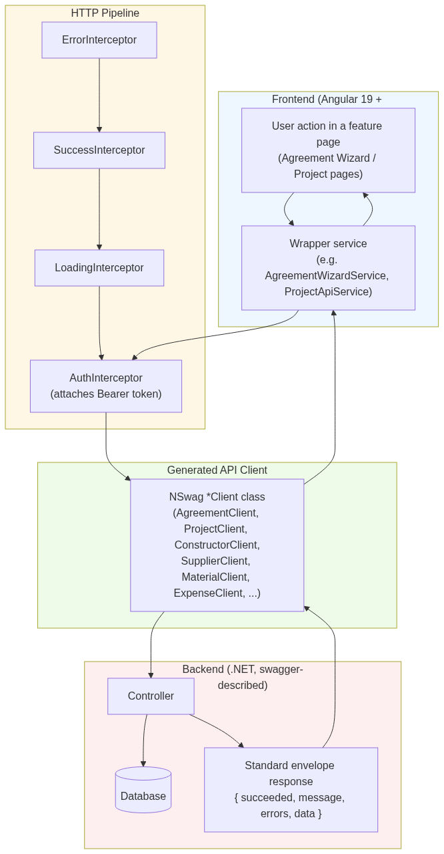
Every mutation (create agreement step, create project, add contractor duty, settle advance, etc.) follows this same path. SuccessInterceptor treats succeeded:false as an error even on HTTP 200, and AuthInterceptor transparently refreshes an expired token and retries once before forcing logout (per CLAUDE.md and confirmed client registration in app.config.ts:72-87).

Business Process Flow
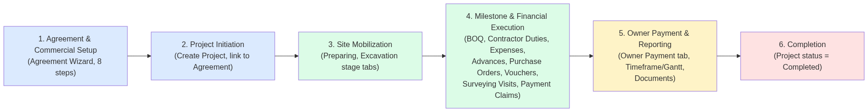
This is the business-level shape of what the code implements. Note: the system has no CRM/lead‑capture stage — the first business event the software records at all is Agreement Step 1; anything that happens before that (sales, RFQ, tendering) is outside this application (see Assumptions).

Mermaid Flowchart
This is the detailed, code‑accurate flow from "create an agreement" through "project is being executed," split into its three natural phases so each diagram stays readable.

Phase 1 — Agreement Wizard (8 steps, linear, no approval gate)
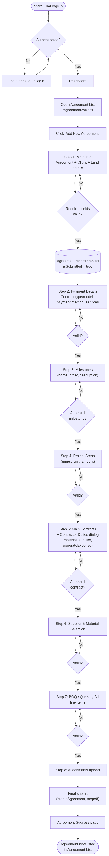

Phase 2 — Project Initiation
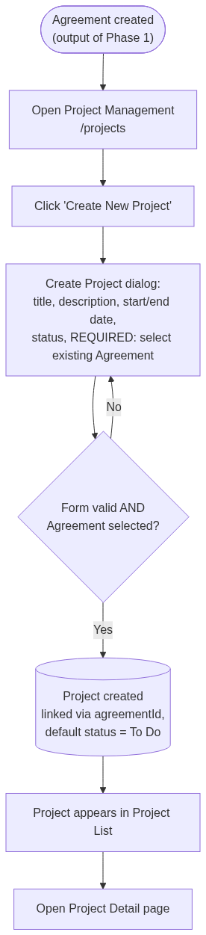

Phase 3 — Execution (Project Detail tabs)
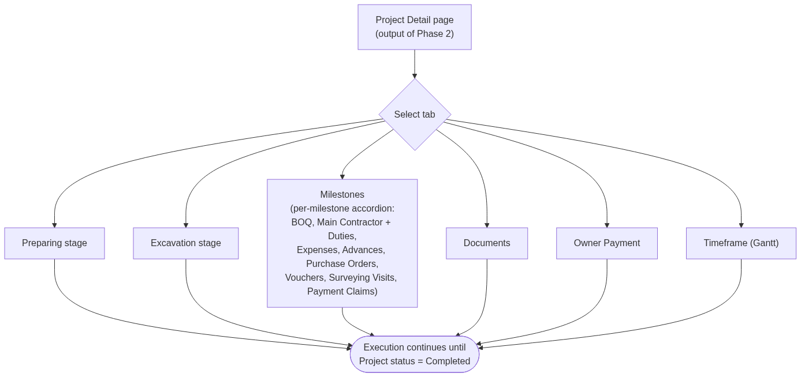

Step-by-Step Explanation
# | Screen / Action | What happens | Responsible role | Effect on status
1 | Login | User authenticates;  AuthGuard  protects everything past this point (  app.routes.ts:35  ) | Any user | n/a
2 | Agreement List → "Add New Agreement" | Navigates to  /agreement-wizard/create  (  agreement-list.component.ts  ) | Admin / ProjectManager (no enforced restriction today) | Agreement does not exist yet
3 | Step 1 — Main Info | Collects Agreement info (name, sector, dates, country/city, area), Client info (contact person, representative), Land info (basin, village, directorate, plot, floor). On valid submit, the system  creates the Agreement row immediately  and sets  isSubmitted = true | ProjectManager/Admin | Agreement created
4 | Step 2 — Payment Details | Contract type/model (Fixed Price, Time & Materials, Cost Plus / Lump Sum, Unit Price, Percentage), payment method, selected services | Same | Agreement updated (step=2)
5 | Step 3 — Milestones | Define named milestones with order/description — these become the backbone that contracts, BOQ lines and quantity bills attach to later | Same | Agreement updated (step=3)
6 | Step 4 — Project Areas | Table of area/annex/unit/amount entries | Same | Agreement updated (step=4)
7 | Step 5 — Main Contracts | Add one or more contracts with a Constructor (contractor), total amount, start/end date; each contract opens a  Contractor Duties dialog  to add duty line items (quantity, price, unit, duty type/responsibility, optional material + supplier, and a  generateExpense  flag that auto‑creates an expense) | Same | Agreement updated (step=5)
8 | Step 6 — Supplier & Material Selection | Table linking a Supplier + Material (+ representative) to the agreement, using the shared Material Select component | Same | Agreement updated (step=6)
9 | Step 7 — BOQ / Quantity Bill | Table of quantity‑bill line items: material, unit, milestone, constructor, supplier, quantity, price (auto‑calculated subtotal) | Same | Agreement updated (step=7)
10 | Step 8 — Attachments | Upload supporting files (base64‑encoded); final call to  createAgreement  with  step=8 | Same | Agreement considered complete → redirect to success page
11 | Create Project dialog | A  separate, simpler  form: title, description, start/end date, status, and a  required dropdown of existing Agreements  (  create-project-dialog.component.ts:81-89  ) | ProjectManager/Admin | Project created,  agreementId  set, default status "To Do"
12 | Project Detail — execution tabs | Overview (static demo Kanban), Preparing, Excavation, Milestones (accordion of BOQ / Main Contractor & Duties / Expenses / Advances / Purchase Orders / Vouchers / Surveying Visits / Payment Claims / Documents), Documents, Owner Payment, Timeframe (Gantt) | ProjectManager, site/financial staff | Project status changes manually as work progresses

No node in this flow represents a review/approval gate — see Status Lifecycle and Assumptions below.

User Journey Flow (Project Manager persona)
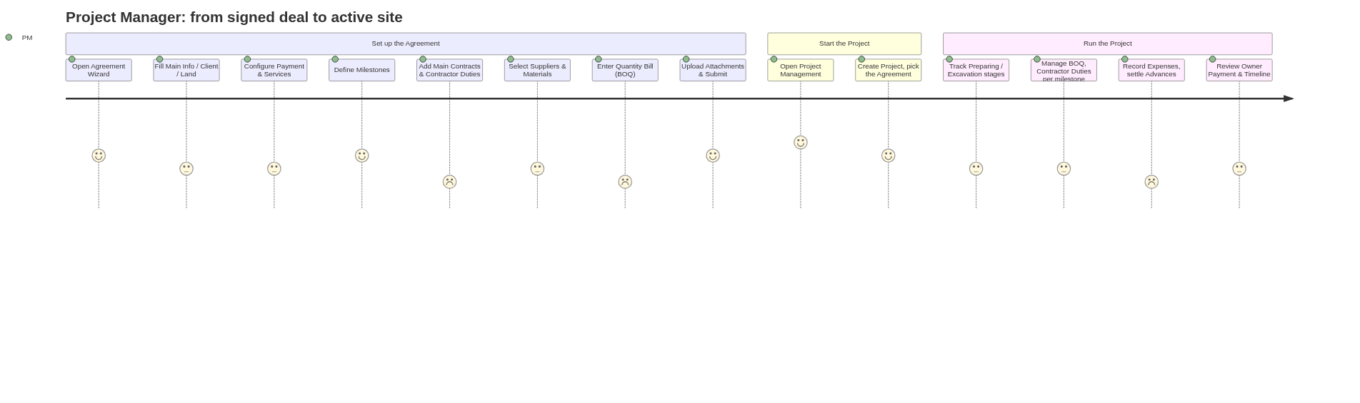
(Satisfaction scores 1–5 are illustrative, reflecting relative form/step complexity observed in the code — not measured user data.)

Status Lifecycle
Three independent, not fully reconciled status models exist in the code:
1. Agreement — no real status enum. Only two booleans on AgreementDto: isSubmitted and isDeleted (api-client.ts:6047-6050). isSubmitted flips to true as early as Step 1, so it indicates "has at least been started," not "fully approved."
2. Project — two different enums are in play:
- The real one sent to the backend on creation, ProjectStatus from the generated client: _0 = To Do, _1 = In Progress, _2 = Review, _3 = Completed (create-project-dialog.component.ts:51-56).
- A legacy, hand‑written enum used purely for the status badge on the Project Detail header: PLANNING / IN_PROGRESS / ON_HOLD / COMPLETED / CANCELLED (project.model.ts:24-30, used in project-detail.component.ts:168-192).
These two do not line up one‑to‑one (e.g. "Review" exists only on the backend side; "On Hold"/"Cancelled" exist only on the legacy display side) — flagged below as a recommendation.
3. Stage — StageStatus: PREPARING → EXCAVATION → FOUNDATION → STRUCTURE → FINISHING → MILESTONE → COMPLETED (project.model.ts:51-59). Only Preparing, Excavation and Milestone currently have a working tab in the UI; Foundation/Structure/Finishing have no dedicated screen yet.
4. Task — TaskStatus: TODO → IN_PROGRESS → REVIEW → BLOCKED → COMPLETED (project.model.ts:63-69).
5. Advance (resident‑engineer cash advance) — 'Open' → 'PartiallySettled' → 'Settled' (advance.model.ts:24). Only Open advances can be edited; Open/PartiallySettled can be settled against expenses.
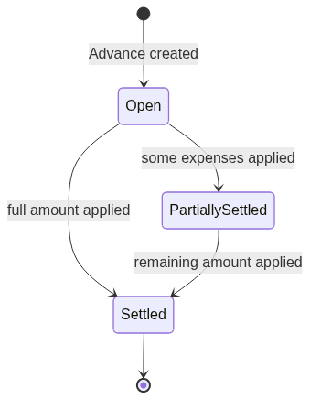
6. Expense locking (not a status field, but a derived lock): an expense is locked from editing/deleting if autoPost = true (auto‑posted by a contractor duty with generateExpense) or if it has been applied to settle an Advance (project-expense-management.component.ts:182-195).

Important Screens / Pages
Page | Route | Component file
Agreement List | /agreement-wizard | agreement-list.component.ts
Agreement Wizard (create/edit/view) | /agreement-wizard/create  ,  /edit/:id  ,  /view/:id | agreement-wizard.component.ts
↳ Steps 1–8 | n/a | components/steps/step1  …  step7  ,  step-milestones
Agreement Success | /agreement-wizard/success | agreement-success.component.ts
Project List | /projects | project-list.component.ts
Create Project Dialog | (modal on Project List) | create-project-dialog.component.ts
Project Detail | /projects/:id | project-detail.component.ts
↳ Milestones (BOQ, Main Contractor/Duties, Expenses, Advances, Purchase Orders, Vouchers, Surveying Visits, Payment Claims, Documents) | (tab) | milestone-stage.component.ts  +  tabs/*
Constructor List / Form | /constructor  ,  /constructor/new  ,  /constructor/edit/:id | constructor-list.component.ts  ,  constructor-form.component.ts
Supplier List / Form | /supplier  ,  /supplier/new  ,  /supplier/edit/:id | supplier-list.component.ts  ,  supplier-form.component.ts
Material Management | /materials | material-management.component.ts

Important APIs / Services
NSwag‑generated clients registered globally in app.config.ts:72-84: AgreementClient, AttachmentClient, LookupClient, ProjectClient, TaskClient, SubTaskClient, ConstructorClient, SupplierClient, ExpenseClient, CurrencyClient, MaterialClient, MaterialCategoryClient, MaterialSubCategoryClient.
Additional clients confirmed in use but registered per-component instead (e.g. providers: [ProjectBOQClient, LookupClient, ConstructorClient, SupplierClient] in boq-tab.component.ts:38): ProjectBOQClient, ProjectMainContractorClient, ProjectMainContractorDutyClient.
Wrapper service | Delegates to | Key methods
agreement-wizard.service.ts | AgreementClient  ,  AttachmentClient  ,  LookupClient  ,  ConstructorClient | createAgreement  ,  getAllAgreements  ,  getAgreementById  ,  getStep1Lookups…getStep6Lookups  , attachment up/download/delete
project-api.service.ts | ProjectClient | createProject  ,  getAllProjects  ,  getProjectById
project.service.ts | raw  HttpClient  (not NSwag) | getProjects  ,  getProjectById  , status mapping for display
boq-api.service.ts | ProjectBOQClient | createOrUpdate  ,  delete  ,  getById  ,  getByStageId
expense-api.service.ts | ExpenseClient | createOrUpdate  ,  delete  ,  getByProjectStageId  ,  getById
advance-api.service.ts | mock data  (  environment.advances.useMock  ) | getByProjectStageId  ,  create  ,  update  ,  settle  ,  getAvailableExpenses  ,  getEngineers
task.service.ts | TaskClient | getAllTasks  ,  createTask  ,  updateTaskStatus  ,  deleteTask
Constructor / Supplier / Material services | ConstructorClient  /  SupplierClient  /  MaterialClient  +  MaterialCategoryClient  +  MaterialSubCategoryClient | standard  getAll/getById/createOrUpdate/delete

Data Entities Involved
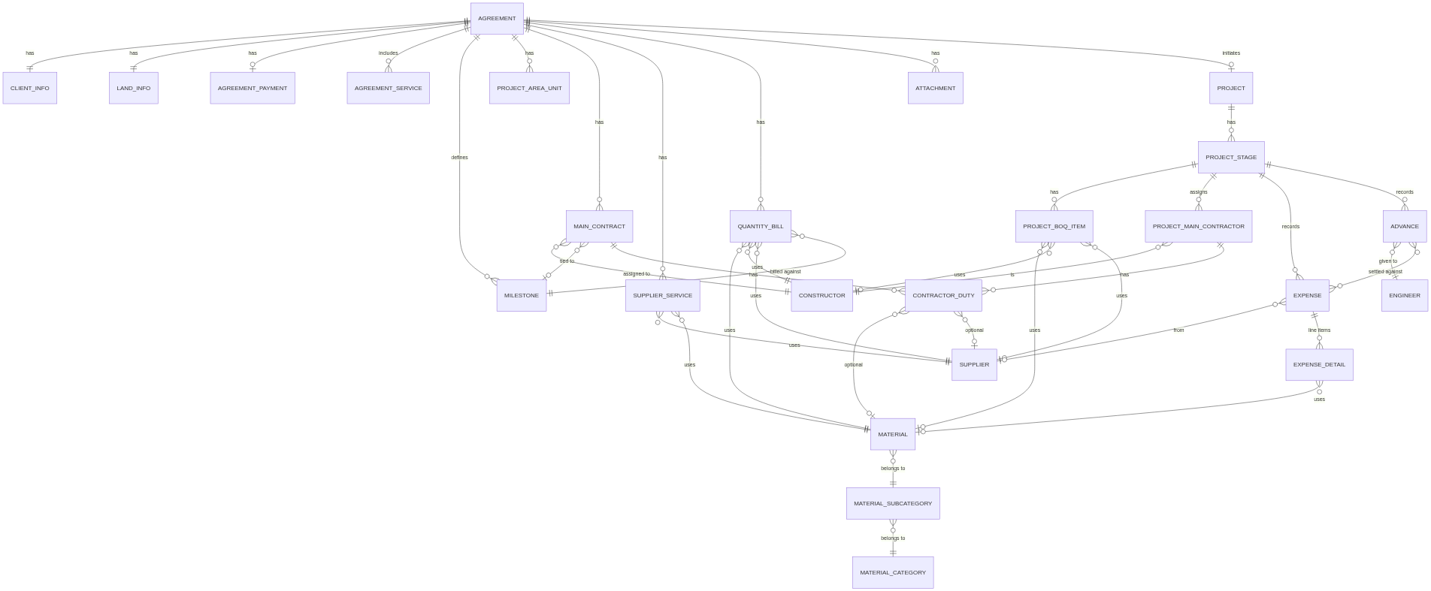
Confirmed entities & their source:
- Agreement / Client info / Land info — step1.component.ts, FirstStepDto (api-client.ts:9447)
- Milestone — MileStonesDto, reused across MainContract/BOQ/QuantityBill
- Main Contract / Contractor Duty — MainContractDto (api-client.ts:14627), ContractorDutyDto (api-client.ts:7151)
- Supplier Service — SupplierServiceDto (api-client.ts:18172)
- Quantity Bill (agreement‑level BOQ) — QuantityBillDto (api-client.ts:17285)
- Project / Project Stage — project.model.ts, ProjectStageDto
- Project BOQ (execution‑level BOQ, separate from Quantity Bill) — boq.model.ts, GetProjectBOQDto (api-client.ts:11743)
- Constructor, Supplier, Material/Category/SubCategory — own feature modules, each with full CRUD
- Expense / Expense Detail — project-expense-management.component.ts
- Advance / Engineer (lookup only) — advance.model.ts
Two BOQ‑like entities exist for two different purposes: QuantityBill is the agreement‑level estimate captured during wizard Step 7, and Project BOQ is a separate execution‑level record tracked per project stage. They are not the same table and are not automatically derived from one another in the code reviewed.

Assumptions / Missing Information
These are explicitly not confirmed in the codebase and should not be treated as fact:
- No client/CRM module: there's no entity or screen for managing a "Client" as master data (name/contacts repeated per agreement) — client details are just free‑text fields on the Agreement.
- No Consultant module or role exists anywhere in the code.
- "Resident Engineer" is only a name lookup inside Advances, with a code comment admitting the backend hasn't decided how to expose it yet (mock-advances.data.ts:17-19) — not a real HR/user entity.
- No Permit entity: "Permits & Approvals" appears only as a static Kanban column label in the (sample‑data‑only) Overview tab (stage-kanban.component.ts:56) — there is no Permit model, service, or screen.
- No formal approval/review workflow for either Agreement or Project. The "Review" value in the backend ProjectStatus enum and the "Review" Kanban column suggest a review step was intended, but no code enforces it, assigns a reviewer, or blocks progress pending approval.
- Whether the backend auto-creates default Project Stages (Preparing/Excavation/Milestones) on project creation could not be confirmed — the frontend only fetches stages by ID, it doesn't create them, so this logic (if it exists) lives entirely server-side.
- Advances run on mock data today (environment.advances.useMock) — there is no generated AdvanceClient, meaning the backend endpoint may not exist yet (advance-api.service.ts:40).
- Overview/Kanban tab and the Staging Board described in docs/STAGING_BOARD_IMPLEMENTATION.md are aspirational — the live Overview tab renders hardcoded sample cards, and the route for the richer staging board is commented out in project-detail.component.html:138-143.
- docs/PROJECT_MANAGEMENT.md describes an older, simpler single‑dialog project model (no agreement link, no milestones) — superseded by the current code but never updated.
- User‑journey satisfaction scores in this report are illustrative only, not measured/telemetry data.

Recommendations to Improve the Flow or Documentation
- Reconcile the two Project status enums. The backend (To Do/In Progress/Review/Completed) and the legacy display enum (Planning/In Progress/On Hold/Completed/Cancelled) don't map cleanly — pick one source of truth and have project-detail.component.ts read it directly instead of through a guessed mapping.
- Decide on, and implement, an actual approval step if one is required by the business (e.g., an Agreement shouldn't be usable to create a Project until someone with the right permission marks it "Approved"). Right now isSubmitted looks like an approval flag but is set on Step 1 of 8, before any commercial detail exists.
- Wire up the existing permission model.*appHasPermission/*appHasRole and the granular agreements.create/projects.delete-style permissions are fully defined but unused — either enforce them on the relevant buttons/routes or remove them to avoid a false sense of access control.
- Add the Agreement Wizard back into the sidebar, or confirm intentionally hiding it — since creating a Project now hard‑requires an Agreement, an Admin/PM with no direct nav entry has to know the /agreement-wizard URL.
- Build the missing stage tabs (Foundation, Structure, Finishing) or remove them from StageStatus if they're no longer planned, since only Preparing/Excavation/Milestone currently have screens.
- Refresh docs/PROJECT_MANAGEMENT.md, docs/AGREEMENT_WIZARD.md, and docs/STAGING_BOARD_IMPLEMENTATION.md — all three describe an earlier version of the feature; keeping them in sync with the code (or deleting superseded ones) would prevent future confusion for new developers.
- Standardize API client registration — most NSwag clients are registered once in app.config.ts, but a few (ProjectBOQClient, ProjectMainContractorClient, ProjectMainContractorDutyClient) are re‑declared per component. Centralizing avoids creating a new client instance per component and keeps the registration pattern consistent.
- Clarify the relationship between agreement‑level "Quantity Bill" and project‑level "Project BOQ." They look like the same business concept (a bill of quantities) modeled twice; if that's intentional (estimate vs. actuals), documenting it would help; if not, consider consolidating.

