PRATICAL-5

CALCULATING LITERACY RATE OF MEN AND WOMEN

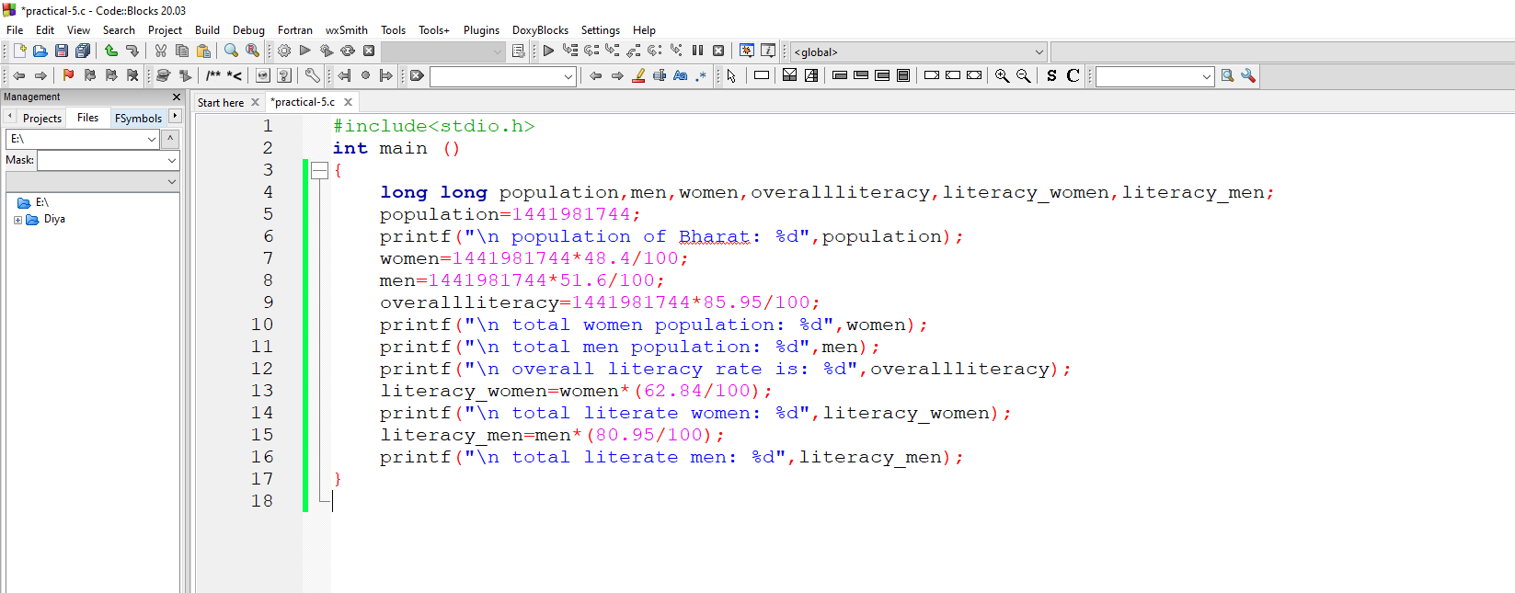

AFTER RUN

