PRACTICAL -18

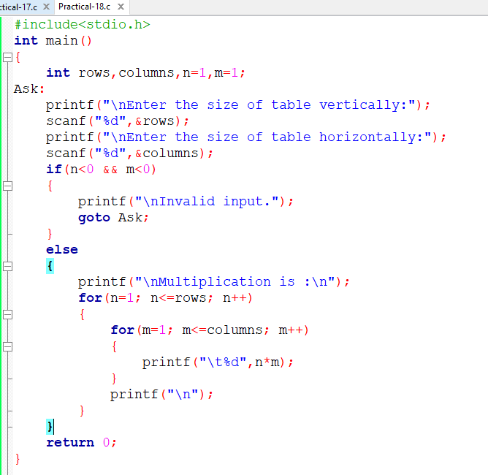

ON ENTERING N=10 AND M=5

WE GET TABLE OF 10X5

