PRATICAL-6

THIS PRATICAL IS FOR TEMPERATURE CONVERSION OF CELSIUS TO FAHRENHEIT

FORMULA USED IS FAHRENHEIT=(CELSIUS\*9\5)+32

FOR CELSIUS=0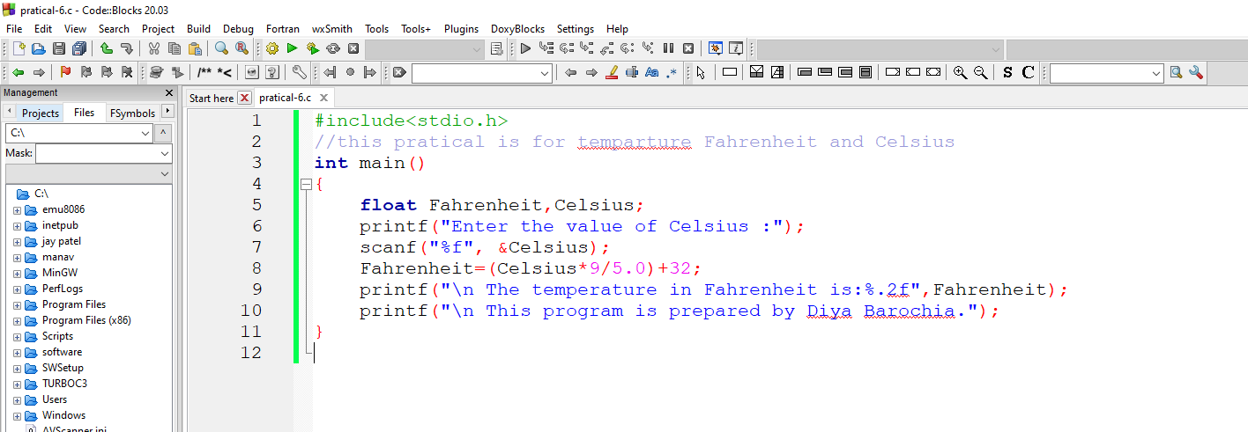

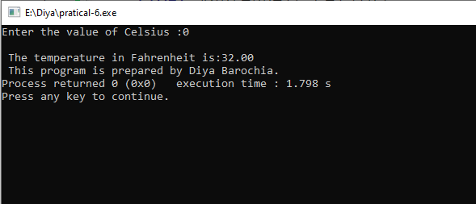

NOW FOR CELSIUS =100

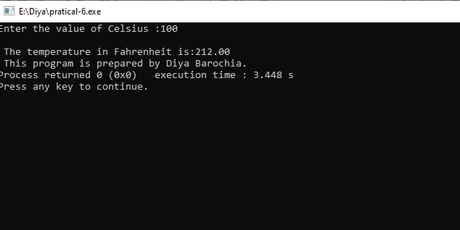

NOW FOR CELSIUS= -40

