Practical-8

To open saving account

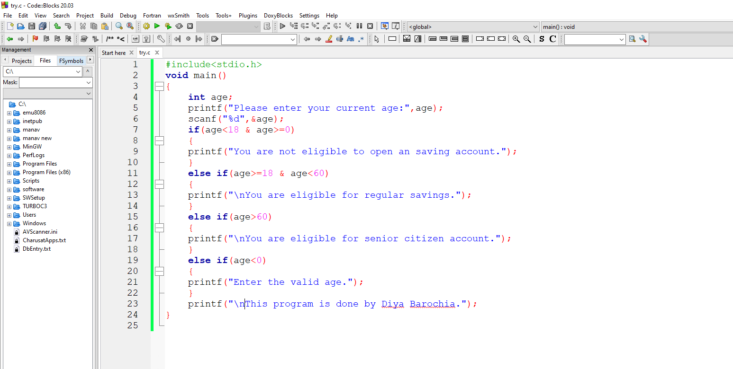

If age =18

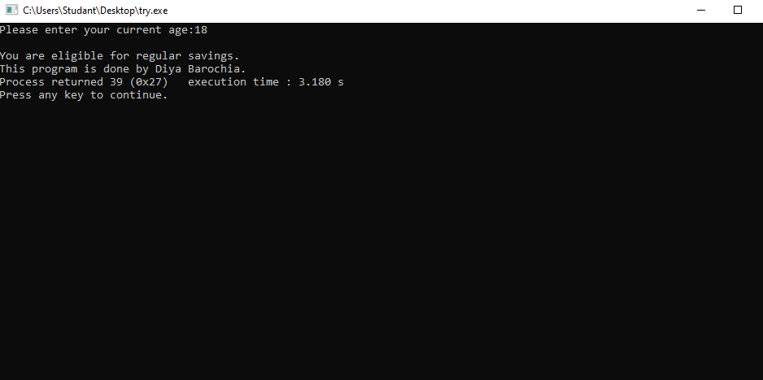

Similarly it tells for all age that you are eligible or not.