**ROLL NUMBER: 2320030199  
NAME: DIYA MAREEZA DOYLE**

**Experiment 2: Networking Commands with Cisco Packet Tracer**

**Objective**

To execute networking commands such as ipconfig, tracert, telnet, ping, nslookup, and netstat using a simple network topology created in Cisco Packet Tracer, and to analyze their outputs and functionality.

**Procedure**

**Step 1: Launch Cisco Packet Tracer**

1. Double-click the Cisco Packet Tracer icon on your desktop or locate it in your applications list to open the program.

**Step 2: Create a Simple Network Topology**

1. **Add Devices:**
   * Drag and drop one router, one switch, and two PCs from the device list onto the workspace.
2. **Connect Devices:**
   * Use the Connection tool to connect the devices as follows:
     + Connect PC0 to the switch using a copper straight-through cable.
     + Connect PC1 to the switch using a copper straight-through cable.
     + Connect the switch to the router using a copper straight-through cable.

**Step 3: Configure Devices**

1. **Configure the Router:**
   * Click on the router and go to the Config tab.
   * Assign IP addresses to the interfaces:
     + **Interface G0/0:** IP address 192.168.1.1, Subnet Mask 255.255.255.0.
     + **Interface G0/1:** IP address 192.168.2.1, Subnet Mask 255.255.255.0.
2. **Configure the PCs:**
   * Click on each PC and go to the Desktop tab, then IP Configuration.
   * Assign the following IP addresses:
     + **PC0:** IP address 192.168.1.2, Subnet Mask 255.255.255.0, Default Gateway 192.168.1.1.
     + **PC1:** IP address 192.168.2.2, Subnet Mask 255.255.255.0, Default Gateway 192.168.2.1.

**Step 4: Execute Networking Commands**

1. **Open Command Prompt on PC0:**
   * Click on PC0, go to the Desktop tab, and open the Command Prompt.
2. **Commands to Execute:**
   * **ipconfig**:
     + Displays the current TCP/IP network configuration values.
   * **tracert**:
     + Traces the path taken to a destination by sending ICMP Echo Request messages.
   * **telnet**:
     + Establishes a Telnet session to the router:

telnet <destination IP> <port>

* + - Configure the router for Telnet:
    - Router> enable
    - Router# configure terminal
    - Router(config)# line vty 0 4
    - Router(config-line)# password cisco
    - Router(config-line)# login

Router# write memory

* + **ping 192.168.2.2**:
    - Sends ICMP Echo Request messages to verify connectivity.
  + **nslookup**:
    - Queries the DNS server to resolve domain names to IP addresses. Example:
      * Add a DNS server to the topology and configure it with an IP address (e.g., 192.168.1.3).
      * Add a DNS entry for www.google.com (e.g., IP address 8.8.8.8).
      * Execute the command:

nslookup www.google.com

* + **netstat**:
    - Displays active TCP connections, routing tables, and network statistics.

**RESULTS:  
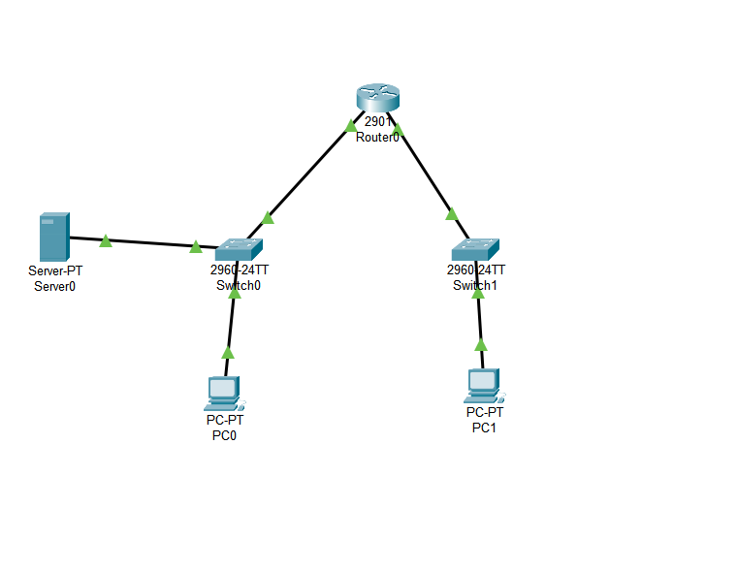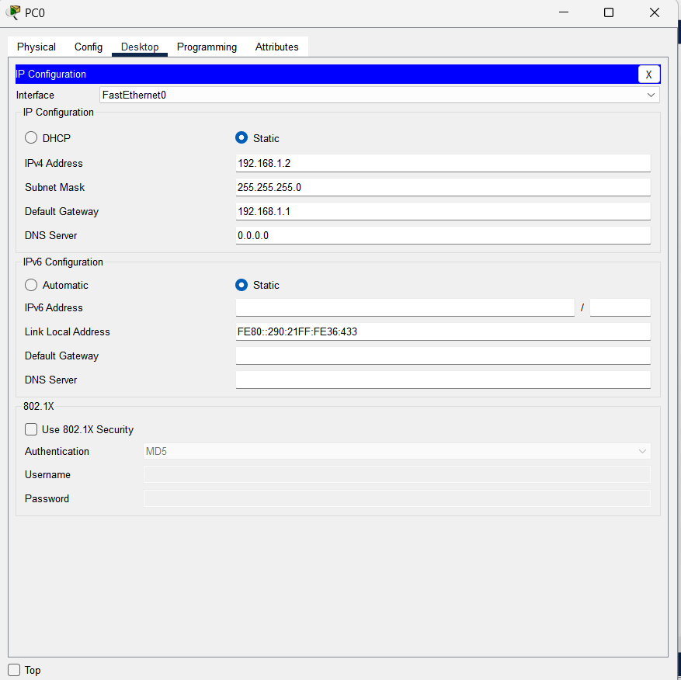**

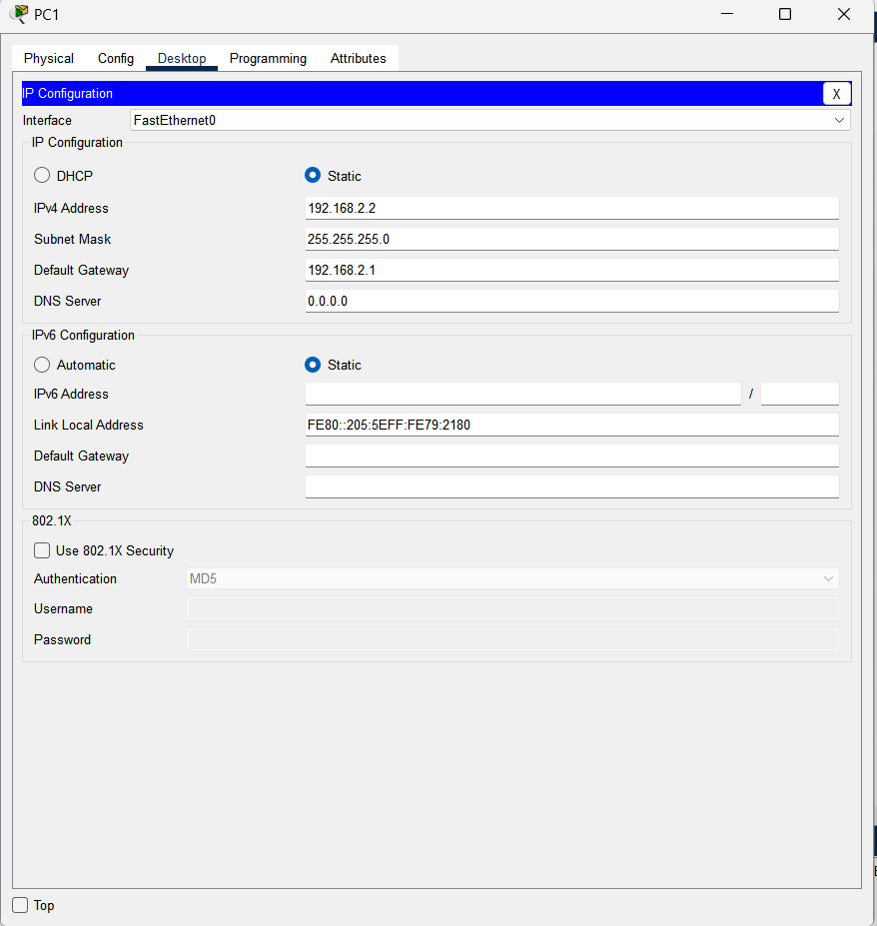

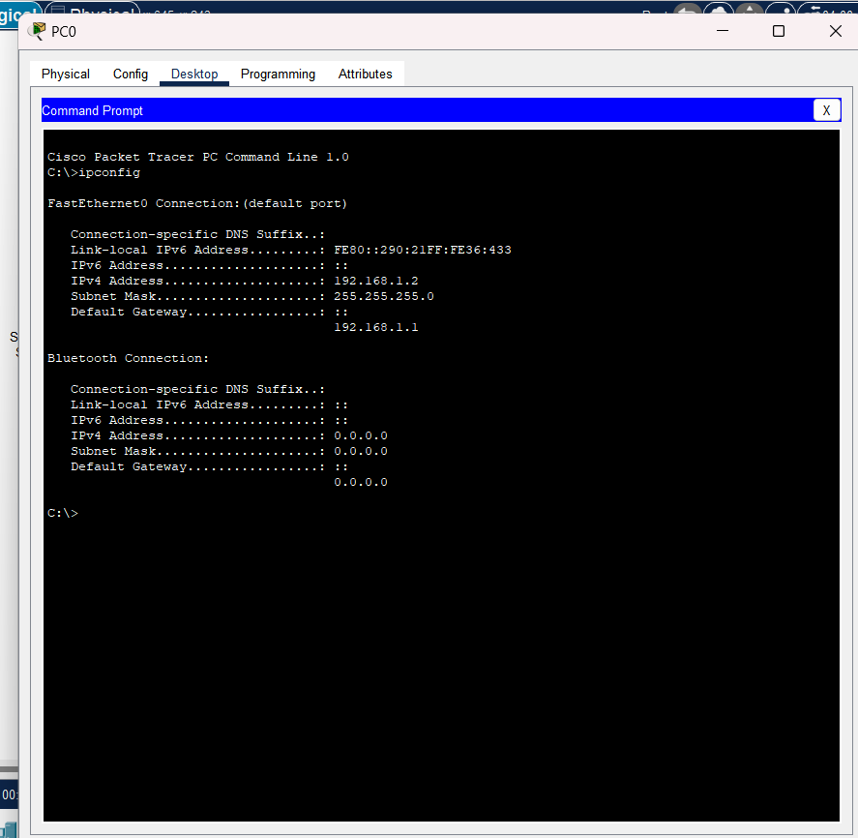

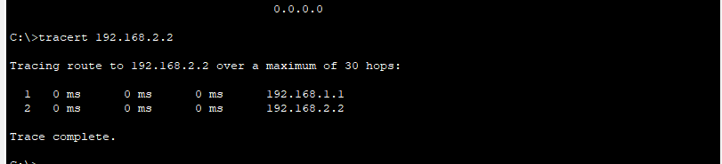

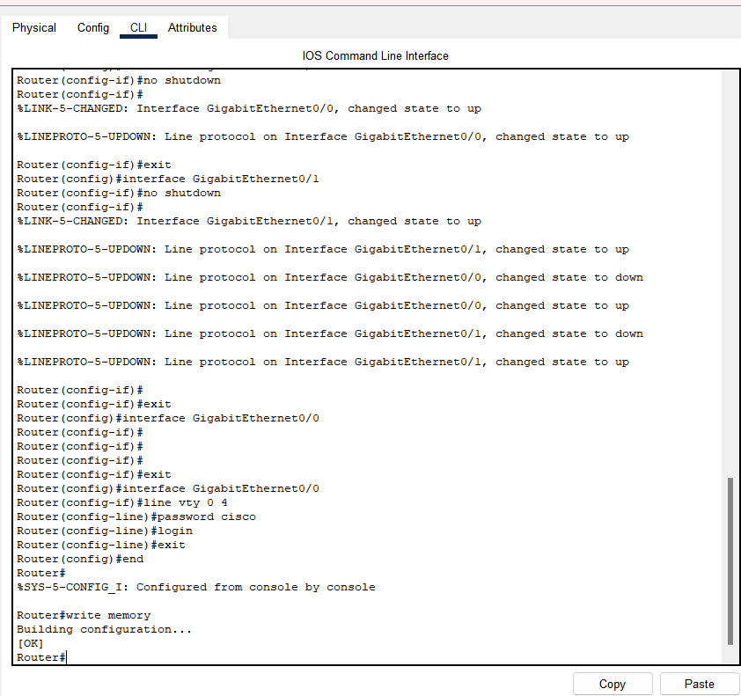

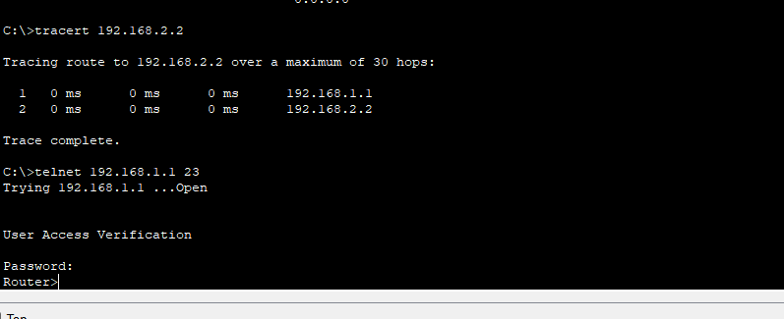



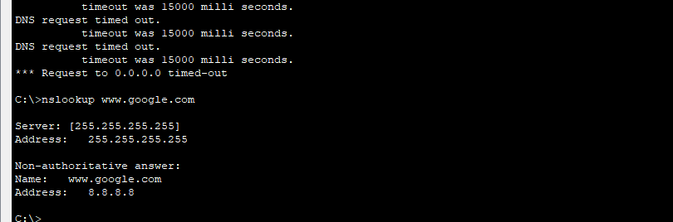

**Conclusion**

The experiment demonstrated the functionality and utility of various networking commands in a controlled environment using Cisco Packet Tracer. By configuring a simple topology, we validated the connectivity between devices, resolved domain names, and analyzed network connections, providing insights into essential network troubleshooting tools. These skills are crucial for diagnosing and managing real-world networks.