**ROLL NUMBER: 2320030199**

**NAME: DIYA MAREEZA DOYLE**

**Experiment 3: Configuration of Basic Switch Setup Using Huawei/Cisco Network Switch in Cisco Packet Tracer**

**Objective:** To configure a basic switch setup using a Cisco network switch in Cisco Packet Tracer and establish connectivity between devices in the network.

**Procedure:**

**Step 1: Setting Up the Network Topology**

1. **Open Cisco Packet Tracer**:
   * Launch the Cisco Packet Tracer application on your system.
2. **Add Devices**:
   * Drag and drop a Cisco switch (e.g., 2960) onto the workspace.
   * Drag and drop two or more PCs onto the workspace.
3. **Connect Devices**:
   * Use the "Connections" option to select the Copper Straight-Through cable.
   * Connect each PC to the switch using the FastEthernet ports:
     + Connect PC0 to FastEthernet0/1.
     + Connect PC1 to FastEthernet0/2.

**Step 2: Configuring the Switch**

1. **Open the CLI (Command-Line Interface) of the Switch**:
   * Click on the switch and go to the CLI tab.
2. **Enter Privileged EXEC Mode**:
3. Switch> enable

Switch#

1. **Enter Global Configuration Mode**:
2. Switch# configure terminal

Switch(config)#

1. **Configure the Switch Hostname (Optional)**:
2. Switch(config)# hostname S1

S1(config)#

1. **Configure VLAN 1 (Default VLAN) Interface with an IP Address**:
2. S1(config)# interface vlan 1
3. S1(config-if)# ip address 192.168.1.1 255.255.255.0
4. S1(config-if)# no shutdown
5. S1(config-if)# exit

S1(config)#

1. **Save the Configuration**:
2. S1(config)# exit

S1# write memory

**Step 3: Configuring PCs**

1. **Assign IP Addresses to PCs**:
   * Click on each PC and go to the **Desktop** tab.
   * Open the **IP Configuration** option.
   * Assign an IP address within the same subnet as the switch's VLAN 1 interface:
     + **PC0**:
       - IP Address: 192.168.1.2
       - Subnet Mask: 255.255.255.0
     + **PC1**:
       - IP Address: 192.168.1.3
       - Subnet Mask: 255.255.255.0

**Step 4: Testing Connectivity**

1. **Ping Between PCs**:
   * Open the **Command Prompt** on one of the PCs (e.g., PC0).
   * Use the ping command to check connectivity to the other PC:

ping 192.168.1.3

**Results:**

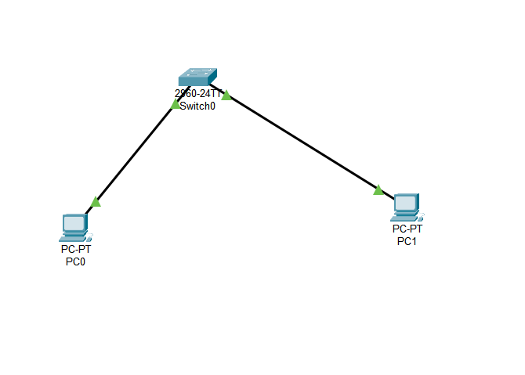

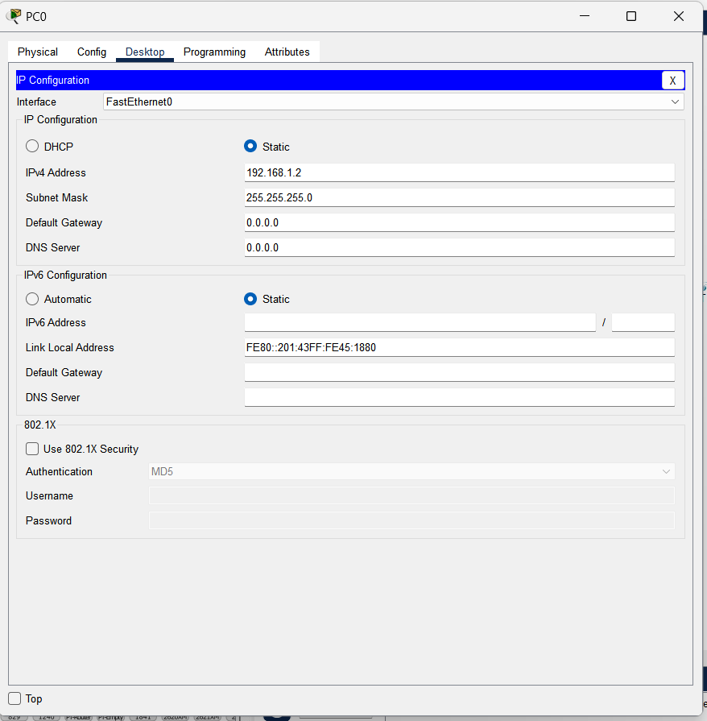

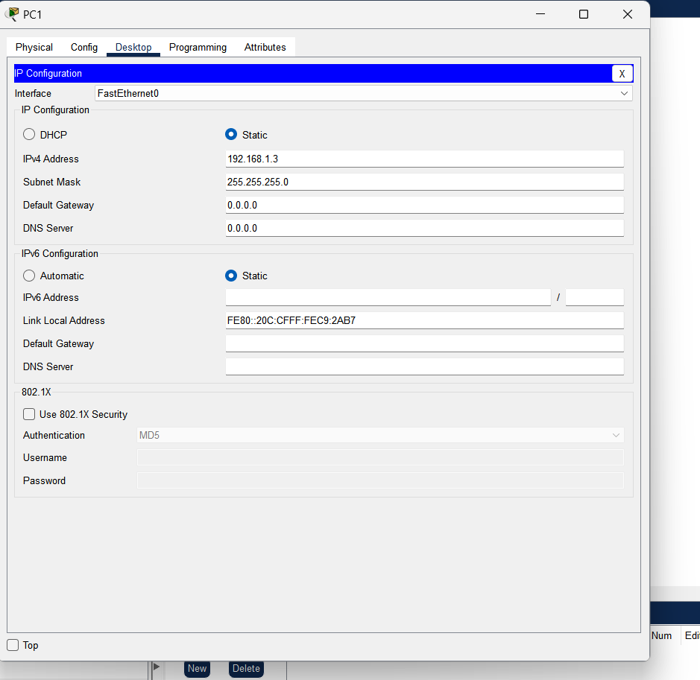

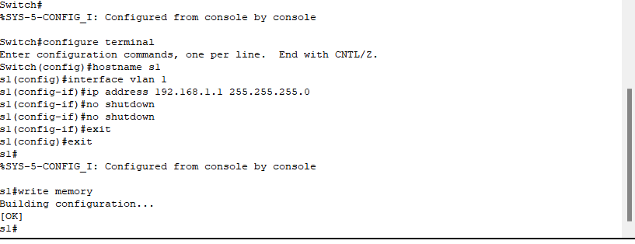

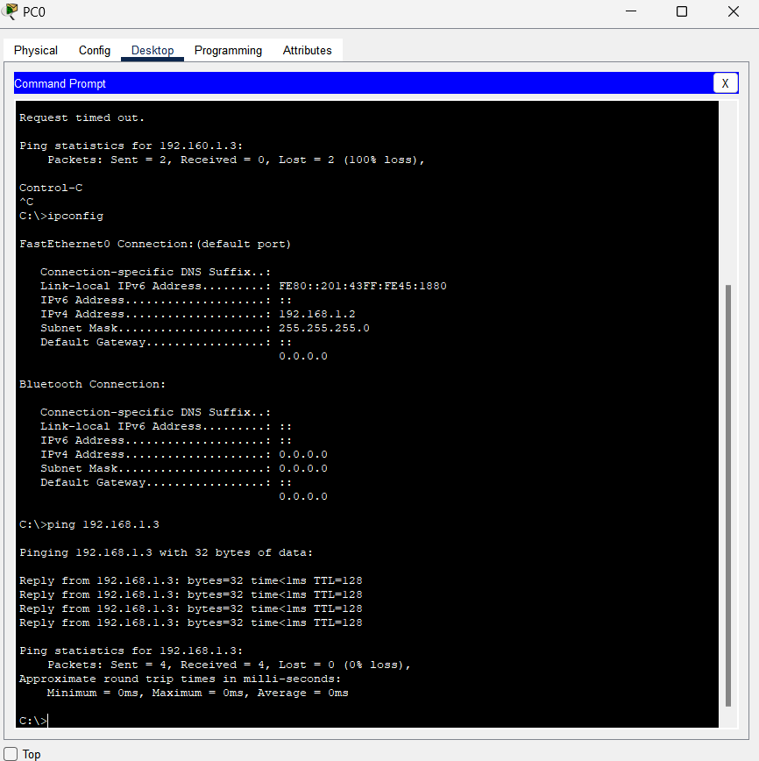

**Conclusion:** The experiment demonstrates the configuration of a basic switch setup using Cisco Packet Tracer. By setting up a simple topology, assigning appropriate IP addresses, and testing connectivity, the network was successfully established. This process highlights the importance of proper switch configuration in a LAN environment.