MLOps Tools and Practices
A Study of Version Control, Data Versioning, and Model Serving Tools
Tools Covered: Git · DVC · TensorFlow Serving

Submitted by: Diya Ghorpade
B.E. — Artificial Intelligence & Machine Learning
BMS Institute of Technology and Management, Bengaluru

Table of Contents
Table of Contents 2
1. Introduction to MLOps and Its Importance 3
2. Stages of the MLOps Lifecycle 4
2.1 Data Management and Version Control 4
2.2 Model Development and Experimentation 4
2.3 Model Training and Validation 4
2.4 Model Packaging, Serving, and Deployment 4
2.5 Monitoring and Maintenance 4
2.6 CI/CD and Automation 5
3. Tools Used in Each Stage of the MLOps Lifecycle 5
3.1 Data Management and Version Control 5
3.2 Model Development and Experimentation 6
3.3 Model Training and Validation 7
3.4 Model Packaging, Serving, and Deployment 8
3.5 Monitoring and Maintenance 8
3.6 CI/CD and Automation 9
4. Detailed Tool Coverage: Purpose, Working, Features, Advantages and Limitations 11
4.1 Tool 1(a): Git — Version Control & Collaboration 11
Working / Features 12
4.2 Tool 1(b): DVC (Data Version Control) 13
Working / Features 14
4.3 Tool 2: TensorFlow Serving 15
Working / Features 16
5. Documentation with Screenshots (Practice / Execution) 18
5.1 Git — Practice Screenshots 19
5.2 DVC — Practice Screenshots 20
5.3 TensorFlow Serving — Practice Screenshots 21
6. Real-World Use Cases 22
6.1 Git 22
6.2 DVC 22
6.3 TensorFlow Serving 22
7. Conclusion and Learning Outcomes 23
8. References 24

1.Introduction to MLOps and Its Importance
Machine Learning Operations (MLOps) is a set of practices that combines Machine Learning, DevOps, and Data Engineering to reliably and efficiently deploy, monitor, and maintain machine learning models in production. While traditional software engineering has mature practices for building, testing, and deploying code, machine learning systems introduce additional complexity: models depend not only on code but also on data and on the statistical behaviour learned from that data. MLOps extends DevOps principles and includes automation, continuous integration/continuous delivery (CI/CD), and monitoring.
The importance of MLOps stems from the fact that a model that performs well in a research notebook rarely translates directly into a robust production system. Data drifts, model performance degrades over time, infrastructure needs to scale, and multiple team members (data scientists, ML engineers, and operations staff) need to collaborate on the same artifacts such as code, data, and models. Without a structured MLOps approach, organizations face:
- Poor reproducibility of experiments and results.
- Difficulty tracking which dataset and code version produced a given model.
- Slow and error-prone manual deployment of models to production.
- Lack of visibility into model performance after deployment (model/data drift).
- Fragmented collaboration between data science and engineering teams.
MLOps solves these problems by introducing version control for code and data, automated pipelines for training and deployment, containerization for consistent environments, and continuous monitoring for models in production. This report focuses on three key tools that support different stages of the MLOps lifecycle: Git and DVC for version control and collaboration, and TensorFlow Serving for model serving and deployment.

2.Stages of the MLOps Lifecycle
The MLOps lifecycle is a continuous process that manages the development, deployment, and maintenance of machine learning models. Unlike a traditional software pipeline, it involves continuous monitoring and retraining as new data becomes available. The major stages are:
2.1 Data Management and Version Control
This stage involves collecting, cleaning, preprocessing, and validating data before it is used for model development. Data versioning is used to maintain different versions of datasets and ensure that experiments can be reproduced. Proper data management also improves data quality, traceability, and auditability.
2.2 Model Development and Experimentation
In this stage, developers perform exploratory data analysis, feature engineering, and model selection. Different algorithms and hyperparameter configurations are tested to identify the most suitable model. Experiment-tracking tools are used to record parameters, dataset versions, and evaluation metrics for each experiment.
2.3 Model Training and Validation
The selected models are trained using the prepared datasets and evaluated using appropriate validation and testing techniques. Performance metrics such as accuracy, precision, recall, F1-score, or mean squared error may be used depending on the application. Models that meet the required performance criteria can be selected for deployment.
2.4 Model Packaging, Serving, and Deployment
Once a model has been validated, it is packaged along with its dependencies and prepared for deployment. The model can be deployed as a batch-processing system or as a real-time inference service through an API. Containerization technologies such as Docker can help ensure consistent deployment across different environments.
2.5 Monitoring and Maintenance
After deployment, the model and its supporting infrastructure are continuously monitored. Important aspects include model performance, data drift, prediction quality, latency, resource usage, and system errors. If performance decreases or the incoming data changes significantly, the model may need to be retrained, updated, or rolled back.
2.6 CI/CD and Automation
CI/CD practices automate the testing, building, and deployment of ML applications and models. Automated pipelines can perform tasks such as data validation, model testing, training, evaluation, and deployment. This reduces manual effort, minimizes errors, and enables models to be updated and released more efficiently.

3.Tools used in each stage
3.1 Data Management and Version Control
Git
Purpose:
Git is used for version control of source code, configuration files, and other project files used in an ML system.
Key Features:
- Tracks changes through commits.
- Supports branching and merging for collaborative development.
- Maintains complete project history.
- Enables multiple developers to work on the same project.
- Helps restore previous versions when required.
DVC
Purpose:
DVC (Data Version Control) is used to manage and version large datasets and machine learning models.
Key Features:
- Tracks different versions of datasets.
- Supports integration with remote storage.
- Links datasets with specific code and model versions.
- Helps reproduce previous experiments.
- Supports reproducible ML data pipelines.
3.2 Model Development and Experimentation
MLflow
Purpose:
MLflow is used for tracking machine learning experiments and managing model versions.
Key Features:
- Records parameters, metrics, and artifacts for each experiment.
- Enables comparison of different model runs.
- Provides model versioning and model registry capabilities.
- Helps maintain a history of experiments.
- Supports reproducibility of model development.
Jupyter Notebook
Purpose:
Jupyter Notebook provides an interactive environment for data exploration, analysis, and model development.
Key Features:
- Combines code, visualizations, and documentation in one environment.
- Supports exploratory data analysis.
- Enables feature engineering and rapid experimentation.
- Allows results to be viewed interactively.
- Supports integration with common Python ML libraries.
3.3 Model Training and Validation
TensorFlow / Keras
Purpose:
TensorFlow and Keras are used to develop, train, and evaluate machine learning and deep learning models.
Key Features:
- Supports development of neural networks and deep learning models.
- Provides GPU acceleration for faster training.
- Offers high-level APIs through Keras.
- Supports model evaluation and performance monitoring.
- Can be used for both experimentation and production model development.
Kubeflow Pipelines
Purpose:
Kubeflow Pipelines is used to automate and orchestrate machine learning workflows on Kubernetes.
Key Features:
- Supports reusable and modular pipeline components.
- Enables containerized ML workflows.
- Supports scalable model training.
- Automates multi-step training and validation processes.
- Helps maintain consistent and reproducible ML workflows.
3.4 Model Packaging, Serving, and Deployment
TensorFlow Serving
Purpose:
TensorFlow Serving is used to deploy and serve trained TensorFlow models for production inference.
Key Features:
- Provides high-performance model inference.
- Supports model version management.
- Provides REST and gRPC APIs for predictions.
- Allows models to be updated and served in production.
- Supports scalable model-serving environments.
TorchServe
Purpose:
TorchServe is used to serve trained PyTorch models in production environments.
Key Features:
- Supports deployment of PyTorch models.
- Allows multiple models to be served.
- Provides model version management.
- Includes built-in metrics for monitoring.
- Supports scalable inference services.
3.5 Monitoring and Maintenance
Prometheus
Purpose:
Prometheus is used to collect and store time-series metrics from ML applications and serving infrastructure.
Key Features:
- Collects system and application performance metrics.
- Uses a pull-based metric collection approach.
- Supports configurable alerting rules.
- Helps monitor service health and resource usage.
- Can track metrics such as latency, request rate, and errors.
Grafana
Purpose:
Grafana is used to visualize and analyze metrics collected from monitoring systems such as Prometheus.
Key Features:
- Provides interactive monitoring dashboards.
- Supports real-time visualization of metrics.
- Can display data from multiple sources.
- Supports alerts and notifications.
- Helps identify performance issues and system abnormalities.
3.6 CI/CD and Automation
GitHub Actions
Purpose:
GitHub Actions is used to automate software development, testing, and deployment workflows.
Key Features:
- Uses YAML-based workflow configuration.
- Automatically triggers workflows based on Git events.
- Supports automated testing and builds.
- Can automate model and application deployment.
- Integrates with cloud platforms and other development tools.
Jenkins
Purpose:
Jenkins is an open-source automation server used to implement CI/CD pipelines.
Key Features:
- Automates software building and testing.
- Supports continuous integration and continuous deployment.
- Provides pipeline-as-code capabilities.
- Has a large ecosystem of plugins.
- Integrates with source-control, testing, containerization, and deployment tools.

4. Detailed Tool Coverage: Purpose, Working, Features, Advantages and Limitations
4.1 Tool 1(a): Git — Version Control and Collaboration
Category: Version Control and Collaboration (Mandatory Tool)
Purpose:
Git is a distributed version control system used to manage source code, configuration files, scripts, and other project files throughout the machine learning lifecycle. It maintains a history of changes, allowing developers to track, compare, and restore different versions of a project. In MLOps, Git is particularly useful for maintaining the code and configuration associated with different ML experiments and deployments.
Website: https://git-scm.com
Working
Git works by maintaining a repository containing the project files and their complete change history. Developers make changes locally, record them using commits, and synchronize them with a remote repository when collaboration is required.
A typical workflow is:
Working Directory → Staging Area → Commit → Remote Repository
Developers can create separate branches for experimental work, test their changes, and merge successful changes into the main branch. This allows ML teams to experiment with new preprocessing methods, algorithms, or configurations without affecting the stable version of the project.
Key Features
- Distributed architecture: Every developer maintains a local copy of the repository and its history, allowing development and version tracking even when working offline.
- Branching and merging: Developers can create separate branches for new features, experiments, or model configurations and merge them into the main branch after validation.
- Commit history: Each commit records a set of changes along with information such as the author, timestamp, and commit message.
- Staging area: Allows developers to select specific changes that should be included in the next commit.
- Remote repositories: Platforms such as GitHub, GitLab, and Bitbucket can be used to store repositories and support collaboration, code reviews, and CI/CD integration.
- Tagging: Specific commits can be tagged to identify important releases or versions, such as a production-ready model configuration.
- Collaboration: Multiple developers can work on the same project while maintaining a structured history of changes.
Advantages
- Free and open-source with widespread industry adoption.
- Provides strong branching and merging capabilities for parallel development and experimentation.
- Lightweight and fast for managing source code.
- Provides complete change history and traceability.
- Integrates easily with CI/CD platforms and cloud development environments.
- Supported by a large ecosystem of tools and hosting platforms.
Limitations
- Git is not designed to efficiently store very large datasets or model-weight files.
- Beginners may require time to understand concepts such as branching, merging, rebasing, and merge conflicts.
- Repository size can increase significantly when large binary files are committed directly.
- Git does not provide specialized data lineage or dataset management capabilities.
- Additional tools such as DVC are generally required for effective versioning of large ML datasets and model artifacts.

4.2 Tool 1(b): DVC — Data Version Control
Category: Version Control and Collaboration (Mandatory Tool)
Purpose:
DVC (Data Version Control) extends the concepts of Git version control to large datasets, machine learning models, and other data-related artifacts. Since datasets and trained model files can be much larger than normal source-code files, storing them directly in Git is inefficient. DVC maintains lightweight metadata in Git while storing the actual data in local or remote storage.
Website: https://dvc.org
Working
DVC works alongside Git. When a dataset or model is added to DVC, a small metadata file is created and tracked by Git, while the actual large file can be stored in a remote storage location.
A typical workflow is:
Dataset → DVC Tracking → Metadata in Git → Data in Remote Storage
For example, different versions of a training dataset can be associated with different Git commits. If an earlier experiment needs to be reproduced, the corresponding dataset version can be retrieved along with the appropriate code version.
DVC can also define complete ML pipelines using files such as dvc.yaml. These pipelines can contain stages such as data preprocessing, model training, and evaluation.
Key Features
- Dataset versioning: Maintains different versions of datasets without storing the complete files directly in Git.
- Model versioning: Can track large trained model files and associate them with specific experiments or code versions.
- Remote storage integration: Supports storage systems such as Amazon S3, Google Cloud Storage, Azure Blob Storage, Google Drive, and local or network storage.
- Pipeline management: DVC pipelines can define dependencies between preprocessing, training, and evaluation stages.
- Pipeline reproducibility: A previous pipeline can be reproduced using the corresponding data and code versions.
- Git integration: DVC works alongside Git using commands such as dvc add, dvc push, dvc pull, and dvc checkout.
- Experiment tracking: Supports recording and comparing metrics from different experiments.
Advantages
- Enables reproducible ML workflows by connecting data, code, and models.
- Keeps Git repositories smaller by storing metadata instead of large datasets.
- Works with multiple cloud and storage providers.
- Provides a practical solution for managing large ML datasets and artifacts.
- Open-source and integrates naturally with Git-based workflows.
- Helps teams reproduce previous experiments and identify which data was used for a particular model.
Limitations
- Adds another tool and workflow that developers must learn in addition to Git.
- Requires properly configured storage for effective team collaboration.
- Managing large datasets can still require significant storage and network resources.
- Its workflow may be less intuitive for beginners compared with traditional Git.
- Pipeline reproducibility depends on correctly defining dependencies, parameters, and stages.

4.3 Tool 2: TensorFlow Serving — Model Serving and Deployment
Category: Model Serving and Deployment
Purpose:
TensorFlow Serving is a production-oriented system for deploying and serving trained machine learning models. It is primarily designed for TensorFlow models and allows applications to send input data to a deployed model and receive predictions through APIs. It helps bridge the gap between model development and real-world production use.
Website: https://www.tensorflow.org/tfx/guide/serving
Working
TensorFlow Serving loads a trained model, typically in TensorFlow's SavedModel format, and makes it available through an inference server. Applications can communicate with this server using REST or gRPC APIs.
A typical workflow is:
Trained Model → SavedModel Format → TensorFlow Serving → REST/gRPC API → Application → Prediction
When a prediction request is received, TensorFlow Serving passes the input to the appropriate model version, performs inference, and returns the prediction to the requesting application.
It can also manage multiple versions of a model, allowing teams to introduce newer versions while retaining older versions for rollback or controlled deployment.
Key Features
- Model serving: Provides an interface for deploying trained TensorFlow models for production inference.
- REST and gRPC APIs: Applications can communicate with the serving system through standard APIs.
- Model versioning: Multiple versions of a model can be managed and served.
- Model updates: New model versions can be loaded without requiring the entire serving application to be rebuilt.
- Batching: Incoming requests can be grouped together to improve hardware utilization and inference throughput.
- Multiple models: A single serving infrastructure can be configured to serve multiple models.
- Container support: TensorFlow Serving can be packaged using Docker and deployed in cloud or Kubernetes environments.
- Scalability: It can be integrated with infrastructure designed to handle increasing numbers of prediction requests.
Advantages
- Optimized for serving TensorFlow models in production.
- Supports high-throughput and low-latency inference.
- Provides both REST and gRPC interfaces.
- Supports model version management and controlled model updates.
- Can be deployed using Docker and Kubernetes.
- Provides a standardized way for applications to access ML predictions.
- Suitable for production environments where reliable model serving is required.
Limitations
- Primarily optimized for TensorFlow models, so models developed using other frameworks may require conversion or a different serving solution.
- Deployment and configuration can be challenging for beginners.
- Complex preprocessing and post-processing logic may require additional application code or an external service.
- Monitoring and detailed observability generally require integration with external tools such as Prometheus and Grafana.
- Using TensorFlow Serving can introduce additional infrastructure complexity compared with directly integrating a small model into an application.

Screenshots:
Project Folder Structure:
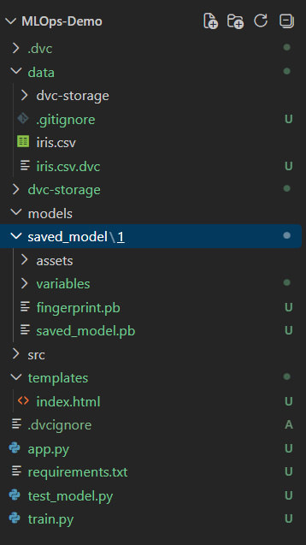

Data Version Control on Iris dataset
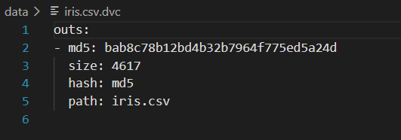

Model Training Output
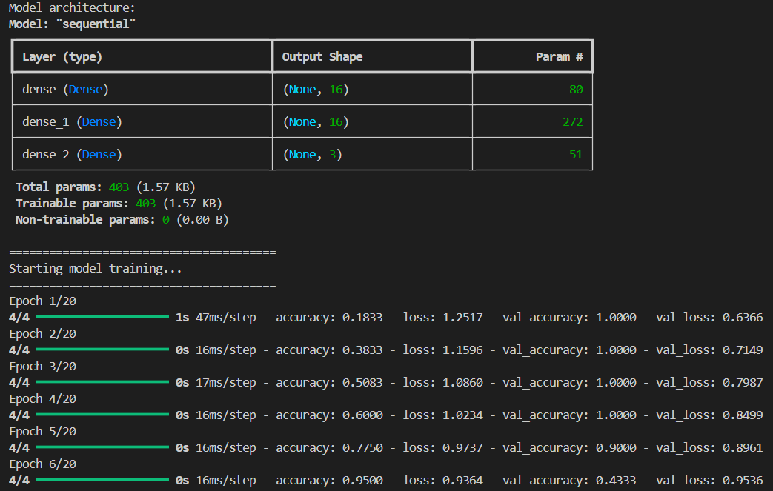
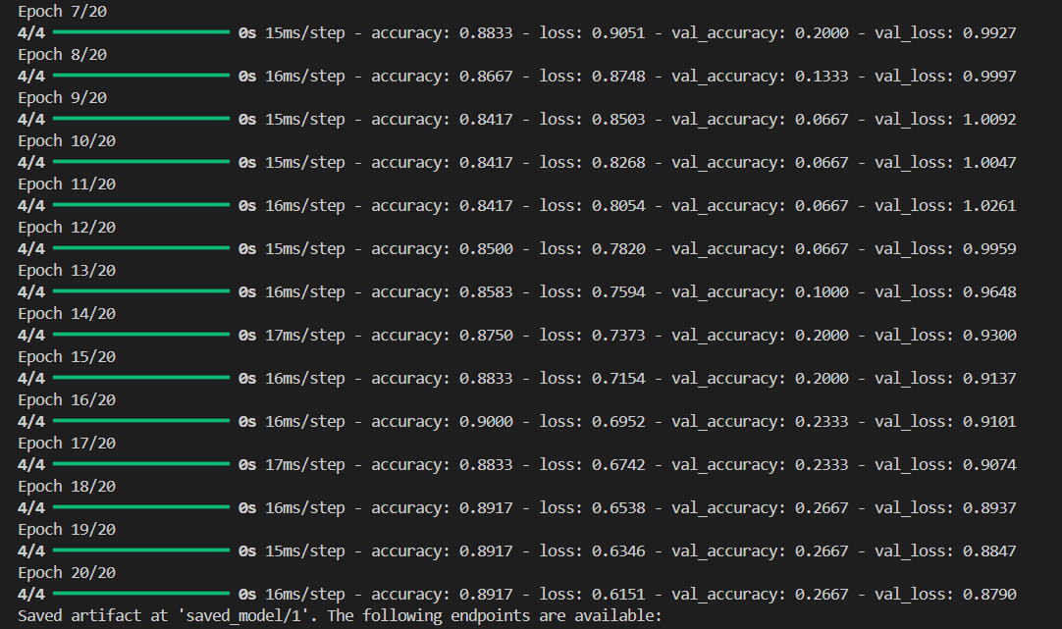
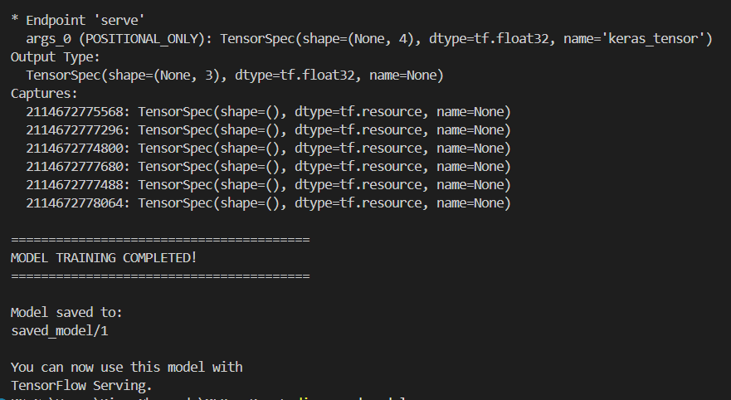

TensorFlow Serving Docker Container
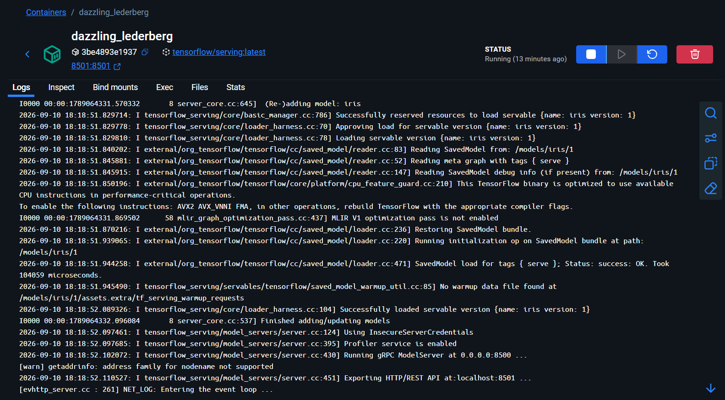

TensorFlow Serving model status and successful prediction response through the REST API
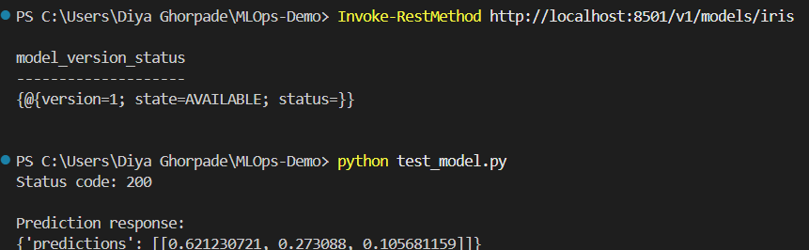
Model Status API
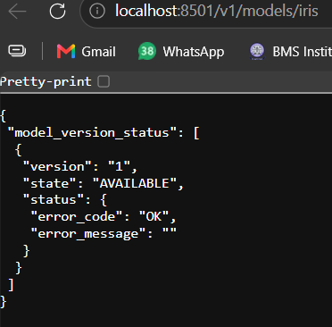
Flask Prediction Interface
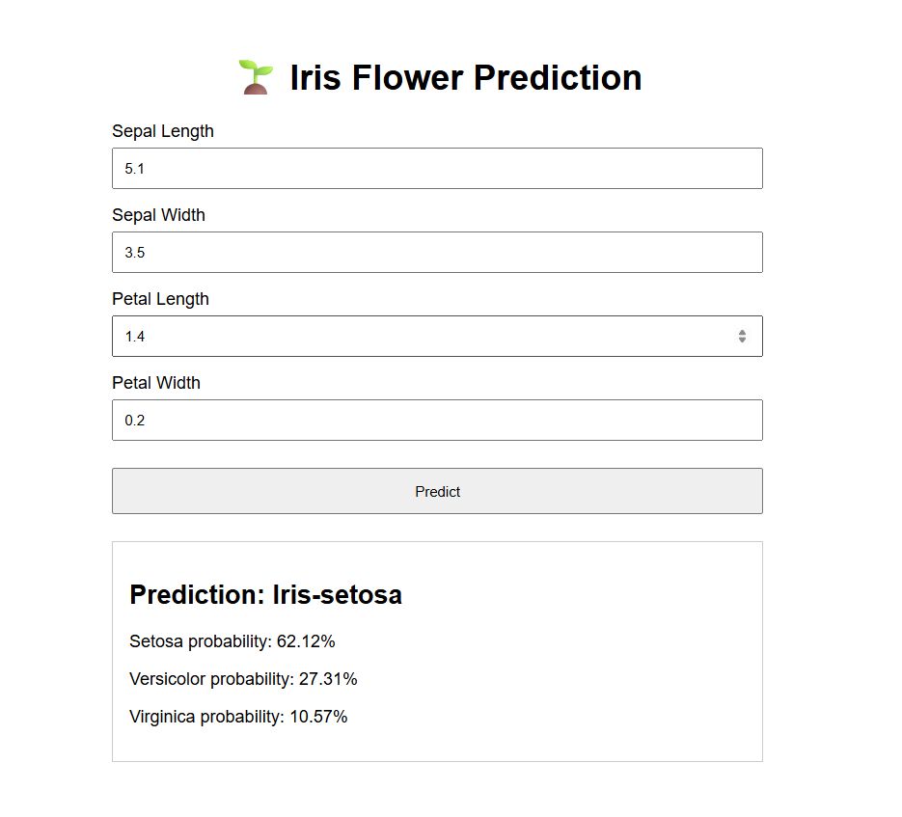
6. Real-World Use Cases
6.1 Git
● Used widely in software and machine learning organizations for managing source code and collaborative development.
● ML teams use Git to version training scripts, configuration files, notebooks, and application code.
● Git supports branching and merging, allowing developers to work on different features or experiments independently.
● It can be integrated with CI/CD tools to automatically test and validate code whenever changes are committed.
6.2 DVC
● Used in machine learning projects to version large datasets, trained models, and other ML artifacts.
● DVC helps maintain reproducibility by keeping track of which dataset version was used for a particular model.
● It is useful in fields such as healthcare, finance, and computer vision where datasets are frequently updated.
● DVC can be integrated with Git so that code versions and corresponding data versions can be maintained together.
6.3 TensorFlow Serving
● Used to deploy trained TensorFlow and Keras models for real-time prediction.
● It can be used in applications such as image classification, recommendation systems, fraud detection, and prediction services.
● TensorFlow Serving provides REST and gRPC APIs through which applications can send input data and receive predictions.
● It supports model versioning, making it easier to update deployed models without changing the complete application.

7. Conclusion and Learning Outcomes
This study demonstrates how Git, DVC, and TensorFlow Serving support different stages of the MLOps lifecycle. Git manages source code, DVC manages datasets and ML artifacts, and TensorFlow Serving makes trained models available for real-time predictions.
The main learning outcomes are:
● Understanding the importance of version control in ML projects.
● Learning how Git can be used to track and manage project changes.
● Understanding how DVC provides version control for datasets and trained models.
● Learning how reproducibility can be maintained by connecting code, data, and model versions.
● Understanding the difference between model training and model serving.
● Gaining practical experience in exporting and serving a TensorFlow model using TensorFlow Serving and Docker.
● Learning how a REST API can be used to send data to a deployed model and receive predictions.
Overall, the implementation shows how different MLOps tools work together to make machine learning workflows more organized, reproducible, and easier to deploy and maintain.

8. References
● Git — Official Documentation: https://git-scm.com
● DVC — Official Documentation: https://dvc.org
● TensorFlow Serving — Official Documentation: https://www.tensorflow.org/tfx/guide/serving
● TensorFlow Serving REST API: https://www.tensorflow.org/tfx/serving/api_rest
● Google Cloud — MLOps: Continuous Delivery and Automation Pipelines in Machine Learning: https://cloud.google.com/architecture/mlops-continuous-delivery-and-automation-pipelines-in-machine-learning
● MLflow — Official Documentation: https://mlflow.org
● Kubeflow — Official Documentation: https://www.kubeflow.org
● Prometheus — Official Documentation: https://prometheus.io
● GitHub Actions — Official Documentation: https://docs.github.com/actions

