Unsupervised Clustering of Greenhouse Plant Growth Metrics

1. Objective
The goal of this study is to identify inherent patterns in plant growth characteristics using an unsupervised learning approach. Since no explicit plant health labels are available, clustering is applied to group plants based on physiological and root-growth features.

2. Dataset Description
The dataset “Greenhouse Plant Growth Metrics” contains:
- Total Samples: 30,000
- Total Features: 14
- Feature Types:
  - 12 numerical features (growth metrics)
  - 2 categorical features (Random, Class)
Key Features Used for Clustering
- ACHP – Average Chlorophyll Content
- PHR – Plant Height Rate
- AWWGV – Average Wet Weight of Vegetative Growth
- ALAP – Average Leaf Area per Plant
- ANPL – Average Number of Leaves per Plant
- ARD – Average Root Diameter
- ADWR – Average Dry Weight of Roots
- PDMVG – Plant Dry Mass of Vegetative Growth
- ARL – Average Root Length
- AWWR – Average Wet Weight of Roots
- ADWV – Average Dry Weight of Vegetation
- PDMRG – Plant Dry Mass of Root Growth
Excluded Features
- Random: Non-informative identifier
- Class: Ground-truth label (excluded to maintain unsupervised setting)

3. Data Preprocessing
3.1 Data Integrity Check
- No missing values detected
- No infinite values present
- Dataset is clean and complete
3.2 Feature Selection
Only numerical features were retained for clustering:
3.3 Feature Scaling
To ensure all features contribute equally:
- Technique Used: Standardization
- Method: Z-score normalization
Implemented using:
  - StandardScaler
  - ColumnTransformer

4. Clustering Methodology
4.1 Algorithm Selection
- Algorithm: K-Means Clustering
4.2 Optimal Cluster Selection
The Elbow Method was used:
- Evaluated K from 1 to 10
- Metric: Inertia (Within-Cluster Sum of Squares)
Observation:
- Significant drop until K = 3
- Marginal improvement beyond that
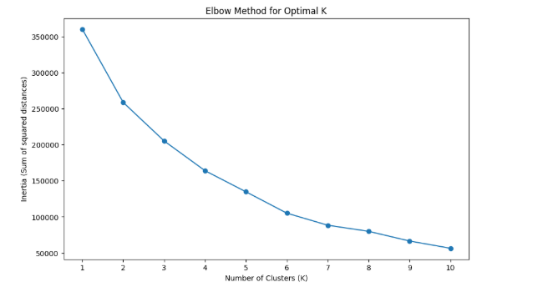
Optimal Clusters Selected: K = 3

4.3 Model Configuration
- n_clusters = 3
- random_state = 42
- n_init = 10 (robust centroid initialization)

5. Clustering Results
Cluster Distribution
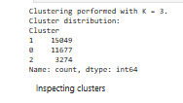
6. Cluster Analysis
Cluster-wise mean values were computed on original (unscaled) data.
Key Discriminative Features (via Boxplot Analysis)
- AWWGV (Vegetative growth mass)
- ARD (Root diameter)
- ADWR (Root dry weight)
- ARL (Root length)
- AWWR (Root wet weight)
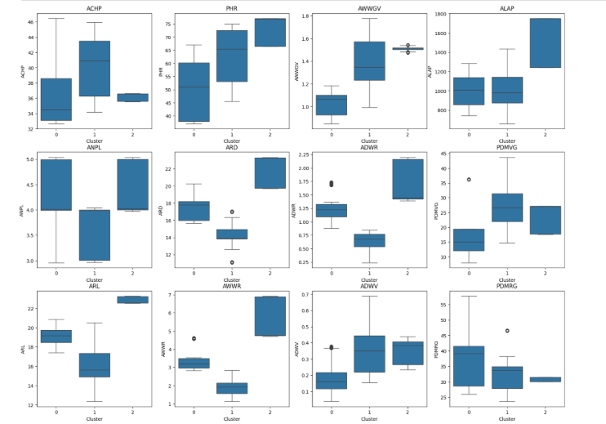

7. Cluster Interpretation
Cluster 2 – High Growth / Healthy Plants
Characteristics:
- Highest root length and diameter
- High root biomass (wet & dry)
- Strong vegetative growth
Interpretation:
- Represents optimal plant health
- Efficient nutrient uptake and strong root system

Cluster 1 – Weak Root System
Characteristics:
- Lowest root diameter and biomass
- Reduced root length
- Moderate vegetative growth
Interpretation:
- Indicates root-deficient plants
- Likely limited nutrient absorption

Cluster 0 – Moderate Roots, Low Shoot Growth
Characteristics:
- Moderate root development
- Lower vegetative growth compared to Cluster 2
Interpretation:
- Plants have functional roots but inefficient shoot growth
- Possible environmental or nutrient imbalance

8. Visualization
Boxplots
- Used to compare feature distributions across clusters
- Revealed overlapping and separable patterns
Key Insight:
Root-related features show strong separation, making them critical clustering drivers.

9. Key Insights
- Root system features are primary determinants of plant growth clusters
- Strong correlation between:
  - Root biomass ↔ Overall plant health
- Identified three distinct growth regimes:
  - Healthy (optimal)
  - Root-deficient
  - Moderately developed

10. Limitations
- K-Means assumes spherical clusters → may oversimplify structure
- No ground-truth validation (unsupervised setting)
- Feature correlation not explicitly reduced (e.g., PCA optional)
- Cluster imbalance (Cluster 2 smaller)

11. Future Improvements
- Apply PCA / t-SNE for better visualization
- Use Silhouette Score / Davies-Bouldin Index for validation
- Try advanced clustering:
  - DBSCAN (density-based)
  - Gaussian Mixture Models (probabilistic)
- Incorporate time-series growth trends if available
- Build supervised model using clusters as pseudo-labels

12. Conclusion
This study successfully applied K-Means clustering to uncover latent plant growth patterns. The analysis demonstrates that:
- Root-related features are critical indicators of plant health
- Three meaningful clusters represent varying growth conditions
- The approach can assist in automated plant health monitoring and decision-making in greenhouse environments

