Technical Documentation
Plant Health Prediction Using Environmental Features: A Data Quality Assessment Study
1. Objective
The objective of this study is to evaluate whether environmental and soil-related features can reliably predict plant health status using machine learning techniques. Additionally, the study investigates whether the dataset contains meaningful predictive signals or suffers from weak feature-target relationships.

2. Dataset Description
- Dataset Size: 1,000 samples
- Total Features: 9
- Target Variable: Health_Status (Binary: 0 = Unhealthy, 1 = Healthy)
Feature List
Feature | Description
Plant_ID | Unique identifier (categorical, dropped for modeling)
Temperature_C | Ambient temperature
Humidity_% | Environmental humidity
Soil_Moisture_% | Soil water content
Soil_pH | Soil acidity/alkalinity
Nutrient_Level | Nutrient concentration
Light_Intensity_lux | Light exposure
Health_Score | Continuous health metric
Health_Status | Binary classification target

3. Data Preprocessing
- No missing values detected
- No duplicate handling required
- Plant_ID excluded from modeling
- Features retained in raw numerical form (tree-based model used)
4. Exploratory Data Analysis (EDA)
4.1 Target Distribution
- Highly imbalanced dataset
  - Class 1 (Healthy): ~85%
  - Class 0 (Unhealthy): ~15%
This imbalance is critical and influences model behavior significantly.
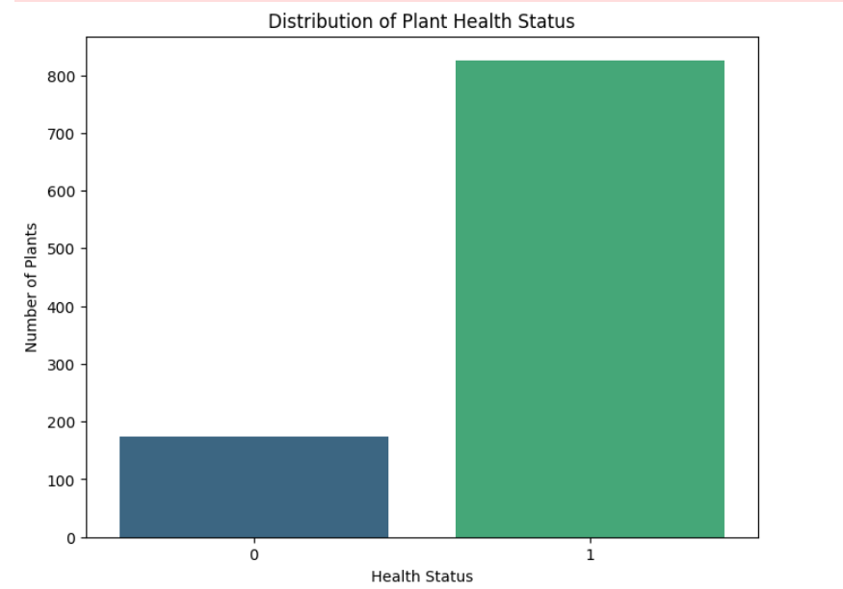

4.2 Feature Distribution
- Health scores roughly normally distributed
- Environmental variables show realistic variance but no visible class separation
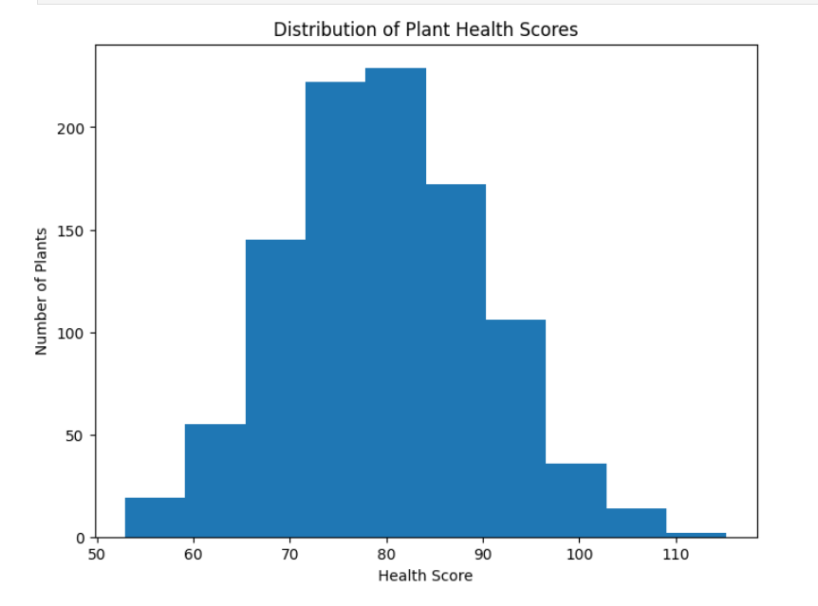

4.3 Correlation Analysis
- Correlation heatmap shows:
  - Weak linear relationships with target
  - No dominant predictive feature
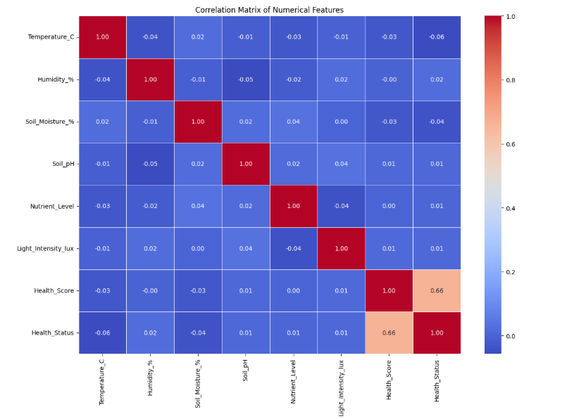

4.4 Box Plot Analysis
- Significant overlap between classes across all features
- No clear threshold separating healthy vs unhealthy plants
Indicates poor separability in feature space

5. Feature Importance & Statistical Analysis
5.1 Mutual Information (MI)
Feature | MI Score
Temperature_C | 0.000
Humidity_% | 0.0019
Soil_Moisture_% | 0.000
Soil_pH | 0.000
Nutrient_Level | 0.000
Light_Intensity_lux | 0.000
Interpretation:
- Near-zero MI → Features provide no information gain about target
- Suggests independence between predictors and label
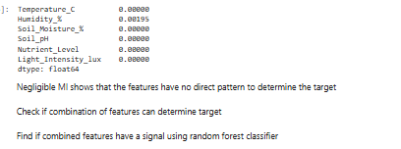

6. Modelling Approach
6.1 Model Used
- Random Forest Classifier
6.2 Training Setup
- Train-Test Split: 80-20
- No hyperparameter tuning (baseline evaluation)

7. Results
7.1 Random Forest Performance
- Accuracy: 85%
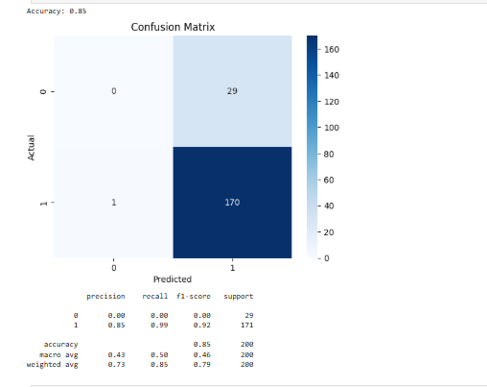
7.2 Key Observation
- Model predicts ONLY class 1
- Completely fails to detect class 0

8. Baseline Comparison
Dummy Classifier (Most Frequent Strategy)
- Accuracy: 85% (same as Random Forest)
This confirms:
The model is not learning anything meaningful

9. Feature Importance (Random Forest)
- Feature importance distributed randomly
- No feature dominates prediction
Indicates:
- Model is fitting noise, not signal

10. Decision Tree Analysis
- Extracted tree rules show:
  - Complex nested splits
  - No consistent decision boundary
  - Overfitting behavior
Reinforces lack of real pattern in data

11. Critical Findings
1. No Predictive Signal
- Mutual Information ≈ 0
- No feature contributes meaningfully
2. Severe Class Imbalance
- Model biased toward majority class
- Minority class completely ignored
3. Random Forest ≈ Dummy Model
- Indicates dataset lacks learnable structure
4. Feature Overlap
- Box plots show identical distributions across classes

12. Root Cause Analysis
The dataset likely suffers from one or more of the following:
Synthetic or Random Labeling
- Target may not be derived from features
Missing Key Features
- Important biological/environmental variables absent
Weak Feature Engineering
- Raw features insufficient to capture plant health dynamics
Label Noise
- Health_Status may not align with actual feature conditions

13. Conclusion
This dataset is not suitable for predictive modeling of plant health status.
- No statistical or machine learning method was able to extract meaningful patterns
- Observed accuracy is misleading due to class imbalance
- Model performance does not exceed trivial baseline

14. Recommendations
Data Improvements
- Collect real-world labeled data
- Ensure labels are derived from measurable conditions
- Add temporal (time-series) data
Feature Engineering
- Interaction features (e.g., Temp × Humidity)
- Threshold-based domain features
- Derived stress indices
Modeling Improvements (if data improves)
- Use imbalance handling:
  - SMOTE
  - Class weights
- Try:
  - XGBoost / LightGBM
  - Neural networks (if signal exists)

15. Final Verdict
Dataset is statistically and practically non-informative for classification tasks.

